Contents

**1. Selenium - Introduction and How to install and Configure Selenium** 6

**2. Selenium - Creating First Selenium Script and Running it on Chrome Browser** 12

**2A. Selenium - Running Selenium Scripts on Firefox Browser** 15

**2B. Selenium - Running Selenium Scripts on Edge Browser** 16

**3. Selenium - Basic Interview Questions** 18

**4. Selenium - Basic WebDriver Methods** 21

**5. Selenium - WebDriver Navigate Methods** 24

**6. Selenium - Closing the background driver.exe files at once** 25

**7. Selenium - Basic HTML Concepts** 27

**8. Selenium - WebDriver Locator Techniques - Introduction** 30

**8A. Selenium - Locating Web Elements Using Different Techniques - Examples** 32

**8B. Selenium - Locating Web Elements Using XPath** 35

**8C. Selenium - Locating Web Elements Using CSSSelectors** 39

**8D. Selenium - Locating Web Elements Using tagName and contains keyword** 43

**9. Selenium - Interview Questions on Locator Techniques** 45

**10. Selenium - WebDriver FindElement methods** 47

**10A. Selenium - FindElements Method and Difference Between FindElement and FindElements Methods** 50

**11. Selenium - Working with Text Areas** 51

**12. Selenium - Working with Checkboxes** 52

**12A. Selenium - Finding total no. of checkboxes and values** 53

**12B. Selenium - Finding no. of checkboxes and values in a group - Limiting WebDriver scope** 54

**13. Selenium - Radio Buttons - Selecting a Radio Button** 55

**13A. Selenium - Radio Buttons - Finding Total Number of Radio Buttons** 56

**13B. Selenium - Radio Buttons - Clicking the radio buttons one by one 10 times** 57

**13C. Selenium - Radio Buttons - Printing all the value attributes of radio buttons** 58

**13D. Selenium - Radio Buttons - Selecting a radio button by comparing a value attribute** 59

**14. Selenium - Dropdown lists - Selecting a value from a dropdown list** 60

**14A. Selenium - Dropdown lists - Getting all the Values and Visible Text from a dropdown list** 62

**14B. Selenium - Dynamic Dropdowns - Second dropdown based on first dropdown** 63

**15. Selenium - Multiselect Multiple Select - Selecting Multiple Values and Deselecting** 64

**16. Selenium - Interview Questions on how to work with different elements** 66

**17. Selenium - Handling Different Javascript Alerts** 68

**18. Selenium - Checking the visibility of an element** 70

**19. Selenium - Using Keyboard Keys - Using Enter Key and Tab Key** 71

**20. Selenium - Interview Questions on Javascript Alerts, Waits and Keyboard Keys** 72

**21. Selenium - Action Class - Handling Mouse and Keyborad Events** 74

**21A. Selenium - Actions Class - Selecting text from Textarea - Double click** 75

**21B. Selenium - Action Class - Menu Dynamic Dropdown - Example 1** 76

**21C. Selenium - Action Class - Menu Dynamic Dropdowns - Example 2** 77

**21D. Selenium - Action Class - Drag and Drop Operations** 78

**22. Selenium - Handling Child Windows** 79

**23. Selenium - Handling Frames** 80

**24. Selenium - Uploading Images - With HTML Upload (input tag)** 81

**24A. Selenium - Uploading Images - CSS Uploads - AutoIT** 82

**25. Selenium - Cookies - Managing Cookies** 84

**25A. Selenium - Cookies - Deleting All Cookies** 86

**25B. Selenium - Cookies - Deleting Cookies based on Domain Name** 87

**26. Selenium - How to disable push notifications in Chrome** 88

**26A. Selenium - How to disable push notifications in Firefox** 90

**26B. Selenium - How to accept insecure certificates in Chrome** 91

**26C. Selenium - How to accept insecure certificates in Firefox** 92

**26D. Selenium - How to hide the Automation tool bar warning in Chrome** 93

**27. Selenium - Interview Questions on Actions Class, child windows, frames, uploading images, cookies, chromeoptions and firefox options** 94

**28. Selenium - Java Synchronization - Implicit Wait and Explicit Wait** 97

**29. Selenium - Javascript Executor** 99

**29A. Selenium - Javascript Basics** 100

**29B. Selenium - Javascript Executor - Reading the values under an Auto Suggest** 102

**29C. Selenium - Javascript Executor - Printing count and all the values under an Auto Suggest** 104

**29D. Selenium - Javascript Executor - Selecting a value from Auto Suggest** 106

**29E. Selenium - Javascript Executor - Scrolling down a webpage using Javascript Executor** 108

**30. Selenium - Interview Questions on JavascriptExecutor** 110

**31. Selenium - Reading Table values** 112

**31A. Selenium - Reading Tables on second page and nth page** 113

**31B. Selenium - Moving to nth page to read table using javascript Executor** 115

**32. Selenium - TestNG - Importance of TestNG and Installing TestNG** 117

**32A. Selenium - TestNG - Running Tests with TestNG** 119

**32B. Selenium - TestNG - TestNG XML - Running Multiple Tests with TestNG** 121

**32C. Selenium - TestNG - Excluding or Including Specific Tests from Execution** 124

**32D. Selenium - TestNG - Running Tests at Package Level** 126

**32E. Selenium - TestNG - Test Annotations** 127

**32F. Selenium - TestNG - Groups in TestNG** 129

**32G. Selenium - TestNG - Helper Attributes in TestNG** 130

**32H. Selenium - TestNG - Parameterizing tests in TestNG** 131

**32I. Selenium - TestNG - Data Provider Annotations - Data driven testing** 134

**32J. Selenium - TestNG - Running Tests in Parallel in TestNG** 136

**32K. Selenium - TestNG - Listeners in TestNG and How to Work with them** 138

**32L. Selenium - TestNG - Taking Screenshots whenever a test fails using listeners in TestNG** 140

**32M. Selenium - TestNG - Setting Priority in TestNG** 145

**32N. Selenium - TestNG - Global Data in Selenium using .properties file** 147

**32O. Selenium - TestNG - Assertions in TestNG** 150

**33. Selenium - TestNG - Interview Questions on TestNG** 152

**34. Selenium - Maven - Maven Introduction** 160

**34A. Selenium - Maven - Requirements for Maven and Installing Maven** 162

**34B. Selenium - Maven - Maven pom.xml and its different Components** 163

**34C. Selenium - Maven - Converting a Project to Maven Project in Eclipse** 168

**34D. Selenium - Maven - Creating a Maven Project using Command Prompt** 169

**34E. Selenium - Maven - Profiling in Maven** 170

**35. Selenium - Maven - Interview Questions** 172

**36. Selenium - Jenkins -What is Jenkins and How Jenkins is used for automation execution** 177

**36A. Selenium - Jenkins - Installing Jenkins on Windows and Running it** 179

**36B. Selenium - Jenkins - Jenkins Overview** 184

**36C. Selenium - Jenkins - Configuring Jenkins, Creating a new Job and Running Jenkins Jobs Manually** 187

**36D. Selenium - Jenkins - Running Jenkins Jobs at a Particular time or at an interval of time or remotely** 192

**36E. Selenium - Jenkins - Reports - TestNG Results Plugin** 194

**36F. Selenium - Jenkins - Reports - Test Results Analyzer Plugin** 196

**36G. Selenium - Jenkins - Sending Test Reports in Email through Jenkins** 196

**37. Selenium - Jenkins Interview Questions** 201

**38. Selenium - Database Testing - Introduction** 202

**38A. Selenium - Database Testing - Setting up a site in our localhost** 204

**38B. Selenium - Database Testing - Submit a New User and Check Database Table** 205

**39. Selenium - Page Object Model - What is Page Object Model and what are its uses** 207

**39A. Selenium - Page Object Model - Implementing Page Object Model** 208

**39B. Selenium - Page Object Factory** 211

**40. Selenium - Page Object Model and Factory Interview Questions** 213

**41. Selenium - Log4j2 - What is Log4j2 and its uses and how to install and configure** 215

**41A. Selenium - Log4j2 - Log4j2 Configuration file to print all the messages** 217

**Logging a particular level of information to console:** 217

**Logging one level for one program, another level for another program and another level for all other programs to Console:** 218

**Setting Logging Levels at Package Level** 219

**41B. Selenium - Log4j2 - How to log into a file** 220

**Basic XML Configuration File To Log Into File** 220

**From One Package to File and Everything Else to Console:** 221

**41C. Selenium - Log4j2 - How to Print Logs into Different Files for Different Packages** 222

**Logger Levels and output** 223

**42. Selenium - Log4j interview Questions** 224

**43. Selenium - Selenium Grid - What is Selenium Grid** 228

**43A. Selenium - Selenium Grid - Setting up Environment for Selenium Grid** 229

**43B. Selenium - Selenium Grid - Selenium Grid with One System** 236

**43C. Selenium - Selenium Grid - Selnium Grid with three nodes (Firefox, Chrome and Opera)** 241

**44. Selenium - Selenium Grid Interview Questions** 242

**45. Selenium - Reading Data from Excel - Apache POI API - Introduction and Basic Program** 246

**45A. Selenium - Reading Data from Excel - Apache POI API - Reading All Data** 248

**45B. Selenium - Reading Data from Excel - Creating a seperate class and calling it** 250

**45C. Selenium - Reading Data from Excel - Creating a seperate class and calling it - Advanced** 253

**45D. Selenium - Writing Data to Excel - Basic Program** 256

**45E. Selenium - Writing Data to Excel – Advanced** 257

**46. Selenium - Interview Questions on reading and writing data to Excel** 259

**47. Selenium - Frameworks - What is a Framework and what are the different frameworks** 261

**47A. Selenium - Frameworks - Sample Application Overview** 262

**48. Selenium - Frameworks - Selenium Modular Framework** 263

**48A. Selenium - Frameworks - Implementing Selenium Modular Framework - Part1** 265

**48B. Selenium - Frameworks - Implementing Selenium Modular Framework - Part2** 267

**48C. Selenium - Frameworks - Implementing Selenium Modular Framework - Part3** 270

**49. Selenium - Frameworks - Selenium Data Driven Framework** 272

**49A. Selenium - Frameworks - Data Driven Framework Implementation - Part1** 274

**49B. Selenium - Frameworks - Data Driven Framework Implementation - Part2** 276

**49C. Selenium - Frameworks - Data Driven Framework Implementation - Part3** 278

**50. Selenium - Frameworks - Selenium Keyword Driven Framework** 282

**50A. Selenium - Frameworks - Implementing Selenium Keyword Driven Framework - Part 1** 285

**50B. Selenium - Frameworks - Implementing Selenium Keyword Driven Framework - Part 2** 287

**50C. Selenium - Frameworks - Implementing Selenium Keyword Driven Framework - Part 3** 288

**50D. Selenium - Frameworks - Implementing Selenium Keyword Driven Framework - Part 4** 290

**50E. Selenium - Frameworks - Implementing Selenium Keyword Driven Framework - Part 5** 293

**50F. Selenium - Frameworks - Implementing Selenium Keyword Driven Framework - Part 6** 295

**50G. Selenium - Frameworks - Implementing Selenium Keyword Driven Framework - Part 7** 297

**50H. Selenium - Frameworks - Implementing Selenium Keyword Driven Framework - Part 8** 299

# **1. Selenium - Introduction and How to install and Configure Selenium**

**Selenium Introduction:**

Selenium is an open source automation testing tool.

It is used exclusively for web-based applications.

You can work on multiple operating systems using selenium

**Platforms Supported by Selenium**

Windows

OS X

Linux

Solaris

**following languages are used with selenium.**

- Java  
- C#  
- Ruby  
- Pyton  
- PHP  
- Perl

**Selenium Browsers Support:**

InternetExplorer

Firefox

Chrome

Safari

**SeleniumHistory**

Selenium came into existence in 2004 when a GUY named Jason Huggins was testing an internal application at ThoughtWorks.

Selenium is a set of different software tools each with a different approach to supporting test automation.

**Selenium Components:**

[Selenium IDE](http://en.wikipedia.org/wiki/Selenium_(software)#Selenium_IDE)

[Selenium Remote Control](http://en.wikipedia.org/wiki/Selenium_(software)#Selenium_Remote_Control)

[Selenium WebDriver](http://en.wikipedia.org/wiki/Selenium_(software)#Selenium_WebDriver)

[Selenium Grid](http://en.wikipedia.org/wiki/Selenium_(software)#Selenium_Grid)

Let’s have a look on each of these components:

[**Selenium IDE**](http://en.wikipedia.org/wiki/Selenium_(software)#Selenium_IDE)

Selenium IDE is a complete [integrated development environment](http://en.wikipedia.org/wiki/Integrated_development_environment) (IDE) for Selenium tests. It is implemented as a [Firefox extension](http://en.wikipedia.org/wiki/Add-on_(Mozilla)), and allows recording, editing, and debugging tests. It was previously known as Selenium Recorder.

Scripts are recorded in Selenese, a special test scripting language for Selenium. Selenese provides commands for performing actions in a browser (click a link, select an option), and for retrieving data from the resulting pages.

It is not only just play back tool, It can records user actions as they are performed and then exports them as reusable script in one of many programming languages that can be later executed.

**Drawbacks:**

As it will come with only Firefox addin. What if you want to test your application which works only in Internet explorer or some any other browser?

Selenium IDE is not suitable when you want to built a robust frameworks.

Selenium IDE doesn’t provide iteration or conditional statements for test scripts.

**Selenium RC (Selenium 1.0)**

Selenium RC was first component in the market which control a browser from a language of your choice. The underlying functionality of Selenium Remote Control is that it uses Javascript library (Selenium core) that could drive interactions with the page, allows us to automatically rerun tests against multiple browsers.

**Selenium RC Architecture**

There is a selenium-RC server which acts as proxy between our Driver code and Application under Test

The client/driver establishes a connection with the selenium-RC server.  
2. Selenium RC server launches a browser (or reuses an old one) with a URL that injects Selenium-Core’s JavaScript into the browser-loaded web page.  
3. The client-driver passes a Selenese command to the server.  
4. The Server interprets the command and then triggers the corresponding JavaScript execution to execute that command within the browser.  
5. Selenium-Core instructs the browser to act on that first instruction, typically opening a page of the AUT.  
6. The browser receives the open request and asks for the website’s content from the Selenium RC server (set as the HTTP proxy for the browser to use).  
7. Selenium RC server communicates with the Web server asking for the page and once it receives it, it sends the page to the browser masking the origin to look like the page comes from the same server as Selenium-Core (this allows Selenium-Core to comply with the Same Origin Policy).  
8. The browser receives the web page and renders it in the frame/window reserved for it

**drawbacks**

As it is entirely use JavaScript to talk to browser, it leads to significant weakness. Every browser impose very strict security rules on the JavaScript being executed to protect the users from malicious scripts

There is no support for Android and IOS Platform

Server need to be started every time to run a program.

Lot of Limitations when a Application has Rich API with dynamic elements

Native keyboard and mouse events cannot be handled in efficient manner

**Webdriver: (Selenium 2.0)**

This brand new automation tool provides all sorts of features, including a more cohesive and object oriented API as well as an answer to the limitations of the old implementation. It supports the WebDriver API underlying technology, along with the Selenium underlying technology,

The architecture of Selenium Webdriver is entirely different from RC. Unlike RC there is no proxy server between AUT and Code.

It makes direct calls to browser native API to get the things executed. Unlike RC it does not Use any proxy server to talk to browser. WebDriver uses the most appropriate way to access the browser API. If we look at Firefox, it uses JavaScript to access the API. If we look at Internet Explorer, it uses C++. That means that it sometimes needs direct help from browser development team. By this approach we can control browsers in the best possible way but has the downside that new browsers entering the market will not be supported straight away like we can with RC.

As Webdriver directly talks with browser we can overcome the limitations of JavaScript security model which we have faced with Selenium Core in RC

Selenium-WebDriver supports the following browsers along with the operating systems these browsers are compatible with.

• Google Chrome 12.0.712.0+

• Internet Explorer 6, 7, 8, 9 - 32 and 64-bit where applicable

• Firefox 3.0, 3.5, 3.6, 4.0, 5.0, 6, 7

• Opera 11.5+

• HtmlUnit 2.9

• Android – 2.3+ for phones and tablets (devices & emulators)

• iOS 3+ for phones (devices & emulators) and 3.2+ for tablets (devices & emulators)

Languages on which Webdriver Supports:

Java,

Javascript,

Ruby,

PHP,

Python,

Perl

C#

You can use any of the above language to Automate application. There is nothing rule like as your website is built with C#,so you have to use only C# code in Webdriver to automate your application.The language you write your code is Application independent.

**Why Webdriver??**

In addition, Selenium 2 still runs Selenium 1’s Selenium RC interface for backwards compatibility

No server required to start.

No support for Android and Iphone platform in RC

Can Handle rich API

Can handle Mouse movements

It directly talks to browser. unlike RC it does not use any proxy server

It supports all the Latest Versions of Firefox

All future enhancements can be done in Webdriver only.

[**Selenium Grid**](http://en.wikipedia.org/wiki/Selenium_(software)#Selenium_Grid)

Selenium Grid allows you to run your tests in parallel, that is, different tests can be run at the same time on different remote machines. Also, if you must run your test suite on multiple environments you can have different remote machines supporting and running your tests in them at the same time. In each case Selenium Grid greatly improves the time it takes to run your suite by making use of parallel processing

**Downloading and Configuring Selenium:**

Once we write selenium code, first the program should identify that it is selenium code. In order for the program to identify it as selenium code, first we need to download selenium and create a link between selenium and project we have created.

Go to google and type “Selenium Download”

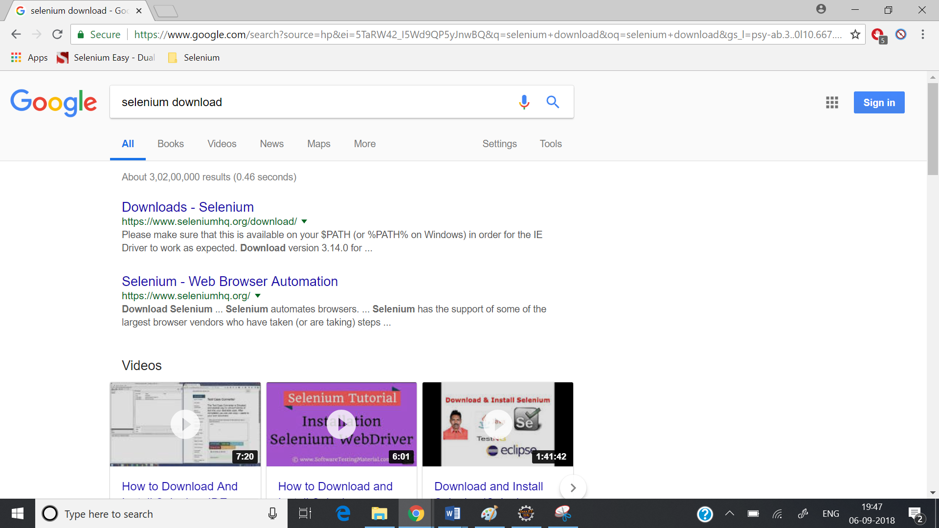

Go to the link “Downloads – Selenium”

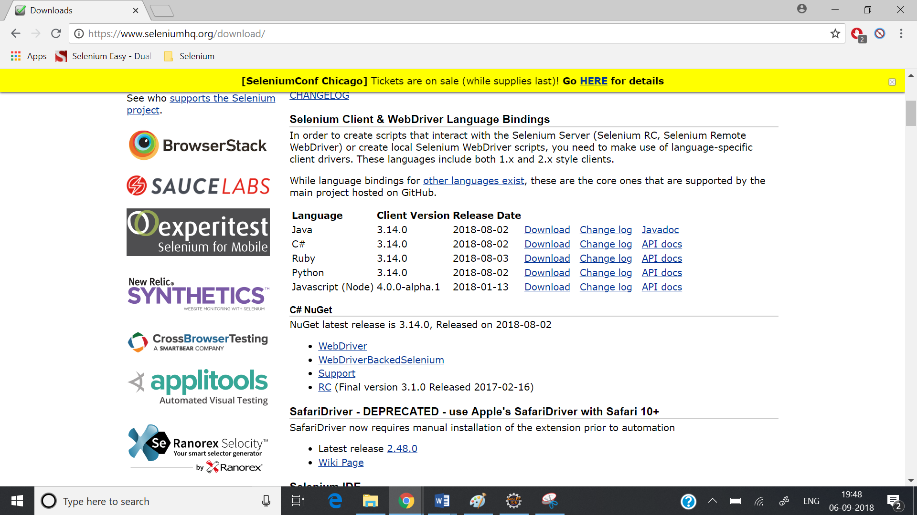

Download Java related jar files.

Once the files are downloaded, unzip them and you will see some jar files.

All these jar files need to be linked to your project.

**Linking the jar files to your selenium project:**

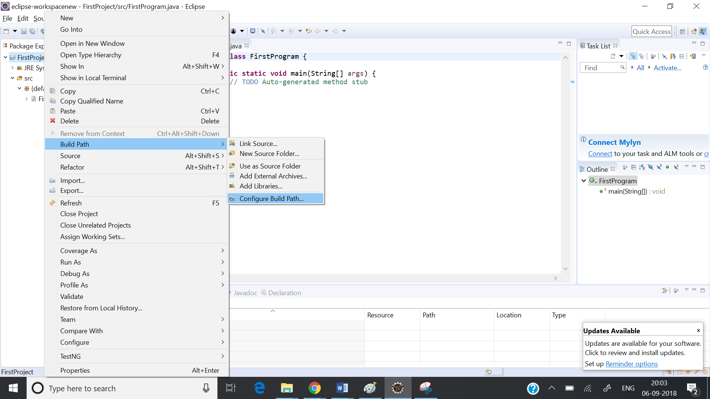

Right click on the project go to Build Path and go to Configure build. A new window opens and then go to Java Build Path and click on the tab “Libraries”.

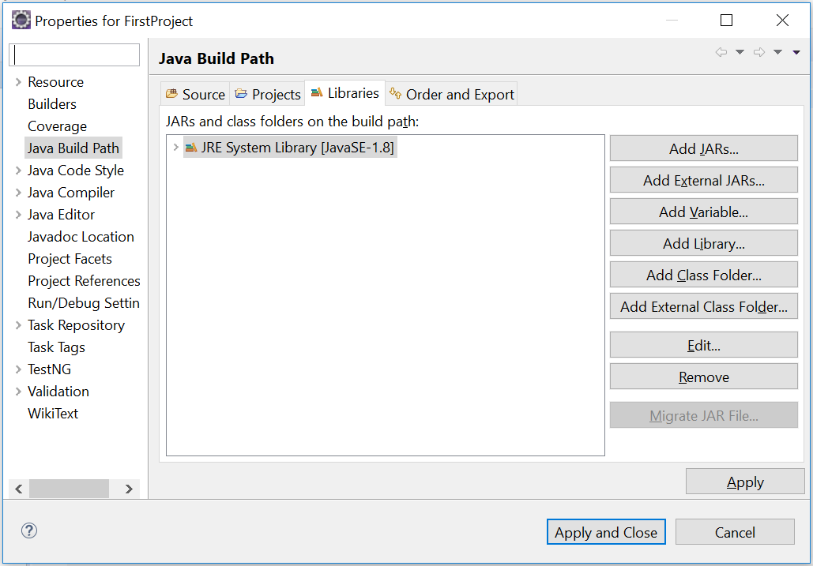

Click on Add External Jars and add all the selenium jar files we have downloaded. Then click on “Apply and Close”.

# **2. Selenium - Creating First Selenium Script and Running it on Chrome Browser**

**Creating First Script using Selenium:**

https://seleniumhq.github.io/selenium/docs/api/java/index.html

Go to the above url and click on WebDriver link and it shows all the methods.

WebDriver is an interface.

The different classes that implemented the above interface are

ChromeDriver, EdgeDriver, FirefoxDriver, InternetExplorerDriver, OperaDriver

ChromeDriver class is used to run tests on chrome browser.

EdgeDriver class is used to run tests on Microsoft Edge.

FirefoxDriver is used to run tests on Firefox browser.

InternetExplorerDriver is used to run tests on Internet Explorer.

OperaDriver is used to run tests on Opera Browser.

First, we need to create an object of the above classes to test any application on any browser.

For executing scripts on Chrome Browser:

WebDriver driver = new ChromeDriver();

Microsoft Edge:

WebDriver driver = new EdgeDriver();

Firefox Browser:

WebDriver driver = new FirefoxDriver();

Internet Explorer:

WebDriver driver = new InternetExplorerDriver();

Opera Explorer:

WebDriver driver = new OperaDriver();

**Example:**

**package** Selenium;

**import** org.openqa.selenium.WebDriver;

**import** org.openqa.selenium.chrome.ChromeDriver;

//import org.openqa.selenium.firefox.FirefoxDriver;

//import org.openqa.selenium.ie.InternetExplorerDriver;

**public** **class** FirstScript {

**public** **static** **void** main(String[] args) {

WebDriver driver = **new** ChromeDriver();

//WebDriver driver = new FirefoxDriver();

//WebDriver driver = new InternetExplorerDriver();

}

}

**Web Drivers for executing the scripts:**

Even though we have created the above objects we can’t directly access the browsers because they belong to different vendors.

We need to download third party browser drivers and mention the paths in the script to access the browsers.

Go to the following url

<https://www.seleniumhq.org/download/>

Go to third party browser drivers section and download chrome driver and unzip it.

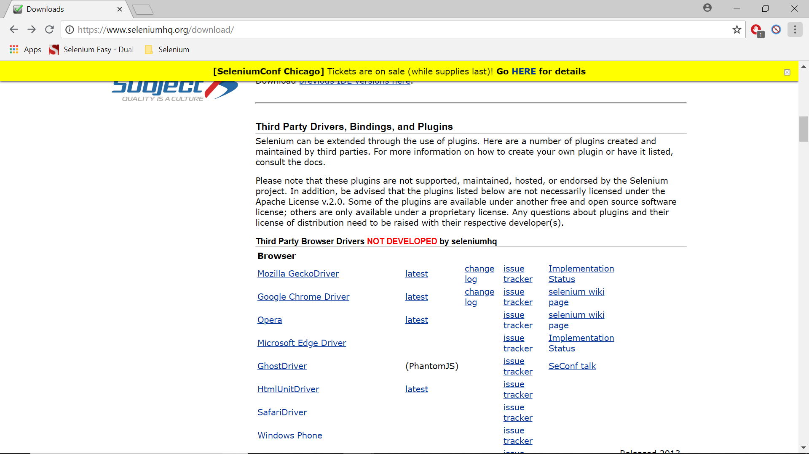

Note: Only Chrome Driver can be downloaded from the above page. Download other drivers searching google.

Note: If any of the drivers are not working download the older versions.

Chrome Driver:

https://chromedriver.storage.googleapis.com/index.html

Once you download the driver you need to set a System Property with these paths in the script.

The system properties you have to set up are:

Chrome Driver:

System.setProperty(“webdriver.chrome.driver”,”Path to chrome driver”);

**Example:**

**package** Selenium;

**import** org.openqa.selenium.WebDriver;

**import** org.openqa.selenium.chrome.ChromeDriver;

**public** **class** ChromeBrowser {

**public** **static** **void** main(String[] args) {

System.*setProperty*("webdriver.chrome.driver", "C:\\BrowserDrivers\\chromedriver.exe");

WebDriver driver = **new** ChromeDriver();

driver.get("http://www.rediff.com");

}

}

The above will open the chrome browser and open the site rediff.com

# **2A. Selenium - Running Selenium Scripts on Firefox Browser**

**Running Selenium Script on Firefox Browser:**

Go to google and search for geckodriver.exe download and download geckodriver.exe. Or download the firefox driver.exe file which is geckodriver.exe from the following location.

<https://github.com/mozilla/geckodriver/releases>

Download the right version based on the operating system you are using and if windows, 32 bit or 64 bit.

Once you download the driver set the system property for this driver exe file.

Firefox Driver:

System.setProperty(“webdriver.gecko.driver”,”Path to firefox driver”);

Gecko Driver:

System.setProperty(“webdriver.ie.driver”,”Path to internet explorer driver”);

**Example:**

**package** Selenium;

**import** org.openqa.selenium.WebDriver;

**import** org.openqa.selenium.firefox.FirefoxDriver;

**public** **class** FirefoxBrowser {

**public** **static** **void** main(String[] args) {

System.*setProperty*("webdriver.gecko.driver", "C:\\BrowserDrivers\\geckodriver.exe");

WebDriver driver = **new** FirefoxDriver();

driver.get("http://www.rediff.com");

}

}

The above will open the firefox browser and open Rediff.com

# **2B. Selenium - Running Selenium Scripts on Edge Browser**

**Running Selenium Script on Edge Browser:**

For running scripts on Edge we need microsoftwebdriver.exe. Go to google and search for microsoftwebdriver.exe. You will see the “WebDriver – Microsoft Edge Development” as the first result.

Click on it and you will see different versions for the edge driver.

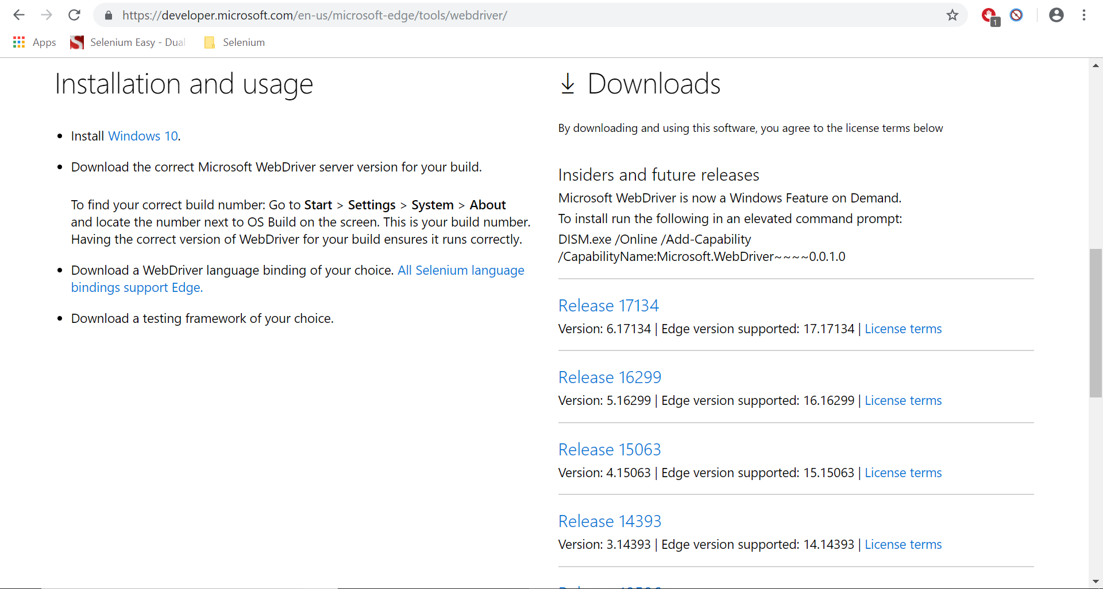

You need to find out which version you have to download. This depends on your windows 10 system version you are using. To find out which version you are using go to search bar and type “settings” and open settings.

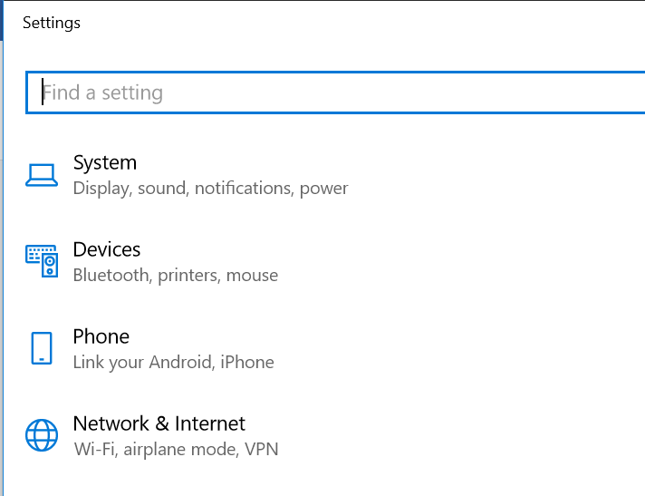

Go to System and then go to About.

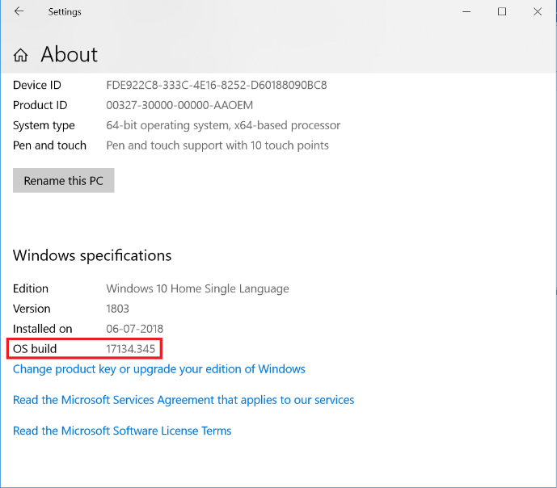

You will see OS build. In my case it is 17134.345. So, I download the Release 17134.

Once you download the driver set the system property for this driver exe file.

Edge Driver:

System.setProperty(“webdriver.edge.driver”,”Path to microsoftwebdriver”);

**package** Selenium;

**import** org.openqa.selenium.WebDriver;

**import** org.openqa.selenium.edge.EdgeDriver;

**public** **class** EdgeBrowser {

**public** **static** **void** main(String[] args) {

System.*setProperty*("webdriver.edge.driver", "C:\\BrowserDrivers\\microsoftwebdriver.exe");

WebDriver driver = **new** EdgeDriver();

driver.get("http://www.rediff.com");

}

}

The above will open the edge browser and open Rediff.com

# **3. Selenium - Basic Interview Questions**

**Selenium – Basic Interview Questions**

**What are the testing types that can be supported by Selenium?**

1. Functional Testing
2. Regression Testing

**What are the limitations of selenium?**

1. Selenium supports only web based applications
2. Captcha and Barcode readers can’t be tested with Selenium
3. Reports can only be generated using third party applications like TestNG or Junit
4. As Selenium is a freeware, there is nothing like immediate vendor support. You have to find support from online communities.

**What are the types of WebDriver APIs available in Selenium?**

1. Firefox Driver
2. Gecko Driver
3. InternetExplorer Driver
4. Chrome Driver
5. HTMLUnit Driver
6. Opera Driver
7. Safari Driver
8. Android Driver
9. iPhone Driver
10. EventFiringWebDriver

**Which WebDriver implementation claims to be the fastest?**

The fastest implementation of WebDriver is the HTMLUnitDriver. It is because the HTMLUnitDriver does not execute tests in the browser.

**What are the Programming Languages supported by Selenium WebDiver?**

1. Java
2. C#
3. Python
4. Ruby
5. Perl
6. PHP

**What are the Operating Systems supported by Selenium WebDriver?**

1. Windows
2. Linux
3. Apple

**What are the Open-source Frameworks supported by Selenium WebDriver?**

1. JUnit
2. TestNG

**How to launch a browser using Selenium WebDriver?**

WebDriver is an Interface. We create an Object of a required driver class such as FirefoxDriver, ChromeDriver, InternetExplorerDriver etc.,

To launch Firefox Driver:

WebDriver driver = new FirefoxDriver();

To launch Chrome Driver:

WebDriver driver = new ChromeDriver();

To launch Internet Explorer Driver:

WebDriver driver = new InternetExplorerDriver();

To launch Safari Driver:

WebDriver driver = new SafariDriver();

**Is the FirefoxDriver a Class or an Interface?**

FirefoxDriver is a Java class, and it implements the WebDriver interface.

**Explain the line of code Webdriver driver = new FirefoxDriver(); ?**

Webdriver driver = new FirefoxDriver();

‘WebDriver‘ is an interface and we are creating an object of type WebDriver instantiating an object of FirefoxDriver class.

**Why do we create like WebDriver driver = new FirefoxDriver(); instead of creating FirefoxDriver driver = new FirefoxDriver?**

If we create a reference variable driver of type WebDriver then we could use the same driver variable to work with any browser of our choice such as IEDriver, SafariDriver etc.,

**What happens if I run this command. driver.get(“www.softwaretestingmaterial.com”) ;**

An exception is thrown. We need to pass HTTP protocol within driver.get() method.

**Is it possible to automate the captcha using Selenium?**

No. It’s not possible.

**List some scenarios which we cannot automate using Selenium WebDriver?**

1. Bitmap comparison is not possible using Selenium WebDriver

2. Automating Captcha is not possible using Selenium WebDriver

3. We can not read bar code using Selenium WebDriver

**Name different driver classes for different browsers?**

ChromeDriver, EdgeDriver, FirefoxDriver, InternetExplorerDriver, OperaDriver

ChromeDriver class is used to run tests on chrome browser.

EdgeDriver class is used to run tests on Microsoft Edge.

FirefoxDriver is used to run tests on Firefox browser.

InternetExplorerDriver is used to run tests on Internet Explorer.

OperaDriver is used to run tests on Opera Browser.

# **4. Selenium - Basic WebDriver Methods**

**Basic WebDriver Methods:**

driver.get() – Opens the url provided

driver.getTitle() – Gets the title of the page

driver.getCurrentUrl() – Gets the current URL

driver.getPageSource() – Shows the page source

driver.close() – closes the browser

driver.quit() – Closes all the browsers opened by Selenium (Child windows etc)

driver.getWindowHandle() – String

driver.getWindowHandles() – Set<String>

driver.switchTo() – Target locator

**Example:**

**package** Selenium;

**import** org.openqa.selenium.WebDriver;

//import org.openqa.selenium.chrome.ChromeDriver;

**import** org.openqa.selenium.firefox.FirefoxDriver;

//import org.openqa.selenium.ie.InternetExplorerDriver;

**public** **class** FirstProgram {

**public** **static** **void** main(String[] args) {

//System.setProperty("webdriver.chrome.driver", "C:\\BrowserDrivers\\chromedriver.exe");

System.*setProperty*("webdriver.gecko.driver", "C:\\BrowserDrivers\\geckodriver.exe");

//System.setProperty("webdriver.ie.driver", "C:\\BrowserDrivers\\IEDriverServer.exe");

//WebDriver driver = new ChromeDriver();

WebDriver driver = **new** FirefoxDriver();

//WebDriver driver = new InternetExplorerDriver();

//Basic WebDriver Methods

//Opening an URL

driver.get("http://www.google.com");

//Getting the title of the page

System.***out***.println("Page Title: "+driver.getTitle());

//Get Current URL

System.***out***.println("Current URL: "+driver.getCurrentUrl());

//Page Source

System.***out***.println("Page Source: "+driver.getPageSource());

//Closing Browser

driver.close();

}

}

The eclipse console may not show the whole output as the output length is limited. For this Go to

Windows -> Preferences -> Run/Debug -> Console and uncheck the checkbox Limit Output and you will see the whole output.

Driver.close() is used to close the browser.

Driver.quit() is used to close the browser and all the associated windows.

Driver.getWindowHandle() is used to get the current window handle on which you are on.

Driver.getWindowHandles() is used to get all the associated window handles.

Driver.switchTo() is used to switch to the child windows or frames.

Thea above three will be discussed more in the later chapters.

5. Selenium - WebDriver Navigate Methods

**WebDriver Navigate Methods:**

driver.navigate().to(URL) – Opens the URL

driver.navigate().back() – Go back to the previous page

driver.navigate().forward() – Go back to the next page

driver.navigate().refresh() – Refreshes the page

Example:

**package** Selenium;

**import** org.openqa.selenium.WebDriver;

**import** org.openqa.selenium.firefox.FirefoxDriver;

**public** **class** FirstProgram {

**public** **static** **void** main(String[] args) {

System.*setProperty*("webdriver.gecko.driver", "C:\\BrowserDrivers\\geckodriver.exe");

WebDriver driver = **new** FirefoxDriver();

//Opening an URL

driver.get("http://www.google.com");

//Navigating to a different URL

driver.navigate().to("http://www.rediff.com");

//Navigating back

driver.navigate().back();

//Navigating forward

driver.navigate().forward();

//Refreshing a page

driver.navigate().refresh();

//Closing Browser

driver.close();

}

}

**What is the difference between driver.get() and driver.navigate().to()?**

Both work in the similar way. But driver.get() never stores history and driver.navigate().to() stores history so that yu navigate backward and forward.

# **5. Selenium - WebDriver Navigate Methods**

**WebDriver Navigate Methods:**

driver.navigate().to(URL) – Opens the URL

driver.navigate().back() – Go back to the previous page

driver.navigate().forward() – Go back to the next page

driver.navigate().refresh() – Refreshes the page

Example:

**package** Selenium;

**import** org.openqa.selenium.WebDriver;

**import** org.openqa.selenium.firefox.FirefoxDriver;

**public** **class** FirstProgram {

**public** **static** **void** main(String[] args) {

System.*setProperty*("webdriver.gecko.driver", "C:\\BrowserDrivers\\geckodriver.exe");

WebDriver driver = **new** FirefoxDriver();

//Opening an URL

driver.get("http://www.google.com");

//Navigating to a different URL

driver.navigate().to("http://www.rediff.com");

//Navigating back

driver.navigate().back();

//Navigating forward

driver.navigate().forward();

//Refreshing a page

driver.navigate().refresh();

//Closing Browser

driver.close();

}

}

**What is the difference between driver.get() and driver.navigate().to()?**

Both work in the similar way. But driver.get() never stores history and driver.navigate().to() stores history so that yu navigate backward and forward.

# **6. Selenium - Closing the background driver.exe files at once**

Closing the geckodriver.exe or chromedriver.exe files at once:

In every selenium script, we use the statement driver.close() or driver.quit() which will close the browser. It’s not only closes the browser but it also closes the background driver.exe files. (chromedriver.exe or firefoxdriver.exe files).

But when you are practicing the examples you won’t close the browsers because if you close them you can’t see your expected results. This will cause a lot of driver.exe files opened in the background and this might make your scripts slow down.

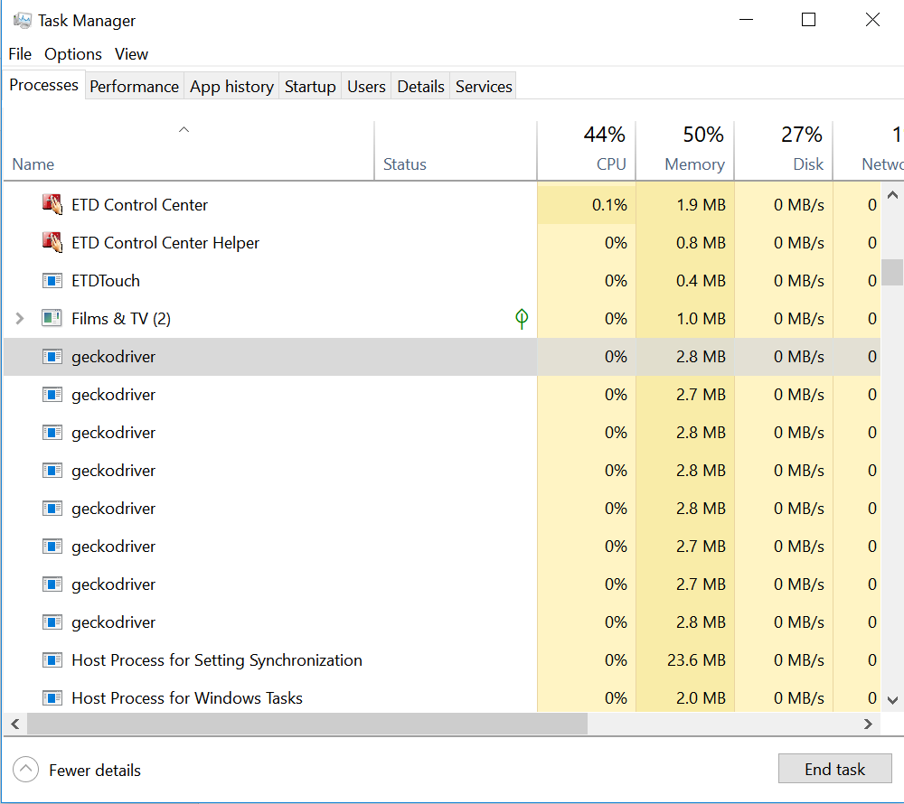

You can go ahead and close them one by one but it will take a lot of time for you. So you can use command prompt to close all these driver.exe files at ones.

Open command prompt, and use the following commands to close all the driver.exe files at once.

taskkill /IM "chromedriver.exe" /F – For killing all the open chromedriver.exe tasks in the background

taskkill /IM “geckodriver.exe” /F – For killing all the open geckodriver.exe files in the background

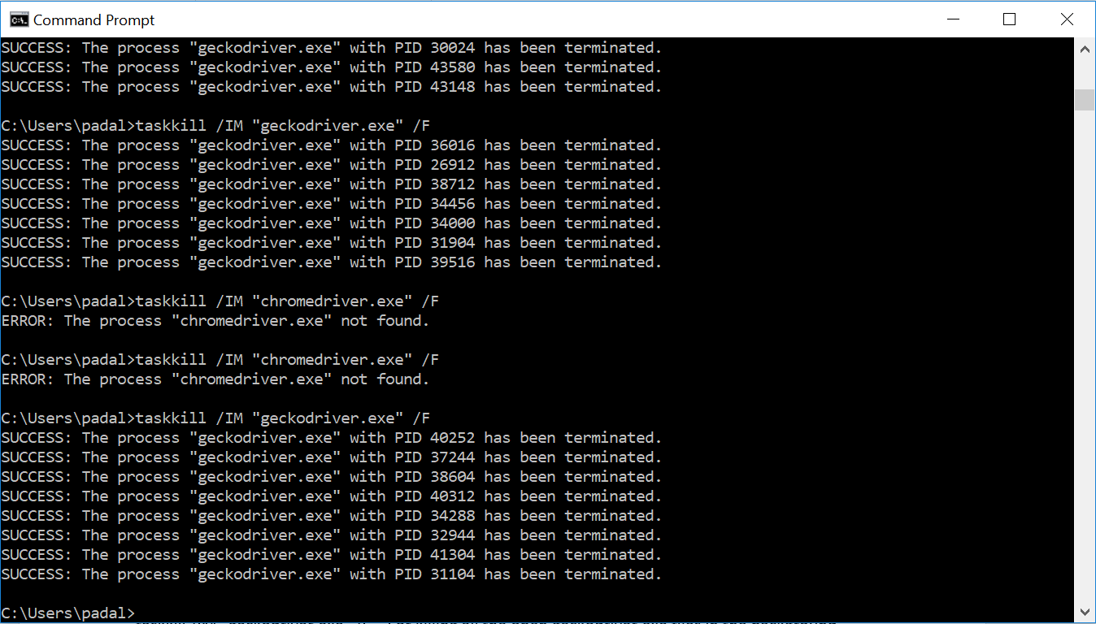

# **7. Selenium - Basic HTML Concepts**

**HTML Concepts on Elements:**

The web pages are developed with HTML.

HTML basically contains the following code.

<html>

<head>

</head>

<body>

</body>

</html>

The head tag contains information like meta information like description, keywords etc. It also contains information about any CSS files and javascript files that have to be included.

The body contains the information that is shown on the web page.

**Text Box:**

<input name=”firstname” id=”firstname” type=”text” >

**Text Area:**

<textarea name=”description” id=”description” rows=”10” cols=”10”></textarea>

**Radio Buttons:**

<input type=”radio” name=”gender” value=”male” checked> Male <br>

<input type=”radio” name=”gender” value=”female”> Female <br>

<input type=”radio” name=”gender” value=”other”> Other <br>

**Checkboxes:**

<input type="checkbox" name="vehicle1" value="Bike"> I have a bike<br>  
<input type="checkbox" name="vehicle2" value="Car"> I have a car<br>  
<input type="checkbox" name="vehicle3" value="Boat" checked> I have a boat<br>

**Static Drop-Down Lists (Drop-Down Select Boxes)**

<select>  
   <option value="volvo">Volvo</option>  
   <option value="saab">Saab</option>  
   <option value="mercedes">Mercedes</option>  
   <option value="audi">Audi</option>  
</select>

**Dynamic Drop-Down Lists**

https://css-tricks.com/examples/DynamicDropdown/

**Multiple Selections**

<select name="cars" size="4"**multiple**>  
   <option value="volvo">Volvo</option>  
   <option value="saab">Saab</option>  
   <option value="fiat">Fiat</option>  
   <option value="audi">Audi</option>  
</select>

**Buttons**

<input type=”button” name=”check” id=”check”>

**Submit Button**

<input type=”submit” name=”submit” id=”submit”>

**Reset Button**

<input type=”reset” name=”reset” id=”reset”>

**Links**

<a href=<http://www.google.com>>google</a><br>

<a href=<http://www.rediff.com>>rediff</a>

**Tables**

<table>

<tr>

<td><b>First Name</b></td><td><b>Last Name</b></td>

</tr>

<tr>

<td>Subbu</td><td>Padala</td>

</tr>

<tr>

<td>Ganesh</td><td>Raja</td>

</tr>

</table>

**Example:**

Please check the separate file.

**Basic Operations That We Can Perform on Different HTML Elements:**

**Text Box:**

Enter Information

Clear Information

**Text Area:**

Enter Information

Clear Information

**Radio Buttons:**

Select a single radio button

**Checkboxes:**

Check checkboxes

Uncheck checkboxes

**Dropdown Lists:**

Select a single value

**Multiple Selections:**

Select multiple values

**Buttons (Normal Button, Submit, Reset):**

Click

**Links:**

Click

# **8. Selenium - WebDriver Locator Techniques - Introduction**

**WebDriver Locator Techniques:**

**Locators supported by Selenium Webdriver:**

* ID
* Name
* ClassName
* linkText
* partialLinkText
* tagName
* Xpath
* CssSelector

**What are we going to learn in the next few chapters?**

Finding an element by ID (driver.findElement(By.id("firstname"))

Finding an element by Name (driver.findElement(By.name("firstname"))

Finding an element by className (driver.findElement(By.className("beautifultextbox"))

Finding an element by Link Text (driver.findElement(By.linkText("google the top search engine"))

Finding an element by Partial Link Text (driver.findElement(By.partialLinkText("google"))

Finding an element by xpath

Finding an element by CSSSelector

Finding elements when the ID, Name, attributes have spaces

* Find an element by id – works
* Finding an element by name – works
* Finding an element by Class Name – Produces error
* Finding element by xpath – works
* Finding element by CSS Selector - works

Finding an element by Xpath

* Writing our own xpaths ("//input[@color='red']"))
* Writing xpaths with regular expression (By.xpath("//*[@id='firstname']"))
* Writing xpaths by using contains keyword (By.xpath("//input[contains(@id,'last')]"))
* Writing xpaths with starts-with keyword (By.xpath("//input[starts-with(@id,'last')]"))
* Writing xpaths with ends-with keyword (By.xpath("//input[ends-with(@id,'name')]"))
* Finding an element using parent child relationship (By.xpath("//div[@name='pcrel']/div/div/input"))
* Finding siblings (By.xpath("//li[@id='list1']/following-sibling::li[2]"))
* Finding parent elements (By.xpath("//div[@id='child2']/parent::div"))
* Finding ancestors (By.xpath("//div[@id='child2']/ancestor::div")

Finding an element by CSS Selector

* Writing our own CSS Selectors using single attribute (By.cssSelector("input[color='red']"))
* Writing our own CSS Selectors using multiple attributes (By.cssSelector("input[color='red'][type='text']"))
* Other ways of writing css selectors tagname#id (By.cssSelector("input#firstname"))
* Other ways of writing css selectors #id (By.cssSelector("#firstname"))
* Other ways of writing css selectors tagname.className (By.cssSelector("input.beautifultextbox"))
* Other ways of writing css selectors tagname.className (By.cssSelector("input.beautifultextbox.colorful"))
* Other ways of writing css selectors .className

(By.cssSelector(".beautifultextbox"))

* Other ways of writing css selectors .className.className (By.cssSelector(".beautifultextbox.colorful"))
* CSS Locators for Sub String Matches – Starting text match with symbol ^ (By.cssSelector("input[color^='red']"))
* CSS Locators for Sub String Matches – Ending text match with symbol $ (By.cssSelector("input[color$='red']"))
* CSS Locators for Sub String Matches – Anywhere text match with symbol * (By.cssSelector("input[color*='red']"))
* CSS Locators using Child Locators (By.cssSelector("form>label>input[id='firstname']"))
* When you find more than one element (findElements(By.cssSelector("input[class*='text']")).get(2))

Finding first element using tag name and enter the value in first element driver.findElement(By.tagName("input")).sendKeys("Venkat");

Finding all elements using tag name and enter the value in a specific element driver.findElements(By.tagName("input")).get(2).sendKeys("Venkat");

Finding an element by visible text ("//div[contains(text(),'I am child 2')]"))

# **8A. Selenium - Locating Web Elements Using Different Techniques - Examples**

In this chapter we learn:

Finding an element by ID (driver.findElement(By.id("firstname"))

Finding an element by Name (driver.findElement(By.name("firstname"))

Finding an element by className (driver.findElement(By.className("beautifultextbox"))

Finding an element by Link Text (driver.findElement(By.linkText("google the top search engine"))

Finding an element by Partial Link Text (driver.findElement(By.partialLinkText("google"))

Finding an element by xpath

Finding an element by CSSSelector

Finding elements when the ID, Name, attributes have spaces

* Find an element by id – works
* Finding an element by name – works
* Finding an element by Class Name – Produces error
* Finding element by xpath – works
* Finding element by CSS Selector - works

Locating an element by ID:

IF the element has id associated with it, we can find the element by

driver.findElement(By.id(“id value”))

driver is the ChromeDriver or FirefoxDriver or InternetExplorerDriver object we create.

findElement() is a method which is used to locate an element. It takes an argument which is a By object and its locator method.

findElement(By.locator()) is the whole thing that is used to identify an element.

Locator can be id, name, className etc.

Once an element is located then we do operations on those elements like entering some text if it is a text box or textarea or click operations if it is a link or a button.

If the operation is entering some text, then we use sendKeys() method to enter text.

If the operation is a click, then we use click() method to enter text.

driver.findElement(By.id("firstname")).sendKeys("Subbu");

Locating an element by Name:

driver.findElement(By.name("firstname")).sendKeys("Subbu");

Locating an element by ClassName:

driver.findElement(By.className("beautifultextbox")).sendKeys("subbu");

Locating an element by linkText:

driver.findElement(By.linkText("google the top search engine")).click();

Locating an element by Partial Link Text:

driver.findElement(By.partialLinkText("google")).click();

Locating an element by xpath:

driver.findElement(By.xpath("//input[@color='red']")).sendKeys("Subbu");

Locating an element by CssSelector:

driver.findElement(By.*cssSelector*("input[color='red']")).sendKeys("Subbu");

If we have space in id, name etc., all these methods work except By.className. By.className with an error.

**Example:**

**package** Selenium;

**import** org.openqa.selenium.By;

**import** org.openqa.selenium.WebDriver;

**import** org.openqa.selenium.firefox.FirefoxDriver;

**public** **class** FirstProgram {

**public** **static** **void** main(String[] args) **throws** InterruptedException {

System.*setProperty*("webdriver.gecko.driver", "C:\\BrowserDrivers\\geckodriver.exe");

WebDriver driver = **new** FirefoxDriver();

//Opening an URL

driver.get("file:///D:/Selenium%20Course/Java/index.html");

Thread.*sleep*(2000);

//Finding element by id

//driver.findElement(By.id("firstname")).sendKeys("Subbu");

//Finding Element by name

//driver.findElement(By.name("firstname")).sendKeys("Subbu");

//Finding Element by Class Name

//driver.findElement(By.className("beautifultextbox")).sendKeys("subbu");

//Finding Element by Link Text

//driver.findElement(By.linkText("google the top search engine")).click();

//Finding Element by Partial Link Text

//driver.findElement(By.partialLinkText("google")).click();

//Finding Element by xpath

//driver.findElement(By.xpath("//input[@color='red']")).sendKeys("Subbu");

//names, ids, class names and attribute names with spaces

//Finding element by id

//driver.findElement(By.id("first name")).sendKeys("Subbu");

//Finding Element by name

//driver.findElement(By.name("first name")).sendKeys("Subbu");

//Finding Element by Class Name - This will produce an error

//driver.findElement(By.className("beautiful text box")).sendKeys("subbu");

//Finding Element by xpath

//driver.findElement(By.xpath("//input[@id='first name']")).sendKeys("subbu");

//Finding element by CSS Selector

//driver.findElement(By.cssSelector("input[id='first name']")).sendKeys("Subbu");

Thread.*sleep*(3000);

//Closing Browser

driver.close();

}

}

# **8B. Selenium - Locating Web Elements Using XPath**

What is Xpath in selenium?

XPath is XML path. It is a syntax or language for finding an element on the webpage using XML path expression. XPath is used to find the location of any element on a webpage using HTML DOM structure.

Finding an element by Xpath

* Writing our own xpaths ("//input[@color='red']"))
* Writing xpaths with regular expression (By.xpath("//*[@id='firstname']"))
* Writing xpaths by using contains keyword (By.xpath("//input[contains(@id,'last')]"))
* Writing xpaths with starts-with keyword (By.xpath("//input[starts-with(@id,'last')]"))
* Writing xpaths with ends-with keyword (By.xpath("//input[ends-with(@id,'name')]"))
* Finding an element using parent child relationship (By.xpath("//div[@name='pcrel']/div/div/input"))
* Finding siblings (By.xpath("//li[@id='list1']/following-sibling::li[2]"))

Note: li[2] gives the second element from the element found

* Finding siblings (By.xpath("//li[@id='list1']/preceding-sibling::li[2]"))

Note: li[2] gives the pre second element from the element found

* Finding parent elements (By.xpath("//div[@id='child2']/parent::div"))
* Finding ancestors (By.xpath("//div[@id='child2']/ancestor::div")
* Finding an element by using visible text

**Testing Xpath or CssSelector in browsers:**

Right click on the web page and go to “Inspect” and then go to console tab.

Under the console tab for xpath use $x(“xpath”) and for CssSelector use $(“Css”). Replace xpath and Css with the xpath and css generated.

**Writing your own xpath:**

//tagName[@attribute=’value’]

Using **regular expression**

//*[@attribute=’value’]

Ex: //*[@color=”red”] – whatever the tag name is but if the attribute is color and if the value is red, do the operation.

Using contains in xpath

//input[contains(@id,'last')]

Using starts-with in xpath

//input[starts-with(@id,'last')]

Using ends-with in xpath

//input[ends-with(@id,'name')]

**Locating an element by using Parent Child Relationship:**

Sometimes you may not have all the attributes you need to locate an element. But you may have some parent tag attributes.

//div[@name='pcrel']/div/div/input

**Identifying Siblings using Xpath:**

For example we have three li elements.

<li id=”tablist-tab1”>

<li>

<li>

If we have to go to the third one

//li[@id=’tablist-tab1]/following-sibling::li[2]

**Identifying Parent tag using Xpath:**

//div[@id='child2']/parent::div

**Identifying Ancestors tags using Xpath:**

//div[@id='child2']/ancestor::div

**Example:**

**package** Selenium;

**import** org.openqa.selenium.By;

**import** org.openqa.selenium.WebDriver;

**import** org.openqa.selenium.firefox.FirefoxDriver;

**public** **class** FirstProgram {

**public** **static** **void** main(String[] args) **throws** InterruptedException {

System.*setProperty*("webdriver.gecko.driver", "C:\\BrowserDrivers\\geckodriver.exe");

WebDriver driver = **new** FirefoxDriver();

//Opening an URL

driver.get("file:///D:/Selenium%20Course/Java/index.html");

Thread.*sleep*(2000);

//Finding Element by xpath

//driver.findElement(By.xpath("//input[@color='red']")).sendKeys("Subbu");

//Finding Element by xpath

//driver.findElement(By.xpath("//input[@id='firstname']")).sendKeys("subbu");

//Finding Element by xpath

//driver.findElement(By.xpath("//input[@name='firstname']")).sendKeys("subbu");

//Finding Element by xpath

//driver.findElement(By.xpath("//input[@class='beautifultextbox']")).sendKeys("subbu");

//Finding Element by xpath when the attribute value has spaces

//driver.findElement(By.xpath("//input[@id='first name']")).sendKeys("subbu");

//Other way of writing xpath using regular expression

//driver.findElement(By.xpath("//*[@id='firstname']")).sendKeys("subbu");

//Finding an element by using xpath contains

//driver.findElement(By.xpath("//input[contains(@id,'last')]")).sendKeys("venkat");

//Finding an element by using xpath starts-with

//driver.findElement(By.xpath("//input[starts-with(@id,'last')]")).sendKeys("venkat");

//Finding an element by using xpath ends-with

//driver.findElement(By.xpath("//input[ends-with(@id,'name')]")).sendKeys("venkat");

//Locating an element using Parent-Child relationship

//driver.findElement(By.xpath("//div[@name='pcrel']/div/div/input")).sendKeys("Ganesh");

//Identifying Siblings

//String str = driver.findElement(By.xpath("//li[@id='list1']/following-sibling::li[2]")).getText();

//System.out.println(str);

//Locating parent

//String str1 = driver.findElement(By.xpath("//div[@id='child2']/parent::div")).getAttribute("color");

//System.out.println(str1);

//String str1 = driver.findElement(By.xpath("//div[@id='child2']/parent::div")).getText();

//System.out.println(str1);

//Locating Ancestors

//String str1 = driver.findElement(By.xpath("//div[@id='child2']/ancestor::div")).getText();

//System.out.println(str1);

//String str1 = driver.findElements(By.xpath("//div[@id='child2']/ancestor::div")).get(1).getText();

//System.out.println(str1);

//Finding an element using visible text

String str = driver.findElement(By.*xpath*("//div[contains(text(),'I am child 2')]")).getAttribute("id");

System.***out***.println(str);

Thread.*sleep*(3000);

//Closing Browser

driver.close();

}

}

# **8C. Selenium - Locating Web Elements Using CSSSelectors**

CSS means cascading style sheets. When we don’t have any id or name etc., then we can use CSS selectors to locate elements on the web page.

**Writing your own cssSelector:**

tagName[attribute=’value’]

tagName[attribute=’value’][attribute=’value’]

Other ways:

tagName#id – You can use this only if you have id, otherwise you can’t use this.

You can skip tag name and directly use #id

Ex: #firstname

Anothr way is:

tagName.classname

ex: input.beautifultextbox

Here dot(.) refers to class name.

If you have multiple classes for a single element like

<button class="submit btn primary-btn flex-table-btn js-submit" **type**="submit" style="background-color: rgb(85, 172, 238);">

Example:

1: css=.primary-btn

2: css=.btn.primary-btn

3: css=.submit.primary-btn

Finding an element by CSS Selector

* Writing our own CSS Selectors using single attribute (By.cssSelector("input[color='red']"))
* Writing our own CSS Selectors using multiple attributes (By.cssSelector("input[color='red'][type='text']"))
* Other ways of writing css selectors tagname#id (By.cssSelector("input#firstname"))
* Other ways of writing css selectors #id (By.cssSelector("#firstname"))
* Other ways of writing css selectors tagname.className (By.cssSelector("input.beautifultextbox"))
* Other ways of writing css selectors tagname.className (By.cssSelector("input.beautifultextbox.colorful"))
* Other ways of writing css selectors tagname.className (By.cssSelector(".beautifultextbox"))
* Other ways of writing css selectors tagname.className (By.cssSelector(".beautifultextbox.colorful"))
* CSS Locators for Sub String Matches – Starting text match with symbol ^ (By.cssSelector("input[color^='red']"))
* CSS Locators for Sub String Matches – Ending text match with symbol $ (By.cssSelector("input[color$='red']"))
* CSS Locators for Sub String Matches – Anywhere text match with symbol * (By.cssSelector("input[color*='red']"))
* CSS Locators using Child Locators (By.cssSelector("form>label>input[id='firstname']"))
* When you find more than one element (findElements(By.cssSelector("input[class*='text']")).get(2))

**Testing Xpath or CssSelector in browsers:**

Right click on the web page and go to

Under the console tab for xpath use $x(“xpath”) and for CssSelector use $(“Css”). Replace xpath and Css with the xpath and css generated.

**package** Selenium;

**import** org.openqa.selenium.By;

**import** org.openqa.selenium.WebDriver;

**import** org.openqa.selenium.firefox.FirefoxDriver;

**public** **class** CssSelctorsEx {

**public** **static** **void** main(String[] args) **throws** InterruptedException {

System.*setProperty*("webdriver.gecko.driver", "C:\\BrowserDrivers\\geckodriver.exe");

WebDriver driver = **new** FirefoxDriver();

//Opening an URL

driver.get("file:///D:/Selenium%20Course/Java/index.html");

//Thread.sleep(2000);

//Finding Element by CssSelector

//driver.findElement(By.cssSelector("input[color='red']")).sendKeys("Subbu");

//Finding Element by using two attributes

//driver.findElement(By.cssSelector("input[color='red'][type='text']")).sendKeys("Subbu");

//Other ways of writing cssSelectors - You can use the following only if you have id

//driver.findElement(By.cssSelector("input#firstname")).sendKeys("subbu");

//Other ways of writing cssSelectors - You can use directly #id

//driver.findElement(By.cssSelector("#firstname")).sendKeys("subbu");

//Other ways of writing cssSelectors - You can use tagName.className

//driver.findElement(By.cssSelector("input.beautifultextbox")).sendKeys("subbu");

//Other ways of writing cssSelectors - You can use tagName.className.clasName

//driver.findElement(By.cssSelector("input.text.primary-text")).sendKeys("subbu");

//Other ways of writing cssSelectors - You can use .className.className

//driver.findElement(By.cssSelector(".text.primary-text")).sendKeys("subbu");

//Other ways of writing cssSelectors - You can use .className.className

//driver.findElement(By.cssSelector(".text.primary-table-text")).sendKeys("subbu");

//Other ways of writing cssSelectors - You can use .className.className

//driver.findElement(By.cssSelector(".primary-text.primary-table-text")).sendKeys("subbu");

//Finding Element by CssSelector - by matching starting text

//driver.findElement(By.cssSelector("input[class^='beautiful']")).sendKeys("Subbu");

//Finding Element by CssSelector - by matching ending text

//driver.findElement(By.cssSelector("input[class$='box']")).sendKeys("Subbu");

//Finding Element by CssSelector - by matching text anywhere

//driver.findElement(By.cssSelector("input[class*='text']")).sendKeys("Subbu");

//Finding Element by CssSelector - by matching text anywhere

//driver.findElement(By.cssSelector("div[id='divtextbox']>div>div>input")).sendKeys("Subbu");

//Finding Element by CssSelector - Locating an element when you have more than one

//driver.findElements(By.cssSelector("input[class*='text']")).get(2).sendKeys("subbu");

Thread.*sleep*(2000);

//Closing Browser

driver.close();

}

}

# **8D. Selenium - Locating Web Elements Using tagName and contains keyword**

**Finding Elements by Using tagName and contains keywords:**

driver.findElement(By.*tagName*("input")).sendKeys("Venkat");

driver.findElements(By.*tagName*("input")).get(2).sendKeys("Venkat");

When we use findElements method with tagName it returns a list of webElements and not an array. So, we have to use get method to go the particular element we want.

Finding first element using tag name and enter the value in first element

driver.findElement(By.tagName("input")).sendKeys("Venkat");

Finding all elements using tag name and enter the value in a specific element

driver.findElements(By.tagName("input")).get(2).sendKeys("Venkat");

Finding an element by visible text ("//div[contains(text(),'I am child 2')]"))

**Example:**

**package** Selenium;

**import** org.openqa.selenium.By;

**import** org.openqa.selenium.WebDriver;

**import** org.openqa.selenium.firefox.FirefoxDriver;

**public** **class** FirstProgram {

**public** **static** **void** main(String[] args) **throws** InterruptedException {

System.*setProperty*("webdriver.gecko.driver", "C:\\BrowserDrivers\\geckodriver.exe");

WebDriver driver = **new** FirefoxDriver();

//Opening an URL

driver.get("file:///D:/Selenium%20Course/Java/index.html");

Thread.*sleep*(2000);

//Identifying an element using tagName

//driver.findElement(By.tagName("input")).sendKeys("Venkat");

//driver.findElements(By.tagName("input")).get(2).sendKeys("Venkat");

//Finding an element using visible text

String str = driver.findElement(By.*xpath*("//div[contains(text(),'I am child 2')]")).getAttribute("id");

System.***out***.println(str);

Thread.*sleep*(3000);

//Closing Browser

driver.close();

}

}

# **9. Selenium - Interview Questions on Locator Techniques**

**Selenium – Interview Questions on Locator Techniques**

**How do you open a web page in selenium?**

driver.get()

**If I give drver.get(**[**www.rediff.com**](http://www.rediff.com)**), will it work?**

No. It throws the exception InvalidArgumentException. You have to provide the url with http.

**How do you get the title of the current page?**

driver.getTitle()

**How can you view the page source?**

driver.getPageSource()

**How do you close the browser?**

driver.close()

driver.quit()

**What is the difference between driver.close() and driver.quit()?**

driver.close() closes the current browser

driver.quit() closes all the instances (like child windows, alerts, popups etc) including current browser.

**What driver method is used to switch to an alert or child window or frame?**

driver.switchTo()

**How to fetch the current page URL in Selenium?**

To fetch the current page URL, we use getCurrentURL().

driver.getCurrentURL()

**What is the difference between driver.getWindowHandle() and driver.getWindowHandles()?**

driver.getWindowHandle() get the window handle of the current window.

driver.getWindowHandles() gets all the browser instances window handles. (child windows opened)

**What is the alternative to driver.get() method to open an URL using Selenium WebDriver?**

Alternative method to driver.get(“url”) method is driver.navigate.to(“url”)

**What is the difference between driver.get() and driver.navigate.to(“url”)?**

driver.get(): To open an URL and it will wait till the whole page gets loaded

driver.navigate.to(): To navigate to an URL and It will not wait till the whole page gets loaded

**Can I navigate back and forth in a browser in Selenium WebDriver? Or What are the different navigation methods?**

driver.navigate().forward(); – to navigate to the next web page with reference to the browser’s history

driver.navigate().back(); – takes back to the previous webpage with reference to the browser’s history

driver.navigate().refresh(); – to refresh the current web page thereby reloading all the web elements

driver.navigate().to(“url”); – to launch a new web browser window and navigate to the specified URL

**What are the Locators available in Selenium?**

In Selenium WebDriver, there are 8 different types of locators:

1. ID
2. ClassName
3. Name
4. TagName
5. LinkText
6. PartialLinkText
7. XPath
8. CSS Selector

**What is an XPath?**

XPath is used to locate the elements. Using XPath, we could navigate through elements and attributes in an XML document to locate web elements.

**Does the locator className works if the class name has spaces?**

No. It produces an exception

# **10. Selenium - WebDriver FindElement methods**

**Driver FindElement() Methods**

**Sending Information to Text Boxes or Text Areas:**

driver.FindElement(By.id(“1”)).sendKeys(“hello”) - Used for Text box and enters the text

**Clicking a button or checkbox or radio button:**

driver.FindElement(By.id(“1”)).click()

**Clearing a value in a Text Box or Text Area:**

driver.FindElement(By.id(“1”)).clear() – clears the value in a text box/text area

**Getting the Attribute:**

driver.FindElement(By.id(“1”)).getAttribute(String arg0) – Gets the attribute

**Getting the CSS value (like color, width etc if these are defined in CSS Class):**

driver.FindElement(By.id(“1”)).getCssValue(String arg0) – Gets the css values of a css class attribute

**Getting the Tag Name:**

driver.FindElement(By.id(“1”)).getTagName() – Retruns whether it is div or span etc

**Getting the visible Text of an element:**

driver.FindElement(By.id(“1”)).getText() – Gets the text

**Check If an element is displayed or hidden:**

driver.FindElement(By.id(“1”)).isDisplayed() –

**Check if an element is enabled or disabled:**

driver.FindElement(By.id(“1”)).isEnabled() –

**Check if an element is selected or not:**

driver.FindElement(By.id(“1”)).isSelected() –

Example:

**package** Selenium;

**import** org.openqa.selenium.By;

**import** org.openqa.selenium.WebDriver;

**import** org.openqa.selenium.firefox.FirefoxDriver;

**public** **class** FEMethods {

**public** **static** **void** main(String[] args) **throws** InterruptedException {

System.*setProperty*("webdriver.gecko.driver", "C:\\BrowserDrivers\\geckodriver.exe");

WebDriver driver = **new** FirefoxDriver();

driver.get("file:///D:/Selenium%20Course/Java/index.html");

//Send keys method

driver.findElement(By.*id*("firstname")).sendKeys("subbu");

Thread.*sleep*(2000);

//Click method

driver.findElement(By.*id*("check")).click();

driver.switchTo().alert().dismiss();

Thread.*sleep*(2000);

//Clear method

driver.findElement(By.*id*("description")).clear();

Thread.*sleep*(2000);

//Get Attribute method

String str = driver.findElement(By.*id*("description")).getAttribute("name");

System.***out***.println("name attribute value is "+str);

Thread.*sleep*(2000);

//getCssValue method

String str1 = driver.findElement(By.*xpath*("//label[@for='upload']")).getCssValue("color");

System.***out***.println("css value is "+str1);

//getTagName method

String str2 = driver.findElement(By.*id*("description")).getTagName();

System.***out***.println("Tag Name is "+str2);

//getText Method

String str3 = driver.findElement(By.*id*("list1")).getText();

System.***out***.println("Text is "+str3);

//isDisplayed method

**if**(driver.findElement(By.*id*("mouseoverbtn")).isDisplayed()) {

System.***out***.println("The element is displayed");

}

**else** {

System.***out***.println("The element is hidden");

}

//isEnabled method

**if**(driver.findElement(By.*id*("disabled")).isEnabled()) {

System.***out***.println("The element is enabled");

}

**else** {

System.***out***.println("The element is disabled");

}

//isSelected method

**if**(driver.findElement(By.*name*("vehicle3")).isSelected()) {

System.***out***.println("The element is selected");

}

**else** {

System.***out***.println("The element is not selected");

}

driver.close();

}

}

# **10A. Selenium - FindElements Method and Difference Between FindElement and FindElements Methods**

FindElements Methods and Difference between FindElement and FindElements Methods:

FindElement – This returns a single matching element. The return type is WebElement. We have many methods like sendKeys(), click() etc under this.

FindElements – This returns a list of WebElements. Since this returns a list, we use get() method first to get a particular WebElement and then we use methods like sendKeys(), click() etc.

Example:

**package** Selenium;

**import** java.util.List;

**import** org.openqa.selenium.By;

**import** org.openqa.selenium.WebDriver;

**import** org.openqa.selenium.WebElement;

**import** org.openqa.selenium.firefox.FirefoxDriver;

**public** **class** findElementsMethod {

**public** **static** **void** main(String[] args) {

System.*setProperty*("webdriver.gecko.driver", "C:\\BrowserDrivers\\geckodriver.exe");

WebDriver driver = **new** FirefoxDriver();

driver.manage().window().maximize();

driver.get("file:///D:/Selenium%20Course/Java/index.html");

List<WebElement> ls = driver.findElements(By.*tagName*("input"));

ls.get(0).sendKeys("first one");

ls.get(1).sendKeys("Second one");

}

}

# **11. Selenium - Working with Text Areas**

Textareas in html are multi-line input elements. Using text box you can enter only one line but using text areas you can enter multiple lines of information.

The methods that we use with textarea rea

1. sendKeys() – to enter information into the text area
2. clear() – to clear any information in the textarea

**Working with TextAreas:**

**package** Selenium;

**import** org.openqa.selenium.By;

**import** org.openqa.selenium.WebDriver;

**import** org.openqa.selenium.firefox.FirefoxDriver;

**public** **class** TextAreaExample {

**public** **static** **void** main(String[] args) **throws** InterruptedException {

System.*setProperty*("webdriver.gecko.driver", "C:\\BrowserDrivers\\geckodriver.exe");

WebDriver driver = **new** FirefoxDriver();

driver.get("file:///D:/Selenium%20Course/Java/index.html");

Thread.*sleep*(2000);

driver.findElement(By.*id*("description")).clear();

driver.findElement(By.*id*("description")).sendKeys("Welcome to selenium classes");;

Thread.*sleep*(3000);

driver.quit();

}

}

# **12. Selenium - Working with Checkboxes**

**Checkboxes:**

We can use driver.findElement() method to find the checkboxes just like text boxes.

If we want to know if a checkbox is already checked use isselected() method. It returns a boolean value.

If we want to uncheck a checkbox, which was already checked, we shouldn’t use clear() method. It is only for text boxes. We have to use click() method only for both checking and unchecking check boxes.

Example:

**package** Selenium;

**import** org.openqa.selenium.By;

**import** org.openqa.selenium.WebDriver;

**import** org.openqa.selenium.firefox.FirefoxDriver;

**public** **class** CheckBoxes {

**public** **static** **void** main(String[] args) **throws** InterruptedException {

System.*setProperty*("webdriver.gecko.driver", "C:\\BrowserDrivers\\geckodriver.exe");

WebDriver driver = **new** FirefoxDriver();

driver.get("file:///D:/Selenium%20Course/Java/index.html");

Thread.*sleep*(2000);

driver.findElement(By.*xpath*("//input[@name='vehicle1']")).click();

Thread.*sleep*(2000);

**boolean** selected = driver.findElement(By.*xpath*("//input[@name='vehicle3']")).isSelected();

**if**(selected) {

System.***out***.println("Vehicle3 is already checked. Unchecking vehicle3");

driver.findElement(By.*xpath*("//input[@name='vehicle3']")).click();

}

Thread.*sleep*(3000);

driver.quit();

}

}

# **12A. Selenium - Finding total no. of checkboxes and values**

Finding total no. of checkboxes and value attributes of checkboxes:

**package** Selenium;

**import** org.openqa.selenium.By;

**import** org.openqa.selenium.WebDriver;

**import** org.openqa.selenium.WebElement;

**import** org.openqa.selenium.firefox.FirefoxDriver;

**public** **class** Checkbox {

**public** **static** **void** main(String[] args) {

// **TODO** Auto-generated method stub

System.*setProperty*("webdriver.gecko.driver", "C:\\BrowserDrivers\\geckodriver.exe");

WebDriver driver = **new** FirefoxDriver();

driver.get("file:///D:/Selenium%20Course/Java/index.html");

**int** no_check_boxes = driver.findElements(By.*xpath*("//input[@type='checkbox']")).size();

System.***out***.println("No. of checkboxes are "+no_check_boxes);

**for**(**int** i=0; i<no_check_boxes; i++) {

String cbvalue = driver.findElements(By.*xpath*("//input[@type='checkbox']")).get(i).getAttribute("value");

System.***out***.println(cbvalue);

}

}

}

# **12B. Selenium - Finding no. of checkboxes and values in a group - Limiting WebDriver scope**

**Finding no. of checkboxes and values in a group – Limiting WebDriver Scope:**

**package** Selenium;

**import** org.openqa.selenium.By;

**import** org.openqa.selenium.WebDriver;

**import** org.openqa.selenium.WebElement;

**import** org.openqa.selenium.firefox.FirefoxDriver;

**public** **class** Checkbox {

**public** **static** **void** main(String[] args) {

// **TODO** Auto-generated method stub

System.*setProperty*("webdriver.gecko.driver", "C:\\BrowserDrivers\\geckodriver.exe");

WebDriver driver = **new** FirefoxDriver();

driver.get("file:///D:/Selenium%20Course/Java/index.html");

**int** no_check_boxes = driver.findElements(By.*xpath*("//input[@type='checkbox']")).size();

System.***out***.println("No. of checkboxes are "+no_check_boxes);

**for**(**int** i=0; i<no_check_boxes; i++) {

String cbvalue = driver.findElements(By.*xpath*("//input[@type='checkbox']")).get(i).getAttribute("value");

System.***out***.println(cbvalue);

}

System.***out***.println("----------------------------------------------");

WebElement cbdriver = driver.findElement(By.*id*("cbgroup1"));

**int** no_check_boxes_group1 = cbdriver.findElements(By.*xpath*(".//input[@type='checkbox']")).size();

System.***out***.println("No. of checkboxes are "+no_check_boxes_group1);

**for**(**int** i=0; i<no_check_boxes_group1; i++) {

String cbvalue = bdriver.findElements(By.*xpath*(".//input[@type='checkbox']")).get(i).getAttribute("value");

System.***out***.println(cbvalue);

}

}

}

# **13. Selenium - Radio Buttons - Selecting a Radio Button**

**Radio Buttons:**

Radio Buttons:<br>

<input type="radio" name="gender" value="male" checked> Male <br>

<input type="radio" name="gender" value="female"> Female <br>

<input type="radio" name="gender" value="other"> Other <br><br>

Radio buttons have same name and that’s how html knows that they belong to the same group and it will allow you to select a single option. If the names are different then you will be able to select more than one radio button but that’s not the intention. We should be able to select only one option.

Since the name and type are same for radio button we can’t use those in xpath to find the radio buttons.

The value attributes differ and we can use this to select the radio buttons.

Example:

**package** Selenium;

**import** org.openqa.selenium.By;

**import** org.openqa.selenium.WebDriver;

**import** org.openqa.selenium.firefox.FirefoxDriver;

**public** **class** RadioButtons {

**public** **static** **void** main(String[] args) **throws** InterruptedException {

System.*setProperty*("webdriver.gecko.driver", "C:\\BrowserDrivers\\geckodriver.exe");

WebDriver driver = **new** FirefoxDriver();

driver.get("file:///D:/Selenium%20Course/Java/index.html");

Thread.*sleep*(2000);

driver.findElement(By.*xpath*("//input[@value='female']")).click();

Thread.*sleep*(2000);

driver.quit();

}

}

# **13A. Selenium - Radio Buttons - Finding Total Number of Radio Buttons**

**Finding the total number of radio buttons in a radio button group:**

findElemets is used to get all the radio buttons with a particular name and size() method is used to get the count.

Example:

**package** Selenium;

**import** org.openqa.selenium.By;

**import** org.openqa.selenium.WebDriver;

**import** org.openqa.selenium.firefox.FirefoxDriver;

**public** **class** RadioButtons {

**public** **static** **void** main(String[] args) **throws** InterruptedException {

System.*setProperty*("webdriver.gecko.driver", "C:\\BrowserDrivers\\geckodriver.exe");

WebDriver driver = **new** FirefoxDriver();

driver.get("file:///D:/Selenium%20Course/Java/index.html");

Thread.*sleep*(2000);

**int** no_radio_buttons = driver.findElements(By.*xpath*("//input[@name='gender']")).size();

System.***out***.println("No. of radio buttons are "+no_radio_buttons);

Thread.*sleep*(2000);

driver.quit();

}

}

# **13B. Selenium - Radio Buttons - Clicking the radio buttons one by one 10 times**

**Clicking the radio buttons one by one for 10 times:**

**package** Selenium;

**import** org.openqa.selenium.By;

**import** org.openqa.selenium.WebDriver;

**import** org.openqa.selenium.firefox.FirefoxDriver;

**public** **class** RadioButtons {

**public** **static** **void** main(String[] args) **throws** InterruptedException {

System.*setProperty*("webdriver.gecko.driver", "C:\\BrowserDrivers\\geckodriver.exe");

WebDriver driver = **new** FirefoxDriver();

driver.get("file:///D:/Selenium%20Course/Java/index.html");

Thread.*sleep*(2000);

**int** no_radio_buttons = driver.findElements(By.*xpath*("//input[@name='gender']")).size();

System.***out***.println("No. of radio buttons are "+no_radio_buttons);

**for**(**int** j=0; j<10; j++) {

**for**(**int** i=0; i<no_radio_buttons; i++) {

driver.findElements(By.*xpath*("//input[@name='gender']")).get(i).click();

}

}

Thread.*sleep*(2000);

driver.quit();

}

}

# **13C. Selenium - Radio Buttons - Printing all the value attributes of radio buttons**

**Printing all the Value attributes:**

**package** Selenium;

**import** org.openqa.selenium.By;

**import** org.openqa.selenium.WebDriver;

**import** org.openqa.selenium.firefox.FirefoxDriver;

**public** **class** RadioButtons {

**public** **static** **void** main(String[] args) **throws** InterruptedException {

System.*setProperty*("webdriver.gecko.driver", "C:\\BrowserDrivers\\geckodriver.exe");

WebDriver driver = **new** FirefoxDriver();

driver.get("file:///D:/Selenium%20Course/Java/index.html");

Thread.*sleep*(2000);

**int** no_radio_buttons = driver.findElements(By.*xpath*("//input[@name='gender']")).size();

System.***out***.println("No. of radio buttons are "+no_radio_buttons);

**for**(**int** i=0; i<no_radio_buttons; i++) {

String str = driver.findElements(By.*xpath*("//input[@name='gender']")).get(i).getAttribute("value");

System.***out***.println(str);

}

Thread.*sleep*(2000);

driver.quit();

}

}

# **13D. Selenium - Radio Buttons - Selecting a radio button by comparing a value attribute**

**Selecting a radio button by comparing value attribute:**

**package** Selenium;

**import** org.openqa.selenium.By;

**import** org.openqa.selenium.WebDriver;

**import** org.openqa.selenium.firefox.FirefoxDriver;

**public** **class** RadioButtons {

**public** **static** **void** main(String[] args) **throws** InterruptedException {

System.*setProperty*("webdriver.gecko.driver", "C:\\BrowserDrivers\\geckodriver.exe");

WebDriver driver = **new** FirefoxDriver();

driver.get("file:///D:/Selenium%20Course/Java/index.html");

Thread.*sleep*(2000);

**int** no_radio_buttons = driver.findElements(By.*xpath*("//input[@name='gender']")).size();

System.***out***.println("No. of radio buttons are "+no_radio_buttons);

**for**(**int** i=0; i<no_radio_buttons; i++) {

String str = driver.findElements(By.*xpath*("//input[@name='gender']")).get(i).getAttribute("value");

**if**(str.equals("other")) {

driver.findElements(By.*xpath*("//input[@name='gender']")).get(i).click();

}

}

Thread.*sleep*(2000);

driver.quit();

}

}

# **14. Selenium - Dropdown lists - Selecting a value from a dropdown list**

**Dropdown lists:**

To do the operations on Dropdown and Multiple select we use select class.

Select is a class which is provided by Selenium to perform multiple operations on DropDown object and Multiple Select object. This class can be found under the ***Selenium’s Support.UI.Select*** package. As Select is also an ordinary class, so it’s object is also created by a New keyword with regular class creation syntax.

**Static Select:**

<select id=”cars_single_selection”>

<option value="volvo">Volvo 1</option>

<option value="saab">Saab 1</option>

<option value="mercedes">Mercedes 1</option>

<option value="audi">Audi 1</option>

</select>

**Methods to select options:**

selectByIndex()

selectByValue()

selectByVisibleIndex()

**Example:**

**package** Selenium;

**import** org.openqa.selenium.By;

**import** org.openqa.selenium.WebDriver;

**import** org.openqa.selenium.firefox.FirefoxDriver;

**import** org.openqa.selenium.support.ui.Select;

**public** **class** DropdownLists {

**public** **static** **void** main(String[] args) **throws** InterruptedException {

System.*setProperty*("webdriver.gecko.driver", "C:\\BrowserDrivers\\geckodriver.exe");

WebDriver driver = **new** FirefoxDriver();

driver.get("file:///D:/Selenium%20Course/Java/index.html");

Thread.*sleep*(2000);

Select s = **new** Select(driver.findElement(By.*xpath*("//select[@id='cars_single_selection']")));

s.selectByIndex(1);

Thread.*sleep*(2000);

s.selectByValue("mercedes");

Thread.*sleep*(2000);

s.selectByVisibleText("Audi 1");

Thread.*sleep*(2000);

driver.quit();

}

}

# **14A. Selenium - Dropdown lists - Getting all the Values and Visible Text from a dropdown list**

**Getting all the values and visible texts in a dropdown list:**

**package** Selenium;

**import** java.util.List;

**import** org.openqa.selenium.By;

**import** org.openqa.selenium.WebDriver;

**import** org.openqa.selenium.WebElement;

**import** org.openqa.selenium.firefox.FirefoxDriver;

**public** **class** DropdownLists {

**public** **static** **void** main(String[] args) **throws** InterruptedException {

System.*setProperty*("webdriver.gecko.driver", "C:\\BrowserDrivers\\geckodriver.exe");

WebDriver driver = **new** FirefoxDriver();

driver.get("file:///D:/Selenium%20Course/Java/index.html");

Thread.*sleep*(2000);

List<WebElement> li = driver.findElements(By.*xpath*("//select[@id='cars_single_selection']/option"));

**int** count = li.size();

**for**(**int** i=0; i<count; i++) {

System.***out***.println("Value Attribute: "+li.get(i).getAttribute("value")+" <--> "+"Visible Text: "+li.get(i).getText());

}

driver.quit();

}

}

# **14B. Selenium - Dynamic Dropdowns - Second dropdown based on first dropdown**

Dynamic Dropdowns:

Go to the following url.

<https://css-tricks.com/examples/DynamicDropdown/>

Based on the values you select from the first drop down, the second drop down values change. Lets see how to automate this.

We have to select Snacks from the first drop down and Chips from the second drop down.

**package** Selenium;

**import** java.util.concurrent.TimeUnit;

**import** org.openqa.selenium.By;

**import** org.openqa.selenium.WebDriver;

**import** org.openqa.selenium.firefox.FirefoxDriver;

**import** org.openqa.selenium.support.ui.Select;

**public** **class** DynamicDropdownone {

**public** **static** **void** main(String[] args) {

System.*setProperty*("webdriver.gecko.driver", "C:\\\\BrowserDrivers\\\\geckodriver.exe");

WebDriver driver = **new** FirefoxDriver();

driver.get("https://css-tricks.com/examples/DynamicDropdown/");

driver.manage().timeouts().implicitlyWait(30, TimeUnit.***SECONDS***);

Select s = **new** Select(driver.findElement(By.*xpath*("//select[@id='text-one']")));

s.selectByValue("snacks");

Select s1 = **new** Select(driver.findElement(By.*xpath*("//select[@id='text-two']")));

s1.selectByValue("chips");

}

}

# **15. Selenium - Multiselect Multiple Select - Selecting Multiple Values and Deselecting**

**Multiple Select:**

**Methods to select options:**

selectByIndex()

selectByValue()

selectByVisibleText()

**Methods to deselect:**

deselectByIndex()

deselectByValue()

deselectByVisibleText()

**Method to deselect all:**

deselectAll()

**Example:**

**package** Selenium;

**import** org.openqa.selenium.By;

**import** org.openqa.selenium.WebDriver;

**import** org.openqa.selenium.firefox.FirefoxDriver;

**import** org.openqa.selenium.support.ui.Select;

**public** **class** MultiSelect {

**public** **static** **void** main(String[] args) **throws** InterruptedException {

System.*setProperty*("webdriver.gecko.driver", "C:\\BrowserDrivers\\geckodriver.exe");

WebDriver driver = **new** FirefoxDriver();

driver.get("file:///D:/Selenium%20Course/Java/index.html");

Thread.*sleep*(2000);

//Creating a select object

Select s = **new** Select(driver.findElement(By.*xpath*("//select[@name='cars_multi_selection']")));

//Selecting an option by index

s.selectByIndex(1);

Thread.*sleep*(2000);

//Selecting an object by value

s.selectByValue("fiat");

Thread.*sleep*(2000);

//Selecting an object by visible text

s.selectByVisibleText("Audi 1");

Thread.*sleep*(2000);

//deselecting by index

s.deselectByIndex(1);

Thread.*sleep*(2000);

//deselecting by value

s.deselectByValue("fiat");

Thread.*sleep*(2000);

//deselecting by visible text

s.deselectByVisibleText("Audi 1");

Thread.*sleep*(2000);

//deselecting all elements

s.selectByIndex(1);

s.selectByValue("fiat");

s.selectByVisibleText("Audi 1");

Thread.*sleep*(2000);

s.deselectAll();

Thread.*sleep*(2000);

driver.quit();

}

}

# **16. Selenium - Interview Questions on how to work with different elements**

**Interview Questions on How to work with different elements?**

**How to check if an element is dsplayed or hidden on a webpage?**

Using isDisplayed() method. It returns true if the element is displayed. It returns false if it is hidden.

**How to check if an element is enabled or disabled?**

Using isEnabled() method. It returns true if the element is enabled. It returns false if it is disabled.

**How do you remove text in a text box or textarea?**

Using clear() method

**How do to pass values to a text box or textarea?**

Using sendKeys() method.

**How to check if a checkbox is already selected?**

Using isSelected() method.

**How to select a check box?**

Using click() method

**Can we use clear() method to unselect a checkbox that was already checked?**

No. You have to use click() method again.

**How to find the total number of particular elements on a web page?**

Use driver.findElements() method and then size() method to get all the elements.

**How do you get the value of an element on a webpage?**

Using getAttribute(“value”)

**How do you limit the scope of WebDriver to a particular portion of webpage?**

First find the web element portion using findElement method and read it into a Webelement. Then use findElement method again on the WebElement. But here you have to search only with in the portion so use xpath with a dot (“.”) before the //.

**How do you select a radio button on a webpage?**

Using click() method.

**How do you select a value from a dropdown list?**

We use Select class.

Select s = new Select(driver.findElement())

Then we use the following methods.

selectByIndex()

selectByValue()

selectByVisibleIndex()

**How to get the text of a dropdown list?**

Using getText() method. Find find the list element and apply getText() method.

**Can we find the text associated with a checkbox using getText() method?**

No. getText() returns null for this. getText() should be used only when the text is wrapped by the tags. For example the text inside a div or span elements etc. In dropdowns also the text is wrapped by <li> tags so we use it for dropdowns but not for the input elements like checkboxes, text boxes etc. Instead we can get the value attribute for these using getAttribute(“value”).

**How do you select a value from multiple select?**

Here also, we use Select class.

Select s = new Select(driver.findElement())

Then we use the following methods.

selectByIndex()

selectByValue()

selectByVisibleIndex()

**How do you unselect a value from a multiple select?**

**Methods to deselect:**

deselectByIndex()

deselectByValue()

deselectByVisibleIndex()

**Method to deselect all:**

deselectAll()

**How to click on a hyperlink using selenium WebDriver?**

Using click() method.

How can we maximize browser window in Selenium?

driver.manage().window().maximize()

**What is the difference between FindElement() and FindElements() methods?**

FindElement – This returns a single matching element. The return type is WebElement. We have many methods like sendKeys(), click() etc under this.

FindElements – This returns a list of WebElements. Since this returns a list, we use get() method first to get a particular WebElement and then we use methods like sendKeys(), click() etc.

# **17. Selenium - Handling Different Javascript Alerts**

**Javascript Alerts (alert, confirm, prompt):**

There are three types of alerts in javascript **– alert, confirm and prompt**

**Alert boxes show you some information.**

**Confirm boxes ask for your confirmation.**

**Prompt boxes ask you for some information and you can enter that and click ok.**

When an alert is present first you need to switch to that alert for performing any operations.

**driver.switchTo().alert();**

You can then perform operations like

**dismiss() or accept() or getText() or sendKeys().**

**package** Selenium;

**import** org.openqa.selenium.By;

**import** org.openqa.selenium.WebDriver;

**import** org.openqa.selenium.firefox.FirefoxDriver;

**public** **class** AlertsExample {

**public** **static** **void** main(String[] args) **throws** InterruptedException {

System.*setProperty*("webdriver.gecko.driver", "C:\\BrowserDrivers\\geckodriver.exe");

WebDriver driver = **new** FirefoxDriver();

driver.get("file:///D:/Selenium%20Course/Java/index.html");

//Javascript alert box

Thread.*sleep*(2000);

driver.findElement(By.*xpath*("//button[@id='check']")).click();

String str = driver.switchTo().alert().getText();

System.***out***.println(str);

Thread.*sleep*(2000);

driver.switchTo().alert().dismiss();

Thread.*sleep*(2000);

//Javascript confirm box

driver.findElement(By.*xpath*("//button[@id='submit']")).click();

Thread.*sleep*(2000);

driver.switchTo().alert().accept();

Thread.*sleep*(2000);

//Javascript prompt box

driver.findElement(By.*xpath*("//button[@id='reset']")).click();

Thread.*sleep*(2000);

driver.switchTo().alert().sendKeys("Welcome to selenium");

Thread.*sleep*(2000);

driver.switchTo().alert().accept();

Thread.*sleep*(2000);

driver.quit();

}

}

# **18. Selenium - Checking the visibility of an element**

**Checking the visibility of an element:**

Use isDisplayed() method to check if the element is displayed or not. This method should be used only when the element is present in the code but not displayed. If we use this method to check if the element is not present at all then it returns an error.

To check if an element is not there at all use findElements().size() method. It will return the number of elements present. If the element is not there it will return zero.

**int** count = driver.findElements(By.*xpath*("//div[@id='myDIV']")).size();

System.***out***.println("No. of Elements: "+count);

Example:

**package** Selenium;

**import** org.openqa.selenium.By;

**import** org.openqa.selenium.WebDriver;

**import** org.openqa.selenium.firefox.FirefoxDriver;

**public** **class** HiddenElement {

**public** **static** **void** main(String[] args) **throws** InterruptedException {

System.*setProperty*("webdriver.gecko.driver", "C:\\BrowserDrivers\\geckodriver.exe");

WebDriver driver = **new** FirefoxDriver();

driver.get("file:///D:/Selenium%20Course/Java/index.html");

Thread.*sleep*(2000);

**boolean** visible = driver.findElement(By.*id*("hiddentext")).isDisplayed();

**if**(!visible) {

System.***out***.println("The element is hidden");

}

Thread.*sleep*(2000);

driver.findElement(By.*id*("makevisible")).click();

visible = driver.findElement(By.*id*("hiddentext")).isDisplayed();

**if**(visible) {

System.***out***.println("The element is visible now");

}

Thread.*sleep*(2000);

driver.quit();

}

}

# **19. Selenium - Using Keyboard Keys - Using Enter Key and Tab Key**

**ENTER Key, TAB Key etc:**

**package** Selenium;

**import** org.openqa.selenium.By;

**import** org.openqa.selenium.Keys;

**import** org.openqa.selenium.WebDriver;

**import** org.openqa.selenium.firefox.FirefoxDriver;

**public** **class** KeysExample {

**public** **static** **void** main(String[] args) **throws** InterruptedException {

System.*setProperty*("webdriver.gecko.driver", "C:\\BrowserDrivers\\geckodriver.exe");

WebDriver driver = **new** FirefoxDriver();

driver.get("file:///D:/Selenium%20Course/Java/index.html");

driver.findElement(By.*id*("firstname")).sendKeys("subbu");

driver.findElement(By.*id*("firstname")).sendKeys(Keys.***TAB***);

**for**(**int** i=0; i<3; i++) {

Thread.*sleep*(2000);

driver.findElement(By.*id*("cars_single_selection")).sendKeys(Keys.***ARROW_DOWN***);

}

Thread.*sleep*(3000);

driver.quit();

}

}

# **20. Selenium - Interview Questions on Javascript Alerts, Waits and Keyboard Keys**

**Interview Questions on Javascript Alerts, Waits and Keyboard Keys:**

**What are the different types of javascript alerts we have?**

alert, confirm and prompt

**How to work with Javascript alerts in selenium?**

We have to first switch to the alert using

Driver.switchTo().alert()

Then we can use the methods dismiss() or accept() or getText() or sendKeys().

**When do we use dismiss() or accept() and getText() or sendKeys()?**

If it is a simple alert we use dismiss().

If it is a prompt we use accept()

If it is a confirm we first use sendKeys() and then accept()

getText() can be used for any type of alert to read the text on the alert.

**What are the different types of waits available in selenium?**

Implicit Waits

Explicit Waits

Fluent Waits

**What is implicit wait in selenium?**

When you request a page to load some of the elements of the page might take some time to load because of the ajax calls or they may have to be loaded from other servers. So, some of the elements load slower than others.

Implicit waits tell to the WebDriver to wait for a certain amount of time before it throws an exception. Once we set the time, WebDriver will wait for the element based on the time we set before it throws an exception. The default setting is 0 (zero). We need to set some wait time to make WebDriver to wait for the required time.

Implicit wait is global. It applies to all elements.

**What is Explicit Wait or WebDriver wait?**

Once the page is loaded we will do some operations which involve calling some services through ajax and these will take some time to load. For example, in amazon shopping cart, when we add an item to shopping cart the number of items in cart will increase. This is done by ajax calls and the whole page won’t be refreshed. Only the number in the cart will change.

When the servers are slow or because of any other issues this may delay appearing of the new elements and these will cause problem to the script. We have to use explicit wait for these. Explicit wait is for a particular element. We will say the script to wait until some expected conditions are met.

For example – an element to be clickable or an element to be visible etc. The explicit wait keeps on checking until the expected conditions are met for a particular time and if these expected conditions are met it will proceed further otherwise it will throw an error.

**What is Fluent Wait In Selenium WebDriver?**

FluentWait can define the maximum amount of time to wait for a specific condition and frequency with which to check the condition before throwing an “ElementNotVisibleException” exception.

**How do you use Enter key in selenium?**

We can use sendKeys(Keys.ENTER)

**How do you use Tab key in selenium?**

We can use sendKeys(Keys.TAB)

**How do you pause test execution for some no. of seconds in selenium?**

We use java method Thread.sleep(no. of milliseconds)

Ex: Thread.sleep(3000)

Here the script will pause for 3 seconds.

**How do you refresh a browser in selenium?**

We can use driver.navigate().refresh().

We can also use **sendKeys(Keys.F5).**

# **21. Selenium - Action Class - Handling Mouse and Keyborad Events**

**Handling Ajax or Mouse Interactions:**

All kinds of Mouse and Keyboard actions will be done using Actions class. Examples are moving mouse to a particular position, selecting a text etc.

Creating an Action object:

Actions a = new Actions(driver);

If you want to move mouse to a particular element use moveToElement method by passing the element as variable and then use build() and perform().

a.moveToElement(driver.findElement(By.id(“firstname”)).build().perform();

Example:

Move the cursor over the “Move Mouse Here” text and “dynamic button 2” button will be displayed. Click on the button and an alert will appear. Dismiss the alert and close the window.

**package** Selenium;

**import** org.openqa.selenium.By;

**import** org.openqa.selenium.Keys;

**import** org.openqa.selenium.WebDriver;

**import** org.openqa.selenium.WebElement;

**import** org.openqa.selenium.firefox.FirefoxDriver;

**import** org.openqa.selenium.interactions.Actions;

**public** **class** ActionsClass {

**public** **static** **void** main(String[] args) **throws** InterruptedException {

System.*setProperty*("webdriver.gecko.driver", "C:\\BrowserDrivers\\geckodriver.exe");

WebDriver driver = **new** FirefoxDriver();

driver.get("file:///D:/Selenium%20Course/Java/index.html");

Thread.*sleep*(2000);

WebElement fn = driver.findElement(By.*id*("movehere"));

Actions a = **new** Actions(driver);

a.moveToElement(fn).build().perform();

Thread.*sleep*(2000);

driver.findElement(By.*id*("mouseoverbtn")).click();

Thread.*sleep*(2000);

driver.switchTo().alert().dismiss();

Thread.*sleep*(2000);

driver.quit();

}

}

# **21A. Selenium - Actions Class - Selecting text from Textarea - Double click**

**Selecting text in Text Area:**

Move the mouse to the text area and double click it to select the text.

**package** Selenium;

**import** org.openqa.selenium.By;

**import** org.openqa.selenium.Keys;

**import** org.openqa.selenium.WebDriver;

**import** org.openqa.selenium.firefox.FirefoxDriver;

**import** org.openqa.selenium.interactions.Actions;

**public** **class** ActionsClass1 {

**public** **static** **void** main(String[] args) **throws** InterruptedException {

System.*setProperty*("webdriver.gecko.driver", "C:\\BrowserDrivers\\geckodriver.exe");

WebDriver driver = **new** FirefoxDriver();

driver.get("file:///D:/Selenium%20Course/Java/index.html");

Thread.*sleep*(2000);

Actions a = **new** Actions(driver);

a.moveToElement(driver.findElement(By.*id*("description"))).doubleClick().build().perform();

driver.findElement(By.*id*("description")).sendKeys(Keys.***BACK_SPACE***);

//You can use Keys.DELETE as well after selection

//driver.findElement(By.id("description")).sendKeys(Keys.DELETE);

//Instead of using two separate statements we can do it in a single statement //a.moveToElement(driver.findElement(By.id("description"))).doubleClick().sendKeys(Keys.BACK_SPACE).build().perform();

Thread.*sleep*(3000);

driver.quit();

}

}

# **21B. Selenium - Action Class - Menu Dynamic Dropdown - Example 1**

Dynamic Dropdown – Example 1:

Let’s see the dynamic dropdowns on Amazon. Once you are on amazon, go to “Your Lists” and “Create a Wish List”. It has to ask to login. This is what we have to automate.

**package** Selenium;

**import** java.util.concurrent.TimeUnit;

**import** org.openqa.selenium.By;

**import** org.openqa.selenium.WebDriver;

**import** org.openqa.selenium.firefox.FirefoxDriver;

**import** org.openqa.selenium.interactions.Actions;

**public** **class** DynamicDropdown {

**public** **static** **void** main(String[] args) **throws** InterruptedException {

System.*setProperty*("webdriver.gecko.driver", "C:\\\\BrowserDrivers\\\\geckodriver.exe");

WebDriver driver = **new** FirefoxDriver();

driver.get("http://www.amazon.in");

driver.manage().timeouts().implicitlyWait(30, TimeUnit.***SECONDS***);

Actions a = **new** Actions(driver);

a.moveToElement(driver.findElement(By.*xpath*("//a[@id='nav-link-wishlist']"))).build().perform();

driver.findElement(By.*linkText*("Create a Wish List")).click();

}

}

# **21C. Selenium - Action Class - Menu Dynamic Dropdowns - Example 2**

Dynamic Dropdowns – Example 2:

Now let’s see another example from Amazon. Once go to Amazon home page, we have to go to “Hello, Sign in Your Orders” then click on the “Sign in” button.

But here the problem is the first time you go to “Hello, Sign in Your Orders”, it will show a different Sign in button and if you move away from here and go back to this link, it will show another kind of Sign in button. So automating this, is a kind of problem.

To automate this, first go this element and then move away from to a different element and then come back to this element. Then you will see the right sign in button.

**package** Selenium;

**import** java.util.concurrent.TimeUnit;

**import** org.openqa.selenium.By;

**import** org.openqa.selenium.WebDriver;

**import** org.openqa.selenium.firefox.FirefoxDriver;

**import** org.openqa.selenium.interactions.Actions;

**public** **class** DynamicDropdowntwo {

**public** **static** **void** main(String[] args) **throws** InterruptedException {

System.*setProperty*("webdriver.gecko.driver", "C:\\\\BrowserDrivers\\\\geckodriver.exe");

WebDriver driver = **new** FirefoxDriver();

driver.get("http://www.amazon.in");

driver.manage().timeouts().implicitlyWait(30, TimeUnit.***SECONDS***);

Actions a = **new** Actions(driver);

a.moveToElement(driver.findElement(By.*xpath*("//a[@id='nav-link-yourAccount']"))).build().perform();

a.moveToElement(driver.findElement(By.*xpath*("//a[@id='nav-link-wishlist']"))).build().perform();

Thread.*sleep*(2000);

a.moveToElement(driver.findElement(By.*xpath*("//a[@id='nav-link-yourAccount']"))).build().perform();

driver.findElement(By.*linkText*("Sign in")).click();

}

}

# **21D. Selenium - Action Class - Drag and Drop Operations**

**Drag and Drop:**

We need to use Actions class for drag and drop.

First identify the WebElement we are moving to the WebElement we are moving to.

Use Actions classes draganddrop method to move the element.

**package** Selenium;

**import** org.openqa.selenium.By;

**import** org.openqa.selenium.WebDriver;

**import** org.openqa.selenium.WebElement;

**import** org.openqa.selenium.firefox.FirefoxDriver;

**import** org.openqa.selenium.interactions.Actions;

**public** **class** DragandDrop {

**public** **static** **void** main(String[] args) **throws** InterruptedException {

System.*setProperty*("webdriver.gecko.driver", "C:\\BrowserDrivers\\geckodriver.exe");

WebDriver driver = **new** FirefoxDriver();

driver.get("file:///D:/Selenium%20Course/Java/index.html");

driver.findElement(By.*xpath*("//div[@id='dvSource']/img[1]")).click();

Actions a = **new** Actions(driver);

WebElement source = driver.findElement(By.*xpath*("//div[@id='dvSource']/img[1]"));

WebElement target = driver.findElement(By.*id*("dvDest"));

Thread.*sleep*(2000);

a.dragAndDrop(source, target).build().perform();

Thread.*sleep*(2000);

driver.switchTo().alert().dismiss();

Thread.*sleep*(2000);

driver.quit();

}

}

# **22. Selenium - Handling Child Windows**

**Handling Child Windows:**

When any child windows are opened when running selenium scripts and if we want to do some operations on child windows, we need to explicitly move to the child window. We can move to any child window we need to get the window handler first.

If we want to get the window handler of the current window we can use getWindowHandle() method. If we want to get all window handles we have to use getWindowHandles() and it returns a set and we can use Iterator to go through the set.

Once we get the window handle we can sue switch() method to switch between different windows.

**package** Selenium;

**import** java.util.Iterator;

**import** java.util.Set;

**import** org.openqa.selenium.By;

**import** org.openqa.selenium.Keys;

**import** org.openqa.selenium.WebDriver;

**import** org.openqa.selenium.firefox.FirefoxDriver;

**public** **class** ChildWindows1 {

**public** **static** **void** main(String[] args) **throws** InterruptedException {

System.*setProperty*("webdriver.gecko.driver", "C:\\BrowserDrivers\\geckodriver.exe");

WebDriver driver = **new** FirefoxDriver();

driver.get("file:///D:/Selenium%20Course/Java/index.html");

String str = driver.getWindowHandle();

System.***out***.println("Parent Window Handle is "+str);

driver.findElement(By.*linkText*("Google Link")).click();

Thread.*sleep*(3000);

Set<String> ids = driver.getWindowHandles();

Iterator<String> it = ids.iterator();

String parentid = it.next();

String childid = it.next();

System.***out***.println("Switching to child window");

driver.switchTo().window(childid);

String str1 = driver.getWindowHandle();

System.***out***.println("Child Window Handle is "+str1);

driver.findElement(By.*id*("lst-ib")).sendKeys("selenium tutorials");

driver.findElement(By.*id*("lst-ib")).sendKeys(Keys.***TAB***);

driver.findElement(By.*xpath*("//input[@value='Google Search']")).click();

driver.quit();

}

}

# **23. Selenium - Handling Frames**

**Frames:**

Frames are like separate html pages embedded in html.

If you want to do any operations on any elements on the frame first you need to switch to the frame.

driver.switchto().frame(element) is used to switch to the frame.

If you are on a frame and want to perform actions on the elements on the parent, then you have to switch back again to the parent. You can use the following commands for that.

driver.switchTo().parentFrame();

driver.switchTo().defaultContent();

**package** Selenium;

**import** org.openqa.selenium.By;

**import** org.openqa.selenium.WebDriver;

**import** org.openqa.selenium.firefox.FirefoxDriver;

**public** **class** Frames1 {

**public** **static** **void** main(String[] args) **throws** InterruptedException {

System.*setProperty*("webdriver.gecko.driver", "C:\\BrowserDrivers\\geckodriver.exe");

WebDriver driver = **new** FirefoxDriver();

driver.get("file:///D:/Selenium%20Course/Java/index.html");

driver.switchTo().frame(driver.findElement(By.*name*("frame1")));

driver.findElement(By.*id*("frfirstname")).sendKeys("testing frames");

Thread.*sleep*(2000);

driver.findElement(By.*id*("frbutton1")).click();

Thread.*sleep*(2000);

driver.switchTo().alert().dismiss();

Thread.*sleep*(2000);

//driver.switchTo().parentFrame();

driver.switchTo().defaultContent();

driver.findElement(By.*id*("firstname")).sendKeys("Subbu");

Thread.*sleep*(2000);

driver.quit();

}

}

# **24. Selenium - Uploading Images - With HTML Upload (input tag)**

**Uploading Images:**

**If we have html upload (using <input> tag):**

If we have <input type=”file”> tag to upload images, you can not use AutoIT. Because you can’t click on the button to upload images/files. You have to use sendKeys() method.

Find the upload button using xpath or by id and use sendKeys() method by passing the image or file path. It will upload the image.

This will work only if the upload is of type <input>. If it is purely css based then this won’t work and we have to go with AutoIt.

Example:

**package** Selenium;

**import** java.io.IOException;

**import** org.openqa.selenium.By;

**import** org.openqa.selenium.WebDriver;

**import** org.openqa.selenium.firefox.FirefoxDriver;

**public** **class** FileUpload {

**public** **static** **void** main(String[] args) **throws** InterruptedException, IOException {

System.*setProperty*("webdriver.gecko.driver", "C:\\BrowserDrivers\\geckodriver.exe");

WebDriver driver = **new** FirefoxDriver();

driver.get("file:///D:/Selenium%20Course/Java/index.html");

Thread.*sleep*(2000);

driver.findElement(By.*id*("uploadimage")).sendKeys("D:\\Selenium Course\\Java\\images\\image1.jpg");

Thread.*sleep*(2000);

driver.findElement(By.*id*("uploadimage")).sendKeys("D:\\Selenium Course\\Java\\images\\image2.jpg");

Thread.*sleep*(2000);

driver.findElement(By.*id*("uploadimage")).sendKeys("D:\\Selenium Course\\Java\\images\\image3.jpg");

Thread.*sleep*(2000);

driver.findElement(By.*id*("uploadimage")).sendKeys("D:\\Selenium Course\\Java\\images\\image4.jpg");

Thread.*sleep*(2000);

driver.quit();

}

}

If you have CSS upload, you can’t use sendKeys() method to upload images. It will give “ElementNotInteractableException”. But you can use click() method which will open the windows prompt you select the images/files. In this case we have to use AutoIT as we have to interact with the windows prompt to select images/files.

# **24A. Selenium - Uploading Images - CSS Uploads - AutoIT**

If you have CSS upload, you can’t use sendKeys() method to upload images. It will give “ElementNotInteractableException”. But you can use click() method which will open the windows prompt you select the images/files. In this case we have to use AutoIT as we have to interact with the windows prompt to select images/files.

AutoIt:

Selenium is a web based automation tool. We can’t use it to select files from a windows based as it is not a web based one and it is a windows based one.

AutoIt is a freeware which uses a combination of mouse movements, keystrokes etc to automate a window based task which is not possible by selenium webdriver.

Downloading and installing AutoIt:

Go to the following link and download AutoIt. Also download AutoIt editor which is used for writing script. Install both.

AutoIt is used for identifying the elements we need on the window prompt.

AutoIt editor is used for writing script.

Now go to “Program Files(x84)” and then to “AutoIt3” and start the “AutoIt3_x64.exe”.

Now go to “SciTE” foloder and start the SciTE.exe file which is the editor.

There are mainly three lines we have to write in the editor.

ControlFocus("File Upload","","Edit1")

ControlSetText("File Upload","","Edit1","D:\Selenium Course\Java\images\image1.jpg")

ControlClick("File Upload","","Button1")

Save the file and it will save as au3 file. Compile it and it will produce a .exe file.

We have to give this exe file in our selenium script so that it will upload the files/images.

**package** Selenium;

**import** java.io.IOException;

**import** org.openqa.selenium.By;

**import** org.openqa.selenium.WebDriver;

**import** org.openqa.selenium.firefox.FirefoxDriver;

**public** **class** FileUpload {

**public** **static** **void** main(String[] args) **throws** InterruptedException, IOException {

System.*setProperty*("webdriver.gecko.driver", "C:\\BrowserDrivers\\geckodriver.exe");

WebDriver driver = **new** FirefoxDriver();

driver.get("file:///D:/Selenium%20Course/Java/index.html");

Thread.*sleep*(2000);

//driver.findElement(By.tagName("label")).sendKeys("D:\\Selenium Course\\Java\\images\\image1.jpg");

driver.findElement(By.*tagName*("label")).click();

//AutoIt exe file

Runtime.*getRuntime*().exec("D:\\Selenium Course\\autoit\\upload.exe");

Thread.*sleep*(2000);

driver.quit();

}

}

# **25. Selenium - Cookies - Managing Cookies**

**Managing Cookies:**

Sometimes, you have to delete cookies before you start running the automation scripts.

Driver.manage() will give the methods to work with cookies.

The following are the different methods.

**Add Cookie:**

Method Name: addCookie(Cookie cookie)

Syntax: driver.manage().addCookie(arg0);

Purpose: To add a specific cookie into cookies. If the cookie's domain name is left blank, it is assumed that the cookie is meant for the domain of the current document.

Parameters: cookie - The name of the cookie to add.

**Delete Cookie**

Method Name: deleteCookie(Cookie cookie)

Syntax: driver.manage().deleteCookie(arg0);

Purpose: Delete a cookie from the browser's "cookie jar". The domain of the cookie will be ignored.

Parameter: Cookie

**Delete Cookie with Name**

Method Name: deleteCookieNamed(java.lang.String name)

Syntax: driver.manage().deleteCookieNamed(arg0);

Purpose: Delete the named cookie from the current domain. This is equivalent to setting the named cookie's expiry date to sometime in the past.

Parameters: name - The name of the cookie to delete

**Delete All Cookies**

Method Name: deleteAllCookies()

Syntax: driver.manage().deleteAllCookies();

Purpose: It will delete all the cookies for the current domain.

Parameters: N/A

**Get Cookies**

Method Name: getCookies()

Syntax: driver.manage().getCookies();

Purpose: Get all the cookies for the current domain. This is the equivalent of calling "document.cookie" and parsing the result.

Returns: A Set of cookies for the current domain.

**Get the Cookie with Specific Name**

Method Name: getCookieNamed(java.lang.String name)

Syntax: driver.manage().getCookieNamed(arg0);

Purpose: To Get a cookie with a given name.

Parameters: name - the name of the cookie

Returns: It will return the cookie value for the name specified, or null if no cookie found with the given name

# **25A. Selenium - Cookies - Deleting All Cookies**

Selenium – Cookies – Deleting All Cookies:

**package** Selenium;

**import** java.util.Set;

**import** java.util.concurrent.TimeUnit;

**import** org.openqa.selenium.Cookie;

**import** org.openqa.selenium.WebDriver;

**import** org.openqa.selenium.firefox.FirefoxDriver;

**public** **class** ManageCookies {

**public** **static** **void** main(String[] args) {

System.*setProperty*("webdriver.gecko.driver", "C:\\\\BrowserDrivers\\\\geckodriver.exe");

WebDriver driver = **new** FirefoxDriver();

driver.manage().timeouts().implicitlyWait(10,TimeUnit.***SECONDS***) ;

driver.get("https://www.trivago.in");

Set<Cookie> st = driver.manage().getCookies();

System.***out***.println("------Before Deleting--------");

**for**(Cookie ck : st) {

System.***out***.println(ck.getName()+" : "+ck.getDomain());

}

driver.manage().deleteAllCookies();

System.***out***.println("------After Deleting-------");

Set<Cookie> st1 = driver.manage().getCookies();

**for**(Cookie ck : st1) {

System.***out***.println(ck.getName()+" : "+ck.getDomain());

}

}

}

# **25B. Selenium - Cookies - Deleting Cookies based on Domain Name**

Deleting Cookies Based on Domain Name:

**package** Selenium;

**import** java.util.Set;

**import** java.util.concurrent.TimeUnit;

**import** org.openqa.selenium.Cookie;

**import** org.openqa.selenium.WebDriver;

**import** org.openqa.selenium.firefox.FirefoxDriver;

**public** **class** ManageCookies {

**public** **static** **void** main(String[] args) {

System.*setProperty*("webdriver.gecko.driver", "C:\\\\BrowserDrivers\\\\geckodriver.exe");

WebDriver driver = **new** FirefoxDriver();

driver.manage().timeouts().implicitlyWait(10,TimeUnit.***SECONDS***) ;

driver.get("https://www.trivago.in");

Set<Cookie> st = driver.manage().getCookies();

System.***out***.println("------Before Deleting--------");

**for**(Cookie ck : st) {

System.***out***.println(ck.getName()+" : "+ck.getDomain());

}

**for**(Cookie ck : st) {

//if((ck.getDomain().equalsIgnoreCase("www.trivago.in")) || (ck.getDomain().equalsIgnoreCase("trivago.in"))) {

**if**(ck.getDomain().contains("trivago")) {

System.***out***.println("cookie matching");

driver.manage().deleteCookie(ck);

}

}

System.***out***.println("------After Deleting-------");

Set<Cookie> st1 = driver.manage().getCookies();

**for**(Cookie ck : st1) {

System.***out***.println(ck.getName()+" : "+ck.getDomain());

}

}

# **26. Selenium - How to disable push notifications in Chrome**

**How to disable push notifications in chrome?**

Sometimes, when you are automating, some sites will show you a notification pop up on the top asking you permission

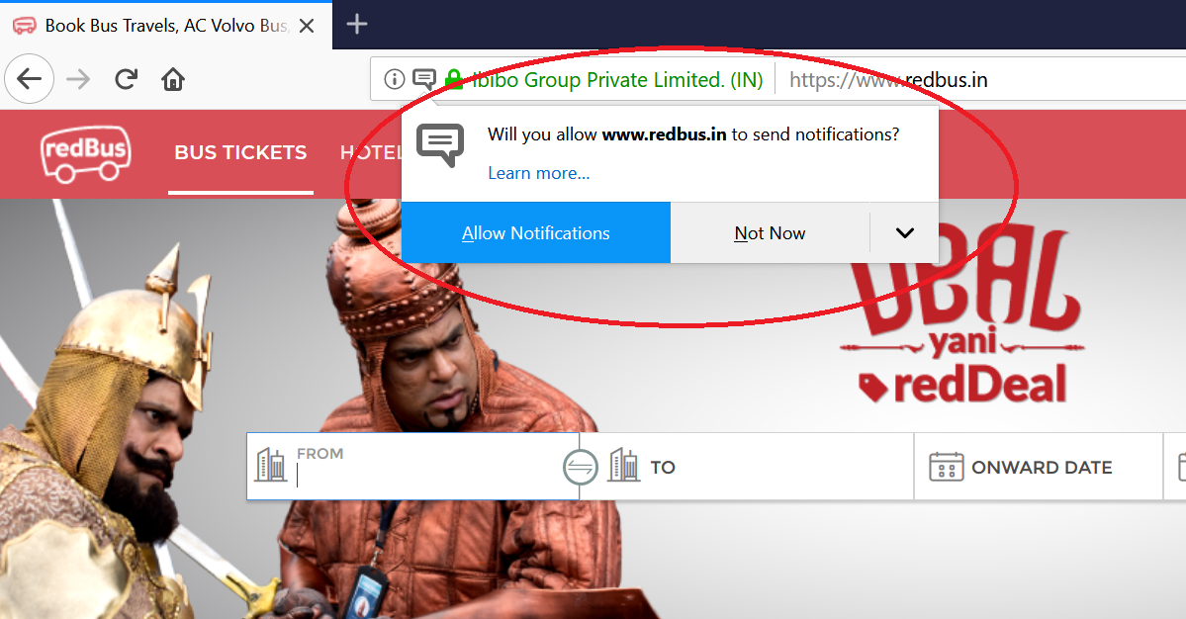

These notification popups will create problems with the automation scripts. So we need to handle them by not showing them during running our automation scripts.

For chrome, we will have to use chromeoptions() to disable these kind of notifications.

chromeoptions is a class that you can use to customize and configure a chrome session.

**package** Selenium;

**import** org.openqa.selenium.By;

**import** org.openqa.selenium.WebDriver;

**import** org.openqa.selenium.chrome.ChromeDriver;

**import** org.openqa.selenium.chrome.ChromeOptions;

**public** **class** disableChromeNotifications {

**public** **static** **void** main(String[] args) {

//Disabling Chrome push notifications

ChromeOptions ops = **new** ChromeOptions();

ops.addArguments("--disable-notifications");

System.*setProperty*("webdriver.chrome.driver", "C:\\BrowserDrivers\\chromedriver.exe");

WebDriver driver = **new** ChromeDriver(ops);

driver.manage().window().maximize();

driver.manage().deleteAllCookies();

driver.get("https://www.redbus.in/");

driver.findElement(By.*xpath*("//input[@id='src']")).sendKeys("Hydera");

}

}

# **26A. Selenium - How to disable push notifications in Firefox**

**Disabling push notifications in Firefox:**

We can disable push notifications in Firefox using FirefoxOptions.

**package** Selenium;

**import** org.openqa.selenium.By;

**import** org.openqa.selenium.WebDriver;

**import** org.openqa.selenium.firefox.FirefoxDriver;

**import** org.openqa.selenium.firefox.FirefoxOptions;

**public** **class** disableChromeNotifications {

**public** **static** **void** main(String[] args) {

//Disabling Firefox push notifications

FirefoxOptions ffo = **new** FirefoxOptions();

ffo.addPreference("dom.webnotifications.enabled",**false**);

System.*setProperty*("webdriver.gecko.driver", "C:\\BrowserDrivers\\geckodriver.exe");

WebDriver driver = **new** FirefoxDriver(ffo);

driver.manage().window().maximize();

driver.manage().deleteAllCookies();

driver.get("https://www.redbus.in/");

driver.findElement(By.*xpath*("//input[@id='src']")).sendKeys("Hydera");

}

}

# **26B. Selenium - How to accept insecure certificates in Chrome**

How to accept insecure certificates in chrome:

Sometimes you will see insecure certificate error message when you run your automation scripts. You need to handle them for your automation scripts to proceed.

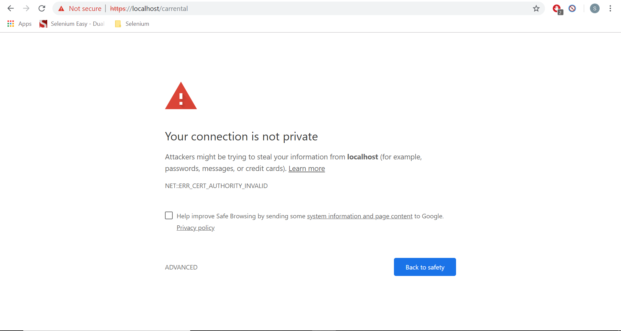

We will use chrome options to accept the insecure certificates.

**package** Selenium;

**import** org.openqa.selenium.WebDriver;

**import** org.openqa.selenium.chrome.ChromeDriver;

**import** org.openqa.selenium.chrome.ChromeOptions;

**public** **class** AutomationBar {

**public** **static** **void** main(String[] args) {

//Disabling Chrome push notifications

ChromeOptions ops = **new** ChromeOptions();

//ops.addArguments("disable-infobars");

ops.setAcceptInsecureCerts(**true**);

System.*setProperty*("webdriver.chrome.driver", "C:\\BrowserDrivers\\chromedriver.exe");

WebDriver driver = **new** ChromeDriver(ops);

driver.manage().window().maximize();

driver.get("https://localhost/carrental");

}

}

# **26C. Selenium - How to accept insecure certificates in Firefox**

**How to accept insecure certificates in Firefox?**

In firefox also you will see the insecure certificates error.

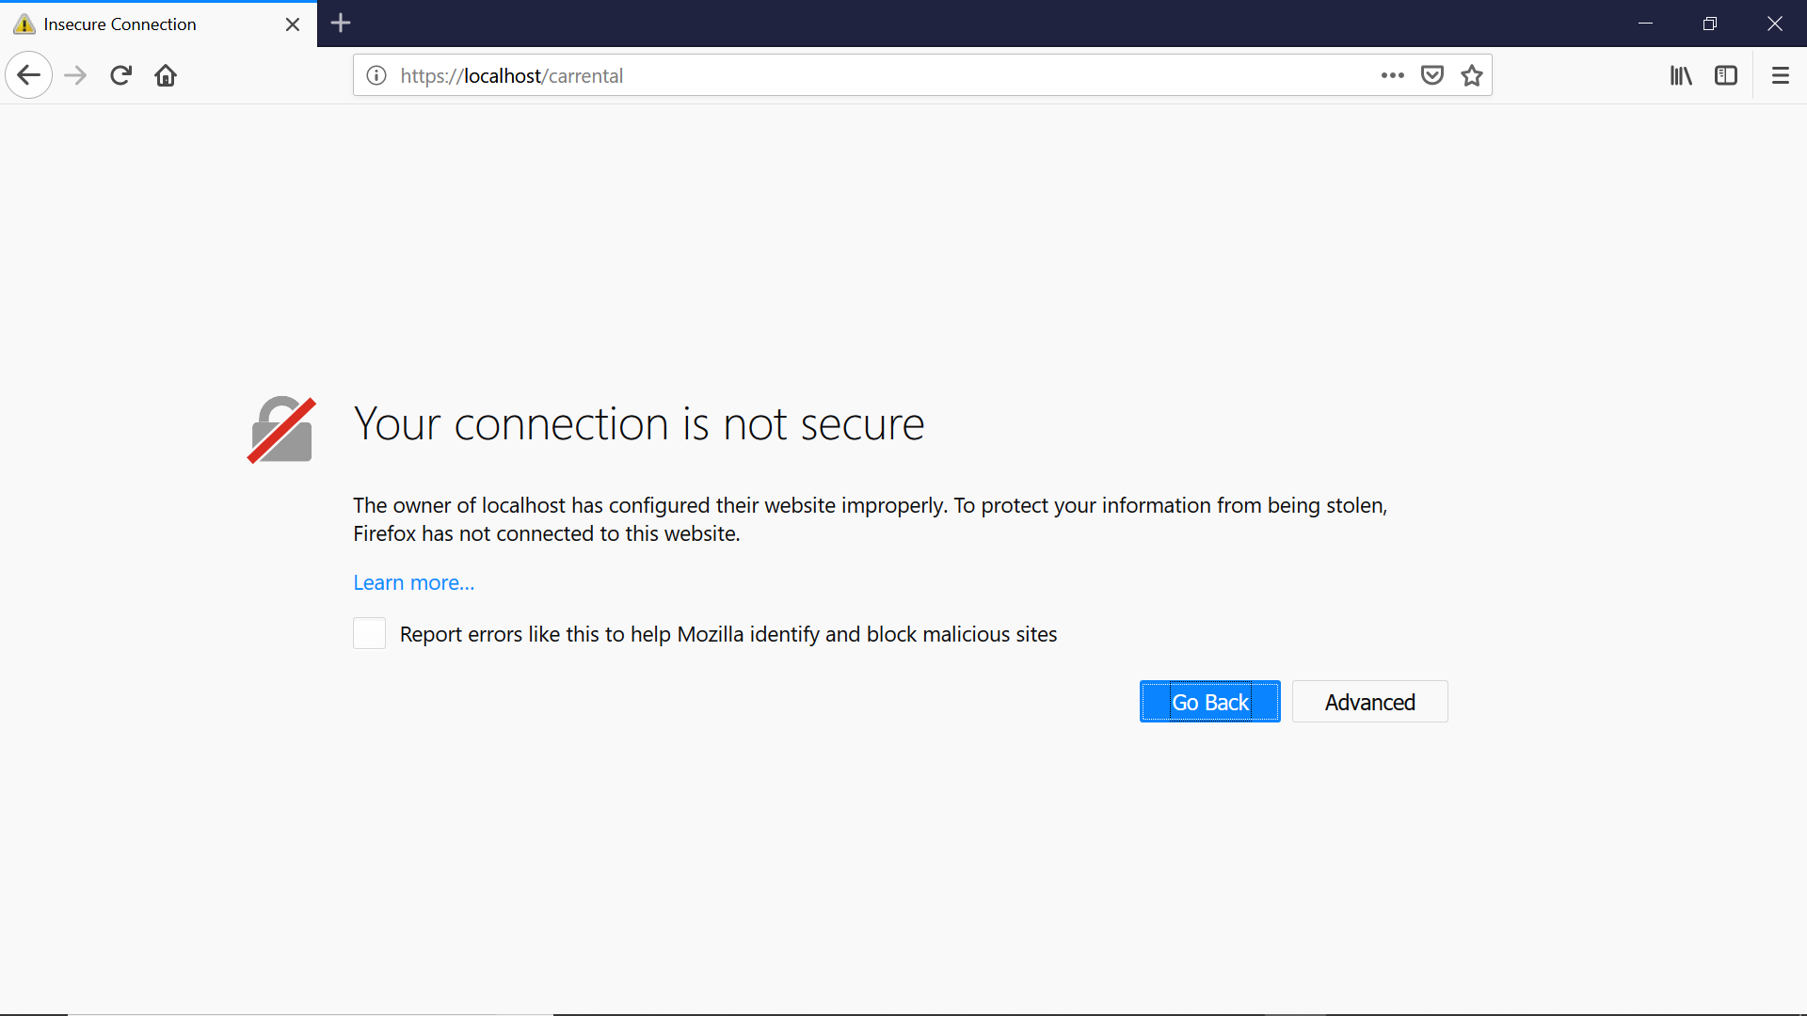

**package** Selenium;

**import** org.openqa.selenium.WebDriver;

**import** org.openqa.selenium.firefox.FirefoxDriver;

**import** org.openqa.selenium.firefox.FirefoxOptions;

**public** **class** AutomationBar {

**public** **static** **void** main(String[] args) {

System.*setProperty*("webdriver.gecko.driver", "C:\\BrowserDrivers\\geckodriver.exe");

FirefoxOptions fo = **new** FirefoxOptions();

fo.setAcceptInsecureCerts(**true**);

WebDriver driver = **new** FirefoxDriver(fo);

driver.manage().window().maximize();

driver.get("https://localhost/carrental");

}

}

# **26D. Selenium - How to hide the Automation tool bar warning in Chrome**

**How to hide Automation tool bar warnings in Chrome:**

When you are running the tests in chrome you will see the information bar saying “Chrome is being controlled by automated test software”. It won’t cause any harm to your automation but it will be annoying to see these kind of information messages sometimes. You can disable them using chromeoptions.

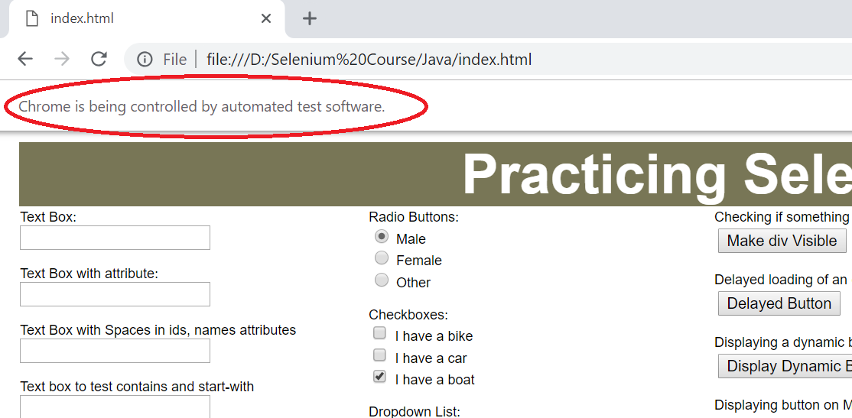

**package** Selenium;

**import** org.openqa.selenium.WebDriver;

**import** org.openqa.selenium.chrome.ChromeDriver;

**import** org.openqa.selenium.chrome.ChromeOptions;

**public** **class** AutomationBar {

**public** **static** **void** main(String[] args) {

//Disabling Chrome push notifications

ChromeOptions ops = **new** ChromeOptions();

ops.addArguments("disable-infobars");

System.*setProperty*("webdriver.chrome.driver", "C:\\BrowserDrivers\\chromedriver.exe");

WebDriver driver = **new** ChromeDriver(ops);

driver.manage().window().maximize();

driver.get("file:///D:/Selenium%20Course/Java/index.html");

}

}

# **27. Selenium - Interview Questions on Actions Class, child windows, frames, uploading images, cookies, chromeoptions and firefox options**

Interview Questions:

**How do you move mouse to a particular position on the screen?**

Using Actions class

Actions a = new Actions()

a.moveToElement(driver.findElement())

**How do you double click on an element?**

Using doubleclick() method.

a.movetoElement(driver.findElement().doubleclick().build().perform());

**How to drag and drop an element in Selenium?**

We need to use Actions class for drag and drop.

First identify the WebElement we are moving to the WebElement we are moving to.

Use Actions classes draganddrop method to move the element.

a.dragAndDrop(source, target).build().perform();

**How do you move to child windows?**

First we have to get the window handle of child window using getWindowHanlde(). Once we get it we need to move to the child window

driver.switchTo().window(childid);

If we have more than one child window we have to use getWindowHandles() which returns a set of all the windows.

**How do you move to frames?**

driver.switchto().frame(element)

**How do you move back to the parent frame?**

driver.switchTo().parentFrame();

driver.switchTo().defaultContent();

**How to upload files or images in selenium?**

If we have <input type=”file”> tag to upload images, you can’t click on the button to upload images/files. You have to use sendKeys() method.

If it is purely css based then we have to go with AutoIt.

**Which method contains methods to manage cookies?**

Driver.manage() contains all the methods to manage cookies.

**How to add a cookie?**

addCookie(Cookie cookie)

**How to delete a cookie?**

deleteCookie(Cookie cookie)

deleteCookieNamed(java.lang.String name)

**How to delete all cookies?**

driver.manage().deleteAllCookies();

**How to get cookies?**

driver.manage().getCookies();

getCookieNamed(java.lang.String name)

**How to disable push notifications in chrome?**

We can do it using ChromeOptions and using addArguments(“--disable-notifications”)

ChromeOptions ops = **new** ChromeOptions();

ops.addArguments("--disable-notifications");

System.*setProperty*("webdriver.chrome.driver", "C:\\BrowserDrivers\\chromedriver.exe");

WebDriver driver = **new** ChromeDriver(ops);

**How to disable push notifications in firefox?**

FirefoxOptions ffo = **new** FirefoxOptions();

ffo.addPreference("dom.webnotifications.enabled",**false**);

System.*setProperty*("webdriver.gecko.driver", "C:\\BrowserDrivers\\geckodriver.exe");

WebDriver driver = **new** FirefoxDriver(ffo);

**How to accept insecure certificates in chrome?**

ChromeOptions ops = **new** ChromeOptions();

ops.setAcceptInsecureCerts(**true**);

System.*setProperty*("webdriver.chrome.driver","C:\\BrowserDrivers\\chromedriver.exe");

WebDriver driver = **new** ChromeDriver(ops);

**How to accept insecure certificates in firefox?**

System.*setProperty*("webdriver.gecko.driver","C:\\BrowserDrivers\\geckodriver.exe");

FirefoxOptions fo = **new** FirefoxOptions();

fo.setAcceptInsecureCerts(**true**);

WebDriver driver = **new** FirefoxDriver(fo);

**How to hide the automation info tool bar in chrome?**

ChromeOptions ops = **new** ChromeOptions();

ops.addArguments("disable-infobars");

System.*setProperty*("webdriver.chrome.driver","C:\\BrowserDrivers\\chromedriver.exe");

WebDriver driver = **new** ChromeDriver(ops);

# **28. Selenium - Java Synchronization - Implicit Wait and Explicit Wait**

**Java Synchronization (Implicit Wait and Explicit Wait):**

When you request a page to load some of the elements of the page might take some time to load because of the ajax calls or they may have to be loaded from other servers. So, some of the elements load slower than others. In these cases, we use implicit wait.

Implicit wait is global. It applies to all elements.

Once the page is loaded we will do some operations which involve calling some services through ajax and these will take some time to load. For example, in amazon shopping cart, when we add an item to shopping cart the number of items in cart will increase. This is done by ajax calls and the whole page won’t be refreshed. Only the number in the cart will change.

When the servers are slow or because of any other issues this may delay appearing of the new elements and these will cause problem to the script. We have to use explicit wait for these. Explicit wait is for a particular element. We will say the script to wait until some expected conditions are met.

For example – an element to be clickable or an element to be visible etc. The explicit wait keeps on checking until the expected conditions are met for a particular time and if these expected conditions are met it will proceed further otherwise it will throw an error.

**package** Selenium;

**import** java.util.concurrent.TimeUnit;

**import** org.openqa.selenium.By;

**import** org.openqa.selenium.WebDriver;

**import** org.openqa.selenium.firefox.FirefoxDriver;

**import** org.openqa.selenium.support.ui.ExpectedConditions;

**import** org.openqa.selenium.support.ui.WebDriverWait;

**public** **class** Synchronization {

**public** **static** **void** main(String[] args) {

System.*setProperty*("webdriver.gecko.driver", "C:\\BrowserDrivers\\geckodriver.exe");

WebDriver driver = **new** FirefoxDriver();

driver.get("file:///D:/Selenium%20Course/Java/index.html");

//Implicit Wait

driver.manage().timeouts().implicitlyWait(10, TimeUnit.***SECONDS***);

driver.findElement(By.*id*("makevisible")).click();

//Explicit wait

WebDriverWait d=**new** WebDriverWait(driver,20);

d.until(ExpectedConditions.*elementToBeClickable*(By.*id*("delayedbutton")));

driver.findElement(By.*id*("delayedbutton")).click();

driver.findElement(By.*id*("dispdynbutton")).click();

d.until(ExpectedConditions.*elementToBeClickable*(By.*id*("dynbutton")));

driver.findElement(By.*id*("dynbutton")).click();

driver.quit();

}

}

# **29. Selenium - Javascript Executor**

**Javascript Executor:**

In Selenium, we use locators like id, name, xpath, cssselector etc. But sometimes these locators can’t identify the elements. For example, in an autosuggest the elements can’t be identified and in those cases we use javascript executor to get the values from the elements.

**What is JavascriptExecutor?**

JavascriptExecutor is an interface that helps to execute javascript through Selenium WebDriver.

**Syntax:**

JavascriptExecutor js = (JavascriptExecutor) driver;

js.executeScript(Script, Arguments);

**Example:**

**package** Selenium;

**import** org.openqa.selenium.JavascriptExecutor;

**import** org.openqa.selenium.WebDriver;

**import** org.openqa.selenium.firefox.FirefoxDriver;

**public** **class** JSExecutor {

**public** **static** **void** main(String[] args) {

System.*setProperty*("webdriver.gecko.driver", "C:\\\\BrowserDrivers\\\\geckodriver.exe");

WebDriver driver = **new** FirefoxDriver();

driver.get("http://www.rediff.com");

JavascriptExecutor js = (JavascriptExecutor)driver;

js.executeScript("alert('Welcome to Subbus Selenium Tutorials');");

}

}

# **29A. Selenium - Javascript Basics**

**Javascript Basics:**

The basic methods we use in javascript are

document.getElementById();

document.getElementsByName()

document.getElementsByTagName()

document.getElementsByClassName()

<html>

<head>

<script type="text/javascript">

function setValueById() {

var element = document.getElementById("firstname");

element.value = "hi";

}

function setValueByName() {

var element = document.getElementsByName("firstname");

element[0].value = "hi";

}

function setValueByTagName() {

var element = document.getElementsByTagName("input");

element[4].value = "hi";

element[4].style.backgroundColor = "red";

}

function setValueByClassName() {

var element = document.getElementsByClassName("beautiful text box");

element[0].value = "hi";

element[0].style.backgroundColor = "blue";

}

</script>

</head>

<body>

Text Box:<br>

<input id="firstname" class="beautifultextbox" type="text" ><input type="button" onClick="setValueById()" value="Set Value by Id"></input><br><br>

Text Box:<br>

<input name="firstname" class="beautifultextbox" type="text" ><input type="button" onClick="setValueByName()" value="Set Value by Name"></input><br><br>

Text Box with attribute:<br>

<input color="red" type="text" ><input type="button" onClick="setValueByTagName()" value="Set Value by Tag Name"></input><br><br>

Text Box with Spaces in ids, names attributes<br>

<input name="first name" id="first name" class="beautiful text box" type="text" ><input type="button" onClick="setValueByClassName()" value="Set Value by Class Name"></input><br><br>

</body>

</html>

# **29B. Selenium - Javascript Executor - Reading the values under an Auto Suggest**

**package** Selenium;

**import** java.util.concurrent.TimeUnit;

**import** org.openqa.selenium.By;

**import** org.openqa.selenium.JavascriptExecutor;

**import** org.openqa.selenium.Keys;

**import** org.openqa.selenium.WebDriver;

**import** org.openqa.selenium.chrome.ChromeDriver;

**import** org.openqa.selenium.chrome.ChromeOptions;

**import** org.openqa.selenium.firefox.FirefoxDriver;

**import** org.openqa.selenium.firefox.FirefoxOptions;

**public** **class** AutoSuggest {

**public** **static** **void** main(String[] args) **throws** InterruptedException {

//Disabling Firefox push notifications

FirefoxOptions ffo = **new** FirefoxOptions();

ffo.addPreference("dom.webnotifications.enabled",**false**);

System.*setProperty*("webdriver.gecko.driver", "C:\\BrowserDrivers\\geckodriver.exe");

WebDriver driver = **new** FirefoxDriver(ffo);

//Disabling Chrome push notifications

// ChromeOptions ops = new ChromeOptions();

// ops.addArguments("--disable-notifications");

// System.setProperty("webdriver.chrome.driver", "C:\\BrowserDrivers\\chromedriver.exe");

// WebDriver driver = new ChromeDriver(ops);

driver.manage().window().maximize();

driver.manage().deleteAllCookies();

driver.get("https://www.redbus.in/");

driver.manage().timeouts().implicitlyWait(30, TimeUnit.***SECONDS***);

driver.findElement(By.*xpath*("//input[@id='src']")).sendKeys("Beng");

Thread.*sleep*(2000);

JavascriptExecutor js = (JavascriptExecutor)driver;

driver.findElement(By.*xpath*("//input[@id='src']")).sendKeys(Keys.***DOWN***);

driver.findElement(By.*xpath*("//input[@id='src']")).sendKeys(Keys.***UP***);

String placevalue = "return document.getElementById('src').value;";

String value = (String) js.executeScript(placevalue);

System.***out***.println(value);

driver.findElement(By.*xpath*("//input[@id='src']")).sendKeys(Keys.***DOWN***);

value = (String) js.executeScript(placevalue);

System.***out***.println(value);

driver.findElement(By.*xpath*("//input[@id='src']")).sendKeys(Keys.***DOWN***);

value = (String) js.executeScript(placevalue);

System.***out***.println(value);

}

}

# **29C. Selenium - Javascript Executor - Printing count and all the values under an Auto Suggest**

**package** Selenium;

**import** java.util.concurrent.TimeUnit;

**import** org.openqa.selenium.By;

**import** org.openqa.selenium.JavascriptExecutor;

**import** org.openqa.selenium.Keys;

**import** org.openqa.selenium.WebDriver;

**import** org.openqa.selenium.chrome.ChromeDriver;

**import** org.openqa.selenium.chrome.ChromeOptions;

**import** org.openqa.selenium.firefox.FirefoxDriver;

**import** org.openqa.selenium.firefox.FirefoxOptions;

**public** **class** AutoSuggest {

**public** **static** **void** main(String[] args) **throws** InterruptedException {

//Disabling Firefox push notifications

FirefoxOptions ffo = **new** FirefoxOptions();

ffo.addPreference("dom.webnotifications.enabled",**false**);

System.*setProperty*("webdriver.gecko.driver", "C:\\BrowserDrivers\\geckodriver.exe");

WebDriver driver = **new** FirefoxDriver(ffo);

//Disabling Chrome push notifications

// ChromeOptions ops = new ChromeOptions();

// ops.addArguments("--disable-notifications");

// System.setProperty("webdriver.chrome.driver", "C:\\BrowserDrivers\\chromedriver.exe");

// WebDriver driver = new ChromeDriver(ops);

driver.manage().window().maximize();

driver.manage().deleteAllCookies();

driver.get("https://www.redbus.in/");

driver.manage().timeouts().implicitlyWait(30, TimeUnit.***SECONDS***);

driver.findElement(By.*xpath*("//input[@id='src']")).sendKeys("Hydera");

Thread.*sleep*(2000);

JavascriptExecutor js = (JavascriptExecutor)driver;

// driver.findElement(By.xpath("//input[@id='src']")).sendKeys(Keys.DOWN);

// driver.findElement(By.xpath("//input[@id='src']")).sendKeys(Keys.UP);

// String placevalue = "return document.getElementById('src').value;";

// String value = (String) js.executeScript(placevalue);

// System.out.println(value);

// driver.findElement(By.xpath("//input[@id='src']")).sendKeys(Keys.DOWN);

// value = (String) js.executeScript(placevalue);

// System.out.println(value);

// driver.findElement(By.xpath("//input[@id='src']")).sendKeys(Keys.DOWN);

// value = (String) js.executeScript(placevalue);

// System.out.println(value);

String oldvalue = "";

**for**(**int** i=0; ; i++) {

**if**(i==0) {

driver.findElement(By.*xpath*("//input[@id='src']")).sendKeys(Keys.***DOWN***);

driver.findElement(By.*xpath*("//input[@id='src']")).sendKeys(Keys.***UP***);

}

**else** {

driver.findElement(By.*xpath*("//input[@id='src']")).sendKeys(Keys.***DOWN***);

}

String placevalue = "return document.getElementById('src').value;";

String value = (String) js.executeScript(placevalue);

**if**(value.equalsIgnoreCase(oldvalue)) {

System.***out***.println("Total No. of Values: "+i);

**break**;

}

**else** {

System.***out***.println(value);

oldvalue = value;

}

}

}

}

# **29D. Selenium - Javascript Executor - Selecting a value from Auto Suggest**

Selecting a value from dropdown:

**package** Selenium;

**import** java.util.concurrent.TimeUnit;

**import** org.openqa.selenium.By;

**import** org.openqa.selenium.JavascriptExecutor;

**import** org.openqa.selenium.Keys;

**import** org.openqa.selenium.WebDriver;

**import** org.openqa.selenium.chrome.ChromeDriver;

**import** org.openqa.selenium.chrome.ChromeOptions;

**import** org.openqa.selenium.firefox.FirefoxDriver;

**import** org.openqa.selenium.firefox.FirefoxOptions;

**public** **class** AutoSuggest {

**public** **static** **void** main(String[] args) **throws** InterruptedException {

//Disabling Firefox push notifications

FirefoxOptions ffo = **new** FirefoxOptions();

ffo.addPreference("dom.webnotifications.enabled",**false**);

System.*setProperty*("webdriver.gecko.driver", "C:\\BrowserDrivers\\geckodriver.exe");

WebDriver driver = **new** FirefoxDriver(ffo);

//Disabling Chrome push notifications

// ChromeOptions ops = new ChromeOptions();

// ops.addArguments("--disable-notifications");

// System.setProperty("webdriver.chrome.driver", "C:\\BrowserDrivers\\chromedriver.exe");

// WebDriver driver = new ChromeDriver(ops);

driver.manage().window().maximize();

driver.manage().deleteAllCookies();

driver.get("https://www.redbus.in/");

driver.manage().timeouts().implicitlyWait(30, TimeUnit.***SECONDS***);

driver.findElement(By.*xpath*("//input[@id='src']")).sendKeys("Hydera");

Thread.*sleep*(2000);

JavascriptExecutor js = (JavascriptExecutor)driver;

String oldvalue = "";

String ourvalue = "Hyderabad Airport";

**for**(**int** i=0; ;i++) {

**if**(i==0) {

driver.findElement(By.*xpath*("//input[@id='src']")).sendKeys(Keys.***DOWN***);

driver.findElement(By.*xpath*("//input[@id='src']")).sendKeys(Keys.***UP***);

}

**else** {

driver.findElement(By.*xpath*("//input[@id='src']")).sendKeys(Keys.***DOWN***);

}

String placevalue = "return document.getElementById('src').value;";

String value = (String) js.executeScript(placevalue);

**if**(value.equalsIgnoreCase(ourvalue)) {

driver.findElement(By.*xpath*("//input[@id='src']")).sendKeys(Keys.***ENTER***);

**break**;

}

**else** **if**(value.equalsIgnoreCase(oldvalue)) {

System.***out***.println("Sorry! The value you are looking for is not present.");

**break**;

}

**else** {

System.***out***.println(value);

oldvalue = value;

}

}

}

}

# **29E. Selenium - Javascript Executor - Scrolling down a webpage using Javascript Executor**

**Scrolling Down the Webpage using JavascriptExecutor:**

**package** Selenium;

**import** org.openqa.selenium.By;

**import** org.openqa.selenium.JavascriptExecutor;

**import** org.openqa.selenium.WebDriver;

**import** org.openqa.selenium.WebElement;

**import** org.openqa.selenium.firefox.FirefoxDriver;

**public** **class** ScrollDown {

**public** **static** **void** main(String[] args) **throws** InterruptedException {

System.*setProperty*("webdriver.gecko.driver", "C:\\BrowserDrivers\\geckodriver.exe");

WebDriver driver = **new** FirefoxDriver();

driver.manage().window().maximize();

driver.get("https://www.rediff.com/");

JavascriptExecutor js = (JavascriptExecutor) driver;

//Scroll until an elemennt comes into view

WebElement Element = driver.findElement(By.*xpath*("//div[@id='ishare_1']"));

js.executeScript("arguments[0].scrollIntoView();", Element);

Thread.*sleep*(1000);

Element = driver.findElement(By.*xpath*("//div[@id='ishare_4']"));

js.executeScript("arguments[0].scrollIntoView();", Element);

Thread.*sleep*(1000);

Element = driver.findElement(By.*xpath*("//div[@id='hdline_14']"));

js.executeScript("arguments[0].scrollIntoView();", Element);

Thread.*sleep*(1000);

Element = driver.findElement(By.*xpath*("//div[@id='hdline_21']"));

js.executeScript("arguments[0].scrollIntoView();", Element);

Thread.*sleep*(1000);

Element = driver.findElement(By.*xpath*("//div[@id='ishare_8']"));

js.executeScript("arguments[0].scrollIntoView();", Element);

System.***out***.println("Last One");

Thread.*sleep*(1000);

//Scroll to the bottom of the page

js.executeScript("window.scrollTo(0, document.body.scrollHeight)");

Thread.*sleep*(2000);

//Scroll to the top of the page

js.executeScript("window.scrollTo(document.body.scrollHeight, 0)");

Thread.*sleep*(2000);

//Scroll by a particular no. of pixels

js.executeScript("window.scrollBy(0, 1000)");

}

}

# **30. Selenium - Interview Questions on JavascriptExecutor**

**What is JavascriptExecutor?**

JavascriptExecutor is an interface that helps to execute javascript through Selenium WebDriver.

**When do we use javascript executor?**

In Selenium, we use locators like id, name, xpath, cssselector etc. But sometimes these locators can’t identify the elements. For example, in an autosuggest the elements can’t be identified and in those cases we use javascript executor to get the values from the elements.

**How to use JavascriptExecutor?**

JavascriptExecutor js = (JavascriptExecutor)driver;

Js.executeScript(script here);

**How do you get elements in javascript?**

document.getElementById();

document.getElementsByName()

document.getElementsByTagName()

document.getElementsByClassName()

**How do you scroll the scrollbar in selenium?**

If you want to scroll a particular element into view you can use the method

Arguments[0].scrollIntoView()

If you want to scroll to the bottom of the page you can use

window.scrollTo(0, document.body.scrollHeight)

If you want to scroll by a particular number of pixels you can use

window.scrollBy(0, no. of pixels)

**How to input text into a textbox without calling sendKeys() method?**

Using JavascriptExecutor we can input text into text box.

**package** Selenium;

**import** org.openqa.selenium.JavascriptExecutor;

**import** org.openqa.selenium.WebDriver;

**import** org.openqa.selenium.firefox.FirefoxDriver;

**public** **class** inputText {

**public** **static** **void** main(String[] args) {

System.*setProperty*("webdriver.gecko.driver", "C:\\BrowserDrivers\\geckodriver.exe");

WebDriver driver = **new** FirefoxDriver();

driver.manage().window().maximize();

driver.get("file:///D:/Selenium%20Course/Java/index.html");

JavascriptExecutor js = (JavascriptExecutor)driver;

js.executeScript("document.getElementById('firstname').value = 'hello';");

}

}

# **31. Selenium - Reading Table values**

Reading Table Values:

**package** Selenium;

**import** org.openqa.selenium.By;

**import** org.openqa.selenium.WebDriver;

**import** org.openqa.selenium.firefox.FirefoxDriver;

**public** **class** TableDetails {

**public** **static** **void** main(String[] args) {

System.*setProperty*("webdriver.gecko.driver", "C:\\BrowserDrivers\\geckodriver.exe");

WebDriver driver = **new** FirefoxDriver();

driver.manage().window().maximize();

driver.get("file:///D:/Selenium%20Course/Java/index.html");

**int** no_rows = driver.findElements(By.*xpath*("//div[@id='tabledetails']/table/tbody/tr")).size();

System.***out***.println("No. of rows "+no_rows);

**for**(**int** i=0; i<no_rows; i++) {

String firstname = driver.findElements(By.*xpath*("//div[@id='tabledetails']/table/tbody/tr")).get(i).findElements(By.*tagName*("td")).get(0).getText();

System.***out***.println((i+1)+".First Name: "+firstname);

String lasttname = driver.findElements(By.*xpath*("//div[@id='tabledetails']/table/tbody/tr")).get(i).findElements(By.*tagName*("td")).get(1).getText();

System.***out***.println((i+1)+".Last Name: "+lasttname);

}

}

}

# **31A. Selenium - Reading Tables on second page and nth page**

Reading Tables on Second Page:

**package** Selenium;

**import** java.util.List;

**import** org.openqa.selenium.By;

**import** org.openqa.selenium.WebDriver;

**import** org.openqa.selenium.WebElement;

**import** org.openqa.selenium.firefox.FirefoxDriver;

**public** **class** DynamicTableone {

**public** **static** **void** main(String[] args) **throws** InterruptedException {

System.*setProperty*("webdriver.gecko.driver", "C:\\BrowserDrivers\\geckodriver.exe");

WebDriver driver = **new** FirefoxDriver();

driver.manage().window().maximize();

driver.get("https://www.moneycontrol.com/markets/earnings/results-calendar/");

driver.findElement(By.*xpath*("//table[@id='tbl_box1']/thead/tr/th[2]")).click();

driver.findElement(By.*xpath*("//a[@data-dt-idx='3']")).click();

List<WebElement> tablecontents = driver.findElements(By.*xpath*("//table[@id='tbl_box1']/tbody/tr"));

**for**(**int** i=0; i<tablecontents.size(); i++){

String stock = driver.findElements(By.*xpath*("//table[@id='tbl_box1']/tbody/tr")).get(i).findElements(By.*tagName*("td")).get(0).getText();

String resdate = driver.findElements(By.*xpath*("//table[@id='tbl_box1']/tbody/tr")).get(i).findElements(By.*tagName*("td")).get(1).getText();

String price = driver.findElements(By.*xpath*("//table[@id='tbl_box1']/tbody/tr")).get(i).findElements(By.*tagName*("td")).get(2).getText();

System.***out***.println(stock+" - "+resdate+" - "+price);

}

**int** pageno = 60;

**for**(**int** i=3; i<(pageno+1); i++) {

driver.findElement(By.*linkText*("Next")).click();

//Thread.sleep(1000);

}

System.***out***.println("---------------Results on 60th page-------------");

tablecontents = driver.findElements(By.*xpath*("//table[@id='tbl_box1']/tbody/tr"));

**for**(**int** i=0; i<tablecontents.size(); i++){

String stock = driver.findElements(By.*xpath*("//table[@id='tbl_box1']/tbody/tr")).get(i).findElements(By.*tagName*("td")).get(0).getText();

String resdate = driver.findElements(By.*xpath*("//table[@id='tbl_box1']/tbody/tr")).get(i).findElements(By.*tagName*("td")).get(1).getText();

String price = driver.findElements(By.*xpath*("//table[@id='tbl_box1']/tbody/tr")).get(i).findElements(By.*tagName*("td")).get(2).getText();

System.***out***.println(stock+" - "+resdate+" - "+price);

}

}

}

# **31B. Selenium - Moving to nth page to read table using javascript Executor**

Moving to nth page to read table using Javascript Executor:

**package** Selenium;

**import** java.util.List;

**import** java.util.concurrent.TimeUnit;

**import** org.openqa.selenium.By;

**import** org.openqa.selenium.JavascriptExecutor;

**import** org.openqa.selenium.WebDriver;

**import** org.openqa.selenium.WebElement;

**import** org.openqa.selenium.firefox.FirefoxDriver;

**public** **class** DynamicTabletwo {

**public** **static** **void** main(String[] args) **throws** InterruptedException {

System.*setProperty*("webdriver.gecko.driver", "C:\\BrowserDrivers\\geckodriver.exe");

WebDriver driver = **new** FirefoxDriver();

driver.manage().window().maximize();

driver.get("https://beta.bseindia.com/corporates/Forth_Results.aspx");

JavascriptExecutor jse = (JavascriptExecutor)driver;

// jse.executeScript("javascript:__doPostBack('ctl00$ContentPlaceHolder1$gvData','Page$11');");

// Thread.sleep(1000);

// jse.executeScript("javascript:__doPostBack('ctl00$ContentPlaceHolder1$gvData','Page$21');");

// Thread.sleep(1000);

// jse.executeScript("javascript:__doPostBack('ctl00$ContentPlaceHolder1$gvData','Page$29');");

**int** pageno = 78;

**int** no_pages_move = (pageno - (pageno%10))/10;

System.***out***.println("No. of pages to move: "+no_pages_move);

**for**(**int** i=1; i<=no_pages_move;i++) {

**int** page_to_click = i*10 + 1;

System.***out***.println("Page to click: "+page_to_click);

jse.executeScript("javascript:__doPostBack('ctl00$ContentPlaceHolder1$gvData','Page$"+page_to_click+"');");

Thread.*sleep*(2000);

}

jse.executeScript("javascript:__doPostBack('ctl00$ContentPlaceHolder1$gvData','Page$"+pageno+"');");

Thread.*sleep*(2000);

//Getting the table contents

List<WebElement> tablecontents = driver.findElements(By.*cssSelector*(".TTRow"));

**for**(**int** i=0; i<tablecontents.size(); i++){

String security_code = driver.findElements(By.*cssSelector*(".TTRow")).get(i).findElements(By.*tagName*("td")).get(0).getText();

String security_name = driver.findElements(By.*cssSelector*(".TTRow")).get(i).findElements(By.*tagName*("td")).get(1).getText();;

String result_date = driver.findElements(By.*cssSelector*(".TTRow")).get(i).findElements(By.*tagName*("td")).get(2).getText();

System.***out***.println(security_code+" - "+security_name+" - "+result_date);

}

}

}

# **32. Selenium - TestNG - Importance of TestNG and Installing TestNG**

**TestNG:**

**Importance of TestNG:**

You have developed 3 test cases and you can execute these 3 test cases one by one. For example you have 100 test cases and if you have to run all these test cases you can’t run these one by one 100 times. In these cases Test NG is very useful where you can group all these test cases and run them automatically one by one.

TestNG is a test framework which is inspired from Junit and NUnit.

**Installing TestNG in Eclipse:**

The installation instructions are at http://testng.org/doc/download.html.

In Eclipse select Help -> Install New Software

In the work with field enter the url “<http://beust.com/eclipse>” and click on add, it should show TestNG after sometime and click on Next until it is installed. Restart eclipse.

To check if TestNG is installed or not goto Window -> Preferences and check by TestNG

**How to run tests with TestNG?**

All the java programs start execution from main method. In case of TestNG, you don’t need to to have main method. You can create all the programming in different methods and use @Test annotation before the methods.

Also when you execute the test you have to execute it as “Run as TestNG”

Make sure you are importing org.testng.annotations.Test

The method should be prefixed by @Test

Once the test is executed, in the console it will give a neat report of how many test cases executed and how many passed an failed.

Example:

**package** TestNGExamples;

**import** org.openqa.selenium.By;

**import** org.openqa.selenium.WebDriver;

**import** org.openqa.selenium.firefox.FirefoxDriver;

**import** org.testng.annotations.Test;

**public** **class** TextBox {

@Test

**public** **void** testbox1() **throws** InterruptedException{

System.*setProperty*("webdriver.gecko.driver", "C:\\BrowserDrivers\\geckodriver.exe");

WebDriver driver = **new** FirefoxDriver();

driver.get("file:///D:/Selenium%20Course/Java/index.html");

driver.findElement(By.*id*("firstname")).sendKeys("Subbu");

Thread.*sleep*(2000);

driver.quit();

}

}

In the above example if you see we don’t have any main method. But we have a method which is prefixed by @Test and these annotations make the script as TestNG script. Once you execute, it will produce the following report.

PASSED: testbox1

===============================================

Default test

Tests run: 1, Failures: 0, Skips: 0

===============================================

===============================================

Default suite

Total tests run: 1, Failures: 0, Skips: 0

===============================================

You can have as many tests as you want which will test the features of the application.

# **32A. Selenium - TestNG - Running Tests with TestNG**

The following example shows you three methods to test three different text boxes.

**package** TestNGExamples;

**import** org.openqa.selenium.By;

**import** org.openqa.selenium.WebDriver;

**import** org.openqa.selenium.firefox.FirefoxDriver;

**import** org.testng.annotations.Test;

**public** **class** TextBox {

@Test

**public** **void** testbox1() **throws** InterruptedException{

System.*setProperty*("webdriver.gecko.driver", "C:\\BrowserDrivers\\geckodriver.exe");

WebDriver driver = **new** FirefoxDriver();

driver.get("file:///D:/Selenium%20Course/Java/index.html");

Thread.*sleep*(2000);

driver.findElement(By.*id*("firstname")).sendKeys("Subbu");

Thread.*sleep*(2000);

driver.quit();

}

@Test

**public** **void** testbox2() **throws** InterruptedException {

System.*setProperty*("webdriver.gecko.driver", "C:\\BrowserDrivers\\geckodriver.exe");

WebDriver driver = **new** FirefoxDriver();

driver.get("file:///D:/Selenium%20Course/Java/index.html");

Thread.*sleep*(2000);

driver.findElement(By.*xpath*("//input[@color='red']")).sendKeys("Venkat");

Thread.*sleep*(2000);

driver.quit();

}

@Test

**public** **void** testbox3() **throws** InterruptedException {

System.*setProperty*("webdriver.gecko.driver", "C:\\BrowserDrivers\\geckodriver.exe");

WebDriver driver = **new** FirefoxDriver();

driver.get("file:///D:/Selenium%20Course/Java/index.html");

Thread.*sleep*(2000);

driver.findElement(By.*id*("first name")).sendKeys("Ganesh");

Thread.*sleep*(2000);

driver.quit();

}

}

Results:

PASSED: testbox1

PASSED: testbox2

PASSED: testbox3

===============================================

Default test

Tests run: 3, Failures: 0, Skips: 0

===============================================

===============================================

Default suite

Total tests run: 3, Failures: 0, Skips: 0

===============================================

In the results tab as well you can see the results.

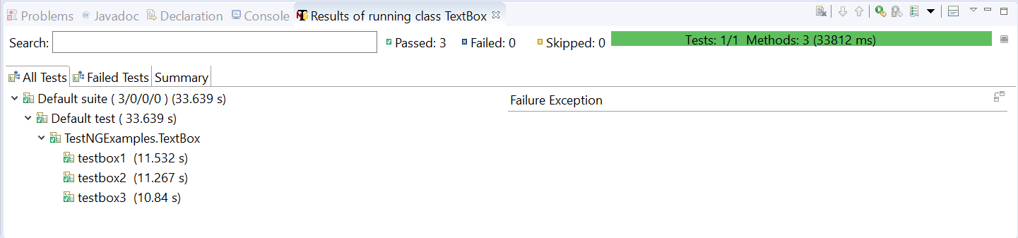

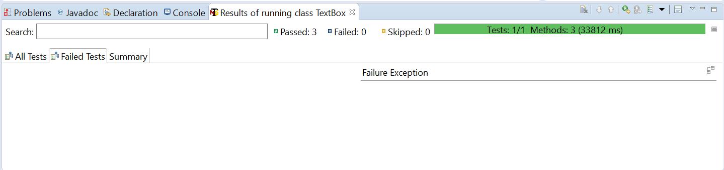

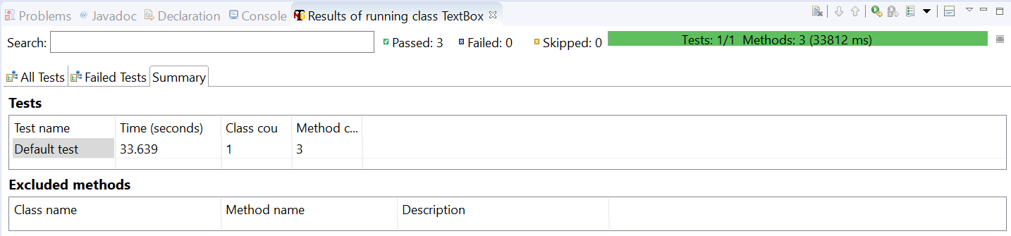

# **32B. Selenium - TestNG - TestNG XML - Running Multiple Tests with TestNG**

**TextNG XML:**

Create different class files for different things like text boxes, textarea, Checkboxes and Radio buttons. I have created the following classes each contain different methods (tests).

* TextBox.java – 4 methods (tests)
* TextArea.java – 2 methods (tests)
* CheckBoxes.java – 2 methods (tests)
* RadioButtons.java – 5 methods (tests)

Now if you want to run all these tests, you have to right click on each of these run them as “TestNG run”. If you have 100s of test cases, you can’t do this. This is where we will use TestNG XML to run whatever test cases we want without manually running them one by one.

For creating a TestNG xml, right click on the project and convert it to TestNG project.

Right Click -> TestNG -> Convert to TestNG

It will create a TestNG folder and a TestNG xml file as testing.xml.

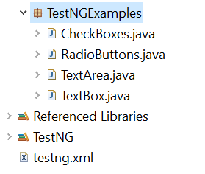

You can change the name of the file as FullTest.xml.

TestNG XML File:

<?xml version=*"1.0"* encoding=*"UTF-8"*?>

<!DOCTYPE suite SYSTEM "http://testng.org/testng-1.0.dtd">

<suite name=*"Suite"*>

<test thread-count=*"5"* name=*"Test"*>

<classes>

<class name=*"TestNGExamples.RadioButtons"*/>

<class name=*"TestNGExamples.CheckBoxes"*/>

<class name=*"TestNGExamples.TextArea"*/>

<class name=*"TestNGExamples.TextBox"*/>

</classes>

</test> <!-- Test -->

</suite> <!-- Suite -->

Suite is the Test Suite name. For example, you are working in an insurance company. You will develop different test cases to test different applications. All these tests come under insurance so you can name the suite as “insurance”.

Under insurance you will have different types. For example, you will have home insurance, auto (vehicle) insurance, health insurance, property insurance etc. You can have all of these as different tests.

Under each test you have classes which are the actual java files you have developed.

Ex:

<?xml version=*"1.0"* encoding=*"UTF-8"*?>

<!DOCTYPE suite SYSTEM "http://testng.org/testng-1.0.dtd">

<suite name=*"insurance"*>

<test thread-count=*"5"* name=*"LifeInsurance"*>

<classes>

<class name=*"LifeInsTests.CreatingNew"*/>

<class name=*" LifeInsTests.ModifyingExisting"*/>

</classes>

</test> <!-- Test -->

<test thread-count=*"5"* name=*"AutoInsurance"*>

<classes>

<class name=*"AutoInsTests.CNOneDriverOneVehcile"*/>

<class name=*"AutoInsTests.CNTwoDriverOneVehcile"*/>

<class name=*"AutoInsTests.CNOneDriverTwoVehcile"*/>

<class name=*"AutoInsTests.CNTwoDriverTwoVehcile"*/>

<class name=*"AutoInsTests.CNTwoDriverThreeVehcile"*/>

<class name=*"AutoInsTests.CNThreeDriverOneVehcile"*/>

</classes>

</test> <!-- Test -->

<test thread-count=*"5"* name=*"HomeInsurance"*>

<classes>

<class name=*"HomeInsTests.ApartmentInsurance"*/>

<class name=*"HomeInsTests.IndividualHouseInsurance"*/>

<class name=*"HomeInsTests.BurglaryCoverage"*/>

<class name=*"TestNGExamples.EarthquakeCoverage"*/>

</classes>

</test> <!-- Test -->

</suite> <!-- Suite -->

Or you can create a test suite for only one kind of insurance.

<?xml version=*"1.0"* encoding=*"UTF-8"*?>

<!DOCTYPE suite SYSTEM "http://testng.org/testng-1.0.dtd">

<suite name=*"AutoInsurance"*>

<test thread-count=*"5"* name=*"AutoInsurance_NewApp"*>

<classes>

<class name=*"AutoInsTests.CNOneDriverOneVehcile"*/>

<class name=*"AutoInsTests.CNTwoDriverOneVehcile"*/>

<class name=*"AutoInsTests.CNOneDriverTwoVehcile"*/>

<class name=*"AutoInsTests.CNTwoDriverTwoVehcile"*/>

<class name=*"AutoInsTests.CNTwoDriverThreeVehcile"*/>

<class name=*"AutoInsTests.CNThreeDriverOneVehcile"*/>

</classes>

</test> <!-- Test -->

<test thread-count=*"5"* name=*"AutoInsurance_ModifyApp"*>

<classes>

<class name=*"LifeInsTests.CreatingNew"*/>

<class name=*" LifeInsTests.ModifyingExisting"*/>

</classes>

</test> <!-- Test -->

</suite> <!-- Suite -->

I have modified the TestNG file created as below.

<?xml version=*"1.0"* encoding=*"UTF-8"*?>

<!DOCTYPE suite SYSTEM "http://testng.org/testng-1.0.dtd">

<suite name=*"BasicSuite"*>

<test thread-count=*"5"* name=*"TextBoxTest"*>

<classes>

<class name=*"TestNGExamples.TextBox"*/>

</classes>

</test> <!-- Test -->

<test thread-count=*"5"* name=*"TextAreaTest"*>

<classes>

<class name=*"TestNGExamples.TextArea"*/>

</classes>

</test> <!-- Test -->

<test thread-count=*"5"* name=*"CheckBoxesTest"*>

<classes>

<class name=*"TestNGExamples.CheckBoxes"*/>

</classes>

</test> <!-- Test -->

<test thread-count=*"5"* name=*"RadioButtonsTest"*>

<classes>

<class name=*"TestNGExamples.RadioButtons"*/>

</classes>

</test> <!-- Test -->

</suite> <!-- Suite -->

You can run the above and check the results.

# **32C. Selenium - TestNG - Excluding or Including Specific Tests from Execution**

**Excluding a specific Test Case and Method (Test) from Execution:**

If you want to exclude a specific test from execution you can delete it from the TestNG xml and run it. But if you want to exclude a specific method from running you can exclude it in TestNG xml as follows.

For example, under the RadioButtons test case I have 5 methods (tests) which are RadioButton1(), RadioButton2(), RadioButton3(), RadioButton4() and RadioButton5().

If you want to exclude RadioButton2() and RadioButton3() you can include them in the TestNG xml as follows.

<?xml version=*"1.0"* encoding=*"UTF-8"*?>

<!DOCTYPE suite SYSTEM "http://testng.org/testng-1.0.dtd">

<suite name=*"Suite"*>

<test thread-count=*"5"* name=*"Test"*>

<classes>

<class name=*"TestNGExamples.RadioButtons"*>

<methods>

<exclude name=*"RadioButton2"* />

<exclude name=*"RadioButton3"* />

</methods>

</class>

<class name=*"TestNGExamples.CheckBoxes"*/>

<class name=*"TestNGExamples.TextArea"*/>

<class name=*"TestNGExamples.TextBox"*/>

</classes>

</test> <!-- Test -->

</suite> <!-- Suite -->

IF we have more number of methods to exclude, use include to run only those tests you want to run.

For example, under TextBox class I have 4 methods but I want to run only TextBox1(). Use include to run only TextBox1() instead of excluding 3 methods.

You can use regular expressions as well to exclude a particular set of test cases.

<?xml version=*"1.0"* encoding=*"UTF-8"*?>

<!DOCTYPE suite SYSTEM "http://testng.org/testng-1.0.dtd">

<suite name=*"Suite"*>

<test thread-count=*"5"* name=*"Test"*>

<classes>

<class name=*"TestNGExamples.RadioButtons"*>

<methods>

<exclude name=*"RadioButton.*"* />

</methods>

</class>

<class name=*"TestNGExamples.CheckBoxes"*/>

<class name=*"TestNGExamples.TextArea"*/>

<class name=*"TestNGExamples.TextBox"*/>

</classes>

</test> <!-- Test -->

</suite> <!-- Suite -->

The above will exclude all the methods that start with “RadioButton”.

# **32D. Selenium - TestNG - Running Tests at Package Level**

**Running the tests at Package Level:**

If you have classified your tests in such a way that each package contains specific tests, you can run the test at package level as well.

<?xml version=*"1.0"* encoding=*"UTF-8"*?>

<!DOCTYPE suite SYSTEM "http://testng.org/testng-1.0.dtd">

<suite name=*"Suite"*>

<test thread-count=*"5"* name=*"Test"*>

<packages>

<package name=*"TestNGExamples"*/>

</packages>

</test> <!-- Test -->

</suite> <!-- Suite -->

# **32E. Selenium - TestNG - Test Annotations**

**Test Annotations:**

<?xml version=*"1.0"* encoding=*"UTF-8"*?>

<!DOCTYPE suite SYSTEM "http://testng.org/testng-1.0.dtd">

<suite name=*"BasicSuite"*>

<test thread-count=*"5"* name=*"TextBoxTest"*>

<classes>

<class name=*"TestNGExamples.TextBox"*/>

</classes>

</test> <!-- Test -->

<test thread-count=*"5"* name=*"TextAreaTest"*>

<classes>

<class name=*"TestNGExamples.TextArea"*/>

</classes>

</test> <!-- Test -->

<test thread-count=*"5"* name=*"CheckBoxesTest"*>

<classes>

<class name=*"TestNGExamples.CheckBoxes"*/>

</classes>

</test> <!-- Test -->

<test thread-count=*"5"* name=*"RadioButtonsTest"*>

<classes>

<class name=*"TestNGExamples.RadioButtons"*/>

</classes>

</test> <!-- Test -->

</suite> <!-- Suite -->

@BeforeTest – This method will be executed before the tests in a test folder

@AfterTest – This method will be executed after the tests in a test folder

@BeforeSuite – This method will be executed before the test suite

@AfterSuite – This method will be executed after the test suite

@BeforeMethod – This method will be executed before each method in a test folder

@AfterMethod – This method will be executed after each method in a test folder’

@BeforeClass – This method will be executed before any method with in a class

@AfterClass – This method will be executed after all the methods with in a class

@BeforeTest and @AfterTest will be run before and after a test. For example if we these in TextBox.java and when we runt he TestNG xml, @BeforeTest method will run before all the methods in TextBox.java and @AfterTest method will run after all the methods in TextBox.java.

These can be used if you have to clear the database tables before running tests etc.

@BeforeSuite and @AfterSuite will run before and after test suite. For example if we have these in any program when we run the TestNG xml,@BeforeSuite method will run before all the methods in all tests under that suite and @AfterSuite will run after all the methods in all tests under the Suite.

These can be used if you want to set the environment variables. Let’s say your environments change for your execution and in these cases you can use this.

@BeforeMethod and @AfterMethod will run before and after each method in a test folder.

If you have to do some validations before and after each method like checking if the server is up or not etc., then we can use these annotations.

@BeforeClass and @AfterClass will run before and after each class.

# **32F. Selenium - TestNG - Groups in TestNG**

**Groups in TestNG:**

For example, if you have to run one method (test) from each test case you have prepared as part of smoke testing, you can create a separate TestNG file and include only those methods.

But instead of doing this, you can use groups. In each and every test case, the methods that you want to run as part of smoke testing, mention them they belong to a group.

@Test(groups={“smoke”})

Once we name the methods belong to smoke testing, change the TestNG xml to execute only those methods belong to smoke. After <test> tag add groups section in TestNG xml.

<?xml version=*"1.0"* encoding=*"UTF-8"*?>

<!DOCTYPE suite SYSTEM "http://testng.org/testng-1.0.dtd">

<suite name=*"Suite"*>

<test thread-count=*"5"* name=*"Test"*>

<groups>

<run>

<include name=*"smoke"*/>

</run>

</groups>

<classes>

<class name=*"TestNGExamples.RadioButtons"*/>

<class name=*"TestNGExamples.CheckBoxes"*/>

<class name=*"TestNGExamples.TextArea"*/>

<class name=*"TestNGExamples.TextBox"*/>

</classes>

</test> <!-- Test -->

</suite> <!-- Suite -->

Even for @BeforeMethod and @AfterMethod and for other annotations also we can use these grouping, if we want to execute these methods as part of execution.

We can also exclude test cases with a group name.

<?xml version=*"1.0"* encoding=*"UTF-8"*?>

<!DOCTYPE suite SYSTEM "http://testng.org/testng-1.0.dtd">

<suite name=*"Suite"*>

<test thread-count=*"5"* name=*"Test"*>

<groups>

<run>

<exclude name=*"smoke"*/>

</run>

</groups>

<classes>

<class name=*"TestNGExamples.RadioButtons"*/>

<class name=*"TestNGExamples.CheckBoxes"*/>

<class name=*"TestNGExamples.TextArea"*/>

<class name=*"TestNGExamples.TextBox"*/>

</classes>

</test> <!-- Test -->

</suite> <!-- Suite -->

# **32G. Selenium - TestNG - Helper Attributes in TestNG**

**Helper Attributes:**

The methods in a class are executed in alphabetical order. If we want to execute a particular method first before other methods then we have to use

@Test(dependsOnMethods={“methodname”})

Example:

@Test(dependsOnMethods={"RadioButton3"})

**public** **static** **void** RadioButton1() **throws** InterruptedException {

System.*setProperty*("webdriver.gecko.driver", "C:\\BrowserDrivers\\geckodriver.exe");

WebDriver driver = **new** FirefoxDriver();

driver.get("file:///D:/Selenium%20Course/Java/index.html");

//Thread.sleep(2000);

driver.findElement(By.*xpath*("//input[@value='female']")).click();

Thread.*sleep*(2000);

driver.quit();

}

You can execute multiple methods also. For this, just put a comma and add the other methods.

@Test(dependsOnMethods={"RadioButton3","RadioButton4"})

**Skipping a particular Test:**

If you want to skip a particular test, you can use @Test(enabled=false).

**Timeout for a Particular Test:**

IF a particular test is taking tool long, you can specify a timeout for that.

@Test(timeOut=4000) – for 40 Sec.

# **32H. Selenium - TestNG - Parameterizing tests in TestNG**

**Parameterizing tests in TestNG:**

Global Parameters like URLs, environment variables etc., can be defined at test level and suite level.

IF you define them at test level, the parameters can be accessed at test level only. If you define them at suite level, the parameters can be accessed for the entire suite.

TestNG XML:

<?xml version=*"1.0"* encoding=*"UTF-8"*?>

<!DOCTYPE suite SYSTEM "http://testng.org/testng-1.0.dtd">

<suite name=*"BasicSuite"*>

<test thread-count=*"5"* name=*"TextBoxTest"*>

**<parameter name=*"URL"* value=*"file:///D:/Selenium%20Course/Java/index.html"*/>**

<classes>

<class name=*"TestNGExamples.TextBox"*/>

</classes>

</test> <!-- Test -->

<test thread-count=*"5"* name=*"TextAreaTest"*>

<classes>

<class name=*"TestNGExamples.TextArea"*/>

</classes>

</test> <!-- Test -->

<test thread-count=*"5"* name=*"CheckBoxesTest"*>

<classes>

<class name=*"TestNGExamples.CheckBoxes"*/>

</classes>

</test> <!-- Test -->

<test thread-count=*"5"* name=*"RadioButtonsTest"*>

<classes>

<class name=*"TestNGExamples.RadioButtons"*/>

</classes>

</test> <!-- Test -->

</suite> <!-- Suite -->

Test file:

**package** TestNGExamples;

**import** org.openqa.selenium.By;

**import** org.openqa.selenium.WebDriver;

**import** org.openqa.selenium.firefox.FirefoxDriver;

**import** org.testng.annotations.AfterMethod;

**import** org.testng.annotations.BeforeMethod;

**import** org.testng.annotations.Parameters;

**import** org.testng.annotations.Test;

**public** **class** TextBox {

**@Parameters({"URL"})**

@Test

**public** **void** TextBox1(**String urlname**) **throws** InterruptedException{

System.*setProperty*("webdriver.gecko.driver", "C:\\BrowserDrivers\\geckodriver.exe");

WebDriver driver = **new** FirefoxDriver();

**driver.get(urlname);**

//Thread.sleep(2000);

driver.findElement(By.*id*("firstname")).sendKeys("Subbu");

//Thread.sleep(2000);

driver.quit();

}

@Parameters({"URL"})

@Test

**public** **void** TextBox2(String urlname) **throws** InterruptedException {

System.*setProperty*("webdriver.gecko.driver", "C:\\BrowserDrivers\\geckodriver.exe");

WebDriver driver = **new** FirefoxDriver();

driver.get(urlname);

//Thread.sleep(2000);

driver.findElement(By.*xpath*("//input[@color='red']")).sendKeys("Venkat");

//Thread.sleep(2000);

driver.quit();

}

@Test

**public** **void** TextBox3() **throws** InterruptedException {

System.*setProperty*("webdriver.gecko.driver", "C:\\BrowserDrivers\\geckodriver.exe");

WebDriver driver = **new** FirefoxDriver();

driver.get("file:///D:/Selenium%20Course/Java/index.html");

//Thread.sleep(2000);

driver.findElement(By.*id*("first name")).sendKeys("Ganesh");

//Thread.sleep(2000);

driver.quit();

}

@Test(groups={"smoke"})

**public** **void** TextBox4() **throws** InterruptedException {

System.*setProperty*("webdriver.gecko.driver", "C:\\BrowserDrivers\\geckodriver.exe");

WebDriver driver = **new** FirefoxDriver();

driver.get("file:///D:/Selenium%20Course/Java/index.html");

//Thread.sleep(2000);

driver.findElement(By.*xpath*("//input[starts-with(@id,'last')]")).sendKeys("Rajesh");

//Thread.sleep(2000);

driver.quit();

}

@BeforeMethod(groups={"smoke"})

**public** **void** BeforeTestExecution() {

System.***out***.println("I will be executed before each method");

}

@AfterMethod(groups={"smoke"})

**public** **void** AfterTestExecution() {

System.***out***.println("I will be executed After each method");

}

}

You can pass multiple values as well.

<?xml version=*"1.0"* encoding=*"UTF-8"*?>

<!DOCTYPE suite SYSTEM "http://testng.org/testng-1.0.dtd">

<suite name=*"BasicSuite"*>

<test thread-count=*"5"* name=*"TextBoxTest"*>

**<parameter name=*"URL"* value=*"file:///D:/Selenium%20Course/Java/index.html"*/>**

**<parameter name=*"USERNAME"* value=*"subbu"*/>**

<classes>

<class name=*"TestNGExamples.TextBox"*/>

</classes>

</test> <!-- Test -->

<test thread-count=*"5"* name=*"TextAreaTest"*>

<classes>

<class name=*"TestNGExamples.TextArea"*/>

</classes>

</test> <!-- Test -->

<test thread-count=*"5"* name=*"CheckBoxesTest"*>

<classes>

<class name=*"TestNGExamples.CheckBoxes"*/>

</classes>

</test> <!-- Test -->

<test thread-count=*"5"* name=*"RadioButtonsTest"*>

<classes>

<class name=*"TestNGExamples.RadioButtons"*/>

</classes>

</test> <!-- Test -->

</suite> <!-- Suite -->

Test File:

Test file:

**package** TestNGExamples;

**import** org.openqa.selenium.By;

**import** org.openqa.selenium.WebDriver;

**import** org.openqa.selenium.firefox.FirefoxDriver;

**import** org.testng.annotations.AfterMethod;

**import** org.testng.annotations.BeforeMethod;

**import** org.testng.annotations.Parameters;

**import** org.testng.annotations.Test;

**public** **class** TextBox {

**@Parameters({"URL","USERNAME"})**

@Test

**public** **void** TextBox1(**String urlname, String uname**) **throws** InterruptedException{

System.*setProperty*("webdriver.gecko.driver", "C:\\BrowserDrivers\\geckodriver.exe");

WebDriver driver = **new** FirefoxDriver();

**driver.get(urlname);**

//Thread.sleep(2000);

**driver.findElement(By.*id*("firstname")).sendKeys(uname);**

//Thread.sleep(2000);

driver.quit();

}

}

# **32I. Selenium - TestNG - Data Provider Annotations - Data driven testing**

**Data Provider Annotation - Global Parameters:**

**Dataprovider Annotation:**

IF you want to datadrive a test you can pass the data as parameters to a specific method using dataprovider annotations.

**package** testpackage;

**import** org.testng.annotations.DataProvider;

**import** org.testng.annotations.Test;

**public** **class** hltest1 {

@Test

**public** **void** hlt1() {

System.***out***.println("hlt1");

}

@Test(dataProvider="getData")

**public** **void** hlt1a(String username, String password){

System.***out***.println("hlt1a");

System.***out***.println(username);

System.***out***.println(password);

}

@Test

**public** **void** hlt1b(){

System.***out***.println("hlt1b");

}

@Test

**public** **void** hlt1c(){

System.***out***.println("hlt1c");

}

@DataProvider

**public** Object[][] getData() {

//First combination - firstun and firstpw

//Second combination - secondun and secondpw

//Third combination - thirdun and thirdpw

Object[][] data = **new** Object[3][2];

data[0][0] = "firstun";

data[0][1] = "firstpw";

data[1][0] = "secondun";

data[1][1] = "secondpw";

data[2][0] = "thirdun";

data[2][1] = "thirdpw";

**return** data;

}

}

TestNG XML:

<?xml version=*"1.0"* encoding=*"UTF-8"*?>

<!DOCTYPE suite SYSTEM "http://testng.org/testng-1.0.dtd">

<suite name=*"Suite"*>

<test name=*"Test"*>

<classes>

<class name=*"testpackage.hltest1"*/>

</classes>

</test>

</suite>

# **32J. Selenium - TestNG - Running Tests in Parallel in TestNG**

**Running Tests in Parallel in TestNG:**

We can run tests in parallel using parallel attribute in testNG xml.

The parallel attribute accepts the following values.

*tests –*All the test cases inside <test> tag of testng.xml file will run parallel

*classes –*All the test cases inside a java class will run parallel

*methods* – All the methods with *@Test* annotation will execute parallel

*instances –*Test cases in same instance will execute parallel but two methods of two different instances will run in different thread.

Example:

**package** TestNGExamples;

**import** org.openqa.selenium.By;

**import** org.openqa.selenium.WebDriver;

**import** org.openqa.selenium.chrome.ChromeDriver;

**import** org.openqa.selenium.firefox.FirefoxDriver;

**import** org.testng.annotations.Test;

**public** **class** ParallelRunning {

@Test

**public** **static** **void** TextArea1() {

System.*setProperty*("webdriver.gecko.driver", "C:\\BrowserDrivers\\geckodriver.exe");

WebDriver driver = **new** FirefoxDriver();

driver.get("file:///D:/Selenium%20Course/Java/index.html");

System.***out***.println(driver.findElement(By.*id*("description")).getText());

driver.quit();

}

@Test(groups={"smoke"})

**public** **static** **void** TextArea2() **throws** InterruptedException {

System.*setProperty*("webdriver.chrome.driver", "C:\\BrowserDrivers\\chromedriver.exe");

WebDriver driver = **new** ChromeDriver();

driver.get("file:///D:/Selenium%20Course/Java/index.html");

driver.findElement(By.*id*("description")).sendKeys("This is description");

Thread.*sleep*(3000);

driver.quit();

}

}

**TestNG XML:**

<?xml version=*"1.0"* encoding=*"UTF-8"*?>

<!DOCTYPE suite SYSTEM "http://testng.org/testng-1.0.dtd">

<suite name=*"BasicSuite"*>

<test parallel=*"methods"* thread-count=*"2"* name=*"ParallelTest"*>

<parameter name=*"URL"* value=*"file:///D:/Selenium%20Course/Java/index.html"*/>

<classes>

<class name=*"TestNGExamples.ParallelRunning"*/>

</classes>

</test> <!-- Test -->

</suite> <!-- Suite -->

# **32K. Selenium - TestNG - Listeners in TestNG and How to Work with them**

**Listeners:**

What is a listener?

A listener is an interface which listens to all the events like test start, test failure, test complete etc. You can use this listener to do some extra actions like taking screenshots when a test is failed. There are many types of listeners in TestNG and we will be looking at iTestListener. First we will see what this listener is and how to use it and then we will look at how to take screenshots when a test is failed.

**package** TestNGExamples;

**import** org.testng.ITestContext;

**import** org.testng.ITestListener;

**import** org.testng.ITestResult;

**public** **class** Listeners **implements** ITestListener{

@Override

**public** **void** onTestStart(ITestResult result) {

// **TODO** Auto-generated method stub

System.***out***.println("Test Started");

}

@Override

**public** **void** onTestSuccess(ITestResult result) {

// **TODO** Auto-generated method stub

System.***out***.println("Test Successful");

}

@Override

**public** **void** onTestFailure(ITestResult result) {

// **TODO** Auto-generated method stub

System.***out***.println("Test Failed");

}

@Override

**public** **void** onTestSkipped(ITestResult result) {

// **TODO** Auto-generated method stub

System.***out***.println("Test Skipped");

}

@Override

**public** **void** onTestFailedButWithinSuccessPercentage(ITestResult result) {

// **TODO** Auto-generated method stub

System.***out***.println("Test failed but within Success percentage");

}

@Override

**public** **void** onStart(ITestContext context) {

// **TODO** Auto-generated method stub

System.***out***.println("Class Started");

}

@Override

**public** **void** onFinish(ITestContext context) {

// **TODO** Auto-generated method stub

System.***out***.println("Class Finished");

}

}

The methods that we can implement are

onTestStart – This will be executed on each test (method) starts

onTestSuccess – This will be executed on each test (method) is successful

onTestFailure – This will be executed when a test(method) fails

onTestSkipped – This will be executed when a test is skipped

onTestFailedButWithinSuccessPercentage

onStart – This will be executed when the test suite starts

onFinish – This will be executed when the test suite finishes execution

When we implement the above listener class we need to mention this in TestNG xml. We do it using listerners tag.

<?xml version=*"1.0"* encoding=*"UTF-8"*?>

<!DOCTYPE suite SYSTEM "http://testng.org/testng-1.0.dtd">

<suite name=*"Suite"*>

<listeners>

<listener class-name=*"TestNGExamples.Listeners"*/>

</listeners>

<test thread-count=*"5"* name=*"Test"*>

<classes>

<class name=*"TestNGExamples.TextBoxNew"*/>

<class name=*"TestNGExamples1.RadioButtons"*/>

</classes>

</test> <!-- Test -->

</suite> <!-- Suite -->

# **32L. Selenium - TestNG - Taking Screenshots whenever a test fails using listeners in TestNG**

**Taking Screenshots When a test fails:**

First, we will look at how to take screenshots.

WebDriver driver = **new** FirefoxDriver();

File src = ((TakesScreenshot)driver).getScreenshotAs(OutputType.***FILE***);

FileUtils.*copyFile*(src, **new** File("D:\\TestNGScreenshots\\screenshot.png"));

Selenium provides an interface “TakesScreenshot” which has a method “getScreenshotAs()” which will get screenshots into a file. This getScreenshotAs() method is implemented in RemoteWebDriver class.

You can't use it from your driver instance because you used the WebDriver interface, which doesn't extends TakesScreenshot interface, to create the driver instance.

Here WebDriver interface doesn’t extend the TakesScreenshot interface. But FirexfoxDriver class implements TakesScreenshot.

In the above declaration we are using driver object with reference type as WebDriver. So we have to cast the driver object to TakesScreenshot to access the method getScreenshotAs().

If we create the driver as

FireforxDriver driver = new FirefoxDriver()

Then we can directly use the method as

FirefoxDriver driver = new FirefoxDriver();

File src = driver.getScreenshotAs(OutputType.FILE);

**How to use Listeners concept in TestNG to take screenshots when a test fails –**

**TestNG xml:**

We add listeners tag to the TestNG xml and mention which listener we want to use.

<?xml version=*"1.0"* encoding=*"UTF-8"*?>

<!DOCTYPE suite SYSTEM "http://testng.org/testng-1.0.dtd">

<suite name=*"Suite"*>

<listeners>

<listener class-name=*"TestNGExamples.Listeners"*/>

</listeners>

<test thread-count=*"5"* name=*"Test"*>

<classes>

<class name=*"TestNGExamples.TextBoxNew"*/>

<class name=*"TestNGExamples1.RadioButtons"*/>

</classes>

</test> <!-- Test -->

</suite> <!-- Suite -->

**Initializing.java**

This class stores the class name(package.class) and the driver in a map. This is public class so that it can be accessed from anywhere. This is static so this belongs to class and will be kind of constant and won’t become null because of creation of object.

**package** TestNGExamples;

**import** java.util.HashMap;

**import** java.util.Map;

**import** org.openqa.selenium.WebDriver;

**public** **class** Initializing {

**public** **static** Map<String, WebDriver> *map1* = **new** HashMap<String, WebDriver>();

}

**TextBoxNew.java**

**package** TestNGExamples;

**import** org.openqa.selenium.By;

**import** org.openqa.selenium.WebDriver;

**import** org.openqa.selenium.firefox.FirefoxDriver;

**import** org.testng.annotations.Test;

**public** **class** TextBoxNew {

@Test

**public** **void** TextBox1() **throws** InterruptedException{

System.*setProperty*("webdriver.gecko.driver", "C:\\BrowserDrivers\\geckodriver.exe");

WebDriver driver = **new** FirefoxDriver();

TestNGExamples.Initializing.*map1*.put("TestNGExamples.TextBoxNew", driver);

driver.get("file:///D:/Selenium%20Course/Java/index.html");

//Thread.sleep(2000);

driver.findElement(By.*id*("firstnam")).sendKeys("Subbu");

TestNGExamples.Initializing.*map1*.remove("TestNGExamples.TextBoxNew");

//Thread.sleep(2000);

driver.quit();

}

@Test

**public** **void** TextBox2() **throws** InterruptedException {

System.*setProperty*("webdriver.gecko.driver", "C:\\BrowserDrivers\\geckodriver.exe");

WebDriver driver = **new** FirefoxDriver();

TestNGExamples.Initializing.*map1*.put("TestNGExamples.TextBoxNew", driver);

driver.get("file:///D:/Selenium%20Course/Java/index.html");

//Thread.sleep(2000);

driver.findElement(By.*xpath*("//input[@color='re']")).sendKeys("Venkat");

//Thread.sleep(2000);

TestNGExamples.Initializing.*map1*.remove("TestNGExamples.TextBoxNew");

driver.quit();

}

@Test

**public** **void** TextBox3() **throws** InterruptedException {

System.*setProperty*("webdriver.gecko.driver", "C:\\BrowserDrivers\\geckodriver.exe");

WebDriver driver = **new** FirefoxDriver();

TestNGExamples.Initializing.*map1*.put("TestNGExamples.TextBoxNew", driver);

driver.get("file:///D:/Selenium%20Course/Java/index.html");

//Thread.sleep(2000);

driver.findElement(By.*id*("first nam")).sendKeys("Ganesh");

//Thread.sleep(2000);

TestNGExamples.Initializing.*map1*.remove("TestNGExamples.TextBoxNew");

driver.quit();

}

@Test

**public** **void** TextBox4() **throws** InterruptedException {

System.*setProperty*("webdriver.gecko.driver", "C:\\BrowserDrivers\\geckodriver.exe");

WebDriver driver = **new** FirefoxDriver();

driver.get("file:///D:/Selenium%20Course/Java/index.html");

//Thread.sleep(2000);

driver.findElement(By.*xpath*("//input[starts-with(@id,'last')]")).sendKeys("Rajesh");

//Thread.sleep(2000);

driver.quit();

}

}

Here we are adding the driver object to the map we created in Initializing.java using the following statement.

TestNGExamples.Initializing.*map1*.put("TestNGExamples.TextBoxNew", driver);

If the test is executed successfully, we will remove the driver object from the map.

TestNGExamples.Initializing.*map1*.remove("TestNGExamples.TextBoxNew");

**Listeners.java:**

**package** TestNGExamples;

**import** java.io.File;

**import** java.io.IOException;

**import** org.openqa.selenium.OutputType;

**import** org.openqa.selenium.TakesScreenshot;

**import** org.openqa.selenium.WebDriver;

**import** org.testng.ITestContext;

**import** org.testng.ITestListener;

**import** org.testng.ITestResult;

**import** org.apache.commons.io.FileUtils;

**public** **class** Listeners **implements** ITestListener{

@Override

**public** **void** onTestStart(ITestResult result) {

// **TODO** Auto-generated method stub

System.***out***.println("Test Started");

}

@Override

**public** **void** onTestSuccess(ITestResult result) {

// **TODO** Auto-generated method stub

System.***out***.println("Test Successful");

}

@Override

**public** **void** onTestFailure(ITestResult result) {

// **TODO** Auto-generated method stub

//TextBox t = new TextBox();

//Initializing a = new Initializing();

String clname = result.getInstanceName();

System.***out***.println("Class Name is "+clname);

WebDriver driver = TestNGExamples.Initializing.*map1*.get(clname);

String mthname = result.getName();

System.***out***.println("Method Name is "+mthname);

File src = ((TakesScreenshot)driver).getScreenshotAs(OutputType.***FILE***);

**try** {

FileUtils.*copyFile*(src, **new** File("D:\\TestNGScreenshots\\"+clname+"."+mthname+".png"));

} **catch** (IOException e) {

// **TODO** Auto-generated catch block

e.printStackTrace();

}

TestNGExamples.Initializing.*map1*.remove(clname);

driver.quit();

System.***out***.println("Test Failed");

}

@Override

**public** **void** onTestSkipped(ITestResult result) {

// **TODO** Auto-generated method stub

System.***out***.println("Test Skipped");

}

@Override

**public** **void** onTestFailedButWithinSuccessPercentage(ITestResult result) {

// **TODO** Auto-generated method stub

System.***out***.println("Test failed but with in Success Percentage");

}

@Override

**public** **void** onStart(ITestContext context) {

// **TODO** Auto-generated method stub

System.***out***.println("Test Started Beginning");

}

@Override

**public** **void** onFinish(ITestContext context) {

// **TODO** Auto-generated method stub

System.***out***.println("Test Started Ending");

}

}

In the listener, in onTestFailure() method we have implemented the screenshot procedure.

# **32M. Selenium - TestNG - Setting Priority in TestNG**

**Setting priority in TestNG:**

**package** TestNGExamples;

**import** org.openqa.selenium.By;

**import** org.openqa.selenium.WebDriver;

**import** org.openqa.selenium.firefox.FirefoxDriver;

**import** org.testng.annotations.AfterMethod;

**import** org.testng.annotations.BeforeMethod;

**import** org.testng.annotations.Parameters;

**import** org.testng.annotations.Test;

**public** **class** TextBox {

@Test(priority=4)

**public** **void** TextBox1() **throws** InterruptedException{

System.*setProperty*("webdriver.gecko.driver", "C:\\BrowserDrivers\\geckodriver.exe");

WebDriver driver = **new** FirefoxDriver();

**driver.get(urlname);**

//Thread.sleep(2000);

driver.findElement(By.*id*("firstname")).sendKeys("Subbu");

//Thread.sleep(2000);

driver.quit();

}

@Test(priority=3)

**public** **void** TextBox2() **throws** InterruptedException {

System.*setProperty*("webdriver.gecko.driver", "C:\\BrowserDrivers\\geckodriver.exe");

WebDriver driver = **new** FirefoxDriver();

driver.get(urlname);

//Thread.sleep(2000);

driver.findElement(By.*xpath*("//input[@color='red']")).sendKeys("Venkat");

//Thread.sleep(2000);

driver.quit();

}

@Test(priority=2)

**public** **void** TextBox3() **throws** InterruptedException {

System.*setProperty*("webdriver.gecko.driver", "C:\\BrowserDrivers\\geckodriver.exe");

WebDriver driver = **new** FirefoxDriver();

driver.get("file:///D:/Selenium%20Course/Java/index.html");

//Thread.sleep(2000);

driver.findElement(By.*id*("first name")).sendKeys("Ganesh");

//Thread.sleep(2000);

driver.quit();

}

@Test(priority=1)

**public** **void** TextBox4() **throws** InterruptedException {

System.*setProperty*("webdriver.gecko.driver", "C:\\BrowserDrivers\\geckodriver.exe");

WebDriver driver = **new** FirefoxDriver();

driver.get("file:///D:/Selenium%20Course/Java/index.html");

//Thread.sleep(2000);

driver.findElement(By.*xpath*("//input[starts-with(@id,'last')]")).sendKeys("Rajesh");

//Thread.sleep(2000);

driver.quit();

}

}

# **32N. Selenium - TestNG - Global Data in Selenium using .properties file**

**Global Data in Selenium:**

Global data is stored separately in a .properties file and we will use this for retrieving global data like url, username, password etc.

We use Properties class in java to retrieve the data.

**Java Program:**

package testpackage;

import java.io.FileInputStream;

import java.io.FileNotFoundException;

import java.io.IOException;

import java.util.Properties;

import org.testng.Assert;

import org.testng.annotations.BeforeSuite;

import org.testng.annotations.DataProvider;

import org.testng.annotations.Test;

public class hltest1 {

@BeforeSuite

public void Login() throws IOException {

Properties prop = new Properties();

FileInputStream fip = new FileInputStream("src/globaldata/data.properties");

prop.load(fip);

System.out.println(prop.getProperty("username"));

System.out.println(prop.getProperty("password"));

System.out.println(prop.getProperty("url"));

}

@Test

public void hlt1() {

System.out.println("hlt1");

}

}

TextNG File:

<?xml version=*"1.0"* encoding=*"UTF-8"*?>

<!DOCTYPE suite SYSTEM "http://testng.org/testng-1.0.dtd">

<suite name=*"Suite"*>

<test name=*"Test"*>

<classes>

<class name=*"testpackage.hltest1"*/>

</classes>

</test>

</suite>

Data.properties file:

username=padalasubbu

password=vinayaka123

url=http://www.mymail.com

browser=firefox

**2nd Program:**

**Data.properties file:**

username=padalasubbu81@gmail.com

password=vinayaka123

url=http://www.gmail.com

browser=firefox

**gltest.java file: This is the super class**

**package** testpackage;

**import** java.io.FileInputStream;

**import** java.io.FileNotFoundException;

**import** java.io.IOException;

**import** java.util.Properties;

**import** org.openqa.selenium.By;

**import** org.openqa.selenium.WebDriver;

**import** org.openqa.selenium.firefox.FirefoxDriver;

**import** org.testng.Assert;

**import** org.testng.annotations.BeforeSuite;

**import** org.testng.annotations.DataProvider;

**import** org.testng.annotations.Test;

**public** **class** gltest {

WebDriver driver;

Properties prop;

FileInputStream fip;

@BeforeSuite

**public** **void** Login() **throws** IOException {

prop = **new** Properties();

fip = **new** FileInputStream("src/globaldata/data.properties");

prop.load(fip);

String browsertoinvoke = prop.getProperty("browser");

**if**(browsertoinvoke.equalsIgnoreCase("firefox"))

{

System.*setProperty*("webdriver.gecko.driver","./Gecko/geckodriver.exe");

driver = **new** FirefoxDriver();

}

**if**(browsertoinvoke.equalsIgnoreCase("chrome"))

{

System.*setProperty*("webdriver.firefox.driver","./Chrome/chromedriver.exe");

driver = **new** FirefoxDriver();

}

**if**(browsertoinvoke.equalsIgnoreCase("id"))

{

System.*setProperty*("webdriver.ie.driver","./Chrome/ie.exe");

driver = **new** FirefoxDriver();

}

}

}

**Login.java – This is child class**

**package** testpackage;

**import** org.openqa.selenium.By;

**import** org.testng.annotations.Test;

**public** **class** login **extends** gltest{

@Test

**public** **void** logingmail(){

String browsertoinvoke = prop.getProperty("url");

String uname = prop.getProperty("username");

String pwd = prop.getProperty("passsword");

System.***out***.println("invoking "+browsertoinvoke);

driver.get(browsertoinvoke);

//driver.findElement(By.xpath("//div[@class='gmail-nav__nav-links-wrap']/a[2]")).click();

driver.findElement(By.*xpath*("//input[@id='identifierId']")).sendKeys(uname);

driver.findElement(By.*xpath*("//div[@id='identifierNext']/content/span")).click();

driver.findElement(By.*xpath*("//input[@name='password']")).sendKeys(pwd);

}

}

# **32O. Selenium - TestNG - Assertions in TestNG**

There are two types of assertions in TestNG.

Hard Assertion

Soft Assertion

A hard assert throws an exception if an assertion fails and mark the test as failed and the test will be aborted.

But a soft assert won’t abort the test even if the assertion fails. It will continue to execute the test steps.

But in order to make a soft assert test case fail we have to add assertAll() at the end.

The following are the different methods under Assert.

AssertEquals

AssertNotEquals

AssertTrue

AssertFalse

AssertNull

AssertNotNull

Example:

**package** Selenium;

**import** org.openqa.selenium.By;

**import** org.openqa.selenium.WebDriver;

**import** org.openqa.selenium.firefox.FirefoxDriver;

**import** org.testng.Assert;

**import** org.testng.annotations.Test;

**import** org.testng.asserts.SoftAssert;

**public** **class** AssertsValidation {

@Test

**public** **void** checkone() {

System.*setProperty*("webdriver.gecko.driver", "C:\\BrowserDrivers\\geckodriver.exe");

WebDriver driver = **new** FirefoxDriver();

driver.manage().window().maximize();

driver.get("file:///D:/Selenium%20Course/Java/index.html");

String expheading = "practicing selenium";

String actheading = driver.findElement((By.*id*("heading"))).getText();

System.***out***.println("Actual Heading is "+actheading);

Assert.*assertEquals*(expheading, actheading);

driver.findElement(By.*id*("firstname")).sendKeys("subbu");

driver.findElement(By.*xpath*("//input[@color='red']")).sendKeys("selenium");

}

@Test

**public** **void** checktwo() {

System.*setProperty*("webdriver.gecko.driver", "C:\\BrowserDrivers\\geckodriver.exe");

WebDriver driver = **new** FirefoxDriver();

driver.manage().window().maximize();

driver.get("file:///D:/Selenium%20Course/Java/index.html");

String expheading = "practicing selenium";

String actheading = driver.findElement((By.*id*("heading"))).getText();

System.***out***.println("Actual Heading is "+actheading);

SoftAssert softAssert = **new** SoftAssert();

softAssert.assertEquals(expheading, actheading);

driver.findElement(By.*id*("firstname")).sendKeys("subbu");

driver.findElement(By.*xpath*("//input[@color='red']")).sendKeys("selenium");

softAssert.assertAll();

}

}

# **33. Selenium - TestNG - Interview Questions on TestNG**

**Interview Questions on TestNG:**

**What is TestNG?**

TestNG is a testing framework inspired from JUnit and NUnit, which is used to run selenium test cases. It has introduced some new functionalities that made TestNG more powerful than JUnit and NUnit. Some of these features are

* Supports annotations
* Supports parallel execution
* Supports parameterizing the test cases with @Parameters annotation
* It allows data driven testing using @DataProvider annotation
* Introduced TestNG groups – You can group the tests into different groups and run whichever group you want.
* Supports dependent test methods, parallel testing etc.
* It generates detailed TestNG reports

**How to run tests with TestNG?**

First you need to install TestNG.

Import org.testng.annotations.Test

Include the annotation @Test before the method.

Right click on the class and run as TestNG.

**What is TestNG xml and why is it used for?**

TestNG xml is a configuration file in TestNG. It is used to define test suites and tests. It provides different options to include packages, classes and independed test methods in our tests. It also allows us to configure multiple tests in a single test suite.

**How to exclude a specific method from running in TestNG?**

If you want to exclude a specific test from execution you can delete it from the TestNG xml and run it. But if you want to exclude a specific method from running you can use exclude tag.

<?xml version=*"1.0"* encoding=*"UTF-8"*?>

<!DOCTYPE suite SYSTEM "http://testng.org/testng-1.0.dtd">

<suite name=*"Suite"*>

<test thread-count=*"5"* name=*"Test"*>

<classes>

<class name=*"TestNGExamples.RadioButtons"*>

<methods>

<exclude name=*"RadioButton2"* />

<exclude name=*"RadioButton3"* />

</methods>

</class>

<class name=*"TestNGExamples.CheckBoxes"*/>

<class name=*"TestNGExamples.TextArea"*/>

<class name=*"TestNGExamples.TextBox"*/>

</classes>

</test> <!-- Test -->

</suite> <!-- Suite -->

If you have more number of methods to exclude, you can use regular expression to exclude those methods.

<?xml version=*"1.0"* encoding=*"UTF-8"*?>

<!DOCTYPE suite SYSTEM "http://testng.org/testng-1.0.dtd">

<suite name=*"Suite"*>

<test thread-count=*"5"* name=*"Test"*>

<classes>

<class name=*"TestNGExamples.RadioButtons"*>

<methods>

<exclude name=*"RadioButton.*"* />

</methods>

</class>

<class name=*"TestNGExamples.CheckBoxes"*/>

<class name=*"TestNGExamples.TextArea"*/>

<class name=*"TestNGExamples.TextBox"*/>

</classes>

</test> <!-- Test -->

</suite> <!-- Suite -->

The above will exclude all the methods starting with RadioButton.

**How to run tests at package level?**

You can use packages main tag with package sub tags to run tests at package level.

<?xml version=*"1.0"* encoding=*"UTF-8"*?>

<!DOCTYPE suite SYSTEM "http://testng.org/testng-1.0.dtd">

<suite name=*"Suite"*>

<test thread-count=*"5"* name=*"Test"*>

<packages>

<package name=*"TestNGExamples"*/>

</packages>

</test> <!-- Test -->

</suite> <!-- Suite -->

**What are the different test annotations we have in TestNG?**

@BeforeTest – This method will be executed before the tests in a test folder

@AfterTest – This method will be executed after the tests in a test folder

@BeforeSuite – This method will be executed before the test suite

@AfterSuite – This method will be executed after the test suite

@BeforeMethod – This method will be executed before each method in a test folder

@AfterMethod – This method will be executed after each method in a test folder’

@BeforeClass – This method will be executed before any method with in a class

@AfterClass – This method will be executed after all the methods with in a class

@BeforeTest and @AfterTest will be run before and after a test. For example if we these in TextBox.java and when we runt he TestNG xml, @BeforeTest method will run before all the methods in TextBox.java and @AfterTest method will run after all the methods in TextBox.java.

These can be used if you have to clear the database tables before running tests etc.

@BeforeSuite and @AfterSuite will run before and after test suite. For example if we have these in any program when we run the TestNG xml,@BeforeSuite method will run before all the methods in all tests under that suite and @AfterSuite will run after all the methods in all tests under the Suite.

These can be used if you want to set the environment variables. Let’s say your environments change for your execution and in these cases you can use this.

@BeforeMethod and @AfterMethod will run before and after each method in a test folder.

If you have to do some validations before and after each method like checking if the server is up or not etc., then we can use these annotations.

@BeforeClass and @AfterClass will run before and after each class.

**How can you create groups in TestNG?**

In each and every test case, the methods that you want to run as part of smoke testing, mention them they belong to a group.

@Test(groups={“smoke”})

@Test(groups={“smoke”,”regression”})

Once we name the methods belong to smoke testing, change the TestNG xml to execute only those methods belong to smoke. After <test> tag add groups section in TestNG xml.

<?xml version=*"1.0"* encoding=*"UTF-8"*?>

<!DOCTYPE suite SYSTEM "http://testng.org/testng-1.0.dtd">

<suite name=*"Suite"*>

<test thread-count=*"5"* name=*"Test"*>

<groups>

<run>

<include name=*"smoke"*/>

</run>

</groups>

<classes>

<class name=*"TestNGExamples.RadioButtons"*/>

<class name=*"TestNGExamples.CheckBoxes"*/>

<class name=*"TestNGExamples.TextArea"*/>

<class name=*"TestNGExamples.TextBox"*/>

</classes>

</test> <!-- Test -->

</suite> <!-- Suite -->

**How to exclude test cases with a group name?**

<?xml version=*"1.0"* encoding=*"UTF-8"*?>

<!DOCTYPE suite SYSTEM "http://testng.org/testng-1.0.dtd">

<suite name=*"Suite"*>

<test thread-count=*"5"* name=*"Test"*>

<groups>

<run>

<exclude name=*"smoke"*/>

</run>

</groups>

<classes>

<class name=*"TestNGExamples.RadioButtons"*/>

<class name=*"TestNGExamples.CheckBoxes"*/>

<class name=*"TestNGExamples.TextArea"*/>

<class name=*"TestNGExamples.TextBox"*/>

</classes>

</test> <!-- Test -->

</suite> <!-- Suite -->

**How do you create dependency of tests on other tests?**

@Test(dependsOnMethods={“methodname”})

**How to skip a particular test in TestNG?**

@Test(enabled=false).

**How to set timeout for a particular test in TestNG?**

@Test(timeOut=4000) – for 40 Sec.

**How do you pass Global parameters in TestNG?**

Global Parameters like URLs, environment variables etc., can be defined at test level and suite level.

IF you define them at test level, the parameters can be accessed at test level only. If you define them at suite level, the parameters can be accessed for the entire suite.

For defining the parameters, first in TestNG, you have to use the parameter tag and define the name and value pair.

**<parameter name=*"URL"* value=*"file:///D:/Selenium%20Course/Java/index.html"*/>**

In the test above the method define the parameter annotation.

**@Parameters({"URL"})**

@Test

**public** **void** TextBox1(**String urlname**) **throws** InterruptedException{

System.*setProperty*("webdriver.gecko.driver", "C:\\BrowserDrivers\\geckodriver.exe");

WebDriver driver = **new** FirefoxDriver();

**driver.get(urlname);**

//Thread.sleep(2000);

driver.findElement(By.*id*("firstname")).sendKeys("Subbu");

//Thread.sleep(2000);

driver.quit();

}

**How to pass multiple parameters in TestNG?**

TestNG xml:

<test thread-count=*"5"* name=*"TextBoxTest"*>

**<parameter name=*"URL"* value=*"file:///D:/Selenium%20Course/Java/index.html"*/>**

**<parameter name=*"USERNAME"* value=*"subbu"*/>**

<classes>

<class name=*"TestNGExamples.TextBox"*/>

</classes>

</test> <!-- Test -->

Test Method:

**@Parameters({"URL","USERNAME"})**

@Test

**public** **void** TextBox1(**String urlname, String uname**) **throws** InterruptedException{

System.*setProperty*("webdriver.gecko.driver", "C:\\BrowserDrivers\\geckodriver.exe");

WebDriver driver = **new** FirefoxDriver();

**driver.get(urlname);**

//Thread.sleep(2000);

**driver.findElement(By.*id*("firstname")).sendKeys(uname);**

//Thread.sleep(2000);

driver.quit();

}

**How to pass parameters to a specific method?**

IF you want to provide parameters to a specific method we use dataprovider annotations.

**package** testpackage;

**import** org.testng.annotations.DataProvider;

**import** org.testng.annotations.Test;

**public** **class** hltest1 {

@Test

**public** **void** hlt1() {

System.***out***.println("hlt1");

}

@Test(dataProvider="getData")

**public** **void** hlt1a(String username, String password){

System.***out***.println("hlt1a");

System.***out***.println(username);

System.***out***.println(password);

}

@Test

**public** **void** hlt1b(){

System.***out***.println("hlt1b");

}

@Test

**public** **void** hlt1c(){

System.***out***.println("hlt1c");

}

@DataProvider

**public** Object[][] getData() {

//First combination - firstun and firstpw

//Second combination - secondun and secondpw

//Third combination - thirdun and thirdpw

Object[][] data = **new** Object[3][2];

data[0][0] = "firstun";

data[0][1] = "firstpw";

data[1][0] = "secondun";

data[1][1] = "secondpw";

data[2][0] = "thirdun";

data[2][1] = "thirdpw";

**return** data;

}

}

**What is a listener in TestNG?**

A listener is an interface which listens to all the events like test start, test failure, test complete etc. You can use this listener to do some extra actions like taking screenshots when a test is failed, clean the database before running script etc.

**Explain about ITestListener?**

ITestListener is an interface which provides the following methods.

onTestStart – This will be executed on each test (method) starts

onTestSuccess – This will be executed on each test (method) is successful

onTestFailure – This will be executed when a test(method) fails

onTestSkipped – This will be executed when a test is skipped

onTestFailedButWithinSuccessPercentage

onStart – This will be executed when the test suite starts

onFinish – This will be executed when the test suite finishes execution

**How to implement listeners in TestNG?**

Define a new class extending the listener (for example iTestListener). Since listener is an interface, implement all the methods of the listener.

Modify the TestNG xml to make sure that the test we are going to run use the above listener. This can be done by using listeners tags.

<?xml version=*"1.0"* encoding=*"UTF-8"*?>

<!DOCTYPE suite SYSTEM "http://testng.org/testng-1.0.dtd">

<suite name=*"Suite"*>

<listeners>

<listener class-name=*"TestNGExamples.Listeners"*/>

</listeners>

<test thread-count=*"5"* name=*"Test"*>

<classes>

<class name=*"TestNGExamples.TextBoxNew"*/>

<class name=*"TestNGExamples1.RadioButtons"*/>

</classes>

</test> <!-- Test -->

</suite> <!-- Suite -->

**How to take screenshots in selenium?**

Selenium provides an interface “TakesScreenshot” which has a method “getScreenshotAs()” which will get screenshots into a file.

WebDriver driver = **new** FirefoxDriver();

File src = ((TakesScreenshot)driver).getScreenshotAs(OutputType.***FILE***);

FileUtils.*copyFile*(src, **new** File("D:\\TestNGScreenshots\\screenshot.png"));

**How to take screenshots for failed tests only in selenium?**

We have to use TestNG and listeners for taking screenshots only for failed methods. We will use the above method in Listeners onTestFailure() method and get the screenshots. But for this we have to pass the driver to the listeners onTestFailure() method. So we normally create a map with test method as key and the driver as the value.

We can get the method name in onTestFailure using the method getInstanceName() and we can get the driver from the map using this method name.

**What is properties file?**

We can use properties file to store any global data like paths, urls, usernames, passwords etc. Whenever we need this data, we create a properties class object and get this data.

Properties prop = new Properties();

FileInputStream fip = new FileInputStream("src/globaldata/data.properties");

prop.load(fip);

System.out.println(prop.getProperty("username"));

**What are the different assertions in TestNG?**

We have two types of assertions in TestNG. They are

1. Hard Assert
2. Soft Assert

Hard Assert fails the test case and aborts the remaining steps.

Soft assert fails the test case but doesn’t abort the remaining test steps. We have to use assertAll() at the end of the test case to make the test case fail. Otherwise it will pass the test case.

**What are the different assertion methods we have?**

The following are the different methods under Assert.

AssertEquals

AssertNotEquals

AssertTrue

AssertFalse

AssertNull

AssertNotNull

**How to set priority in TestNG?**

We use priority attribute in @Test annotation for setting priority.

Ex:

@Test(priority=1)

@Test(Priority=2)

**How to run tests in parallel in TestNG?**

Using parallel attribute in TestNG xml.

<?xml version=*"1.0"* encoding=*"UTF-8"*?>

<!DOCTYPE suite SYSTEM "http://testng.org/testng-1.0.dtd">

<suite name=*"BasicSuite"*>

<test parallel=*"methods"* thread-count=*"2"* name=*"ParallelTest"*>

<parameter name=*"URL"* value=*"file:///D:/Selenium%20Course/Java/index.html"*/>

<classes>

<class name=*"TestNGExamples.ParallelRunning"*/>

</classes>

</test> <!-- Test -->

</suite> <!-- Suite -->

**How to disable or ignore a test case in TestNG?**

@Test(enabled = false)

# **34. Selenium - Maven - Maven Introduction**

**Maven:**

Maven is a project management tool. Using Maven you can Validate the code of your project, compile the code, run tests, generates the jar/war/ear files and deploys them the server.

Maven’s Life Cycle:

The first thing you have to know about maven is its life cycle. It’s life cycles consists the following phases.

1. Validate
2. process-resources
3. Compile
4. Test
5. Package
6. Verify
7. Install
8. Deploy

Validate – Checks if a project is correct and all information is available.

Resources – Downloads all the needed repositories and keep them in “.m2” local repository.

Compile – Compile the code (.class files will be generated)

Test – Run the unit tests/TestNG tests

Package – Bundle the package (a jar/tar/war file will be created)

Verify – Run any checks on the results of the tests to ensure quality criteria is met

Install – Generate the artefact (The result of the package) and keep it in local repository (.m2 folder)

Deploy – Upload the artefact into remote repository (Nexus)

**Maven Commands:**

mvn validate – runs the validate command to check if a project is correct and all information is available

mvn process-resources – runs the command to check if the required resources are there or not. If not it will download the resources from maven repository into the local repository which is .m2 folder.

Note: maven repository is a public repository where people upload their repositories and maven will download the required repositories from there. We will discuss the repositories (dependencies and plugins) required in the maven xml section.

Maven repository: <https://mvnrepository.com/>

mvn compile – This command will compile and generate class files.

mvn test – This command will run the tests like Junit tests or TestNG tests.

mvn package – This command will generate the jar files.

mvn verify – This command verify the tests that were run and checks if the required quality criteria is met.

mvn install – This keeps the generated artefact from package command and stores it in local repository (.m2 folder)

mvn deploy – It deploys the generated jar files/war files into remote repository or server.

Maven works in hierarchical model. That means when you run any commands above, it runs all the previous commands as well starting from validate.

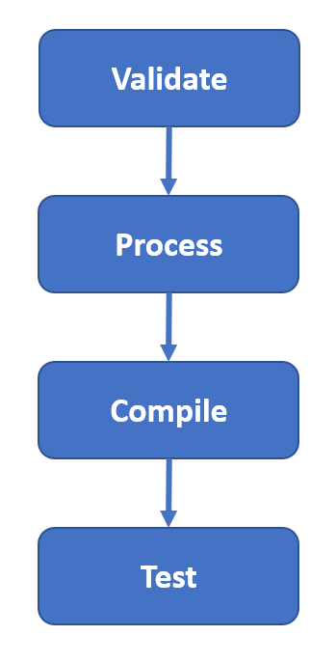

For running our selenium tests we directly use “mvn test” command.

# **34A. Selenium - Maven - Requirements for Maven and Installing Maven**

**Requirements for Maven and Installing Maven?**

The main requirement for installing maven is java.

Because maven was developed in java, java should be installed on your system and paths should be set up.

**Installing Maven:**

For installing maven, go to google and search for “Maven Download”. You will get the first result for downloading the maven.

Or you can go to the following url and you can download it.

<https://maven.apache.org/download.cgi>

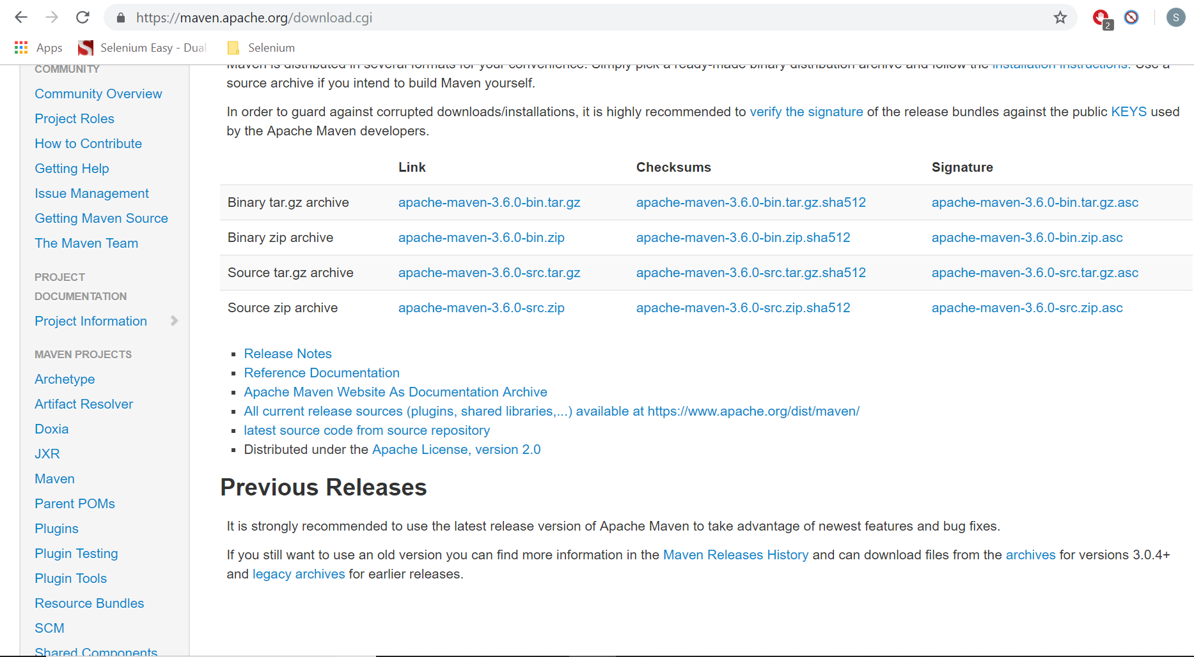

Download the binary zip file and unzip it.

Once you unzip it in any folder, you need to set up environment variables.

Go to Advanced settings, environment variables and go to system variables.

You need to se the following two system variables.

MAVEN_HOME – Set the home path (The folder where you have unzipped Maven)

Path – Add the bin folder path to this.

# **34B. Selenium - Maven - Maven pom.xml and its different Components**

**Pom.xml file:**

How does maven know what resources are required for building your project? This is through an xml file which is called pom.xml.

In pom.xml we mention all the resources in the form of resources and dependencies.

When you run any command like mvn deploy it searches for the pom.xml file in the local directory and runs the command.

mvn -f pom.xml deploy

mvn deploy – will search for the pom.xml in the current directory

mvn clean deploy – clean command will clear the target directory each time.

**Example pom.xml file:**

POM means project object model. It is an XML representation of a Maven project held in a file “pom.xml”. The below is an example pom.xml file.

<project xmlns="http://maven.apache.org/POM/4.0.0"

xmlns:xsi="http://www.w3.org/2001/XMLSchema-instance"

xsi:schemaLocation="http://maven.apache.org/POM/4.0.0

http://maven.apache.org/xsd/maven-4.0.0.xsd">

<modelVersion>4.0.0</modelVersion>

<groupId>com.google.finance</groupId>

<artifactId>quick.analytics</artifactId>

<packaging>jar</packaging>

<version>1.0-SNAPSHOT</version>

<name>Test Version</name>

<url>http://maven.apache.org</url>

<dependencies>

<dependency>

<groupId>junit</groupId>

<artifactId>junit</artifactId>

<version>4.11</version>

<scope>test</scope>

</dependency>

</dependencies>

</project>

Maven Coordinates:

groupId, artifactId and version are the maven coordinates.

groupId: This is the unique name given to the project so that it can be identified uniquely across all the projects. Generally, this groupId is the company domain name in the reverse order with out www followed by department followed by anything else you want. For example if google is developing a project called “quick analytics” by the finance department then this group id can be “com.google.finance”

artifactId: Artifact is a file, usually a JAR that gets deployed to a Maven repository. Generally this is the project name so this can be “quick.analytics”.

version: This is the version for the jar/war/ear files generated. Generally first test files will be generated so these are named as 1.0-SNAPSHOT. If everything works then version will be changed to the actual version like 1.0.

The other elements in the pom.xml are

packaging: here you mention whether you want to build a jar file or war file or ear file.

name: This the name of jar file created. If it is a test version (SNAPSHOT) we are creating, we will give name like Test Version etc otherwise will give the actual name.

This is the basic information we will provide.

There are another two main types of information we have to specify.

1. Dependency information
2. Plugin information.

**Dependency Information:**

There are two dependencies we have to use.

1. Selenium dependency
2. TestNG dependency

Go to google and search for “Selenium Maven Dependency” and go to the maven repository link and copy the dependency section. The following is the link.

<https://mvnrepository.com/artifact/org.seleniumhq.selenium/selenium-java>

<dependency>

<groupId>org.seleniumhq.selenium</groupId>

<artifactId>selenium-java</artifactId>

<version>3.14.0</version>

</dependency>

Similarly get TestNG dependency. You can get it from

<https://mvnrepository.com/artifact/org.testng/testng>

<dependency>

<groupId>org.testng</groupId>

<artifactId>testng</artifactId>

<version>6.14.3</version>

<scope>test</scope>

</dependency>

Now under the dependencies section, update the xml with the above two.

<project xmlns="http://maven.apache.org/POM/4.0.0"

xmlns:xsi="http://www.w3.org/2001/XMLSchema-instance"

xsi:schemaLocation="http://maven.apache.org/POM/4.0.0

http://maven.apache.org/xsd/maven-4.0.0.xsd">

<modelVersion>4.0.0</modelVersion>

<groupId>com.google.finance</groupId>

<artifactId>quick.analytics</artifactId>

<packaging>jar</packaging>

<version>1.0-SNAPSHOT</version>

<name>Test Version</name>

<url>http://maven.apache.org</url>

<dependencies>

<dependency>

<groupId>org.seleniumhq.selenium</groupId>

<artifactId>selenium-java</artifactId>

<version>3.14.0</version>

</dependency>

<dependency>

<groupId>org.testng</groupId>

<artifactId>testng</artifactId>

<version>6.14.3</version>

<scope>test</scope>

</dependency>

</dependencies>

</project>

Plugin Information:

Go to google and search for “Maven Surefire Plugin xml” and you will get the following.

<build>

<pluginManagement>

<plugins>

<plugin>

<groupId>org.apache.maven.plugins</groupId>

<artifactId>maven-surefire-plugin</artifactId>

<version>2.22.0</version>

</plugin>

</plugins>

</pluginManagement>

</build>

In addition to the above since we want to run the tests from TestNG, we need to have the configuration section as well in <plugin>

Add it to the pom.xml above dependencies.

<configuration>

<suiteXmlFiles>

<suiteXmlFile>testng.xml</suiteXmlFile>

</suiteXmlFiles>

</configuration>

So the plugins section becomes,

<build>

<pluginManagement>

<plugins>

<plugin>

<groupId>org.apache.maven.plugins</groupId>

<artifactId>maven-surefire-plugin</artifactId>

<version>2.22.0</version>

<configuration>

<suiteXmlFiles>

<suiteXmlFile>testng.xml</suiteXmlFile>

</suiteXmlFiles>

</configuration>

</plugin>

</plugins>

</pluginManagement>

</build>

In the above tesng.xml is the TestNG xml file we provide.

So now the overall pom.xml look like

<project xmlns="http://maven.apache.org/POM/4.0.0"

xmlns:xsi="http://www.w3.org/2001/XMLSchema-instance"

xsi:schemaLocation="http://maven.apache.org/POM/4.0.0

http://maven.apache.org/xsd/maven-4.0.0.xsd">

<modelVersion>4.0.0</modelVersion>

<groupId>com.google.finance</groupId>

<artifactId>quick.analytics</artifactId>

<packaging>jar</packaging>

<version>1.0-SNAPSHOT</version>

<name>Test Version</name>

<url>http://maven.apache.org</url>

<build>

<pluginManagement>

<plugins>

<plugin>

<groupId>org.apache.maven.plugins</groupId>

<artifactId>maven-surefire-plugin</artifactId>

<version>2.22.0</version>

<configuration>

<suiteXmlFiles>

<suiteXmlFile>testng.xml</suiteXmlFile>

</suiteXmlFiles>

</configuration>

</plugin>

</plugins>

</pluginManagement>

</build>

<dependencies>

<dependency>

<groupId>org.seleniumhq.selenium</groupId>

<artifactId>selenium-java</artifactId>

<version>3.14.0</version>

</dependency>

<dependency>

<groupId>org.testng</groupId>

<artifactId>testng</artifactId>

<version>6.14.3</version>

<scope>test</scope>

</dependency>

</dependencies>

</project>

This forms our whole pom.xml for running our selenium tests. There might a lot of other dependencies and plugins available but those are used by developers or devops engineers and completely for build or packaging purpose. For running selenium tests with TestNG this xml should be fine.

# **34C. Selenium - Maven - Converting a Project to Maven Project in Eclipse**

**Converting a project to Maven Project in Eclipse:**

Right click on any project and go to Configure -> Convert to Maven Project.

The remaining procedure of updating the xmls etc is same.

# **34D. Selenium - Maven - Creating a Maven Project using Command Prompt**

**Creating a Maven Project (From CMD):**

mvn archetype:generate -DgroupId=subbu.selenium.tutorials -DartifactId=MavenSelenium -DarchetypeArtifactId=maven-archetype-quickstart -DinteractiveMode=false

Explanation of the above command:

mvn archetype:generate – This will actually create a project

groupId – Unique name to the project

artifactId – Project name

archetypeArtifactId – it’s a template of the project to start with

**Importing the project with Eclipse:**

To import a mvn project into eclipse, Eclipse looks for classpath file. So we have to create this first.

Go to the project folder Mavenjava and execute the command

mvn eclipse:eclipse

Now go to eclipse and go to File -> Import -> Maven -> Existing Maven Projects. Find the project and import it. It should import the maven project created using cmd.

You can see that groupId we gave will always be the package name and artifactId will always be the project name.

**Updating pom.xml:**

Update the pom.xml as shown in the previous picture.

Now go to command prompt and execute the command mvn -test.

It should run all the test.

If you want to control testNG from mvn command, for example you want to execute only apium test cases, then use like

mvn -Dtest=CheckBoxes test

# **34E. Selenium - Maven - Profiling in Maven**

**Profiling in Maven:**

If you have to run different tests each time like regression, smoke etc., create different TestNG files. But when running these from mvn define profiles and run the following commands each time.

mvn test -PRegression

mvn test -PSmoke

mvn test -Pall

P is profile in the above.

POM.xml for the above with profiles.

<project xmlns=*"http://maven.apache.org/POM/4.0.0"* xmlns:xsi=*"http://www.w3.org/2001/XMLSchema-instance"*

xsi:schemaLocation=*"http://maven.apache.org/POM/4.0.0 http://maven.apache.org/maven-v4_0_0.xsd"*>

<modelVersion>4.0.0</modelVersion>

<groupId>qaclickacademy</groupId>

<artifactId>Mavenjava</artifactId>

<packaging>jar</packaging>

<version>1.0-SNAPSHOT</version>

<name>Mavenjava</name>

<url>http://maven.apache.org</url>

<profiles>

<profile>

<id>Regression</id>

<build>

<pluginManagement>

<plugins>

<plugin>

<groupId>org.apache.maven.plugins</groupId>

<artifactId>maven-surefire-plugin</artifactId>

<version>2.22.0</version>

<configuration>

<suiteXmlFiles>

<suiteXmlFile>testngapiumrest.xml</suiteXmlFile>

</suiteXmlFiles>

</configuration>

</plugin>

</plugins>

</pluginManagement>

</build>

</profile>

<profile>

<id>Smoke</id>

<build>

<pluginManagement>

<plugins>

<plugin>

<groupId>org.apache.maven.plugins</groupId>

<artifactId>maven-surefire-plugin</artifactId>

<version>2.22.0</version>

<configuration>

<suiteXmlFiles>

<suiteXmlFile>testngselenium.xml</suiteXmlFile>

</suiteXmlFiles>

</configuration>

</plugin>

</plugins>

</pluginManagement>

</build>

</profile>

<profile>

<id>All</id>

<build>

<pluginManagement>

<plugins>

<plugin>

<groupId>org.apache.maven.plugins</groupId>

<artifactId>maven-surefire-plugin</artifactId>

<version>2.22.0</version>

<configuration>

<suiteXmlFiles>

<suiteXmlFile>testng.xml</suiteXmlFile>

</suiteXmlFiles>

</configuration>

</plugin>

</plugins>

</pluginManagement>

</build>

</profile>

</profiles>

<dependencies>

<dependency>

<groupId>org.seleniumhq.selenium</groupId>

<artifactId>selenium-java</artifactId>

<version>3.13.0</version>

</dependency>

<dependency>

<groupId>org.testng</groupId>

<artifactId>testng</artifactId>

<version>6.14.3</version>

<scope>test</scope>

</dependency>

<dependency>

<groupId>io.rest-assured</groupId>

<artifactId>rest-assured</artifactId>

<version>3.1.0</version>

<scope>test</scope>

</dependency>

<dependency>

<groupId>io.appium</groupId>

<artifactId>java-client</artifactId>

<version>6.1.0</version>

</dependency>

</dependencies>

</project>

# **35. Selenium - Maven - Interview Questions**

**Selenium Maven Interview Questions:**

**What is maven?**

Maven is a project management tool. Using Maven you can Validate the code of your project, compile the code, run tests, generates the jar/war/ear files and deploys them the server.

**Can you explain maven’s life cycle?**

Maven life cycle consists the following phases.

1. Validate
2. process-resources
3. Compile
4. Test
5. Package
6. Verify
7. Install
8. Deploy

Validate – Checks if a project is correct and all information is available.

Resources – Downloads all the needed repositories and keep them in “.m2” local repository.

Compile – Compile the code (.class files will be generated)

Test – Run the unit tests/TestNG tests

Package – Bundle the package (a jar/tar/war file will be created)

Verify – Run any checks on the results of the tests to ensure quality criteria is met

Install – Generate the artefact (The result of the package) and keep it in local repository (.m2 folder)

Deploy – Upload the artefact into remote repository (Nexus)

**Can you give some maven commands?**

mvn validate – runs the validate command to check if a project is correct and all information is available

mvn process-resources – runs the command to check if the required resources are there or not. If not it will download the resources from maven repository into the local repository which is .m2 folder.

Note: maven repository is a public repository where people upload their repositories and maven will download the required repositories from there. We will discuss the repositories (dependencies and plugins) required in the maven xml section.

Maven repository: <https://mvnrepository.com/>

mvn compile – This command will compile and generate class files.

mvn test – This command will run the tests like Junit tests or TestNG tests.

mvn package – This command will generate the jar files.

mvn verify – This command verify the tests that were run and checks if the required quality criteria is met.

mvn install – This keeps the generated artefact from package command and stores it in local repository (.m2 folder)

mvn deploy – It deploys the generated jar files/war files into remote repository or server.

**What happens when we run the command “mvn test”?**

Maven works in hierarchical model. That means when you run the command “mvn test”, it runs all the previous commands as well starting from validate.

**What is pom.xml and what is it’s importance?**

Maven needs some resources for building the project and running the tests. Pom.xml provides these resources that maven needs to build and run the tests.

When you run any command like mvn deploy it searches for the pom.xml file in the local directory and runs the command.

**What is main information that we need to specify in pom.xml ?**

We need to mention two main types of information.

1. Dependency information
2. Plugin information

**Can you mention some dependencies that we use in pom.xml?**

1. Selenium dependency
2. TestNG dependency

**What plug in we use in pom.xml for running TestNG tests?**

Maven Surefire Plugin

**What are the requirements for installing Maven?**

You should have java installed on your system.

**How can you create a maven project using command prompt?**

mvn archetype:generate -DgroupId=subbu.selenium.tutorials -DartifactId=MavenSelenium -DarchetypeArtifactId=maven-archetype-quickstart -DinteractiveMode=false

Explanation of the above command:

mvn archetype:generate – This will actually create a project

groupId – Unique name to the project

artifactId – Project name

archetypeArtifactId – it’s a template of the project to start with

**How can you import a project into eclipse using command prompt?**

To import a mvn project into eclipse, Eclipse looks for classpath file. So we have to create this first.

Go to the project folder Mavenjava and execute the command

mvn eclipse:eclipse

Now go to eclipse and go to File -> Import -> Maven -> Existing Maven Projects. Find the project and import it. It should import the maven project created using cmd.

You can see that groupId we gave will always be the package name and artifactId will always be the project name.

**What command you use to run tests through maven?**

mvn test

**How can you execute only test cases to a particular test in TestNG xml through Maven?**

mvn -Dtest=CheckBoxes test

**What is profiling in maven?**

If you have to run different tests each time like regression, smoke etc., create different TestNG files. But when running these from mvn define profiles and run the following commands each time.

mvn test -PRegression

mvn test -PSmoke

mvn test -Pall

P is profile in the above.

POM.xml for the above with profiles.

<project xmlns=*"http://maven.apache.org/POM/4.0.0"* xmlns:xsi=*"http://www.w3.org/2001/XMLSchema-instance"*

xsi:schemaLocation=*"http://maven.apache.org/POM/4.0.0 http://maven.apache.org/maven-v4_0_0.xsd"*>

<modelVersion>4.0.0</modelVersion>

<groupId>qaclickacademy</groupId>

<artifactId>Mavenjava</artifactId>

<packaging>jar</packaging>

<version>1.0-SNAPSHOT</version>

<name>Mavenjava</name>

<url>http://maven.apache.org</url>

<profiles>

<profile>

<id>Regression</id>

<build>

<pluginManagement>

<plugins>

<plugin>

<groupId>org.apache.maven.plugins</groupId>

<artifactId>maven-surefire-plugin</artifactId>

<version>2.22.0</version>

<configuration>

<suiteXmlFiles>

<suiteXmlFile>testngapiumrest.xml</suiteXmlFile>

</suiteXmlFiles>

</configuration>

</plugin>

</plugins>

</pluginManagement>

</build>

</profile>

<profile>

<id>Smoke</id>

<build>

<pluginManagement>

<plugins>

<plugin>

<groupId>org.apache.maven.plugins</groupId>

<artifactId>maven-surefire-plugin</artifactId>

<version>2.22.0</version>

<configuration>

<suiteXmlFiles>

<suiteXmlFile>testngselenium.xml</suiteXmlFile>

</suiteXmlFiles>

</configuration>

</plugin>

</plugins>

</pluginManagement>

</build>

</profile>

<profile>

<id>All</id>

<build>

<pluginManagement>

<plugins>

<plugin>

<groupId>org.apache.maven.plugins</groupId>

<artifactId>maven-surefire-plugin</artifactId>

<version>2.22.0</version>

<configuration>

<suiteXmlFiles>

<suiteXmlFile>testng.xml</suiteXmlFile>

</suiteXmlFiles>

</configuration>

</plugin>

</plugins>

</pluginManagement>

</build>

</profile>

</profiles>

<dependencies>

<dependency>

<groupId>org.seleniumhq.selenium</groupId>

<artifactId>selenium-java</artifactId>

<version>3.13.0</version>

</dependency>

<dependency>

<groupId>org.testng</groupId>

<artifactId>testng</artifactId>

<version>6.14.3</version>

<scope>test</scope>

</dependency>

<dependency>

<groupId>io.rest-assured</groupId>

<artifactId>rest-assured</artifactId>

<version>3.1.0</version>

<scope>test</scope>

</dependency>

<dependency>

<groupId>io.appium</groupId>

<artifactId>java-client</artifactId>

<version>6.1.0</version>

</dependency>

</dependencies>

</project>

# **36. Selenium - Jenkins -What is Jenkins and How Jenkins is used for automation execution**

**Jenkins:**

What is Jenkins:

Jenkins is a continuous integration tool.

What is continuous integration?

Normal Development Process:

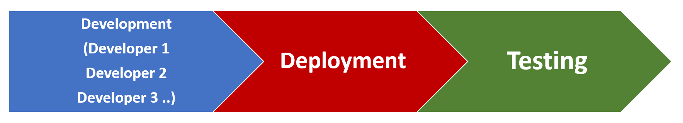

In Normal development process developers develop the code in local machine and after some time or the development is completed it will be deployed to the test environment. Once it is deployed testing will be started but because a large piece of code is deployed at one time there will be potential defects that might arise might stop the entire testing. Because one functioanality that was developed by developer 1 will be modified by the second developer at a later stage and this might result in potential defects.

In continuous integration the code that is developed by developers will be deployed to the servers many times a day and testing will be performed each time the code is deployed.

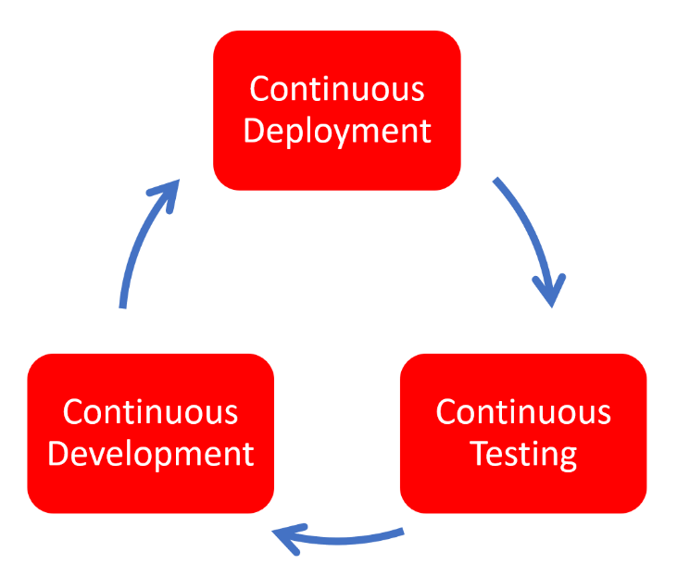

So, Continuous integration is a development practice that requires developers to integrate code into a shared repository several times a day. It is a process of running your tests on a non-developer machine automatically when someone pushes the new code into the source repository.

Using Jenkins, we can trigger tests when someone pushes new code into the repository.

Why do we need continuous integration?

Using continuous integration, we can detect problems as early as possible in the development lifecycle.

Since code is deployed, built and tested thoroughly potential defects can be caught in the early stages of life cycle.

# **36A. Selenium - Jenkins - Installing Jenkins on Windows and Running it**

**Installing Jenkins on Windows and Running:**

Requirements:

JDK should be installed on the system. As Jenkins was developed using Java, JDK should be installed on the system to run Jenkins.

Download the war package from Jenkins.io.

Now go to the folder where the war file is located in CMD, and run the following command.

java -jar jenkins.war --httpPort=9090

I have downloaded the war file to Jenkins folder in D drive so I am running the command from there.

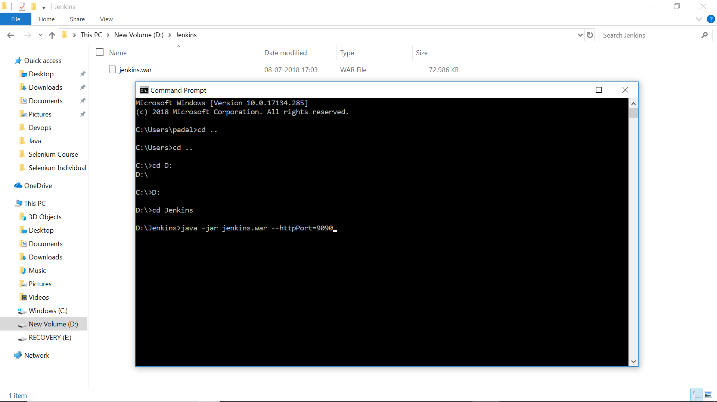

First time it will take sometime as it has to download some information from net. It stores all this information in a “.Jenkins” folder in “C:/User/YourUsername”. If you delete this folder then you can install Jenkins again.

Once all the installation is completed you can see the message on CMD that “Jenkins is fully up and running”

Once Jenkins is installed, it can be accessed at localhost:9090. The default port is 8080 but since I am using apache server running on that port I have specified Jenkins to use another port on 9090.

Now access Jenkins from web using the url <http://localhost:9090>

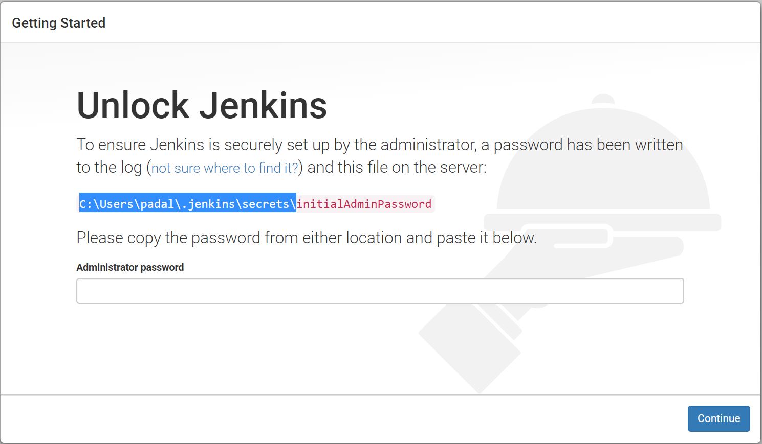

Once you open the above URL it will ask you to enter password. It will also show that the password is stored in a secret place and show you a path. Open the file and get the password and enter it. It is stored in “initialAdminPassword” file under secrets folder under “.Jenkins” folder.

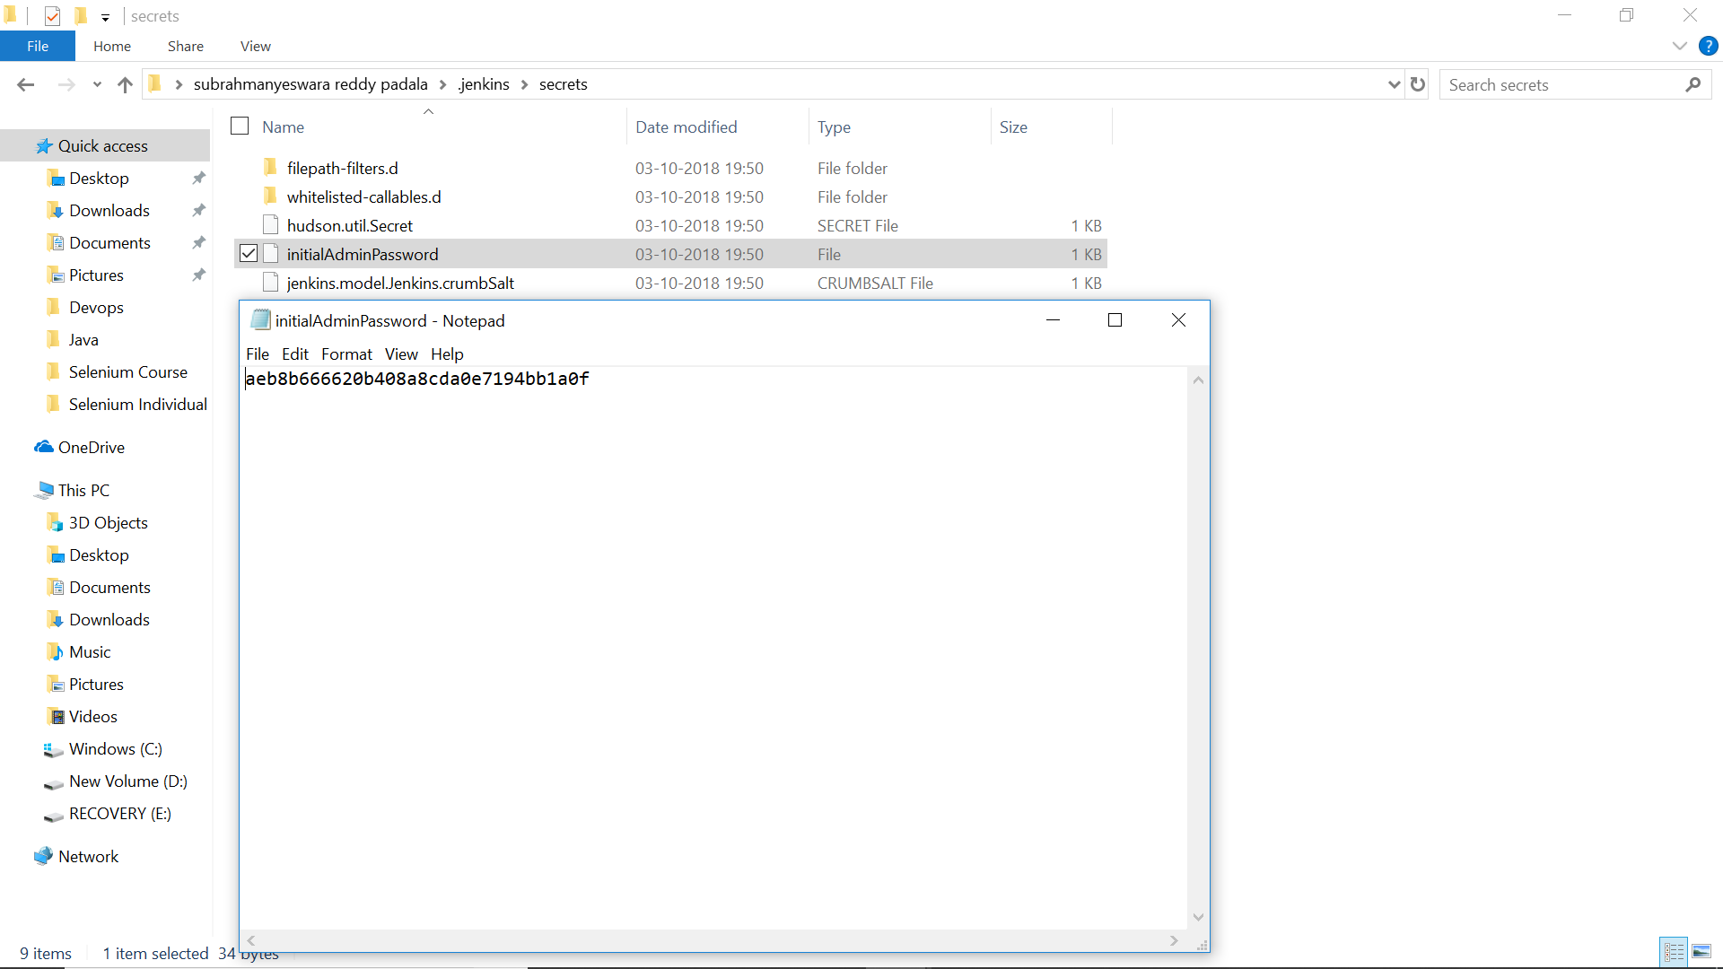

Copy the password and enter it into the password filed. Once you enter the password and click on continue it will open a screen asking you to select plugins. You can skip this to go to the next level.

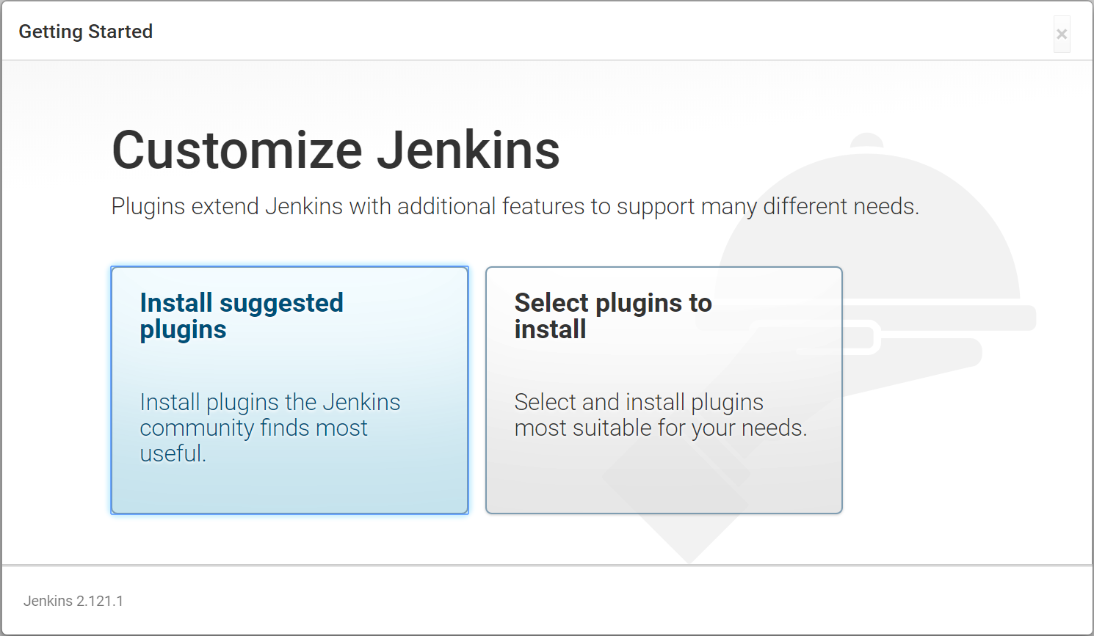

It will show a message that Jenkins is ready and click on continue

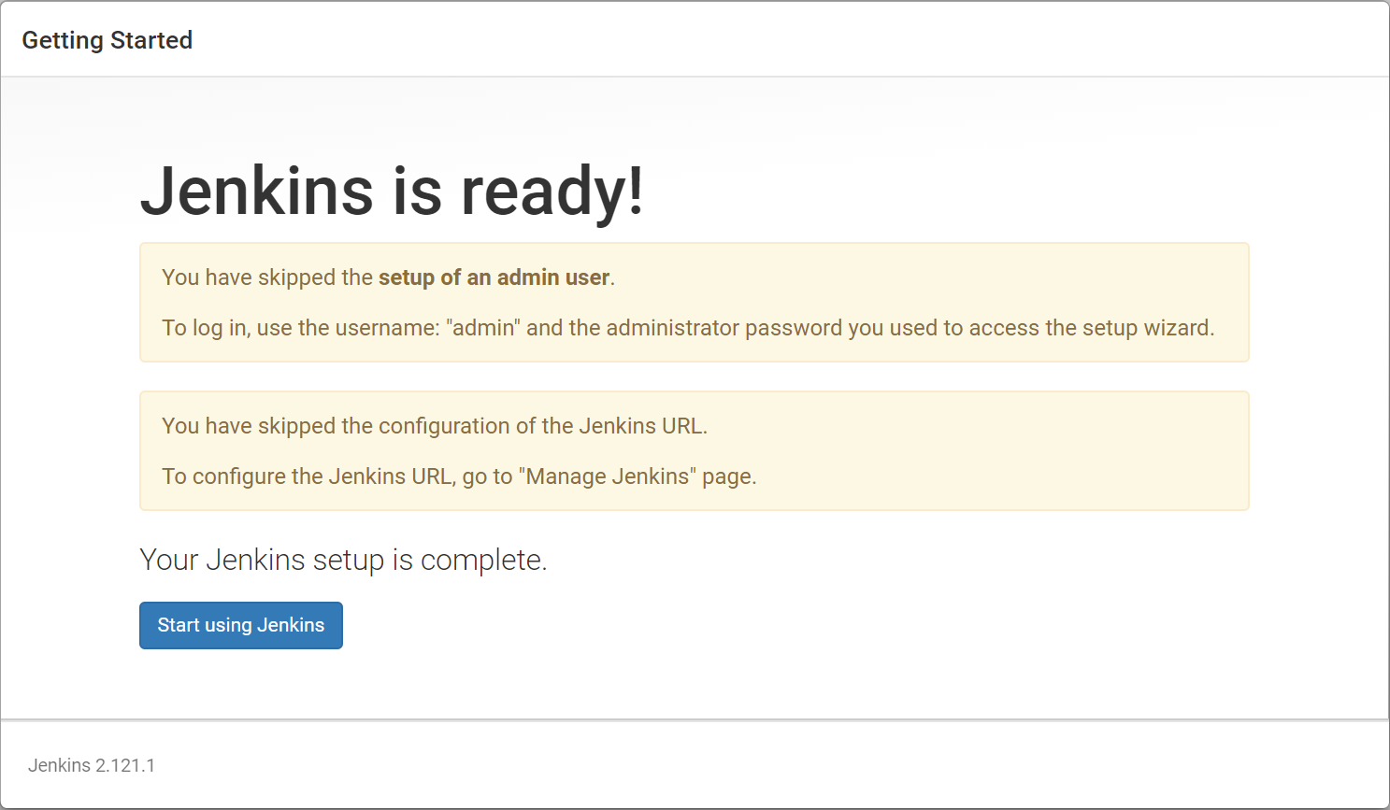

Now it should show the welcome screens. Now on the top right corner, if you move your mouse pointer over the admin link, it will show a dropdown arrow mark. Click on that and click on “Configure” link. Here you can change the password.

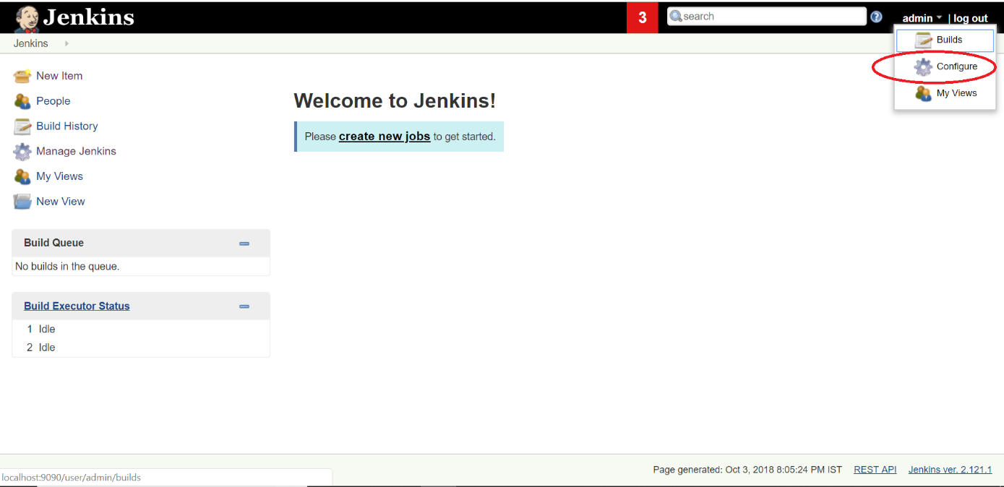

For easiness, I am changing the password to admin.

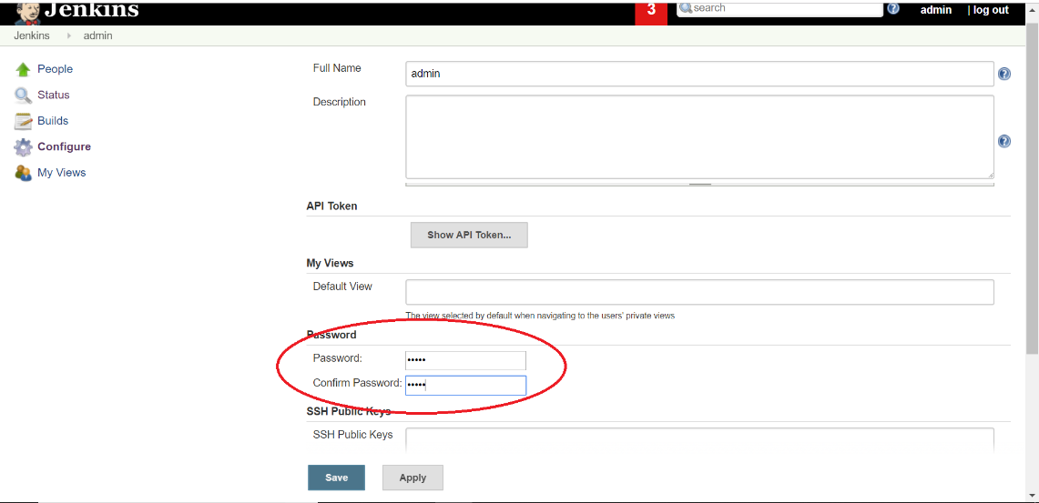

So now my username and password are

Username: admin

Password: admin

Next time when you want to start Jenkins, go to the same folder where you have the war file and run the command

java -jar jenkins.war --httpPort=9090

and this time it will be quick and if you open the url <http://localhost:9090>, it will ask you for the password and you can enter your password.

# **36B. Selenium - Jenkins - Jenkins Overview**

Jenkins Overview:

Once you login to Jenkins the first screen you will see is welcome screen. Since it is the first time you will see this screen. If you have created any jobs, you will those jobs list here.

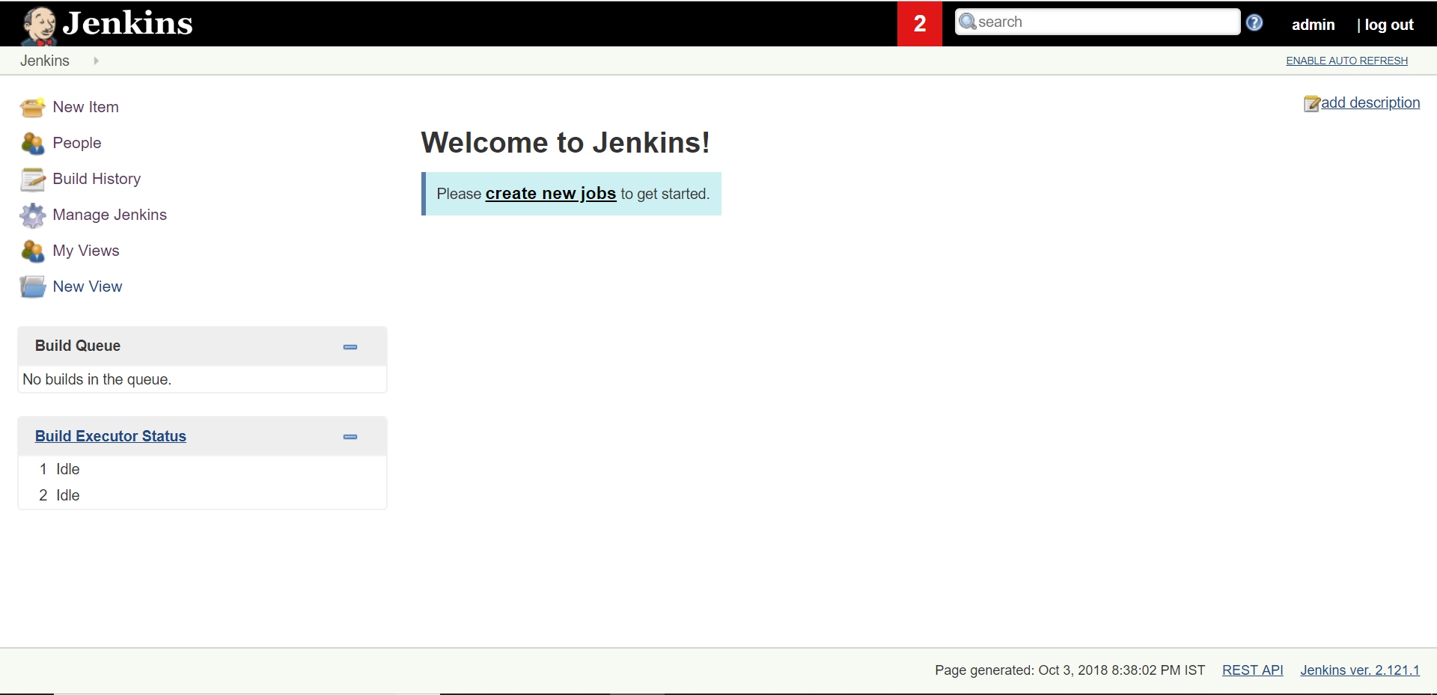

On the lefthand side you will see a menu.

New Item – You can create a new job here.

People – You can see all the users here.

Build Hisotry – It shows the jobs you have run.

Manage Jenkins – You can configure Jenkins here.

My Views – Here you can see the views you have created.

New View – You can create a new view here.

Build Queue – If multiple jobs are executing at a time, it shows all the jobs that are in queue to run.

Build Executor Status – It shows the jobs that are executing.

Lets have a look at the Manage Jenkins Section.

Manage Jenkins:

Once you click on Manage Jenkins you will see different options and the ones that we are interested are

* Configure System
* Global Tool Configuration
* Manage Plugins

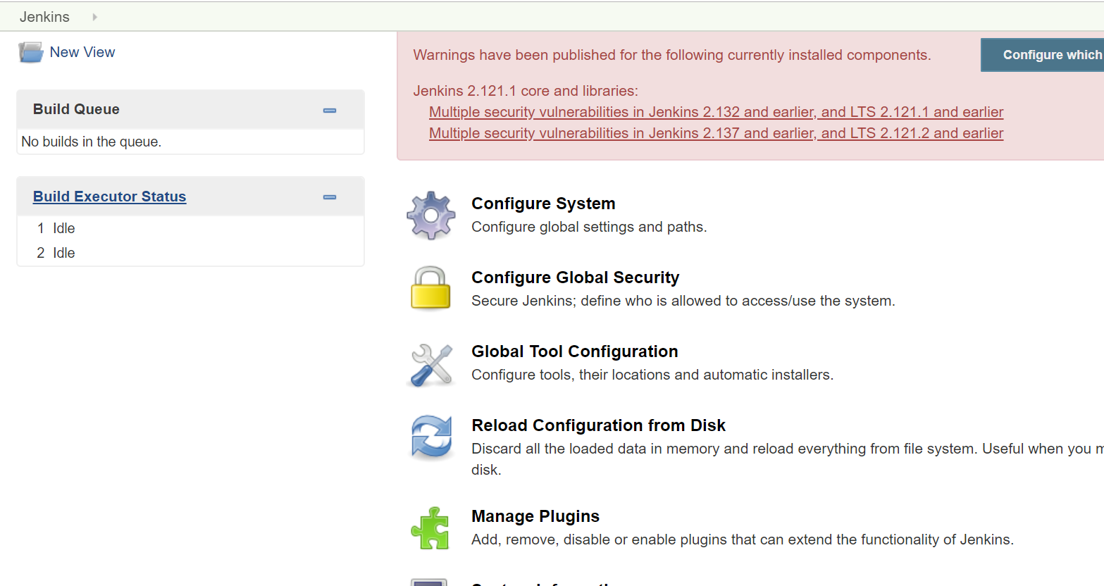

Configure System:

Here you can configure the global settings and paths. Once you open this the main setting we are interested in is System Admin’s mail. Jenkin’s URL shows the URL we are uing to access Jenkins.

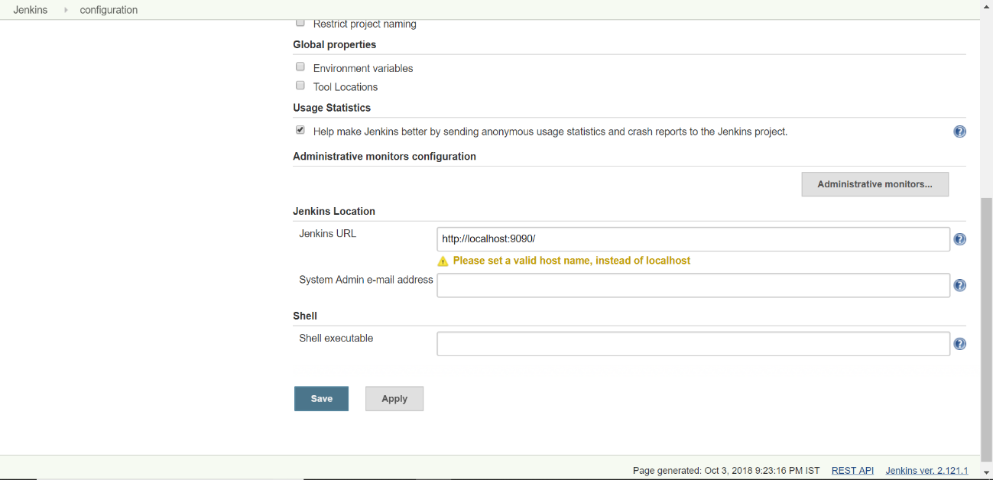

Next one is Global Tool Configuration:

Here we have to add the paths for JDK and MAVEN.

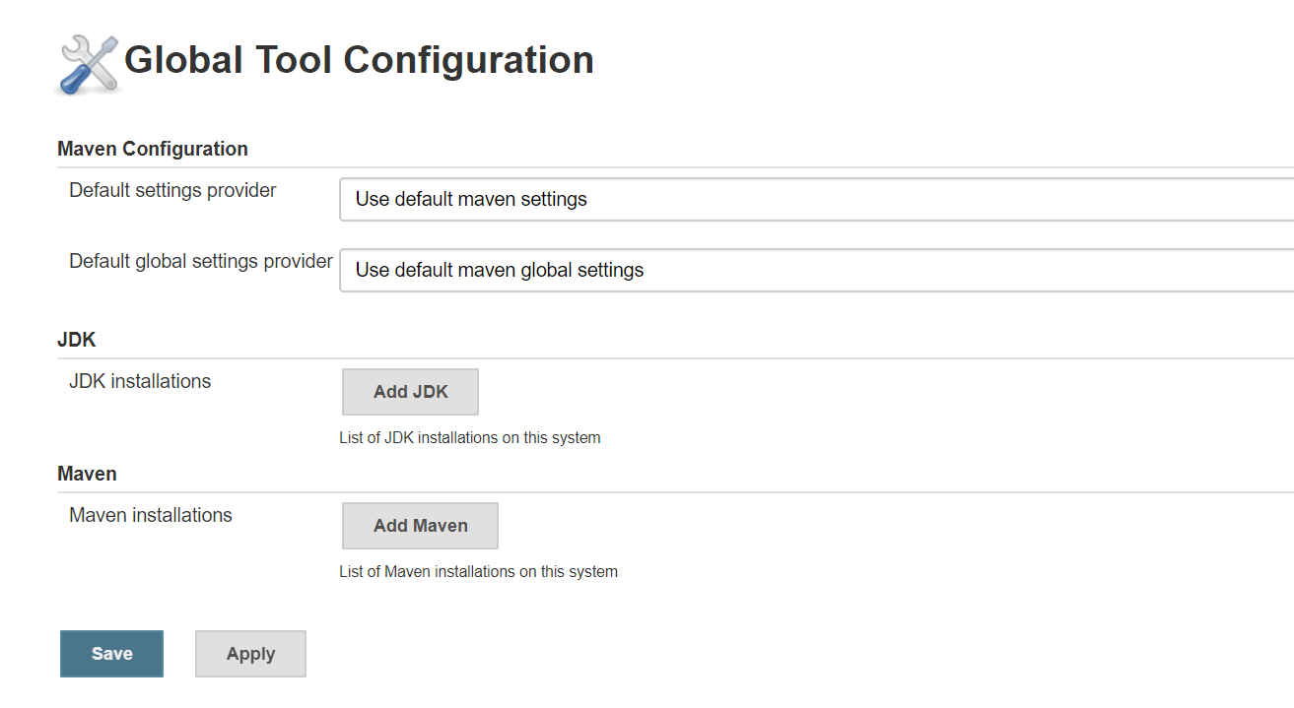

Next one is is Manage Plugins:

Here we can search for plugins and install them. The main plugins that we use are

1. TestNG Results
2. Test Results Analyzer

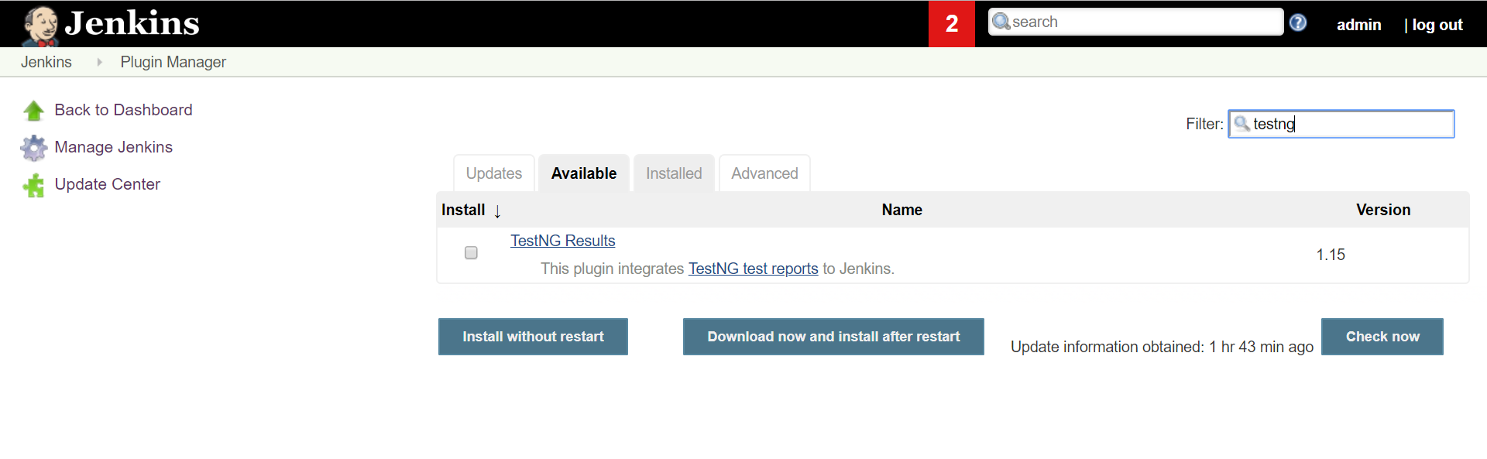

# **36C. Selenium - Jenkins - Configuring Jenkins, Creating a new Job and Running Jenkins Jobs Manually**

**Configuring Jenkins for running Jenkins Jobs:**

Now open Jenkins and go to Global Tool Configuration and set up the paths for JDK and Maven.

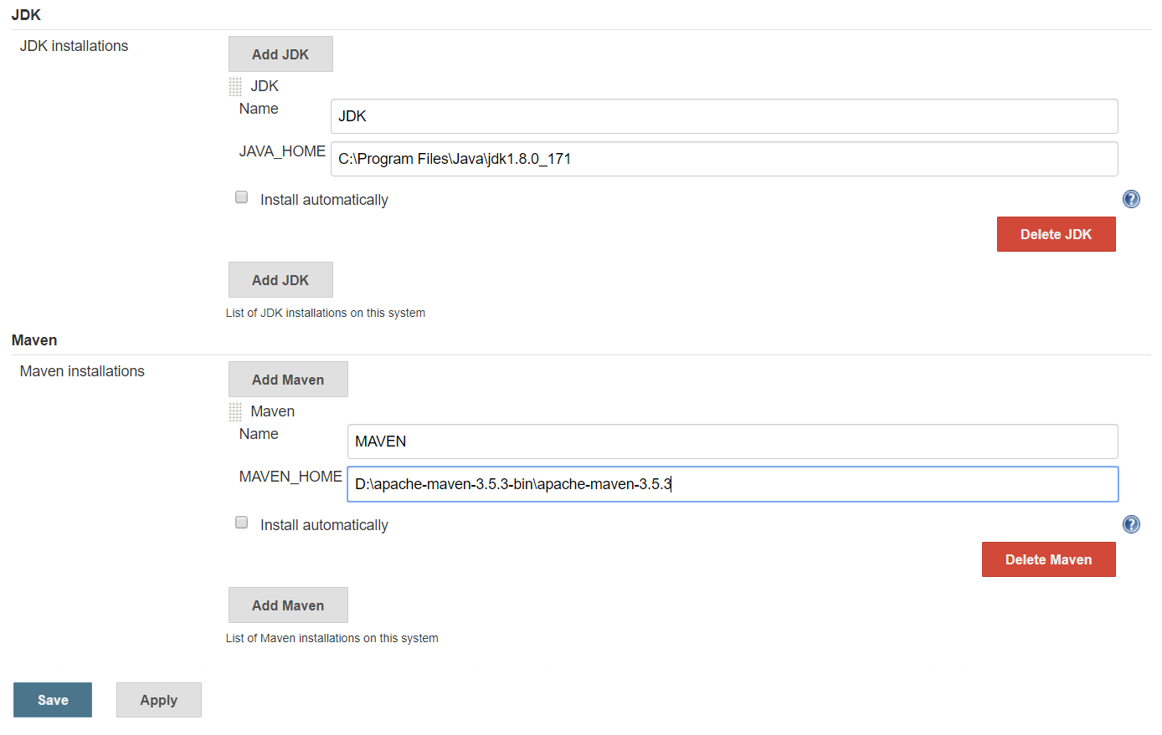

Since JDK is installed in C driver under program files under Java, I have provided the path.

Similarly provide the path for Maven as well. Once you enter both the details save it.

Now create a new job in Jenkins. Click on either New Item or “Create new jobs” on the home page.

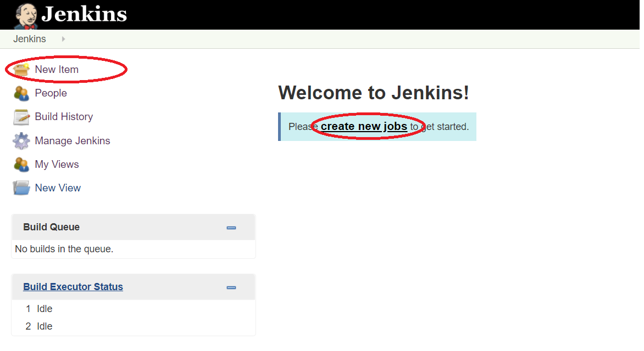

Then it asks for the job name. Enter any name you want and select Free Style Project. I have enter it as FirstProject.

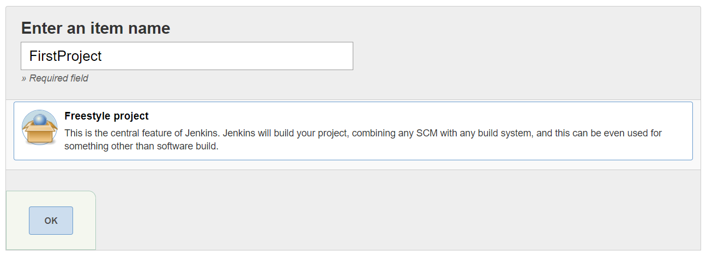

In order to set up the project which is in our local machine, under GENERAL tab click on Advanced button and select “Custom Workspace” and enter the url of the project. We need to give the url until where the POM.xml is located.

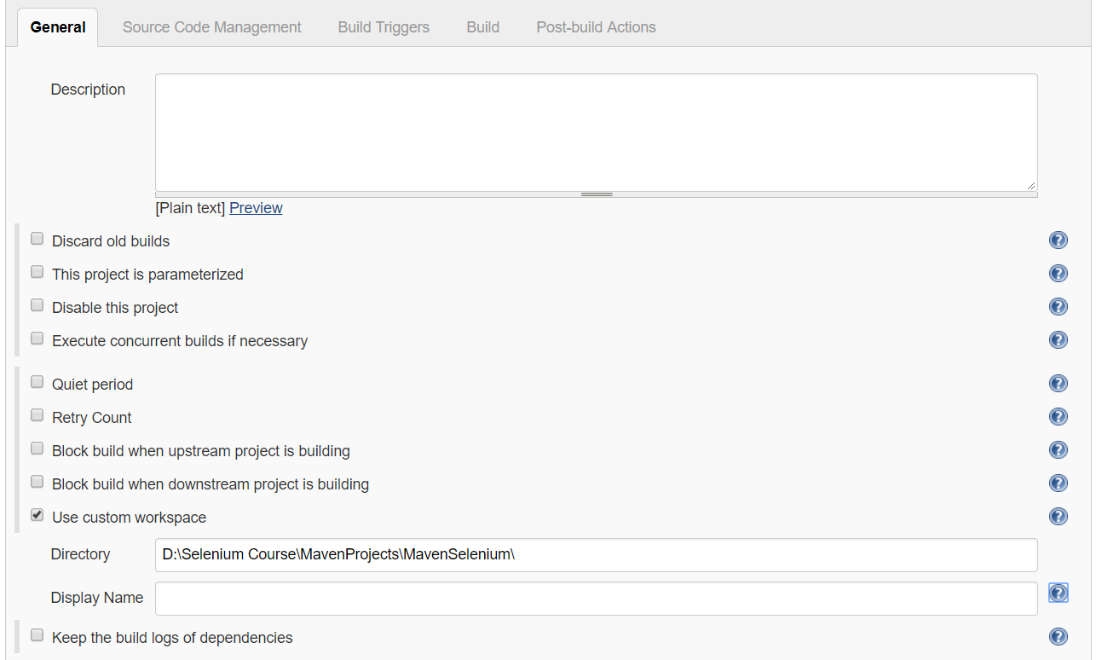

You can get the directory where the pom.xml is, by righ clicking on the pom.xml and click on properties in Eclipse.

Note: Instead of putting the path there, you can copy the project into “.jenkins” folder (this folder will be created once Jenkins is installed).

Then you can provide the url as ${JENKINS_HOME}/ProjectName

Under “Build” section click on “Add Build Step” and select “Invoke Top-Level Maven Targets”. You can select the maven version here and enter the goal as “test”. You don’t need to provide mvn command here. If you have used profiles in Maven pom.xml and if you want to run only one profile, then you can use it like test -PRegression and here P means profile.

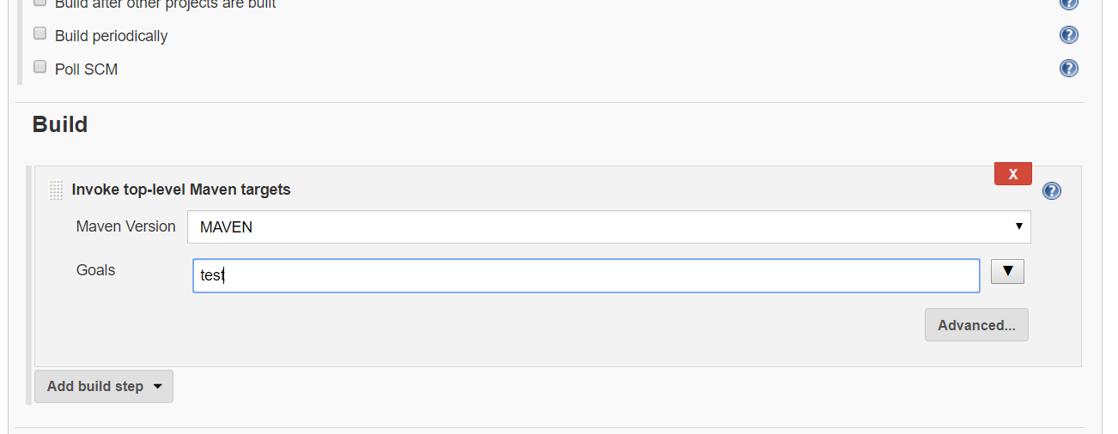

Now after saving, if you are on the home page you can run the project manually by clicking on the alarm clock image. If you are with in the job page, you can run the job by cliking “Build Now” on the left menu.

On the Home Page:

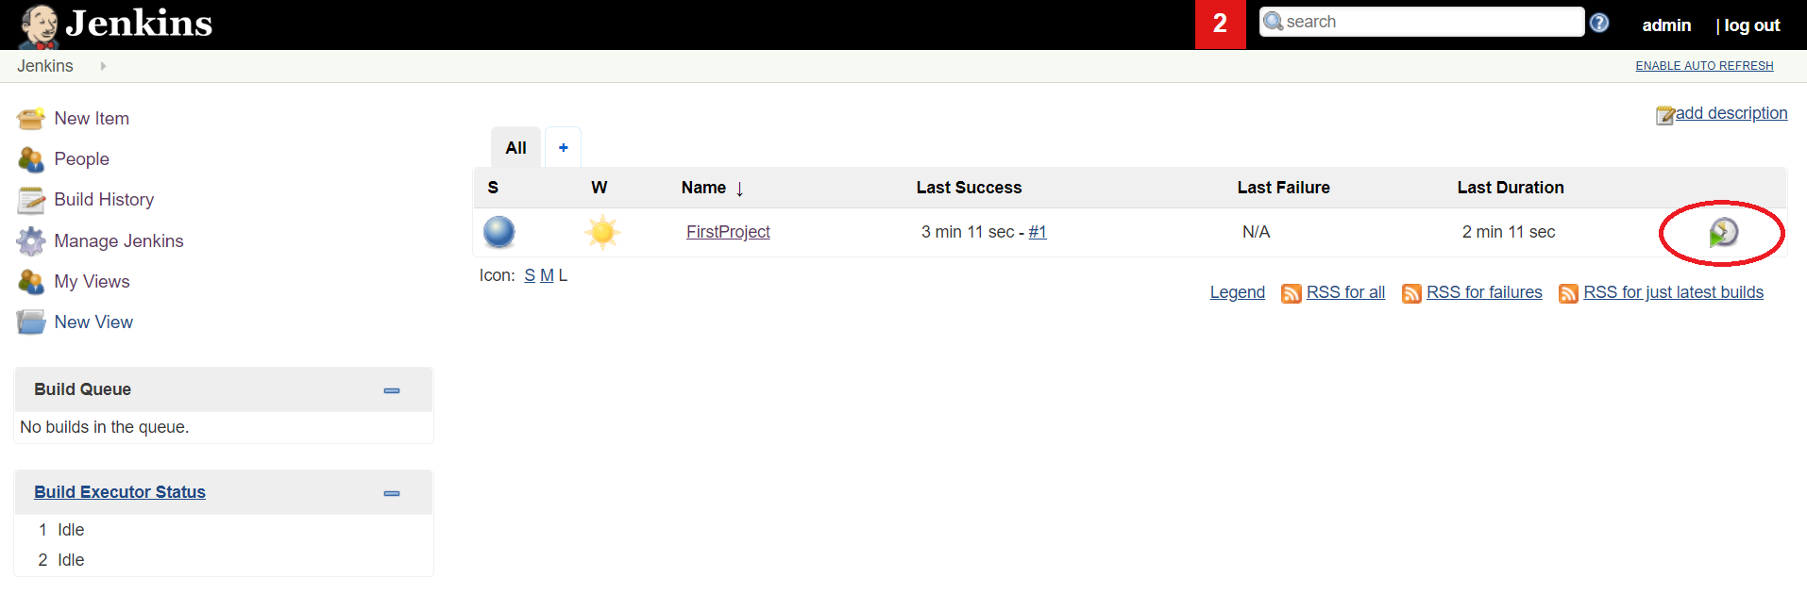

On the Job Page:

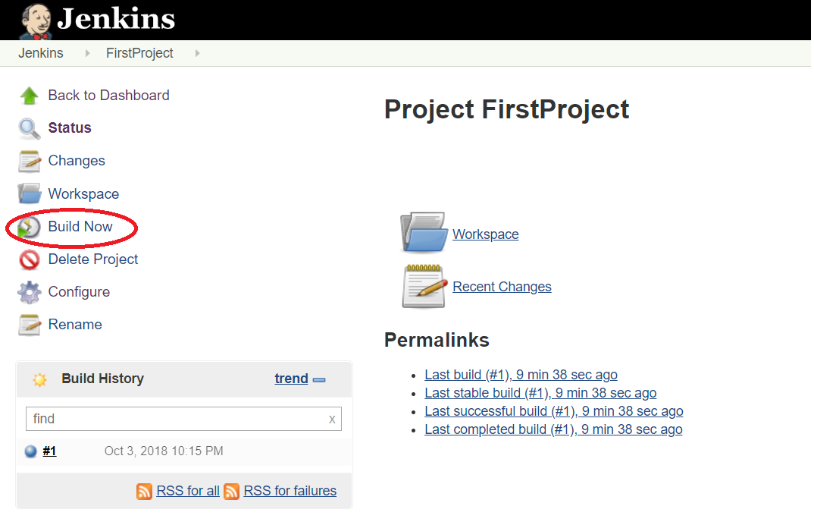

Reports: Once the tests are run through TestNG, in eclipse under “target” folder, under surefire-reports you will find index.html file. Right click, click on properties and select the path and open it in any browser and you will see the results.

# **36D. Selenium - Jenkins - Running Jenkins Jobs at a Particular time or at an interval of time or remotely**

**How to run Tests automatically at a particular time or at a particular interval of time or from remotely?**

For this we need to use build triggers. Under build triggers we have the following options.

* Trigger builds remotely
* Build after one other projects are built
* Build Periodically
* Poll SCM

Triggering Builds Remotely:

If you select this option it will ask for a key. You can enter any key you want like “A34FSA5434FGS”. It will display a message that

“Use the following URL to trigger build remotely: JENKINS_URL/job/FirstProject/build?token=TOKEN_NAME or /buildWithParameters?token=TOKEN_NAME  
Optionally append &cause=Cause+Text to provide text that will be included in the recorded build cause.”

So you can construct the URL as follows and if you access it now from other computer, it will trigger the job.

[http://localhost:9090/job/FirstProject/build?token= A34FSA5434FGS](http://localhost:9090/job/FirstProject/build?token=%20A34FSA5434FGS)

Build after one other projects are built:

If you select this option it will ask you for the other project which you want it to be completed. Then this job will trigger.

Build Periodically:

This option follows the syntax of cron.

Cron is a command to an operating system or a server for a job that is to be executed at a specified time.

In cron each line consists of 5 fields separated by tab or white space.

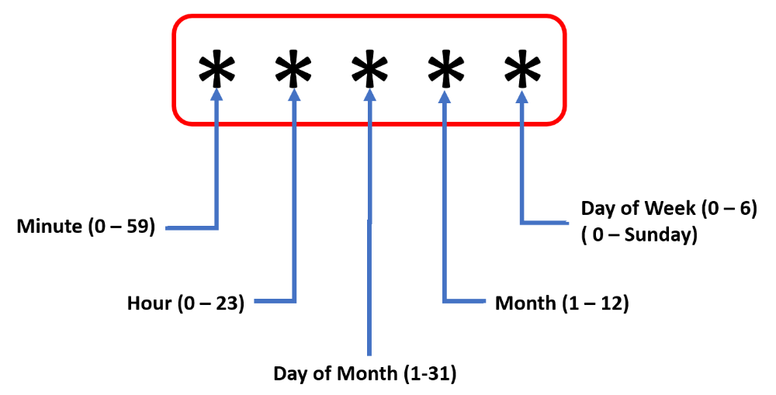

If you specify the option as * * * * * this means the job will be triggered every minute.

If you specify the option as 5 * * * * this means the job will be triggered every fifth minute after the hour (not every 5 minutes). That means it will be triggered at 1:05, 2:05 etc.

* * 5 * * * - every day at 5 AM
* 1 5 * * * - every day at 5:01 AM

Poll SCM:

This opton is same as above but instead of running the tests every minute or so, it will check the server at the specific interval mentioned and see if there are any changes in the code. If there are any changes, then only it runs the tests. Otherwise not.

# **36E. Selenium - Jenkins - Reports - TestNG Results Plugin**

TestNG Results Plugin:

We have seen the results produced under surefire-reports in Eclipse.

TestNG Results plugin provides some addintional fetures for reports.

Go to Manage Jenkins section and click on “Manage Plugins” link.

Go to the “Available” tab and search with the words “TestNG Results” and it will show you the plugin.

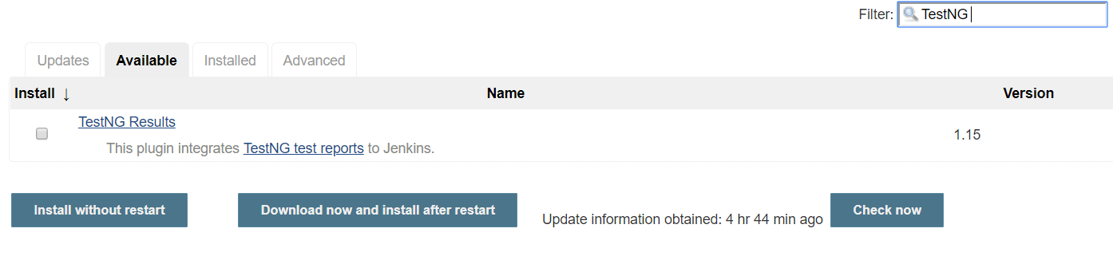

Select the plugin and click on “Install without restart”.

Once the plugin is started go to the configuration section of any job and go to the Post Build Actions.

Post Build Actions means any action that has to be taken once the job is completed. Click on “Add Post-Build Action” and select the “Publish TestNG results” option and save it.

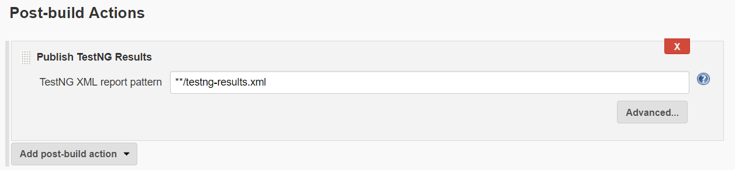

Now run the job manually.

Once the job is completed, go to the job and on left side you will see the link TestNG results.

Clcik on the link and you will see the test results like how many test cases are passed, how many are failed etc..

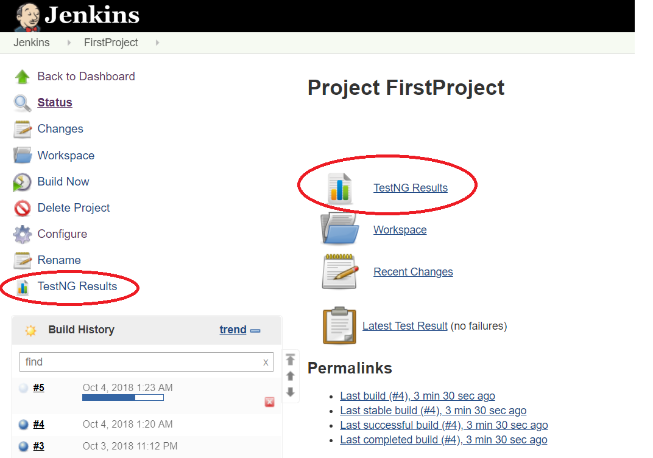

Click on TestNG Results.

On this page and you will see the results.

# **36F. Selenium - Jenkins - Reports - Test Results Analyzer Plugin**

Test Results Analyzer Plugin:

If you want to see the results of all previous runs, then you can use Test results analyser plugin. Go to “Manage Jenkins” and then search with “Test Results Analyzer” in the “Available” section and it should show the plugin. Install it without restart.

Once it is installed you don’t need to do any settings.

If you go to any job, you will see it on the left “Test Results Analyzer”. Click on it and it will show the results.

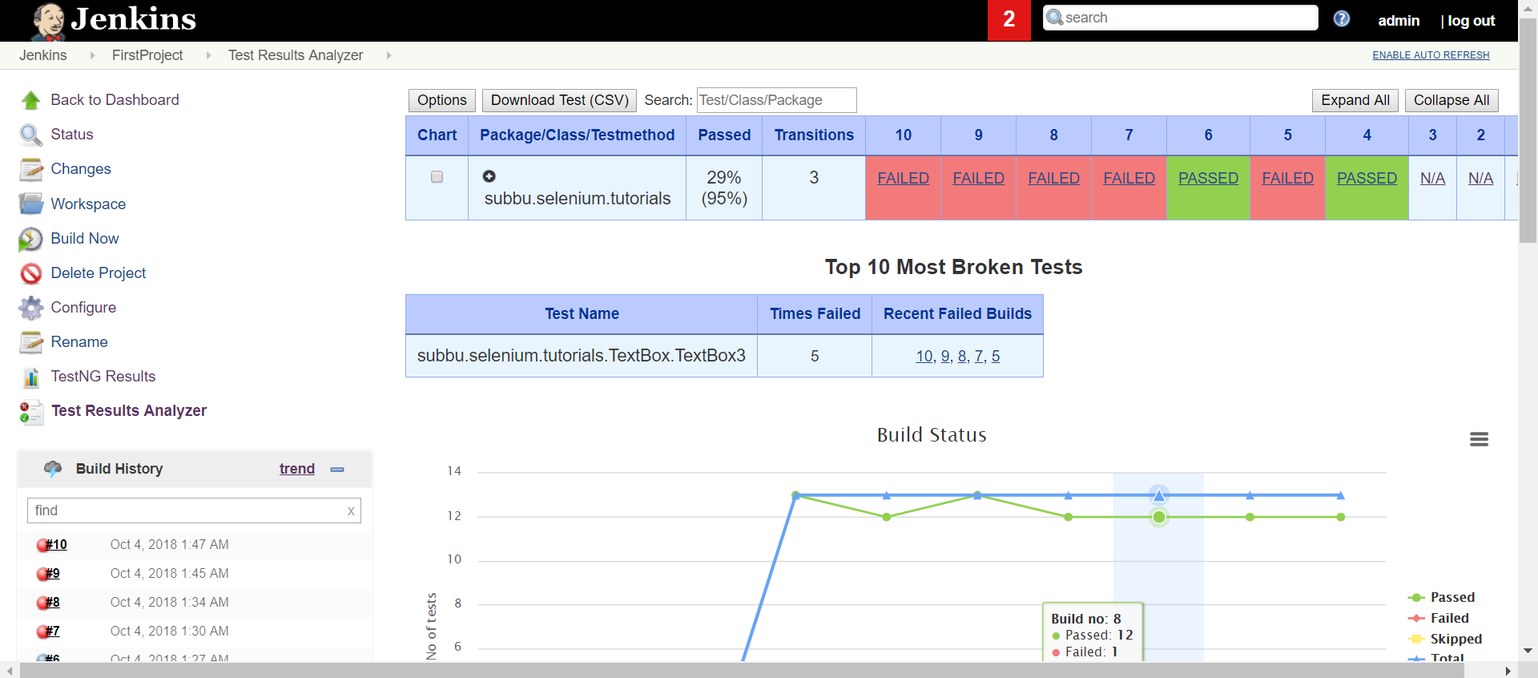

# **36G. Selenium - Jenkins - Sending Test Reports in Email through Jenkins**

**Emain Configuaration in Jenkins**

Install the plugin “Email Extension”

Now go to Manage Jenkins and go to “Configure System”.

Here you will see a new settings “Extended E-mail Notification” added.

Enter the settings as follows. (Enter your own email id and password and save it).

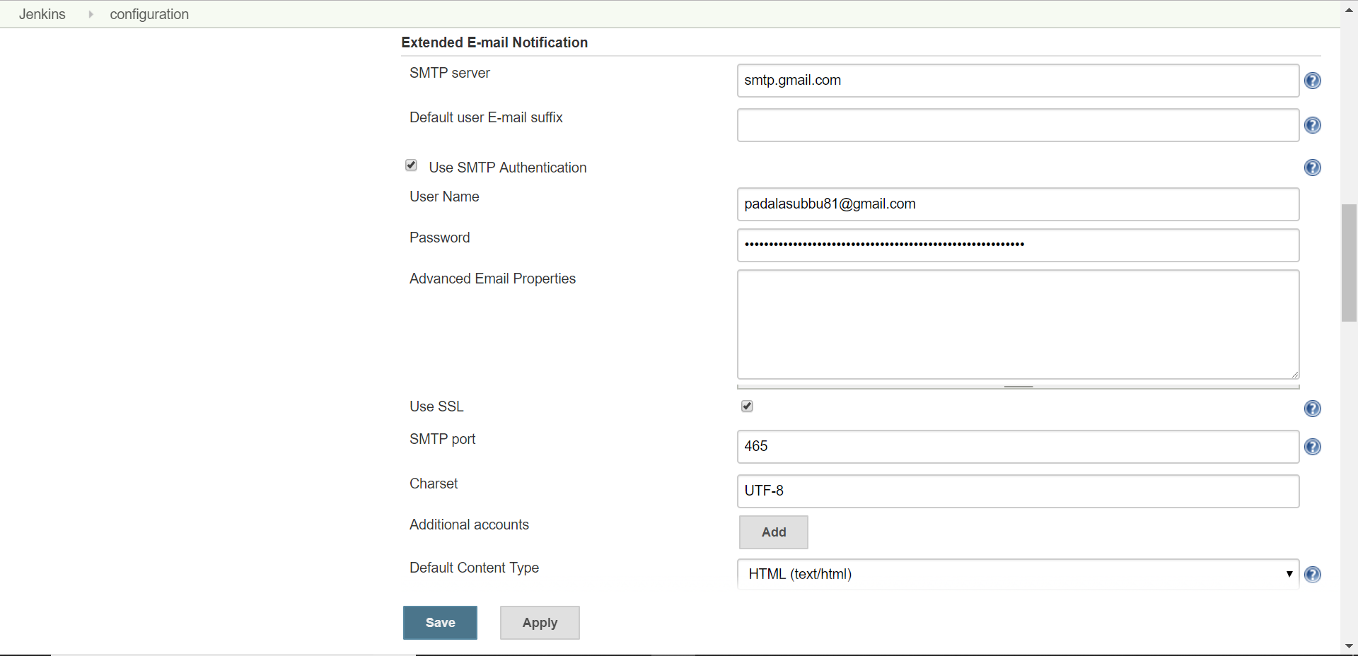

Now go to the project configuration and click on “Add Post-Build action” and you will see “Editable Email Notification”. Click on advanced settings and Add the following settings.

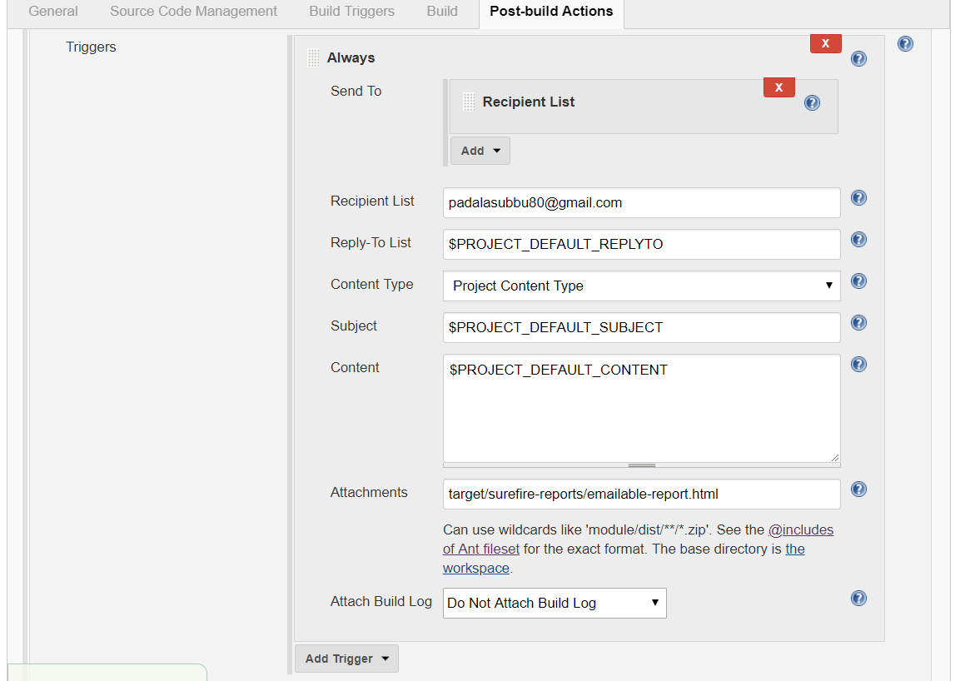

Since we are using gmail, we need to make some changes to gmail settings to use gmail SMPT server. The following are the changes.

1. Enable IMAP in your gmail settings.

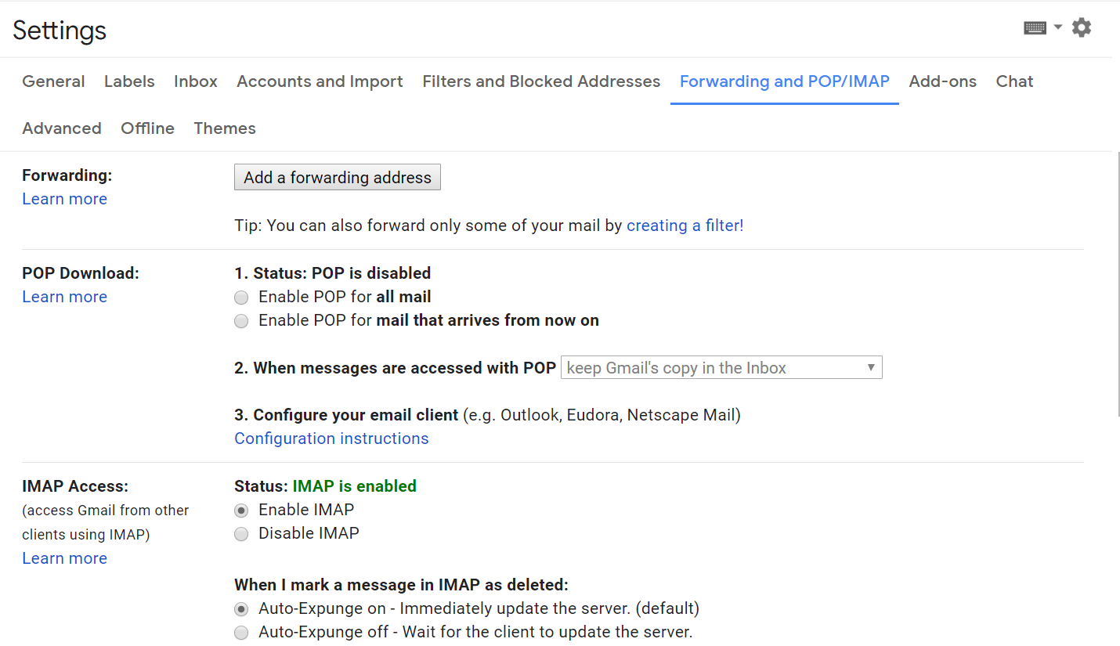

2. Allow Less secure apps for the gmail account you are using.

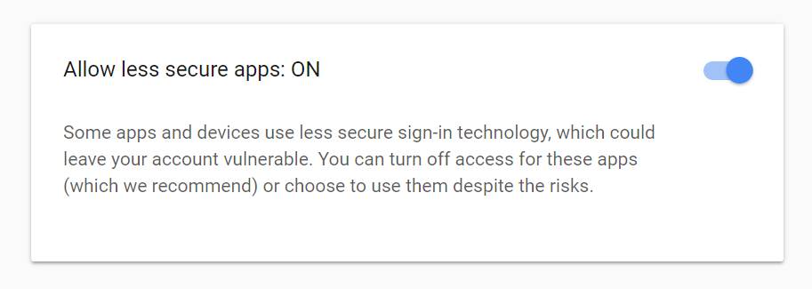

You can do it by going to your google account and going to **Sign-in & security** tab.

Now you should be able to send emails.

# **37. Selenium - Jenkins Interview Questions**

**Selenium – Jenkins Interview Questions:**

**What is Jenkins?**

Jenkins is a continuous integration tool.

**What is a continuous integration system?**

Continuous integration is a development practice that requires developers to integrate code into a shared repository several times a day. It is a process of running your tests on a non-developer machine automatically when someone pushes the new code into the source repository.

Using Jenkins, we can trigger tests when someone pushes new code into the repository.

**Why do we need continuous integration?**

Using continuous integration, we can detect problems as early as possible in the development lifecycle.

Since code is deployed, built and tested thoroughly potential defects can be caught in the early stages of life cycle.

**What are the requirements for installing Jenkins?**

Requirements:

JDK should be installed on the system. As Jenkins was developed using Java, JDK should be installed on the system to run Jenkins.

**How do you run Jenkins?**

Go to the folder where the Jenkins war file is downloaded and run the following command.

java -jar jenkins.war --httpPort=9090

This will start the server on port 9090. Now if you go to browser and type <http://localhost:9090> it will open Jenkins home page.

**What is the default port that Jenkins start if you don’t specify the port no. in the above command?**

8080

# **38. Selenium - Database Testing - Introduction**

What is database testing?

Database testing is to test the database tables to make sure that the data is loading properly into them.

For example, we are filling an online registration form and once we click submit button the data will be stored in some table in the database. We may have to make sure that the data is storing correctly in the table. This comes under database testing.

We will be using Java JDBC to connect to the database.

There are 5 steps to connect any java application with the database using JDBC. These steps are as follows:

* Register the Driver class
* Create connection
* Create statement
* Execute queries
* Close connection

We have already discussed these steps in Java Database Connectivity in java tutorials but I will go through those steps again quickly.

1. Register the Driver Class

The forName() method of class Class is used to register the driver class.

For MySQL it is:

Class.forName("com.mysql.jdbc.Driver");

For Oracle it is:

Class.forName("oracle.jdbc.driver.OracleDriver");

1. Create a connection object

For MySQL:

Connection con=DriverManager.getConnection("jdbc:mysql://localhost:3306/dbname","root","root");

For Oracle:

Connection con=DriverManager.getConnection("jdbc:oracle:thin:@localhost:1521:xe","system","password");

1. Create the statement object

For MysQL/Oracle:

Statement stmt=con.createStatement();

1. Execute Query

ResultSet rs=stmt.executeQuery("select * from emp");

While(rs.next()){

System.out.println(rs.getInt(1)+” “+rs.getString(2));

}

**Note: For selecting data we use stmt.executeQuery**

**For inserting, updating, deleting data we use stmt.executeUpdate**

1. Close the connection

con.close()

So in the next example, we will submit a user registration form and verify the database table that the information is loaded correctly.

First we need to setup a site in our localhost and then we will do a database test by submitting the registration form.

# **38A. Selenium - Database Testing - Setting up a site in our localhost**

**Setting up a site in our local host:**

The site we are setting up is an online car rental system. This is developed in php and you can download it for free at the following location.

<https://code-projects.org/online-car-rental-using-php-source-code/>

You don’t need to use the same system but you can use any system you want. If you can set up that system on your localhost, you can use that.

Now go to the XAMPP control panel and start the apache server and mysql.

Once you download the car rental system, go to the phpMyAdmin and create a new database “carrental”.

You will see a folder sqlfile in the downloaded project. It contains a sql file in this and run this file in the database and all the tables will be created.

Now create a new user with all the privileges and we will be using this user to update the configuration files in the project.

Now go to the car rental folder and you will see “includes” folder and there is a config file with in that folder. Update the file with the user details that we have created.

Now go to the Admin folder and you will another “includes” folder and there is another config file and update this file as well with the DB username and password we have created.

Now everything is set up.

If you go to the link <http://localhost/carrental> you should be able to see the site.

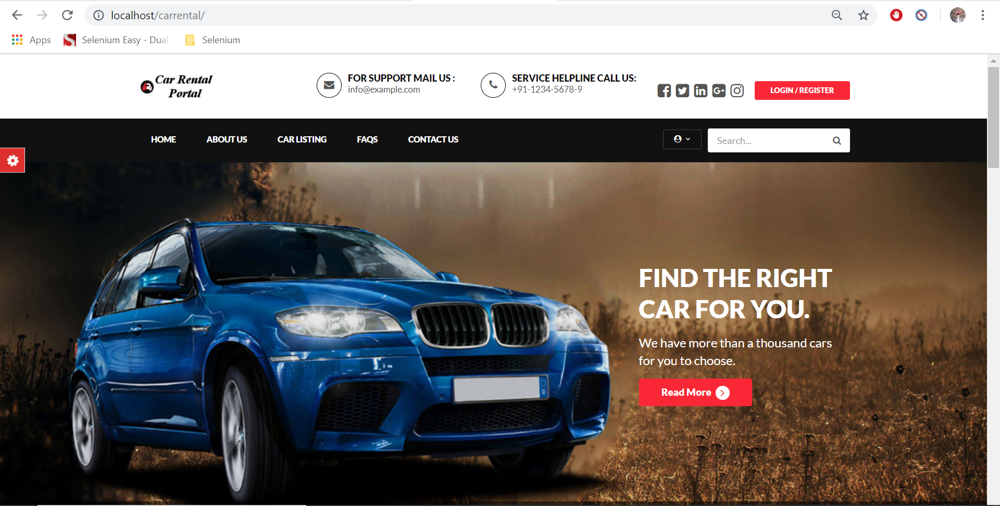

# **38B. Selenium - Database Testing - Submit a New User and Check Database Table**

**package** databasetesting;

**import** java.sql.Connection;

**import** java.sql.DriverManager;

**import** java.sql.ResultSet;

**import** java.sql.Statement;

**import** java.util.HashMap;

**import** java.util.Map;

**import** org.openqa.selenium.By;

**import** org.openqa.selenium.WebDriver;

**import** org.openqa.selenium.firefox.FirefoxDriver;

**public** **class** registeruser {

**static** String *firstname*;

**static** String *mobileno*;

**static** String *emailid*;

**public** **static** **void** main(String[] args) **throws** InterruptedException {

System.*setProperty*("webdriver.gecko.driver", "C:\\BrowserDrivers\\geckodriver.exe");

WebDriver driver = **new** FirefoxDriver();

Map<String, String> details = **new** HashMap<String, String>();

details.put("fullname", "subbu");

details.put("mobileno", "9178765654");

details.put("emailid", "subbu@gmail.com");

details.put("password", "subbu");

driver.get("http://localhost/carrental/");

driver.findElement(By.*cssSelector*(".btn.btn-xs")).click();

driver.findElement(By.*xpath*("//a[@href='#signupform']")).click();

driver.findElement(By.*name*("fullname")).sendKeys(details.get("fullname"));

driver.findElement(By.*name*("mobileno")).sendKeys(details.get("mobileno"));

driver.findElement(By.*name*("emailid")).sendKeys(details.get("emailid"));

driver.findElements(By.*name*("password")).get(1).sendKeys(details.get("password"));

driver.findElement(By.*name*("confirmpassword")).sendKeys(details.get("password"));

driver.findElement(By.*id*("submit")).click();

//Connecting to database

**try** {

Class.*forName*("com.mysql.cj.jdbc.Driver");

Connection con = DriverManager.*getConnection*("jdbc:mysql://localhost:3306/carrental","subbu123","subbu123");

Statement stmt=con.createStatement();

ResultSet rs=stmt.executeQuery("select * from carrental.tblusers where EmailId = '"+details.get("emailid")+"'");

**while**(rs.next()) {

System.***out***.println(rs.getString(2)+" "+rs.getString(3)+" "+rs.getString(5));

*firstname* = rs.getString(2);

*emailid* = rs.getString(3);

*mobileno* = rs.getString(5);

}

stmt.executeUpdate("delete from carrental.tblusers where EmailId = '"+details.get("emailid")+"'");

con.close();

}

**catch**(Exception e) {

System.***out***.println(e);

}

**if**(*firstname*.equals(details.get("fullname"))) {

System.***out***.println("Full Name is matching");

}

**if**(*mobileno*.equals(details.get("mobileno"))) {

System.***out***.println("Mobile no. is matching");

}

**if**(*emailid*.equals(details.get("emailid"))) {

System.***out***.println("Email is matching");

}

Thread.*sleep*(3000);

driver.quit();

}

}

# **39. Selenium - Page Object Model - What is Page Object Model and what are its uses**

**Page Object Model:**

What is Page Object Model?

Page Object Model is about developing an object repository.

Normally, when we do selenium scripts, we do it like

Driver.findElement(By.id(“firstname”)).sendKeys(“Subbu”);

If it is only one script that should be fine. But let’s say you have developed 1000 scripts and all of them contain the above statement. Now if the developers changed the application and they changed the id of the element “firstname” to “fstname” and all of your scripts fail. If you want to make them work, you need to change the id in your script from “firstname” to “fstname” in all of those 1000 scripts which is very time consuming.

But if you have a single place where you can change it just once, that would be very good and it won’t be time consuming for you to make the scripts up and running. This is achieved by page object model. So,

* Page object model is a design pattern to create object repository for web UI elements
* Under this model, for each webpage in an application, there will be a corresponding Objects page.
* We will put each object in a method on the objects page and the method name will be given in a way that it is very easy to under what we are doing.
* The object pages will find the webelements of the page.
* If change is required for any of the webelement, we will just change it in the objects page.

What are the advantages?

* Easy to maintain – Even if the webelement changes we will just change it in the objects page.
* Easy Readability of scripts – Since the method’s names are given in such a way that they represent what operation we are doing, if any new tester comes in he can easily understand the scripts.
* Reduce or Eliminate Duplicacy – Since we are capturing all the elements in an object page, the element will be defined only once so it eliminates the duplicacy.
* Re-Usability of code – We can create object for the objects pages and we can reuse them.

# **39A. Selenium - Page Object Model - Implementing Page Object Model**

Implementing page object model:

I have given sample files to work with this. We have four web pages and they are popage1.html, popage2.html, popage3.html and popage4.html. Each page contains links to others. Open popage1.html.

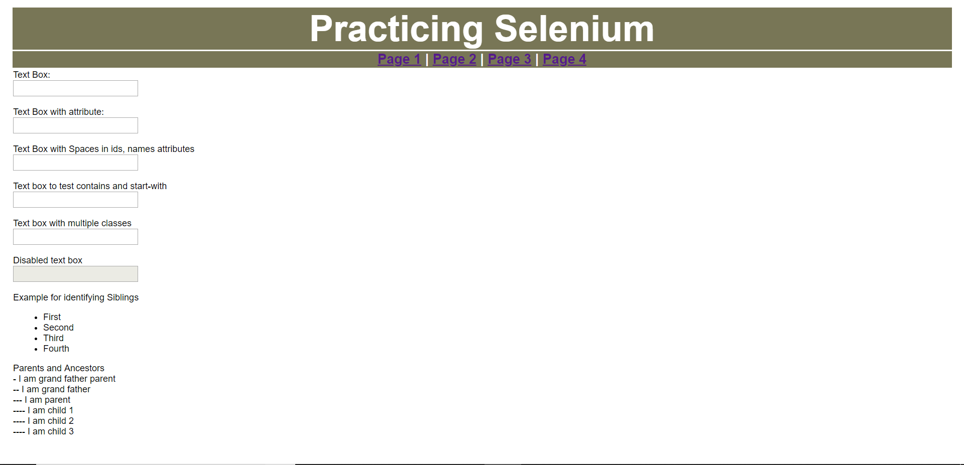

Create a new project “PageObjectModel” and create two packages “objectrepository” and “testcases” under this. “objectrepository” contains all the classes of objects (for all the four pages we have) and the test cases contain the actual test cases.

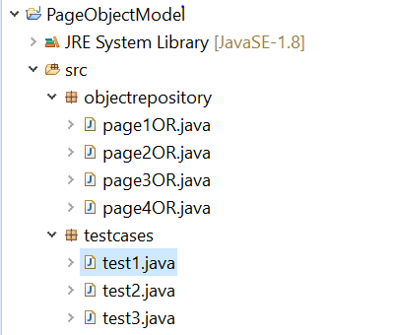

pag1OR.java:

**package** objectrepository;

**import** org.openqa.selenium.By;

**import** org.openqa.selenium.WebDriver;

**import** org.openqa.selenium.WebElement;

**public** **class** page1OR {

WebDriver driver;

**public** page1OR(WebDriver driver){

**this**.driver = driver;

}

**public** WebElement firstname() {

WebElement firstname = driver.findElement(By.*id*("firstname"));

**return** firstname;

}

**public** WebElement fnwithattr() {

WebElement fnwithattr = driver.findElement(By.*xpath*("//input[@color='red']"));

**return** fnwithattr;

}

**public** WebElement fnwithspaces() {

WebElement fnwithspaces = driver.findElement(By.*id*("first name"));

**return** fnwithspaces;

}

**public** WebElement fnstartwith() {

WebElement fnstartwith = driver.findElement(By.*xpath*("//input[starts-with(@id,'last')]"));

**return** fnstartwith;

}

**public** WebElement fnwithmultclass() {

WebElement fnwithmultclass = driver.findElement(By.*cssSelector*(".text.primary-text"));

**return** fnwithmultclass;

}

**public** WebElement page4() {

WebElement page4 = driver.findElement(By.*linkText*("Page 4"));

**return** page4;

}

}

test1.java:

**package** testcases;

**import** org.openqa.selenium.WebDriver;

**import** org.openqa.selenium.firefox.FirefoxDriver;

**import** objectrepository.page1OR;

**public** **class** test1 {

**public** **static** **void** main(String[] args) **throws** InterruptedException {

System.*setProperty*("webdriver.gecko.driver", "C:\\BrowserDrivers\\geckodriver.exe");

WebDriver driver = **new** FirefoxDriver();

driver.get("file:///D:/Selenium%20Course/Java/pageobjectmodel/popage1.html");

page1OR p1 = **new** page1OR(driver);

p1.firstname().sendKeys("subbu");

p1.fnwithattr().sendKeys("Ganesh");

p1.fnwithspaces().sendKeys("Ram");

p1.fnstartwith().sendKeys("Naresh");

p1.fnwithmultclass().sendKeys("suresh");

p1.page4().click();

Thread.*sleep*(2000);

driver.close();

}

}

# **39B. Selenium - Page Object Factory**

Page Object Factory:

Page Object Factory provides an annotation @FindBy which makes identification of web elements much easier.

To use this annotation first we need to initialize the page object factory using

**PageFactory.*initElements*(driver, this);**

Example:

**package** objectrepository;

**import** org.openqa.selenium.By;

**import** org.openqa.selenium.WebDriver;

**import** org.openqa.selenium.WebElement;

**import** org.openqa.selenium.support.FindBy;

**import** org.openqa.selenium.support.PageFactory;

**public** **class** page1ORPF {

WebDriver driver;

**public** page1ORPF(WebDriver driver){

**this**.driver = driver;

PageFactory.*initElements*(driver, **this**);

}

@FindBy(id="firstname")

WebElement firstname;

**public** WebElement firstname() {

**return** firstname;

}

@FindBy(xpath="//input[@color='red']")

WebElement fnwithattr;

**public** WebElement fnwithattr() {

**return** fnwithattr;

}

@FindBy(id="first name")

WebElement fnwithspaces;

**public** WebElement fnwithspaces() {

**return** fnwithspaces;

}

@FindBy(xpath="//input[starts-with(@id,'last')]")

WebElement fnstartwith;

**public** WebElement fnstartwith() {

**return** fnstartwith;

}

@FindBy(css=".text.primary-text")

WebElement fnwithmultclass;

**public** WebElement fnwithmultclass() {

**return** fnwithmultclass;

}

@FindBy(linkText="Page 4")

WebElement page4;

**public** WebElement page4() {

**return** page4;

}

}

Test1.java

**package** testcases;

**import** org.openqa.selenium.WebDriver;

**import** org.openqa.selenium.firefox.FirefoxDriver;

//import objectrepository.page1OR;

**import** objectrepository.page1ORPF;

**public** **class** test1 {

**public** **static** **void** main(String[] args) **throws** InterruptedException {

System.*setProperty*("webdriver.gecko.driver", "C:\\BrowserDrivers\\geckodriver.exe");

WebDriver driver = **new** FirefoxDriver();

driver.get("file:///D:/Selenium%20Course/Java/pageobjectmodel/popage1.html");

page1ORPF p1 = **new** page1ORPF(driver);

p1.firstname().sendKeys("subbu");

p1.fnwithattr().sendKeys("Ganesh");

p1.fnwithspaces().sendKeys("Ram");

p1.fnstartwith().sendKeys("Naresh");

p1.fnwithmultclass().sendKeys("suresh");

p1.page4().click();

Thread.*sleep*(2000);

driver.close();

}

}

# **40. Selenium - Page Object Model and Factory Interview Questions**

**What is Page Object Model?**

Page Object Model is about developing an object repository. It’s a design pattern which has become popular for enhancing test maintenance and reducing code duplication.

**Why do we need page object model?**

This is mainly for test maintenance and eliminate code duplication.

Normally, when we do selenium scripts, we do it like

Driver.findElement(By.id(“firstname”)).sendKeys(“Subbu”);

If it is only one script that should be fine. But let’s say you have developed 1000 scripts and all of them contain the above statement. Now if the developers changed the application and they changed the id of the element “firstname” to “fstname” and all of your scripts fail. If you want to make them work, you need to change the id in your script from “firstname” to “fstname” in all of those 1000 scripts which is very time consuming.

But if you have a single place where you can change it just once, that would be very good and it won’t be time consuming for you to make the scripts up and running. This is achieved by page object model.

**How page object model is achieved in selenium automation?**

* Under this model, for each webpage in an application, there will be a corresponding Objects page.
* We will put each object in a method on the objects page and the method name will be given in a way that it is very easy to under what we are doing.
* The object pages will find the webelements of the page.

If change is required for any of the webelement, we will just change it in the objects page.

**What are the advantages of page object model?**

* Easy to maintain – Even if the webelement changes we will just change it in the objects page.
* Easy Readability of scripts – Since the method’s names are given in such a way that they represent what operation we are doing, if any new tester comes in he can easily understand the scripts.
* Reduce or Eliminate Duplicacy – Since we are capturing all the elements in an object page, the element will be defined only once so it eliminates the duplicacy.
* Re-Usability of code – We can create object for the objects pages and we can reuse them.

**Is Page object model a framework?**

Page Object Model is a Design Pattern

**What is Page Factory?**

Page Factory is an inbuilt page object model concept for Selenium Web Driver, but it is much optimized. Page Object Factory provides an annotation @FindBy which makes identification of web elements much easier.

**How do you initialize page object factory?**

PageFactory.*initElements*(driver, this);

**What is the difference between Page Object Model (POM) and Page Factory?**

Page Object is a class that represents a web page and hold the functionality and members.

Page Factory is a way to initialize the web elements you want to interact with within the page object when you create an instance of it.

# **41. Selenium - Log4j2 - What is Log4j2 and its uses and how to install and configure**

**Logging Framework – log4J:**

What is Log4j and what are its uses?

Log4J is a reliable, fast and flexible logging framework (APIs) written in Java which is distributed under the Apache Software License. It is used by programmers to output log statements to a variety of targets. These are very useful in case of errors as the root cause of the error can be located.

Log4J is developed by apache to log any errors, output etc.

Why Log4J:

Log4j is fully configurable using .properties or .xml.

Log4j enables you to find out easily which are information messages, which are debug messages, which are errors and which are fatal errors.

Log4j records information upto class level. For example, you can output only error messages for one class and for another info. Messages only. Similarly at package level also.

If any error occurs, it will show you the class name also, if configured.

**Installing log4j:**

Go to google and type apache log4j download.

Download the binary zip file.

**Important note: Now once you unzip this you will see different jar files and you need only log4jcore and log4japi. If you include anymore files in build path you will get classnotfound exception.**

Maven Dependency:

URL: <https://logging.apache.org/log4j/2.0/maven-artifacts.html>

If you want to download the resources using maven, Log4j 2 is broken up into an API and an implementation (core), where the API provides the interface that applications should code to.

So you have to include 2 dependency information files.

<dependencies>

<dependency>

<groupId>org.apache.logging.log4j</groupId>

<artifactId>log4j-api</artifactId>

<version>2.13.0</version>

</dependency>

<dependency>

<groupId>org.apache.logging.log4j</groupId>

<artifactId>log4j-core</artifactId>

<version>2.13.0</version>

</dependency>

</dependencies>

***Note: Some versions of the above are giving errors. So use version 2.11.1***

Example:

**package** Log4JTutorials;

**import** org.apache.logging.log4j.LogManager;

**import** org.apache.logging.log4j.Logger;

**public** **class** TextBox {

**private** **static** Logger *log* = LogManager.*getLogger*(TextBox.**class**.getName());

**public** **static** **void** main(String[] args) {

*log*.trace("This is trace message");

*log*.debug("This is debug message");

*log*.info("This is info message");

*log*.warn("This is warn message");

*log*.error("This is error message");

*log*.fatal("This is fatal message"); }

}

Import the following package manually.

**import** org.apache.logging.log4j.*;

Now create a logger object inside the class by passing the class name.

**private** **static** Logger *log* = LogManager.*getLogger*(TextBox.**class**.getName());

The different methods inside this object are debug(), error(), fatal(), info() etc.

Result:

ERROR StatusLogger No Log4j 2 configuration file found. Using default configuration (logging only errors to the console), or user programmatically provided configurations. Set system property 'log4j2.debug' to show Log4j 2 internal initialization logging. See https://logging.apache.org/log4j/2.x/manual/configuration.html for instructions on how to configure Log4j 2

00:53:01.107 [main] ERROR package1.First - This is error message

00:53:01.107 [main] FATAL package1.First - This is fatal message

The above prints only error and fatal messages and not debug and info messages. This is because it needs a configuration file called Log4j 2. If we don’t use the configuration file, it uses a default configuration file and prints only Error and Fatal message.

If you don’t use the log 4j 2 configuration file, it will use default configuration file and debug and info messages won’t be printed.

There are mainly 6 types of information can be logged.

* trace
* debug
* info
* warn
* error
* fatal

# **41A. Selenium - Log4j2 - Log4j2 Configuration file to print all the messages**

**Log4j configuration file:**

Log4j configuration can be found by searching google with “log4j configuration” and you can find it at <https://logging.apache.org/log4j/2.x/manual/configuration.html>.

**Basic Configuration:**

## **Logging a particular level of information to console:**

The basic configuration file is:

<?xml version=*"1.0"* encoding=*"UTF-8"*?>

<Configuration status=*"WARN"*>

<Appenders>

<Console name=*"Console1"* target=*"SYSTEM_OUT"*>

<PatternLayout pattern=*"%d{HH:mm:ss.SSS} [%t] %-5level %logger{36} - %msg%n"*/>

</Console>

</Appenders>

<Loggers>

<Root level=*"fatal"*>

<AppenderRef ref=*"Console1"*/>

</Root>

</Loggers>

</Configuration>

The basic XML contains mainly two things.

1. What to log? – Loggers section
2. Where to log? – Appenders section

In the above xml, first it checks what has to be logged. So in the Loggers section, we have specified the root level as fatal. So it logs the fatal information only. Then it checks where it has to log. Then it will verify the AppenderRef tag where the ref is “Console1”.

Now it goes to Appenders tag and look for the name “Console1”. When it finds the name it checks the starting tag. The starting tag is Console so it will log in the console.

Pattern is defined under the where to log tag (In this case it is console. It can be RollingFile also if we want to log them into files).

Put the above file in log4j2.xml and put it under a folder like “resources”. Add the resources folder to build path.

***Note: You need to add the folder containing the log4j2.xml to build path/source folder.***

Right click on the project and click on build path -> Configure build path -> Java Build Path -> go to source tab -> Add Folder and add the new folder created (where our xml file is stored).

## **Logging one level for one program, another level for another program and another level for all other programs to Console:**

Now for example we want to log fatal only for some programs, info only for some programs and for everything else trace then we can have the xml file as follows.

<?xml version=*"1.0"* encoding=*"UTF-8"*?>

<Configuration status=*"WARN"*>

<Appenders>

<Console name=*"Console1"* target=*"SYSTEM_OUT"*>

<PatternLayout

pattern=*"%d{HH:mm:ss.SSS} [%t] %-5level %logger{36} - %msg%n"* />

</Console>

</Appenders>

<Loggers>

<Logger

name=*"log4j2Examples.diffLevelsForDiffPacks.PR2InfoLogging"*

level=*"info"*

additivity=*"false"*>

<AppenderRef ref=*"Console1"* />

</Logger>

<Logger

name=*"log4j2Examples.diffLevelsForDiffPacks.PR2ErrorLogging"*

level=*"error"*

additivity=*"false"*>

<AppenderRef ref=*"Console1"* />

</Logger>

<Root level=*"trace"*>

<AppenderRef ref=*"Console1"* />

</Root>

</Loggers>

</Configuration>

In the above xml we have define two <Logger> sections and <Root> section under <Loggers>.

If we want to log only a particular type of messages for a particular program or package, we define it under the <Logger> section. It contains

* name attribute – Give the name of the package or program here.
* level attribute – Give what kind of information we want to log like trace, info, error etc.
* additivity attribute – false. It prevents the messages logging two times.
* AppenderRef tag – it contains an attribute “ref” which gives the name of what appender tag it has to look for under <Appenders> tag.

<Appenders> tag contains the information of where to log with the reference names.

* If it contains a <Console> tag that means information will be logged in console.
* If it contains a <RollingFile> tag that means information will be logged in a file and we have to provide the file information.
* Information can be logged to Console or File

We will also have a <PatternLayout> tag in <Console> or <RollingFile> using which we can mention how the information should be logged.

**Important Note: Name the file as log4j2.xml only. Otherwise it will use the default one.**

## **Setting Logging Levels at Package Level**

If you have multiple packages, and you want for one package only errors but for the remaining you want all the message then you have to use <logger> tag.

<?xml version=*"1.0"* encoding=*"UTF-8"*?>

<Configuration status=*"WARN"*>

<Appenders>

<Console name=*"Console1"* target=*"SYSTEM_OUT"*>

<PatternLayout

pattern=*"%d{HH:mm:ss.SSS} [%t] %-5level %logger{36} - %msg%n"* />

</Console>

</Appenders>

<Loggers>

<Logger

name=*"log4j2Examples.diffLevelsForDiffPacks"*

level=*"error"*

additivity=*"false"*>

<AppenderRef ref=*"Console1"* />

</Logger>

<Root level=*"trace"*>

<AppenderRef ref=*"Console1"* />

</Root>

</Loggers>

</Configuration>

Here for the programs in the package “*log4j2Examples.diffLevelsForDiffPacks*” only error level will be logged. For all other packages and programs trace level will be logged.

# **41B. Selenium - Log4j2 - How to log into a file**

**Logs into File:**

## **Basic XML Configuration File To Log Into File**

If we want to log into a file, only the <Appenders> section will change.

In the appenders section we need to add the <RollingFile> tag.

The <RollingFile> tag contains the attributes

name – this we will use in <Loggers> section under <Root> in <AppenderRef>.

fileName – Here we can give the starting file name. This is the initial file that is created. If we don’t use this attribute the initial file output.log won’t be created. Everything will be created with filePattern.

We also need to add <Properties> section under configuration using which we can mention the basepath where we can log the details.

<?xml version=*"1.0"* encoding=*"UTF-8"*?>

<Configuration status=*"WARN"*>

<Properties>

<Property name=*"basePath"*>./logs</Property>

</Properties>

<Appenders>

<RollingFile name=*"loggerfile"* fileName=*"${basePath}/output.log"*

filePattern=*"${basePath}/output-%d{yyyy-MM-dd-HH-mm-ss.SSS}.log"*>

<PatternLayout

pattern=*"%d{HH:mm:ss.SSS} [%t] %-5level %logger{36} - %msg%n"* />

<SizeBasedTriggeringPolicy size=*"500"* />

</RollingFile>

</Appenders>

<Loggers>

<Root level=*"trace"*>

<AppenderRef ref=*"loggerfile"* />

</Root>

</Loggers>

</Configuration>

## **From One Package to File and Everything Else to Console:**

<?xml version=*"1.0"* encoding=*"UTF-8"*?>

<Configuration status=*"WARN"*>

<Properties>

<Property name=*"basePath"*>./logs</Property>

</Properties>

<Appenders>

<RollingFile name=*"loggerfile"*

fileName=*"${basePath}/output.log"*

filePattern=*"${basePath}/output-%d{yyyy-MM-dd-HH-mm-ss.SSS}.log"*>

<PatternLayout

pattern=*"%d{HH:mm:ss.SSS} [%t] %-5level %logger{36} - %msg%n"* />

<SizeBasedTriggeringPolicy size=*"500"* />

</RollingFile>

<Console name=*"Console1"* target=*"SYSTEM_OUT"*>

<PatternLayout

pattern=*"%d{HH:mm:ss.SSS} [%t] %-5level %logger{36} - %msg%n"* />

</Console>

</Appenders>

<Loggers>

<logger name=*"log4j2Examples.testPackage"* level=*"error"*

additivity=*"false"*>

<AppenderRef ref=*"Console1"* />

</logger>

<Root level=*"trace"*>

<AppenderRef ref=*"loggerfile"* />

</Root>

</Loggers>

</Configuration>

You can define the path in parameter <Properties>. You can use this basepath in RollingFile to log whatever we want.

<Properties>

<Property name=*"basePath"*>./logs</Property>

</Properties>

This will first create a folder logs.

<RollingFile name=*"File"* fileName=*"${basePath}/output.log"* filePattern=*"${basePath}/output-%d{yyyy-MM-dd}.log"*>

<PatternLayout pattern=*"%d{HH:mm:ss.SSS} [%t] %-5level %logger{36} - %msg%n"*/>

<SizeBasedTriggeringPolicy size=*"500"* />

</RollingFile>

This section under Appenders will create a log file as output.log under basepath. Once it reaches the file size mentioned in <SizeBasedTriggeringPolicy size=*"500"* /> it will create another file with the pattern mentioned in filePattern.

# **41C. Selenium - Log4j2 - How to Print Logs into Different Files for Different Packages**

**Printing logs into different files for different packages:**

If we have two files in two different packages, we

**package1/First.java file**

**package** package1;

**import** org.apache.logging.log4j.LogManager;

**import** org.apache.logging.log4j.Logger;

**public** **class** logtest {

**private** **static** Logger *log* = LogManager.*getLogger*(logtest.**class**.getName());

**public** **static** **void** main(String[] args) {

// **TODO** Auto-generated method stub

*log*.debug("This is debug message");

*log*.info("This is info message");

*log*.error("This is error message");

*log*.fatal("This is fatal message");

}

}

**package2/First.java file**

**package** package1;

**import** org.apache.logging.log4j.LogManager;

**import** org.apache.logging.log4j.Logger;

**public** **class** logtest {

**private** **static** Logger *log* = LogManager.*getLogger*(logtest.**class**.getName());

**public** **static** **void** main(String[] args) {

// **TODO** Auto-generated method stub

*log*.debug("This is debug message");

*log*.info("This is info message");

*log*.error("This is error message");

*log*.fatal("This is fatal message");

}

}

**XML File:**

<?xml version=*"1.0"* encoding=*"UTF-8"*?>

<Configuration status=*"WARN"*>

<Properties>

<Property name=*"basePath"*>./logs</Property>

</Properties>

<Appenders>

<RollingFile name=*"package1logs"* fileName=*"${basePath}/package1_output.log"* filePattern=*"${basePath}/package1_output-%d{MM-dd-yy-HH-mm-ss}.log"*>

<PatternLayout pattern=*"%d{HH:mm:ss.SSS} [%t] %-5level %logger{36} - %msg%n"*/>

<SizeBasedTriggeringPolicy size=*"500"* />

</RollingFile>

<RollingFile name=*"package2logs"* fileName=*"${basePath}/package2_output.log"* filePattern=*"${basePath}/package2_output-%d{MM-dd-yy-HH-mm-ss}.log"*>

<PatternLayout pattern=*"%d{HH:mm:ss.SSS} [%t] %-5level %logger{36} - %msg%n"*/>

<SizeBasedTriggeringPolicy size=*"500"* />

</RollingFile>

<Console name=*"Console"* target=*"SYSTEM_OUT"*>

<PatternLayout pattern=*"%d{HH:mm:ss.SSS} [%t] %-5level %logger{36} - %msg%n"*/>

</Console>

</Appenders>

<Loggers>

<logger name=*"package1.First"* level=*"error"* additivity=*"false"*>

<AppenderRef ref=*"package1logs"*/>

</logger>

<logger name=*"package2.First"* level=*"trace"* additivity=*"false"*>

<AppenderRef ref=*"package2logs"*/>

</logger>

<Root level=*"trace"*>

<AppenderRef ref=*"Console"*/>

</Root>

</Loggers>

</Configuration>

# **Logger Levels and output**

|  |  |  |  |  |  |  |
| --- | --- | --- | --- | --- | --- | --- |
| *Log4J Levels* | *TRACE Level* | *DEBUG Level* | *INFO Level* | *WARN Level* | *ERROR Level* | *FATAL Level* |
| **TRACE Level** | Y | Y | Y | Y | Y | Y |
| **DEBUG Level** | N | Y | Y | Y | Y | Y |
| **INFO Level** | N | N | Y | Y | Y | Y |
| **WARN Level** | N | N | N | Y | Y | Y |
| **ERROR Level** | N | N | N | N | Y | Y |
| **FATAL Level** | N | N | N | N | N | Y |
| **ALL Level** | Y | Y | Y | Y | Y | Y |
| **OFF Level** | N | N | N | N | N | N |

# **42. Selenium - Log4j interview Questions**

**Log4J Interview Questions**

**What is Log4j and what are its uses?**

Log4J is a reliable, fast and flexible logging framework (APIs) written in Java which is distributed under the Apache Software License. It is used by programmers to output log statements to a variety of targets. These are very useful in case of errors as the root cause of the error can be located.

Log4J is developed by apache to log any errors, output etc.

**Why Log4J?**

Log4j is fully configurable using .properties or .xml.

Log4j enables you to find out easily which are information messages, which are debug messages, which are errors and which are fatal errors.

Log4j records information upto class level. For example, you can output only error messages for one class and for another info. Messages only. Similarly at package level also.

If any error occurs, it will show you the class name also, if configured.

**How to install Log4j?**

Go to google and type apache log4j download.

Download the binary zip file.

**Important note: Now once you unzip this you will see different jar files and you need only log4jcore and log4japi. If you include anymore files in build path you will get classnotfound exception.**

**What is Log4j configuration file?**

Log4j configuration file is an xml file which is used by Log4j framework to find what information like info, error etc to be logged, how to log it and where to log it.

**What if we don’t use the Log4j configuration file?**

If you don’t use the log 4j 2 configuration file, it will use default configuration file and debug and info messages won’t be printed.

**Which tags in Log4j defines where to log the information?**

Appenders tags define the place where to log the information.

**Which tags in Log4j define how to log?**

PatternLayout tag.

**Which tags in Log4j define what information to log?**

Loggers tag.

Loggers tag contains two tags. Logger and Root.

These two tags contain an attribute level.

If level is trace, all the information info, debug, error, fatal will be printed.

If level is error, only error and fatal information will be logged.

**What is the difference between Logger and Root?**

If you have multiple packages and for one package you want only errors and fatal information should be logged and for other you want all the information to be logged, then you can mention that one package where you want only errors and fatal under logger tag with level as error and under root you can mention the level as trace. So that only for that one package errors and fatal information will be logged and for all other packages all other information will be logged.

<?xml version=*"1.0"* encoding=*"UTF-8"*?>

<Configuration status=*"WARN"*>

<Appenders>

<Console name=*"Console"* target=*"SYSTEM_OUT"*>

<PatternLayout pattern=*"%d{HH:mm:ss.SSS} [%t] %-5level %logger{36} - %msg%n"*/>

</Console>

</Appenders>

<Loggers>

<logger name=*"loggingpackage2.logtest1"* level=*"error"* additivity=*"false"*>

<AppenderRef ref=*"Console"*/>

</logger>

<Root level=*"trace"*>

<AppenderRef ref=*"Console"*/>

</Root>

</Loggers>

</Configuration>

In the above example we defined loggingpackage2 under logger with level as error so only errors and fatal information will be logged for these.

For all others, since we logged the level as trace, all the information will be logged.

**How to log into a file?**

<?xml version=*"1.0"* encoding=*"UTF-8"*?>

<Configuration status=*"WARN"*>

<Properties>

<Property name=*"basePath"*>./logs</Property>

</Properties>

<Appenders>

<RollingFile name=*"File"* fileName=*"${basePath}/output.log"* filePattern=*"${basePath}/output-%d{yyyy-MM-dd}.log"*>

<PatternLayout pattern=*"%d{HH:mm:ss.SSS} [%t] %-5level %logger{36} - %msg%n"*/>

<SizeBasedTriggeringPolicy size=*"500"* />

</RollingFile>

<Console name=*"Console"* target=*"SYSTEM_OUT"*>

<PatternLayout pattern=*"%d{HH:mm:ss.SSS} [%t] %-5level %logger{36} - %msg%n"*/>

</Console>

</Appenders>

<Loggers>

<logger name=*"loggingpackage2.logtest1"* level=*"error"* additivity=*"false"*>

<AppenderRef ref=*"File"*/>

</logger>

<Root level=*"trace"*>

<AppenderRef ref=*"File"*/>

</Root>

</Loggers>

</Configuration>

You can define the path in parameter <Properties>. You can use this basepath in RollingFile to log whatever we want.

<Properties>

<Property name=*"basePath"*>./logs</Property>

</Properties>

This will first create a folder logs.

<RollingFile name=*"File"* fileName=*"${basePath}/output.log"* filePattern=*"${basePath}/output-%d{yyyy-MM-dd}.log"*>

<PatternLayout pattern=*"%d{HH:mm:ss.SSS} [%t] %-5level %logger{36} - %msg%n"*/>

<SizeBasedTriggeringPolicy size=*"500"* />

</RollingFile>

This section under Appenders will create a log file as output.log under basepath. Once it reaches the file size mentioned in <SizeBasedTriggeringPolicy size=*"500"* /> it will create another file with the pattern mentioned in filePattern.

**How to log into different files for different packages?**

<?xml version=*"1.0"* encoding=*"UTF-8"*?>

<Configuration status=*"WARN"*>

<Properties>

<Property name=*"basePath"*>./logs</Property>

</Properties>

<Appenders>

<RollingFile name=*"package1logs"* fileName=*"${basePath}/package1_output.log"* filePattern=*"${basePath}/package1_output-%d{MM-dd-yy-HH-mm-ss}.log"*>

<PatternLayout pattern=*"%d{HH:mm:ss.SSS} [%t] %-5level %logger{36} - %msg%n"*/>

<SizeBasedTriggeringPolicy size=*"500"* />

</RollingFile>

<RollingFile name=*"package2logs"* fileName=*"${basePath}/package2_output.log"* filePattern=*"${basePath}/package2_output-%d{MM-dd-yy-HH-mm-ss}.log"*>

<PatternLayout pattern=*"%d{HH:mm:ss.SSS} [%t] %-5level %logger{36} - %msg%n"*/>

<SizeBasedTriggeringPolicy size=*"500"* />

</RollingFile>

<Console name=*"Console"* target=*"SYSTEM_OUT"*>

<PatternLayout pattern=*"%d{HH:mm:ss.SSS} [%t] %-5level %logger{36} - %msg%n"*/>

</Console>

</Appenders>

<Loggers>

<logger name=*"package1.First"* level=*"error"* additivity=*"false"*>

<AppenderRef ref=*"package1logs"*/>

</logger>

<logger name=*"package2.First"* level=*"trace"* additivity=*"false"*>

<AppenderRef ref=*"package2logs"*/>

</logger>

<Root level=*"trace"*>

<AppenderRef ref=*"Console"*/>

</Root>

</Loggers>

</Configuration>

We have to create different RollingFile tags with different file names.

Also we have to create different logger tags with whatever level of information we need.

# **43. Selenium - Selenium Grid - What is Selenium Grid**

**Working with Selenium Grid:**

**What is selenium Grid?**

Selenium Grid is used to run your automation tests on multiple platforms and browsers simoultaneously.

For example, if you have 1000 test cases and if execute all those 1000 test cases on one machine it will take a lot of time. But if you have 5 machines and if you can run those 1000 test cases on 5 different machines, 200 each on each system, then the time of execution will be reduced to almost 1/5th of the original time.

Selenium Grid enables you to run your automation test cases on different platforms and browsers parallelly.

**When to use Selenium Grid:**

Save time on execution: As mentioned above, if there are a number of test cases you have to execute and if you want to reduce the time of execution, you can use selenium Grid.

If you want to perform your testing on multiple platforms and multiple browsers, you can use selenium.

**Selenium Grid Architecture:**

Selenium Grid contains a hub and different nodes.

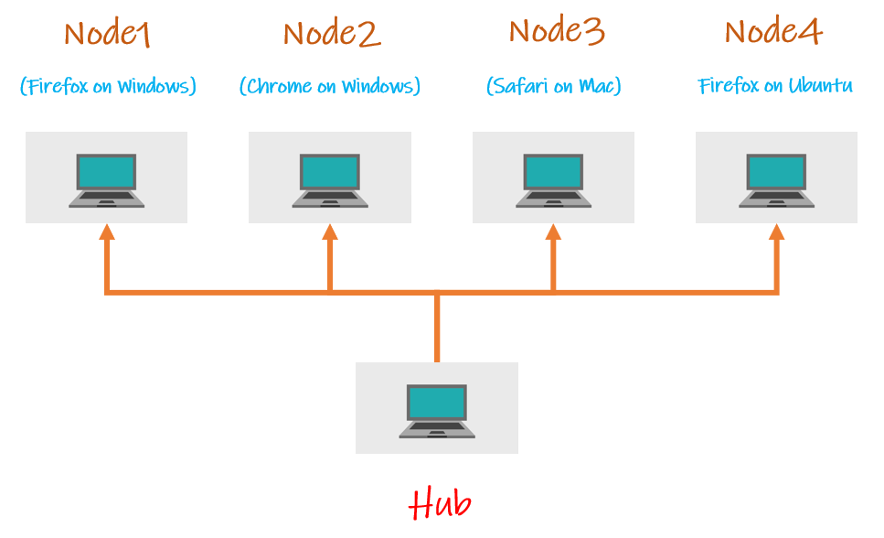

Hub:

* A hub is the central point where you load your tests into.
* There should be only one hub in a grid
* The hub will allocate the test cases based on the conditions mentioned and the automation will be done on the nodes.

Node:

* Nodes are the machines that you have allocated to the hub and the tests will be performed on the nodes.
* There can be one or more nodes in the grid.
* Nodes can be launched on multiple machines with different machines with different platforms and browsers.
* The machines running the nodes need not be the same platform as that of the hub.

# **43A. Selenium - Selenium Grid - Setting up Environment for Selenium Grid**

**Setting up the environment for Selenium Grid:**

In this example, I am going to show you how to work with selenium Grid using Virtual box. I will be using my laptop as hub, and the instances I create on VM Box as nodes. The following picture shows you what I am doing.

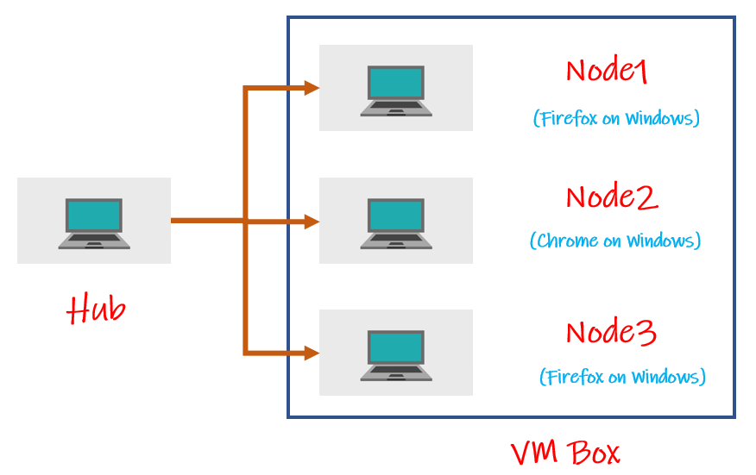

I am going to create a VM Box with three instances. I am going use my laptop as hub and use the three instances as nodes.

**Setting up VMBox and network for Selenium Grid:**

Download VMBox and install windows as one instance on VMBox. Go to google and search VMBox Download or you can download it from the following link.

<https://www.virtualbox.org/wiki/Downloads>

You also need to have ISO files of the platform you want to install on VMBox. Since I want to install windows instance on the virtual machine, download Windows ISO file. (I downloaded windows 10 ISO file).

You also need to have windows key while you are installing the instance on VMBox. You can use your own key for that.

Now open VMBox and click on “New” at the top.

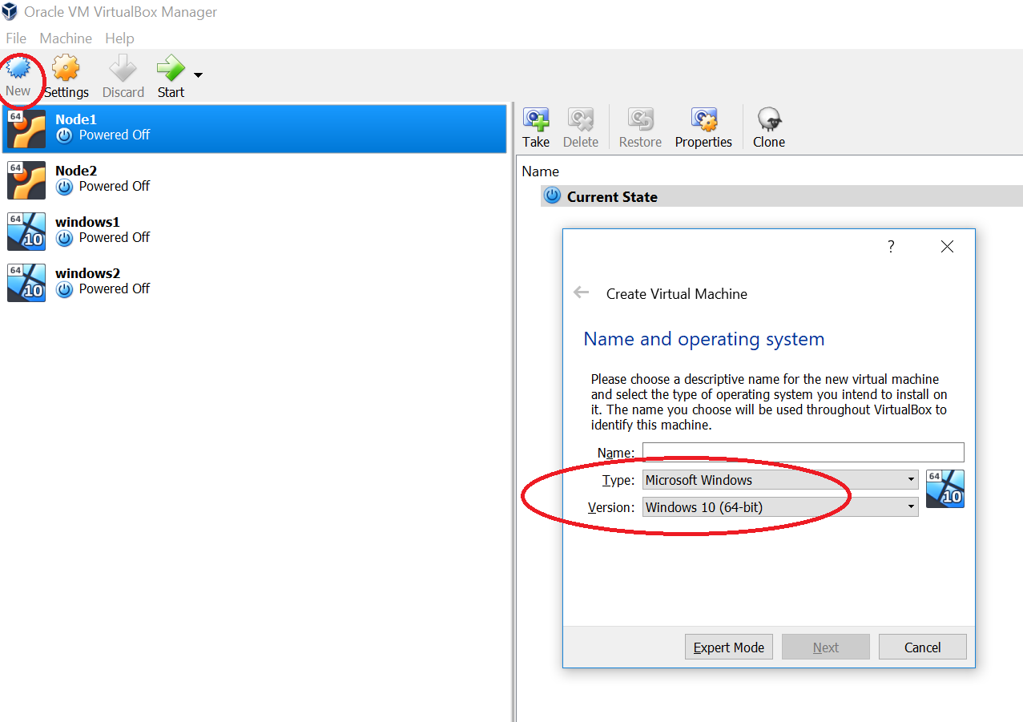

Select the operating system as Windows and select the version of the platform you want to install. Since I downloaded windows 10 ISO file and sicne my system is 64 bit I selected as “Windows 10 (64 bit)”. Give a name to the instance. I gave it as Windows3.

Now allocated RAM memory for this. I have allocated around 3GB.

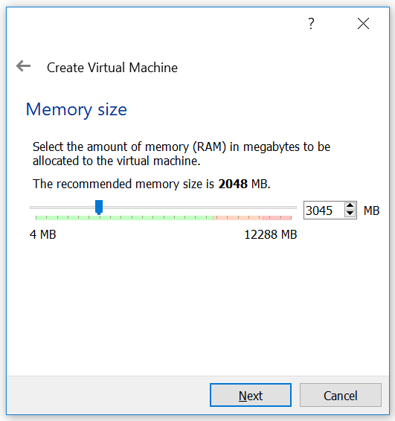

Select “Create Virtual Hard Disk now” and click on “Create”.

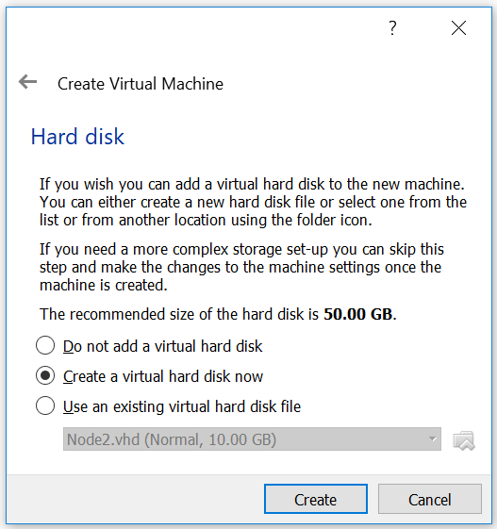

Now select VDI(Virtual Box Disk Image) and click “Next”

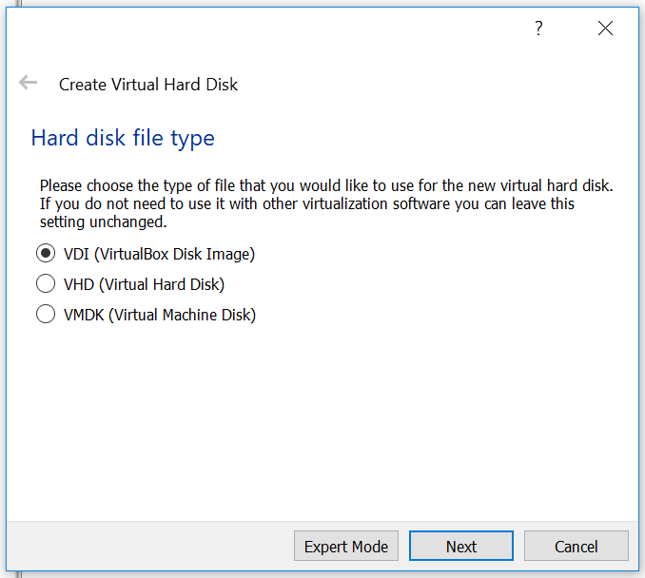

Now leave the default images as they are and click on “Create”.

It will create an instance. Now we have to install windows on it.

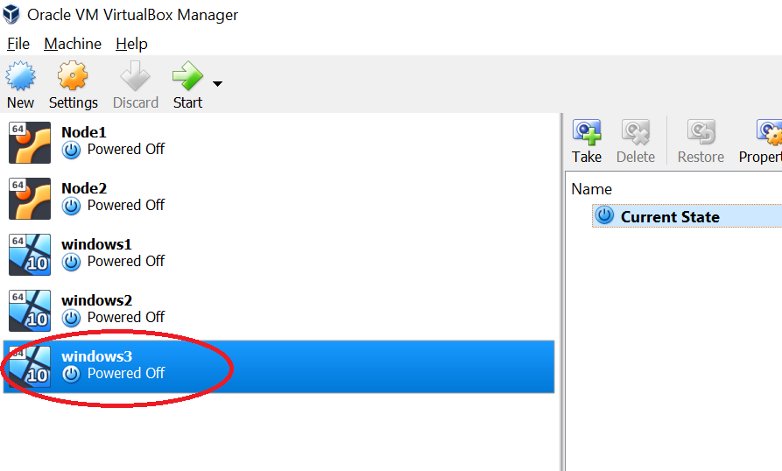

For installing windows on the machine, select the new instance you have created and click on settings and go to storage. Clcik on the CD symbol there and select the ISO file you have.

Now click ok.

Now click on start and it will open the system and go through the steps and install windows on it.

Once everything is completed, you should be able to see the windows machine started.

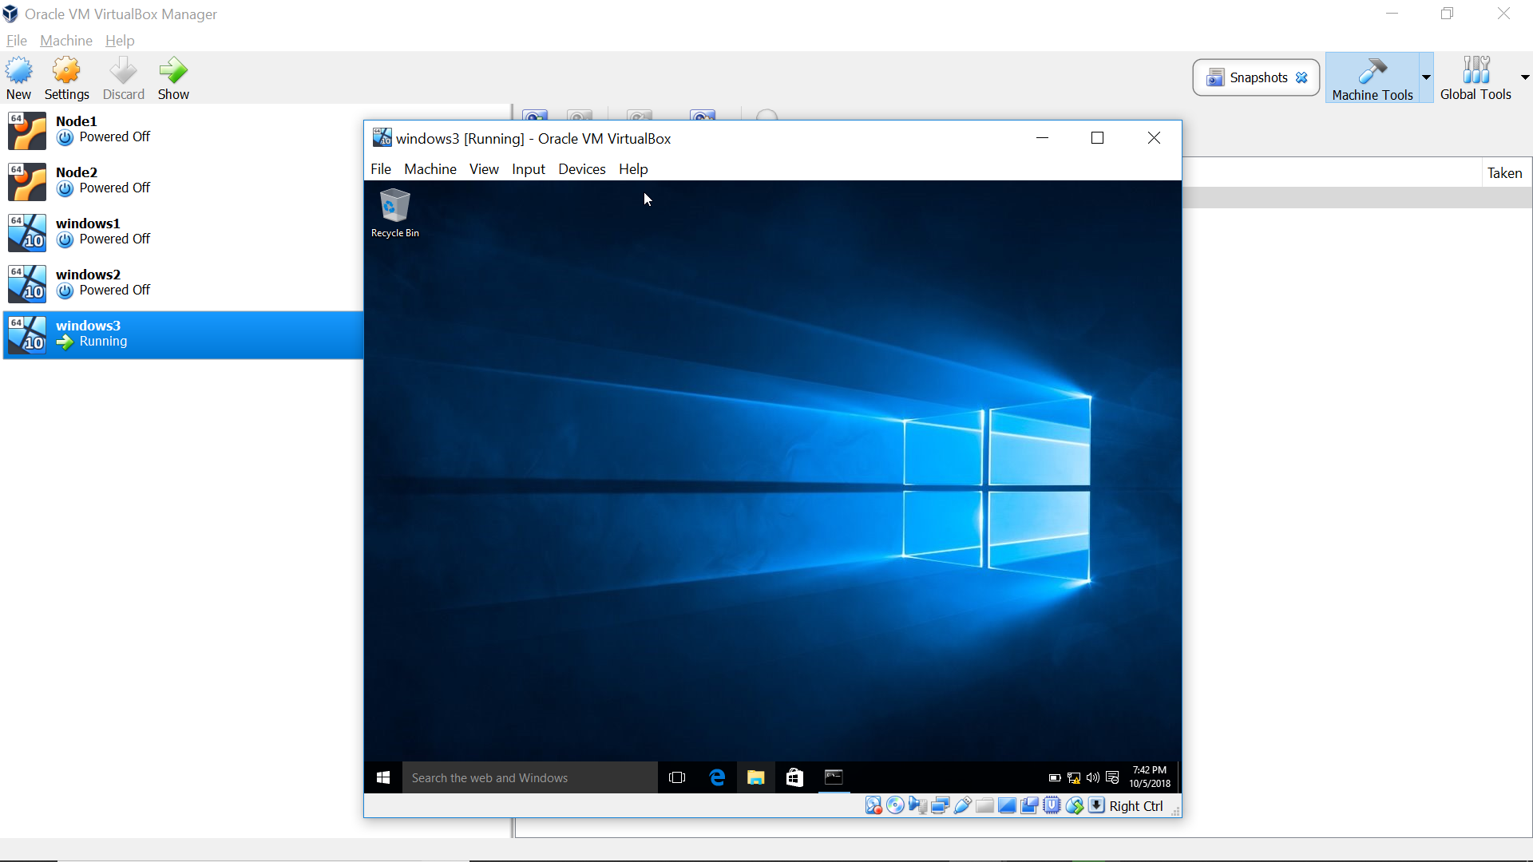

Now go to command prompt and type “ipconfig”. You will see IP address like 10.0.2.15.

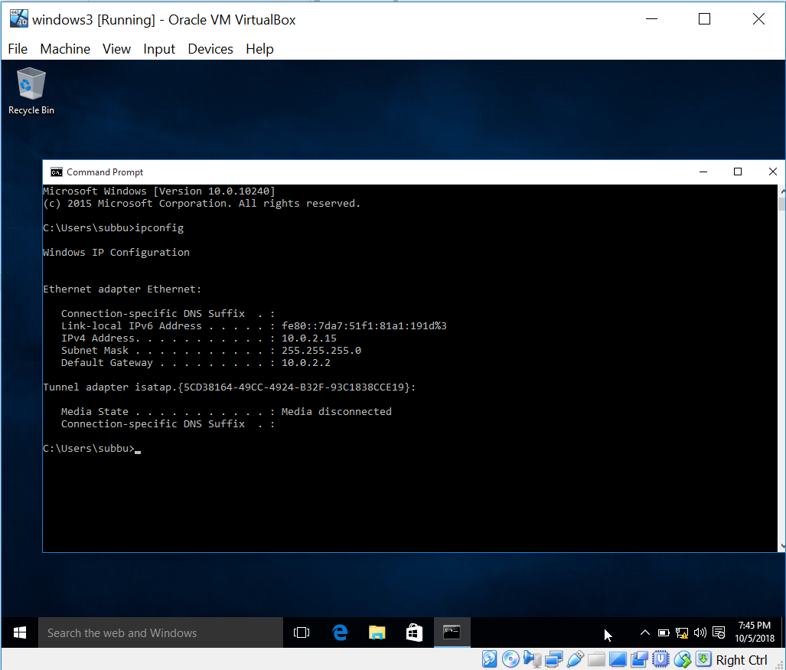

This is the IP address provided by NAT which is the default adapter. This won’t work for connecting from our local machine to the VMBox instance. We need to add another adapter which Host Only adapter.

So, power off the instance and on the VMBox go to settings for the instance and go to Network. Here you will see that the default adapter is “NAT”. Go to “Adapter 2” and enable it and add “Host Only Adapter”.

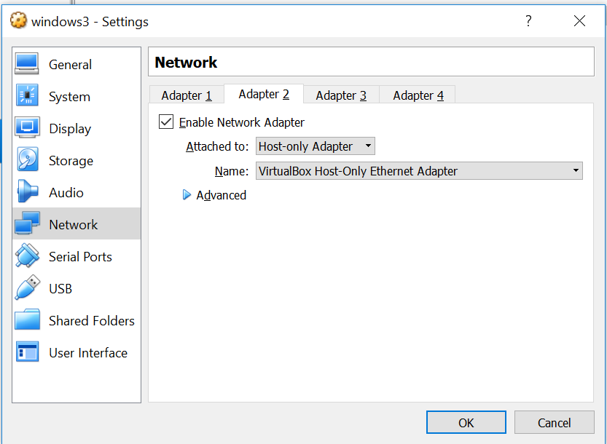

Click ok and start the windows machine you created.

Now if you check the IPAddress in command prompt you will see two IP addresses. One is the NAT address and the other is the Host-Only Adapter address. The Host-Only adapter IP address which looks like 192.168.56.102 will be used for connection between Hub and Node.

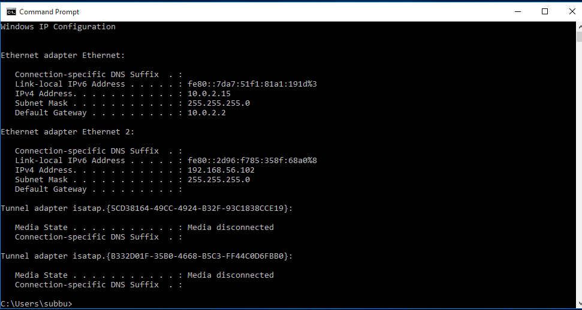

Like this set up a few instances.

On each of the instances

1. Install Jdk on these instances and set the paths
2. download the browsers(firefox) you need and install them
3. download the selenium stand alone server
4. download the driver.exe files for the browsers (Edge: MicrosoftWebDriver.exe, Firefox: geckodriver.exe, Chrome: Chrome.exe)
5. Disable windows firewall (Ping for node to hub and hub to node and see if they are working, if not disable firewall)

Place the driver.exe files and the selenium stand alone server in the same folder.

So, now your system is ready to setup selenium Grid.

# **43B. Selenium - Selenium Grid - Selenium Grid with One System**

Now on the hub open command prompt and go to the folder where selenium stand alone jar file is there and run the command

java -jar selenium-server-standalone-3.13.0.jar -role hub

Once the command is run, it shows that “Selenium Grid Hub is up and running” and it should show where Nodes and clients should be connected.

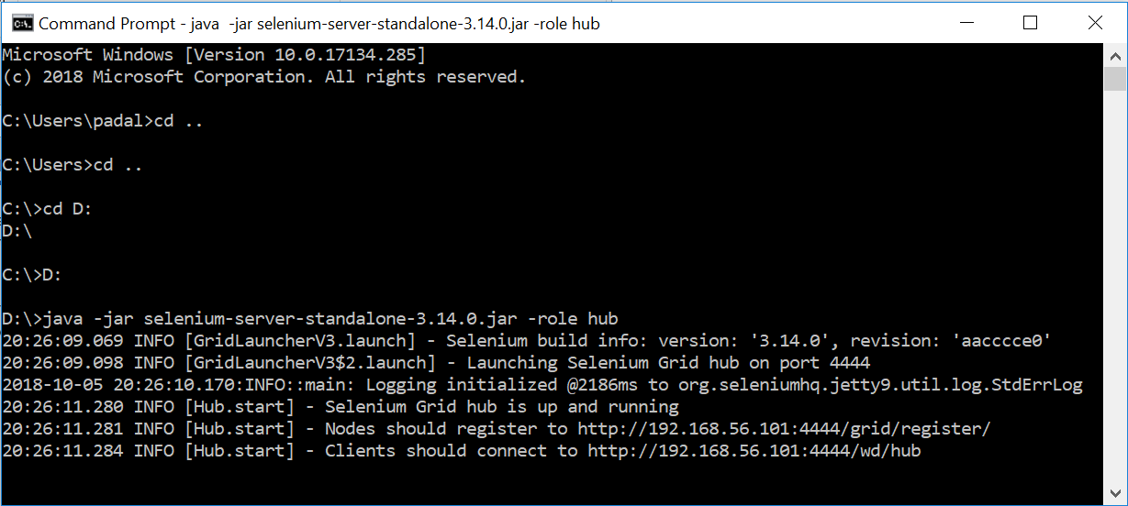

When we start the nodes we use the url mentioned in the statement “Nodes should register to ….” and in the actual program when we set tup the WebDriver we use the url mentioned in the statement “Clients should connect to ….”.

Now go to the node and run the following command.

java -Dwebdriver.gecko.driver=”C:\Users\subbu\selenium\geckodriver.exe” -jar selenium-server-standalone-3.14.0.jar -role webdriver -hub [http://192.168.56.101:4444/grid/register -port 5566](http://192.168.56.101:4444/grid/register%20-port%205566) -host Host-Only adapter ip address

Replace the paths like the driver files paths, server jar files extensions etc. with your paths and versions.

If you run the above command on the VMBox machine instance, it should show that it is connected to the hub and ready to use.

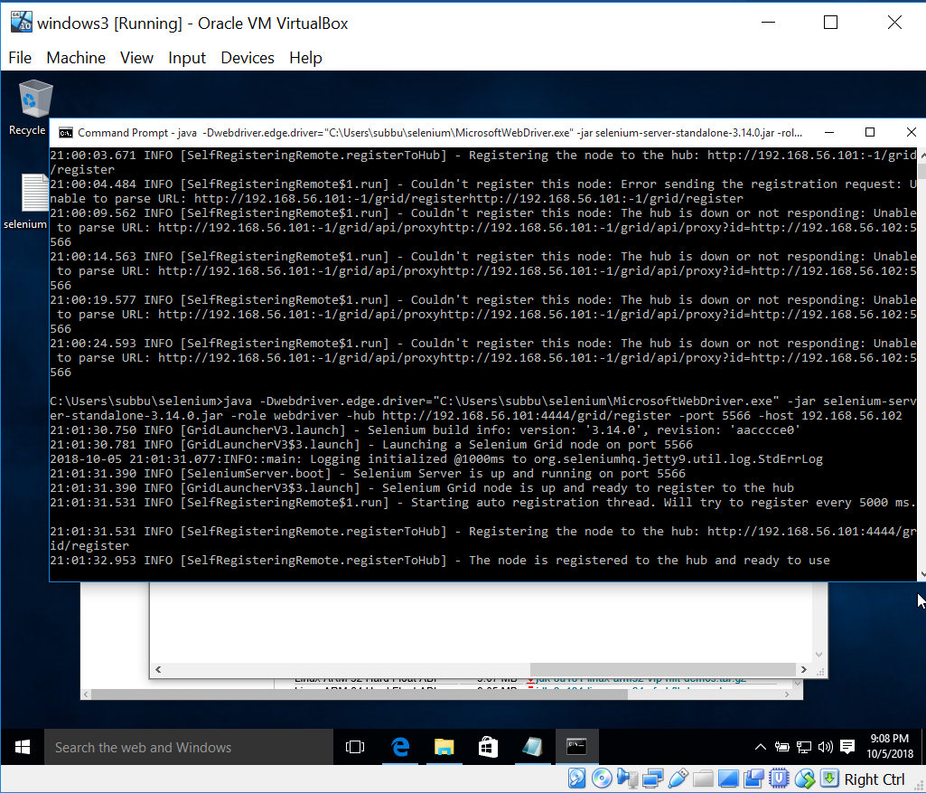

The following url should show all the systems that are connected to the hub. On the hub machine also it should show that a node is registered.

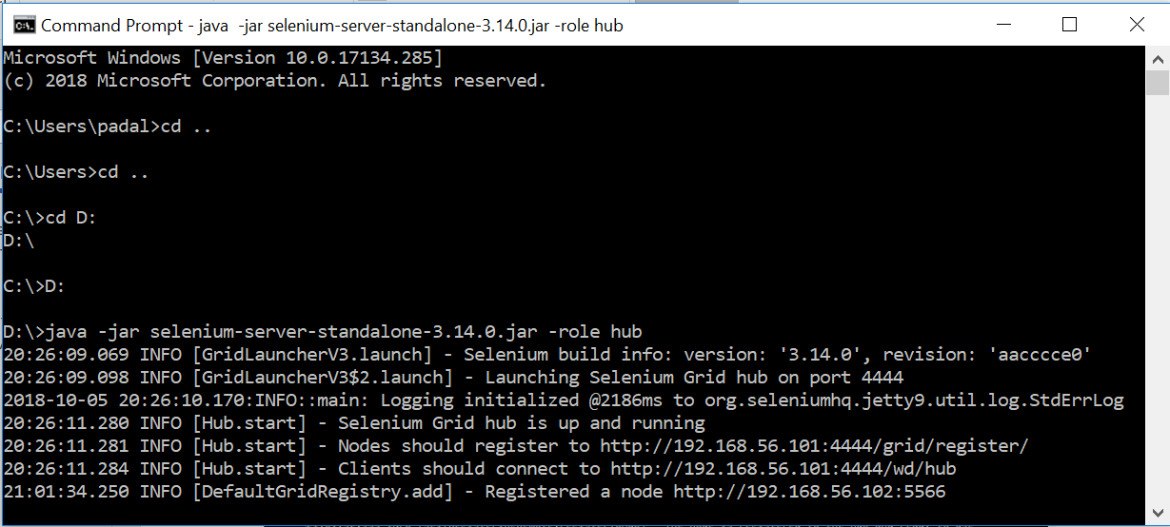

Now if you go to the console, it should show all the browsers registered to the hub. Go to the url “<http://192.168.56.101:4444/grid/console>” and you will see the nodes registered.

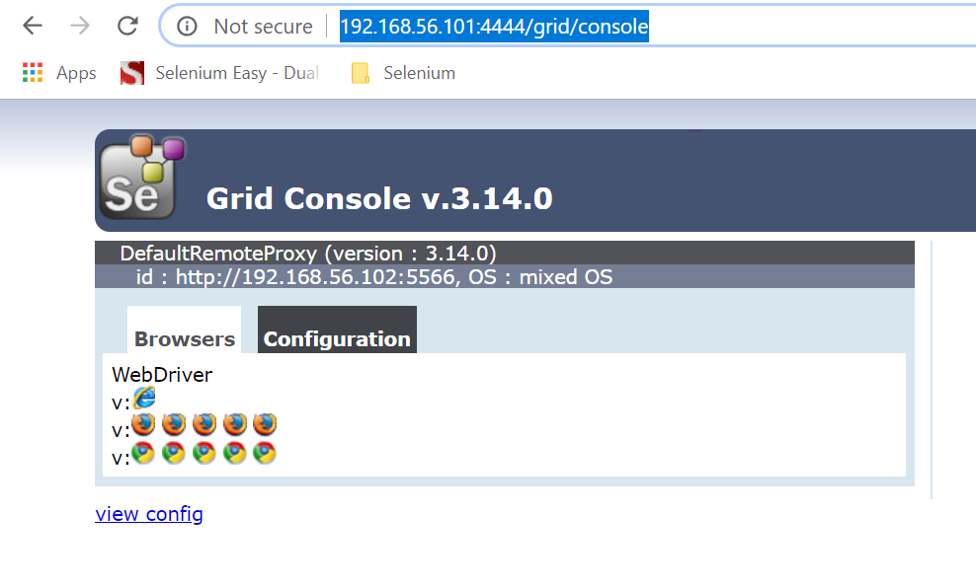

It should show the text “DefaultRemoteProxy (Version of the selenium server) and the id of the node (ip address). If it does not show then it won’t work.

Now write two scripts as follows.

Script1:

**package** SeleniumGridExamples;

**import** java.net.MalformedURLException;

**import** java.net.URL;

**import** org.openqa.selenium.Platform;

**import** org.openqa.selenium.WebDriver;

**import** org.openqa.selenium.remote.DesiredCapabilities;

**import** org.openqa.selenium.remote.RemoteWebDriver;

**import** org.testng.annotations.Test;

**public** **class** SLCase1 {

@Test

**public** **static** **void** test1() **throws** MalformedURLException, InterruptedException {

// **TODO** Auto-generated method stub

DesiredCapabilities dc = **new** DesiredCapabilities();

dc.setBrowserName("firefox");

dc.setPlatform(Platform.***WINDOWS***);

System.***out***.println("desired cap. done case1");

WebDriver driver = **new** RemoteWebDriver(**new** URL("http://192.168.56.101:4444/wd/hub"), dc);

driver.get("http://www.eenadu.net");

Thread.*sleep*(5000);

driver.quit();

}

}

Script2:

**package** SeleniumGridExamples;

**import** java.net.MalformedURLException;

**import** java.net.URL;

**import** org.openqa.selenium.Platform;

**import** org.openqa.selenium.WebDriver;

**import** org.openqa.selenium.remote.DesiredCapabilities;

**import** org.openqa.selenium.remote.RemoteWebDriver;

**import** org.testng.annotations.Test;

**public** **class** SLCase2 {

@Test

**public** **static** **void** test2() **throws** MalformedURLException, InterruptedException {

// **TODO** Auto-generated method stub

DesiredCapabilities dc = **new** DesiredCapabilities();

dc.setBrowserName("firefox");

dc.setPlatform(Platform.***WINDOWS***);

System.***out***.println("desired cap. done case2");

WebDriver driver = **new** RemoteWebDriver(**new** URL("http://192.168.56.101:4444/wd/hub"), dc);

driver.get("http://www.sakshi.com");

Thread.*sleep*(5000);

driver.quit();

}

}

**Desired Capabilities:**

When we run the scripts on selenium grid we need to set the desired capabilities. Desired capabilities set the browser we want, platform we want.

Here the WebDriver line we use is

WebDriver driver = **new** RemoteWebDriver(**new** URL("http://192.168.56.101:4444/wd/hub"), dc);

We set the url that we see in the hub’s command prompt “Clients should connect to <http://192.168.56.101:4444/wd/hub>”. We also pass the DesiredCapabilities object to this method.

Now conver the above two test cases into TestNG in eclipse. (Right on the package and convert them).

TestNG XML:

<?xml version=*"1.0"* encoding=*"UTF-8"*?>

<!DOCTYPE suite SYSTEM "http://testng.org/testng-1.0.dtd">

<suite name=*"Suite"*>

<test thread-count=*"5"* name=*"Test"*>

<classes>

<class name=*"SeleniumGridExamples.SLCase2"*/>

<class name=*"SeleniumGridExamples.SLCase1"*/>

</classes>

</test> <!-- Test -->

</suite> <!-- Suite -->

Now the TestNG xml and you should be able to see that the tests are running on the node.

# **43C. Selenium - Selenium Grid - Selnium Grid with three nodes (Firefox, Chrome and Opera)**

# **44. Selenium - Selenium Grid Interview Questions**

**Selenium Grid Interview Questions**

**What is selenium Grid?**

Selenium Grid is used to run your automation tests on multiple platforms and browsers simultaneously.

**When to use Selenium Grid?**

Save time on execution: As mentioned above, if there are a number of test cases you have to execute and if you want to reduce the time of execution, you can use selenium Grid.

If you want to perform your testing on multiple platforms and multiple browsers, you can use selenium.

**Can you explain the architecture of Selenium Grid?**

Selenium Grid contains a hub and different nodes.

Hub:

* A hub is the central point where you load your tests into.
* There should be only one hub in a grid
* The hub will allocate the test cases based on the conditions mentioned and the automation will be done on the nodes.

Node:

* Nodes are the machines that you have allocated to the hub and the tests will be performed on the nodes.
* There can be one or more nodes in the grid.
* Nodes can be launched on multiple machines with different machines with different platforms and browsers.
* The machines running the nodes need not be the same platform as that of the hub.

**What are the advantages of Selenium Grid?**

It allows running test cases in parallel thereby saving test execution time.

It allows multi-browser testing

It allows us to execute test cases on multi-platform

**What is a hub in Selenium Grid?**

A hub is a server or a central point that controls the test executions on different machines.

**What is a node in Selenium Grid?**

Node is the machine which is attached to the hub. There can be multiple nodes in Selenium Grid.

**Explain how selenium Grid works?**

First Selenium Grid sent the tests to the hub and these tests will get redirected to Selenium Webdriver, which launch the browser and run the test. With entire test suite, it will run tests in parallel.

**How to run tests in multiple browsers in parallel? Is there any other option other than selenium grid?**

*public class BrowserLaunch {*  
*WebDriver driver=null;*

*// Pass parameter browser from testng.xml*  
*@Parameters(“browser”)*

*public void initiateBrowser(String browser){*

*// compare browser  information and then open respective browser*  
*if(browser.equals(“Firefox”))*  
*{*

*driver = new FirefoxDriver();*  
*}*

*else if*  
*{*

*\\set path to the IE driver*

*System.setProperty(“webdriver.ie.driver”, “\iexploredriver.exe”);*  
*driver =new InternetExplorerDriver();*  
*}*

*else*  
*{*

*\\set path to the  Chrome driver*

*System.setProperty(“webdriver.chrome.driver”, “\chromedriver.exe”);*  
*driver =new ChromeDriver();*  
*}*  
*}*

*//Now create ClassName class and call extend the above class*

*@Test*  
*public class ClassName extends BrowserLaunch{*

*public void Gmail(){*

*driver.get(“http://www.gmail.com”);*  
*}*  
*}*

**What is the component in Selenium-Grid which routes the selenese requests from the Test in Selenium-Grid?**

Selenium hub is the component in Selenium-Grid which routes the selenese requests from the Test.

**What is the default maximum number of browsers that can run in parallel on the node?**

Five is the default value assigned to a maximum number of browsers that can run in parallel on the node.

**What is the default port number assigned by the hub?**

4444 is the default port used by the hub.

**What is the primary purpose of Selenium-Grid?**

The primary purpose of Selenium-Grid is parallel Test Execution.

**How many hubs does selenium-grid have?**

The selenium-grid has only one hub which is the master of the network.

**How do I specify an environment while starting grid slave machine?**

We can specify an environment using “-Denvironment” while starting selenium grid slave machine.

Ex:

java -Dwebdriver.gecko.driver=”C:\Users\subbu\selenium\geckodriver.exe” -jar selenium-server-standalone-3.14.0.jar -role webdriver -hub [http://192.168.56.101:4444/grid/register -port 5566](http://192.168.56.101:4444/grid/register%20-port%205566) -host Host-Only adapter ip address

**How do you start a hub in Selenium Grid?**

By running the following command from command-line we can start hub in Selenium-Grid

*java -jar selenium-server-standalone-xxxx.jar -role hub*

**How do you start node in Selenium Grid?**

By running the following command from command-line we can start node in Selenium-Grid by using default parameters

*java -jar selenium-server-standalone-xxxx.jar -role webdriver  -hub http://localhost:4444/grid/register*

**How can we run test scripts on the Selenium-Grid?**

By using Desired capabilities and the RemoteWebDriver objects we can run test scripts on the Grid.

**How can we specify the browser and OS information in selenium-grid?**

DesiredCapabilities is used to set the browser type and the OS of our Node.

DesiredCapabilities capabilities = DesiredCapabilities.chrome();

capabilities.setBrowserName(“chrome”);

capabilities.setPlatform(Platform.WINDOWS);

**How the RemoteWebDriver object used in selenium-grid?**

RemoteWebDriver is used to select the Node on which we want to run our tests on a different machine.

How to configure hub in selenium grid?

Download Selenium Server Standalone jar file

Launch the command prompt and navigate to the location where we placed the Selenium server jar file.

Type the command at command prompt, java -jar selenium-server-standalone-xxx.jar -role hub

Open the browser and navigate to http://localhost:4444, to verify whether the hub is running or not.

**How to configure a node in selenium-grid?**

Download Selenium Server on all our node machines.

Go to Command Prompt and type IPCONFIG to find out the IP Address. Ex:http://192.168.1.164:4444

Open Command Prompt to register hub machine with Node Machine, type

java -jar selenium-server-standalone-3.3.1.jar -role node-hub

http://192.168.1.164:4444/grid/register-port 5555

After executing the command to return to the Hub and navigate the URL http://localhost:4444 or http://192.168.1.164:4444

# **45. Selenium - Reading Data from Excel - Apache POI API - Introduction and Basic Program**

Apache POI API – We use apache POI API for excel data driven testing

Apache POI is a Java API for Microsoft documents. Using this API we can access excel documents, read data from them and write data to them.

Download Apache poi:

Go to google and search “Apache poi download” and download the zip folder and unzip it.

Note: If you use maven to run the tests, you don’t need to download anything. Just add the following maven dependencies and it will download everything.

poi-ooxml and poi

Now configure the build path and add the all the jar files downloaded.

Right click on the project, go to build path and configure build path and go to libraries and click on add external jars and add the above two files.

**Using Maven:**

If you want to use maven to download the resources, you need the above two dependencies for reading and writing.

<dependency>

<groupId>org.apache.poi</groupId>

<artifactId>poi</artifactId>

<version>4.1.1</version>

</dependency>

<dependency>

<groupId>org.apache.poi</groupId>

<artifactId>poi-ooxml</artifactId>

<version>4.1.1</version>

</dependency>

Now create a separate folder under the project with name “data” and store the excel file you have created.

Steps:

* Create object for XSSFWorkbook class
* Get access to sheet
* Get access to all rows of sheet
* Access to specific row from all rows
* Get access to all cells of Row
* Access the data from cells into Arrays

**Sample:**

Data Sheet:

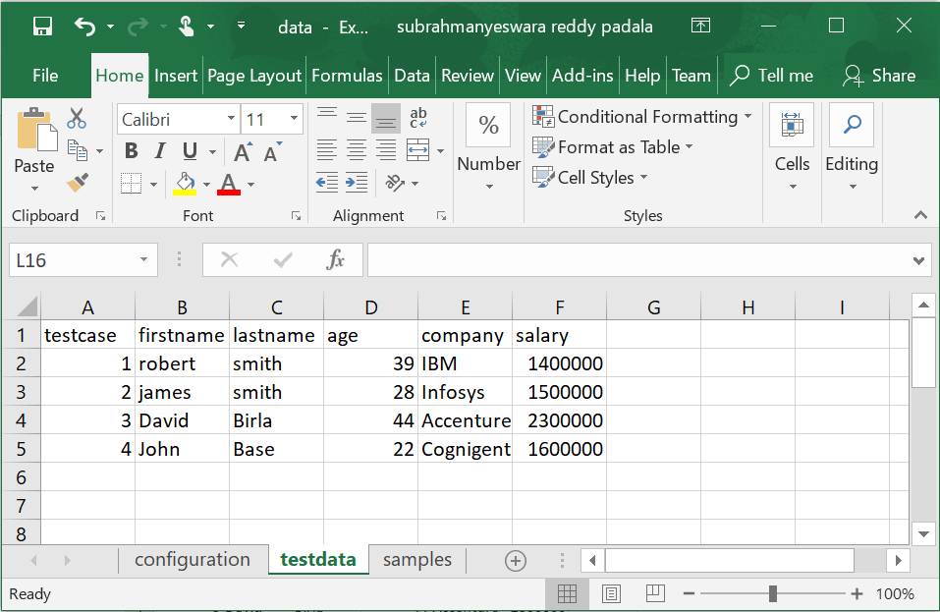

How do you read data from an excel cell?

* First we have to create an input stream object using FileInputStream
* Then create an object for XSSFWorkbook by passing the input stream object
* Now create an object for XSSFSheet using the above workbook object and using getSheet() method by passing the sheet name as argument or getSheetAt() method by passing the sheet index.
* Create an object for Row using the Sheet object created and using the method getRow() by passing the row number.
* Now create an object for Cell by using the Row object and method getCell() by passing the cell number.
* Now we can use the Cell object method getStringValue() to get string value if the cell contains text.
* If the cell contains numeric value then use the method getNumericValue().

**package** ExcelTesting;

**import** java.io.FileInputStream;

**import** java.io.FileNotFoundException;

**import** java.io.IOException;

**import** java.util.Iterator;

**import** org.apache.poi.ss.usermodel.Cell;

**import** org.apache.poi.ss.usermodel.Row;

**import** org.apache.poi.xssf.usermodel.XSSFSheet;

**import** org.apache.poi.xssf.usermodel.XSSFWorkbook;

**public** **class** ExcelReadingBasic {

**public** **static** **void** main(String[] args) **throws** IOException {

//Get access to the workbook

FileInputStream fis = **new** FileInputStream("./data/data.xlsx");

XSSFWorkbook workbook = **new** XSSFWorkbook(fis);

//Get the sheet you want

XSSFSheet sheet = workbook.getSheet("testdata");

//Get a row number

Row row = sheet.getRow(1);

//Get a cell number

Cell cell = row.getCell(1);

//Get that cell value

System.***out***.println(cell.getStringCellValue());

workbook.close();

}

}

# **Reading number from a Cell Using DataFormater – First Way**

If a cell contains a numeric text then reading the cell using cell.getStringCellValue() returns an error. We can use DataFormatter() to get the cell value in the form of string.

//Get that cell value

DataFormatter df = **new** DataFormatter();

String cellvalue = df.formatCellValue(cell);

**Example:**

**package** exceldatadriven;

**import** java.io.FileInputStream;

**import** java.io.IOException;

**import** org.apache.poi.ss.usermodel.Cell;

**import** org.apache.poi.ss.usermodel.DataFormatter;

**import** org.apache.poi.ss.usermodel.Row;

**import** org.apache.poi.xssf.usermodel.XSSFSheet;

**import** org.apache.poi.xssf.usermodel.XSSFWorkbook;

**public** **class** Pr2ReadSingleCellValueNumToStringFirstWay {

**public** **static** **void** main(String[] args) **throws** IOException {

FileInputStream fis = **new** FileInputStream("data/testdata.xlsx");

//Create xssfworkbook object

XSSFWorkbook workbook = **new** XSSFWorkbook(fis);

//Get the sheet you want

XSSFSheet sheet = workbook.getSheet("Sheet1");

//Get a row number

Row row = sheet.getRow(1);

//Get a cell number

Cell cell = row.getCell(3);

//Get that cell value

DataFormatter df = **new** DataFormatter();

String cellvalue = df.formatCellValue(cell);

System.***out***.println(cellvalue);

workbook.close();

}

}

# **Reading number from a Cell Using NumberToTextConverter – Second Way**

If we have a number in a cell then use cell.getNumericText() to get the number and then pass it to NumberToTextConverter.ToText() which will convert it to a string.

NumberToTextConverter.*toText*(cell.getNumericCellValue();

**Example:**

**package** exceldatadriven;

**import** java.io.FileInputStream;

**import** java.io.IOException;

**import** org.apache.poi.ss.usermodel.Cell;

**import** org.apache.poi.ss.usermodel.CellType;

**import** org.apache.poi.ss.usermodel.Row;

**import** org.apache.poi.ss.util.NumberToTextConverter;

**import** org.apache.poi.xssf.usermodel.XSSFSheet;

**import** org.apache.poi.xssf.usermodel.XSSFWorkbook;

**public** **class** Pr3ReadSingleCellValueNumToStringSecondWay {

**public** **static** **void** main(String[] args) **throws** IOException {

FileInputStream fis = **new** FileInputStream("data/testdata.xlsx");

//Create xssfworkbook object

XSSFWorkbook workbook = **new** XSSFWorkbook(fis);

//Get the sheet you want

XSSFSheet sheet = workbook.getSheet("Sheet1");

//Get a row number

Row row = sheet.getRow(1);

//Get a cell number

Cell cell = row.getCell(3);

//Get that cell value

**if**(cell.getCellType() == CellType.***STRING***) {

System.***out***.println(cell.getStringCellValue());

}

**else** {

System.***out***.println(NumberToTextConverter.*toText*(cell.getNumericCellValue()));

}

workbook.close();

}

}

# **Reading Data from An Entire Row**

row.iterator() method provides an iterator<Cell> and we can iterate over it using hasNext() and next() methods and get all the cell values in that row.

How do you read data from a row in an excel sheet?

* First we have to create an input stream object using FileInputStream

FileInputStream fis = **new** FileInputStream("data/testdata.xlsx");

* Then create an object for XSSFWorkbook by passing the input stream object

XSSFWorkbook workbook = **new** XSSFWorkbook(fis);

* Now create an object for XSSFSheet using the above workbook object and using getSheet() method by passing the sheet name as argument or getSheetAt() method by passing the sheet index.

XSSFSheet sheet = workbook.getSheet("Sheet1");

* Create an object for Row using the Sheet object created and using the method getRow() by passing the row number.

Row row = sheet.getRow(1);

* Now create an iterator for the row which will return an iterator<Cell> and we iterate over the cells using hasNext() and next() methods and we will get access to each cell in that row.
* Now we can use DataFormatter and get the values of the cell as String.

Iterator<Cell> it = row.iterator();

**while**(it.hasNext())

{

//Get the Cell

Cell cell = it.next();

DataFormatter df = **new** DataFormatter();

String cellvalue = df.formatCellValue(cell);

System.***out***.println(cellvalue);

}

**package** exceldatadriven;

**import** java.io.FileInputStream;

**import** java.io.IOException;

**import** java.util.Iterator;

**import** org.apache.poi.ss.usermodel.Cell;

**import** org.apache.poi.ss.usermodel.DataFormatter;

**import** org.apache.poi.ss.usermodel.Row;

**import** org.apache.poi.xssf.usermodel.XSSFSheet;

**import** org.apache.poi.xssf.usermodel.XSSFWorkbook;

**public** **class** Pr4ReadEntireRow {

**public** **static** **void** main(String[] args) **throws** IOException {

FileInputStream fis = **new** FileInputStream("data/testdata.xlsx");

//Create xssfworkbook object

XSSFWorkbook workbook = **new** XSSFWorkbook(fis);

//Get the sheet you want

XSSFSheet sheet = workbook.getSheet("Sheet1");

//Get a row number

Row row = sheet.getRow(1);

Iterator<Cell> it = row.iterator();

**while**(it.hasNext())

{

//Get the Cell

Cell cell = it.next();

DataFormatter df = **new** DataFormatter();

String cellvalue = df.formatCellValue(cell);

System.***out***.println(cellvalue);

}

workbook.close();

}

}

# **45A. Selenium - Reading Data from Excel - Apache POI API - Reading All Data**

row.iterator() method provides an iterator<Cell> and we can iterate over it using hasNext() and next() methods and get all the cell values in that row.

How do you read data from a row in an excel sheet?

* First we have to create an input stream object using FileInputStream

FileInputStream fis = **new** FileInputStream("data/testdata.xlsx");

* Then create an object for XSSFWorkbook by passing the input stream object

XSSFWorkbook workbook = **new** XSSFWorkbook(fis);

* Now create an object for XSSFSheet using the above workbook object and using getSheet() method by passing the sheet name as argument or getSheetAt() method by passing the sheet index.

XSSFSheet sheet = workbook.getSheet("Sheet1");

* Create an iterator for the Row using the Sheet object created and we iterate over the row using hasNext() and next() methods and we will get access to each row in the sheet

//Get all the rows

Iterator<Row> rows = sheet.iterator();

**while**(rows.hasNext()) {

Row rowno = rows.next();

* Now create an iterator for the row which will return an iterator<Cell> and we iterate over the cells using hasNext() and next() methods and we will get access to each cell in that row.
* Now we can use DataFormatter and get the values of the cell as String.

Iterator<Cell> it = row.iterator();

**while**(it.hasNext())

{

//Get the Cell

Cell cell = it.next();

DataFormatter df = **new** DataFormatter();

String cellvalue = df.formatCellValue(cell);

System.***out***.println(cellvalue);

}

**package** ExcelTesting;

**import** java.io.FileInputStream;

**import** java.io.IOException;

**import** java.util.Iterator;

**import** org.apache.poi.ss.usermodel.Cell;

**import** org.apache.poi.ss.usermodel.CellType;

**import** org.apache.poi.ss.usermodel.Row;

**import** org.apache.poi.ss.util.NumberToTextConverter;

**import** org.apache.poi.xssf.usermodel.XSSFSheet;

**import** org.apache.poi.xssf.usermodel.XSSFWorkbook;

**public** **class** ExcelReading {

**public** **static** **void** main(String[] args) **throws** IOException {

//Get access to the workbook

FileInputStream fis = **new** FileInputStream("./data/data.xlsx");

XSSFWorkbook workbook = **new** XSSFWorkbook(fis);

//Get the sheet you want

XSSFSheet sheet = workbook.getSheet("testdata");

//Get all the rows

Iterator<Row> rows = sheet.iterator();

**while**(rows.hasNext()) {

Row rowno = rows.next();

//System.out.println(rowno.getRowNum());

//System.out.println(rowno.getPhysicalNumberOfCells());

//System.out.println(rowno.getLastCellNum());

Iterator<Cell> cells = rowno.iterator();

**int** i = 0;

**if**(rowno.getRowNum() > 0) {

**while**(cells.hasNext()) {

i++;

Cell value = cells.next();

String cellvalue;

//System.out.println("i value is "+i);

//System.out.println("Total cells are "+rowno.getPhysicalNumberOfCells());

**if**(value.getCellTypeEnum()==CellType.***STRING***)

{

cellvalue = value.getStringCellValue();

}

**else**

{

cellvalue = NumberToTextConverter.*toText*(value.getNumericCellValue());

}

**if**(i == rowno.getPhysicalNumberOfCells()) {

System.***out***.println(cellvalue);

}

**else** {

System.***out***.print(cellvalue+" ");

}

}

}

}

workbook.close();

}

}

# **45B. Selenium - Reading Data from Excel - Creating a seperate class and calling it**

**Class which will be called:**

**package** ExcelTesting;

**import** java.io.FileInputStream;

**import** java.io.IOException;

**import** java.util.ArrayList;

**import** java.util.HashMap;

**import** java.util.Iterator;

**import** java.util.List;

**import** java.util.Map;

**import** org.apache.poi.ss.usermodel.Cell;

**import** org.apache.poi.ss.usermodel.CellType;

**import** org.apache.poi.ss.usermodel.Row;

**import** org.apache.poi.ss.util.NumberToTextConverter;

**import** org.apache.poi.xssf.usermodel.XSSFSheet;

**import** org.apache.poi.xssf.usermodel.XSSFWorkbook;

**public** **class** ExcelReadingMaps {

**public** Map<String,List<String>> getData(String path, String sheetname) **throws** IOException {

Map<String, List<String>> mp = **new** HashMap<String, List<String>>();

//Get access to the workbook

//FileInputStream fis = new FileInputStream("./data/data.xlsx");

FileInputStream fis = **new** FileInputStream(path);

XSSFWorkbook workbook = **new** XSSFWorkbook(fis);

//Get the sheet you want

//XSSFSheet sheet = workbook.getSheet("testdata");

XSSFSheet sheet = workbook.getSheet(sheetname);

//Get all the rows

Iterator<Row> rows = sheet.iterator();

**while**(rows.hasNext()) {

String testcase = "";

List<String> ls = **new** ArrayList<String>();

Row rowno = rows.next();

//System.out.println(rowno.getRowNum());

//System.out.println(rowno.getPhysicalNumberOfCells());

//System.out.println(rowno.getLastCellNum());

Iterator<Cell> cells = rowno.iterator();

**int** i = 0;

**if**(rowno.getRowNum() > 0) {

**while**(cells.hasNext()) {

i++;

Cell value = cells.next();

String cellvalue;

//System.out.println("i value is "+i);

//System.out.println("Total cells are "+rowno.getPhysicalNumberOfCells());

**if**(value.getCellTypeEnum()==CellType.***STRING***)

{

cellvalue = value.getStringCellValue();

}

**else**

{

cellvalue = NumberToTextConverter.*toText*(value.getNumericCellValue());

}

**if**(i == 1) {

testcase = cellvalue;

}

**else** {

ls.add(cellvalue);

}

}

mp.put(testcase, ls);

}

}

workbook.close();

//System.out.println(mp);

**return**(mp);

}

}

Class that calls the above class:

**package** ExcelTesting;

**import** java.io.IOException;

**import** java.util.List;

**import** java.util.Map;

**import** java.util.Map.Entry;

**public** **class** ReadMaps {

**public** **static** **void** main(String[] args) **throws** IOException {

String path = "./data/data.xlsx";

String sheetname = "testdata";

ExcelReadingMaps erm = **new** ExcelReadingMaps();

Map<String, List<String>> mp = erm.getData(path, sheetname);

**int** notestcases = mp.size();

//System.out.println(notestcases);

**for**(**int** i=0; i<notestcases; i++) {

**for**(Entry<String, List<String>> mp1: mp.entrySet()) {

String testcase = mp1.getKey();

System.***out***.println("Test Case: "+testcase);

List<String> testdata = mp1.getValue();

System.***out***.println("First Name: "+testdata.get(0));

System.***out***.println("Last Name: "+testdata.get(1));

System.***out***.println("Age: "+testdata.get(2));

System.***out***.println("Company: "+testdata.get(3));

System.***out***.println("Salary: "+testdata.get(4));

}

}

}

}

# **45C. Selenium - Reading Data from Excel - Creating a seperate class and calling it - Advanced**

Class which will be called:

**package** ExcelTesting;

**import** java.io.FileInputStream;

**import** java.io.IOException;

**import** java.util.ArrayList;

**import** java.util.HashMap;

**import** java.util.Iterator;

**import** java.util.List;

**import** java.util.Map;

**import** org.apache.poi.ss.usermodel.Cell;

**import** org.apache.poi.ss.usermodel.CellType;

**import** org.apache.poi.ss.usermodel.Row;

**import** org.apache.poi.ss.util.NumberToTextConverter;

**import** org.apache.poi.xssf.usermodel.XSSFSheet;

**import** org.apache.poi.xssf.usermodel.XSSFWorkbook;

**public** **class** ExcelTestingMapsnew {

**public** Map<String, Map<String, String>> readdata() **throws** IOException {

Map<String, Map<String, String>> mp = **new** HashMap<String, Map<String, String>>();

//Get access to the workbook

FileInputStream fis = **new** FileInputStream("./data/data.xlsx");

//FileInputStream fis = new FileInputStream(path);

XSSFWorkbook workbook = **new** XSSFWorkbook(fis);

//Get the sheet you want

XSSFSheet sheet = workbook.getSheet("testdata");

//XSSFSheet sheet = workbook.getSheet(sheetname);

//Get all the rows

Iterator<Row> rows = sheet.iterator();

List<String> fieldnames = **new** ArrayList<String>();

**while**(rows.hasNext()) {

String testcase = "";

List<String> ls = **new** ArrayList<String>();

Map<String, String> mpss = **new** HashMap<String, String>();

Row rowno = rows.next();

Iterator<Cell> cells = rowno.iterator();

**int** i = 0;

**if**(rowno.getRowNum() == 0)

{

**int** k = 0;

**while**(cells.hasNext()) {

Cell value = cells.next();

String cellvalue;

**if**(value.getCellTypeEnum()==CellType.***STRING***)

{

cellvalue = value.getStringCellValue(); }

**else**

{

cellvalue = NumberToTextConverter.*toText*(value.getNumericCellValue());

}

**if**(k>0) {

fieldnames.add(cellvalue);

//System.out.println(cellvalue);

}

k++;

}

}

**if**(rowno.getRowNum() > 0) {

**while**(cells.hasNext()) {

i++;

Cell value = cells.next();

String cellvalue;

**if**(value.getCellTypeEnum()==CellType.***STRING***)

{

cellvalue = value.getStringCellValue();

}

**else**

{

cellvalue = NumberToTextConverter.*toText*(value.getNumericCellValue());

}

**if**(i == 1) {

testcase = cellvalue;

}

**else** {

ls.add(cellvalue);

}

}

**for**(**int** j=0; j<fieldnames.size(); j++) {

mpss.put(fieldnames.get(j), ls.get(j));

}

mp.put(testcase, mpss);

}

}

workbook.close();

//System.out.println(mp);

**return**(mp);

}

}

Class that calls the above program:

**package** ExcelTesting;

**import** java.io.IOException;

**import** java.util.List;

**import** java.util.Map;

**import** java.util.Map.Entry;

**public** **class** ReadMapsnew {

**public** **static** **void** main(String[] args) **throws** IOException {

ExcelTestingMapsnew erm = **new** ExcelTestingMapsnew();

Map<String, Map<String, String>> mp = erm.readdata();

//System.out.println(mp);

//int notestcases = mp.size();

//System.out.println(notestcases);

**for**(Entry<String, Map<String,String>> mp1: mp.entrySet()) {

String testcase = mp1.getKey();

System.***out***.println("Test Case: "+testcase);

//List<String> testdata = (List<String>) mp1.getValue();

Map<String, String> mp2 = mp1.getValue();

System.***out***.println("First Name: "+mp2.get("firstname"));

System.***out***.println("Last Name: "+mp2.get("lastname"));

System.***out***.println("Company : "+mp2.get("company"));

System.***out***.println("Age: "+mp2.get("age"));

System.***out***.println("Salary: "+mp2.get("salary"));

}

}

}

# **45D. Selenium - Writing Data to Excel By Creating a New Workbook - Basic Program**

How to create a new excel workbook and write data into a particular cell and save the workbook?

1. Create a new workbook without passing any file.

XSSFWorkbook workbook = **new** XSSFWorkbook();

1. Create a blank sheet

XSSFSheet spreadsheet = workbook.createSheet("Results");

1. Create a row by passing index.

XSSFRow row = spreadsheet.createRow(0);

1. Create a new cell by passing index. Use setCellValue() method to set a value into cell.

Cell cell0 = row.createCell(0);

cell0.setCellValue("DB Test");

Cell cell1 = row.createCell(1);

cell1.setCellValue("Pass");

1. Now create a file output stream with the path and file name.

FileOutputStream out = **new** FileOutputStream(**new** File("./data/testresults.xlsx"));

1. Now write the data to the output stream object created.

workbook.write(out);

1. Close the workbook and file output stream.

out.close();

workbook.close();

**package** ExcelTesting;

**import** java.io.File;

**import** java.io.FileOutputStream;

**import** java.io.IOException;

**import** org.apache.poi.ss.usermodel.Cell;

**import** org.apache.poi.xssf.usermodel.XSSFRow;

**import** org.apache.poi.xssf.usermodel.XSSFSheet;

**import** org.apache.poi.xssf.usermodel.XSSFWorkbook;

**public** **class** WriteDataBasic {

**public** **static** **void** main(String[] args) **throws** IOException {

//Create a blank workbook

XSSFWorkbook workbook = **new** XSSFWorkbook();

//Create a blank sheet

XSSFSheet spreadsheet = workbook.createSheet("Results");

//Create row

XSSFRow row = spreadsheet.createRow(0);

//Create a cell

Cell cell0 = row.createCell(0);

cell0.setCellValue("DB Test");

Cell cell1 = row.createCell(1);

cell1.setCellValue("Pass");

Cell cell2 = row.createCell(2);

cell2.setCellValue("UI Test");

Cell cell3 = row.createCell(3);

cell3.setCellValue("Pass");

FileOutputStream out = **new** FileOutputStream(**new** File("./data/testresults.xlsx"));

workbook.write(out);

out.close();

workbook.close();

}

}

# **Write Data to An Existing Excel Workbook**

This is similar to the above program but you have to open the workbook for the existing file.

**package** exceldatadriven;

**import** java.io.FileInputStream;

**import** java.io.FileOutputStream;

**import** java.io.IOException;

**import** java.util.Iterator;

**import** org.apache.poi.ss.usermodel.Cell;

**import** org.apache.poi.ss.usermodel.DataFormatter;

**import** org.apache.poi.ss.usermodel.Row;

**import** org.apache.poi.xssf.usermodel.XSSFSheet;

**import** org.apache.poi.xssf.usermodel.XSSFWorkbook;

**public** **class** Pr10WriteDataIntoOneCellExistingExcel **throws** IOException {

**public** **static** **void** main(String[] args) {

//Get access to the workbook

FileInputStream fis = **new** FileInputStream("data/testdata.xlsx");

//Create workbook object

XSSFWorkbook workbook = **new** XSSFWorkbook(fis);

//Get the sheet you want

XSSFSheet sheet = workbook.getSheet("Sheet1");

//Get the column names row

Row row = sheet.getRow(0);

**int** actualcol = 0;

**boolean** colfound = **false**;

Iterator<Cell> cells = row.iterator();

**while**(cells.hasNext()) {

Cell cell = cells.next();

DataFormatter df = **new** DataFormatter();

String cellvalue = df.formatCellValue(cell);

**if**(cellvalue.equalsIgnoreCase("salary")) {

actualcol = cell.getColumnIndex();

colfound = **true**;

}

**if**(colfound) {

**break**;

}

}

fis.close();

//Get access to the workbook

FileOutputStream fos = **new** FileOutputStream("data/testdata.xlsx");

Row rowtoput = sheet.getRow(1);

Cell celltoput = rowtoput.createCell(actualcol);

celltoput.setCellValue("100000");

workbook.write(fos);

fos.close();

workbook.close();

}

}

# **45E. Selenium - Writing Data to Excel – Advanced**

**package** ExcelTesting;

**import** java.io.File;

**import** java.io.FileOutputStream;

**import** java.io.IOException;

**import** java.util.ArrayList;

**import** java.util.HashMap;

**import** java.util.Map;

**import** java.util.Map.Entry;

**import** org.apache.poi.ss.usermodel.Cell;

**import** org.apache.poi.xssf.usermodel.XSSFRow;

**import** org.apache.poi.xssf.usermodel.XSSFSheet;

**import** org.apache.poi.xssf.usermodel.XSSFWorkbook;

**public** **class** WriteDataToExcel {

**public** **static** **void** main(String[] args) **throws** IOException {

//Create a blank workbook

XSSFWorkbook workbook = **new** XSSFWorkbook();

//Create a blank sheet

XSSFSheet spreadsheet = workbook.createSheet("Results");

//Create row

XSSFRow row = spreadsheet.createRow(0);

Cell cell0 = row.createCell(0);

cell0.setCellValue("Test Case");

Cell cell1 = row.createCell(1);

cell1.setCellValue("First Test");

Cell cell2 = row.createCell(2);

cell2.setCellValue("Result");

Cell cell3 = row.createCell(3);

cell3.setCellValue("Second Test");

Cell cell4 = row.createCell(4);

cell4.setCellValue("Result");

//Create a map write data

Map <String, ArrayList<String>> testresults = **new** HashMap<String, ArrayList<String>>();

ArrayList<String> list1 = **new** ArrayList<String>();

ArrayList<String> list2 = **new** ArrayList<String>();

ArrayList<String> list3 = **new** ArrayList<String>();

ArrayList<String> list4 = **new** ArrayList<String>();

list1.add("DB Test");

list1.add("Pass");

list1.add("UI Test");

list1.add("Pass");

testresults.put("1", list1);

list2.add("DB Test");

list2.add("Fail");

list2.add("UI Test");

list2.add("Pass");

testresults.put("2", list2);

list3.add("DB Test");

list3.add("Pass");

list3.add("UI Test");

list3.add("Fail");

testresults.put("3", list3);

list4.add("DB Test");

list4.add("Fail");

list4.add("UI Test");

list4.add("Fail");

testresults.put("4", list4);

System.***out***.println(testresults);

**for**(Entry<String, ArrayList<String>> mp1: testresults.entrySet()) {

row = spreadsheet.createRow(Integer.*parseInt*(mp1.getKey()));

Cell cellnew = row.createCell(0);

cellnew.setCellValue(mp1.getKey());

**for**(**int** i=1; i<=mp1.getValue().size(); i++) {

cellnew = row.createCell(i);

cellnew.setCellValue(mp1.getValue().get(i-1));

}

}

FileOutputStream out = **new** FileOutputStream(**new** File("./data/testresults.xlsx"));

workbook.write(out);

out.close();

workbook.close();

}

}

# **46. Selenium - Interview Questions on reading and writing data to Excel**

**Interview questions on reading and writing data to Excel:**

**What API did you use to read data from excel?**

Apache POI API.

**What dependencies you need to run the Apache POI tests from Maven?**

poi-ooxml and poi

**Can you briefly explain the steps involved in reading data from an excel file?**

Steps:

* Create object for XSSFWorkbook class
* Get access to sheet
* Get access to all rows of sheet
* Access to specific row from all rows
* Get access to all cells of Row
* Access the data from cells into Arrays

**How do you create an object for XSSFWorkbook class?**

First we need to get the excel file into a FileInputSteam object. Then we can create an object of XSSFWorkbook using that.

FileInputStream fis = **new** FileInputStream("./data/data.xlsx");

XSSFWorkbook workbook = **new** XSSFWorkbook(fis);

**How do you get access to the sheet?**

XSSFSheet sheet = workbook.getSheet("testdata");

**How do you get a particular row?**

Row row = sheet.getRow(1);

**How do you get a particular cell?**

Cell cell = row.getCell(1);

**How do you write data to an excel sheet?**

//Create a blank workbook

XSSFWorkbook workbook = **new** XSSFWorkbook();

//Create a blank sheet

XSSFSheet spreadsheet = workbook.createSheet("Results");

//Create row

XSSFRow row = spreadsheet.createRow(0);

//Create a cell

Cell cell0 = row.createCell(0);

cell0.setCellValue("DB Test");

Cell cell1 = row.createCell(1);

cell1.setCellValue("Pass");

Cell cell2 = row.createCell(2);

cell2.setCellValue("UI Test");

Cell cell3 = row.createCell(3);

cell3.setCellValue("Pass");

FileOutputStream out = **new** FileOutputStream(**new** File("./data/testresults.xlsx"));

workbook.write(out);

out.close();

workbook.close();

# **47. Selenium - Frameworks - What is a Framework and what are the different frameworks**

**Selenium Frameworks:**

What is a framework?

A framework is a structure of how the selenium scripts can be written to have many advantages.

Advantages of Automation Framework:

* Reusability of code
* Maximum coverage
* Low-cost Maintenance
* Minimal manual intervention
* Easy Reporting

Reusability of Code:

**Types of Frameworks:**

There are different types of frameworks available for selenium automation and the following are the ones that are mostly used.

* Selenium Modular Framework
* Selenium Data Driven Framework
* Selenium Keyword Driven Framework
* Selenium Hybrid Framework

# **47A. Selenium - Frameworks - Sample Application Overview**

**Sample Project:**

Let’s have a look at the sample project that we have installed earlier. Because we are going to use the same project for automation and we will be using different frameworks to automate it. So, we have to know the application.

The project contains two modules.

1. Admin Module – http://localhost/carrental/admin
2. User Module – http://localhost/carrental

As an admin, you can do the following actions. First login into the application.

Dashboard: You can see the activities overview like no. of regist ered users, no. of listed vehicles, total no. of bookings etc., here.

Brands: You can manage brands and also can add new brands here.

Vehicles: You can manage vehicles and add new vehicles here.

Manage Booking: You can approve or reject bookings here.

Manage Testimonials: You can manage testimonials like make them active or inactive here.

Manage Contact Us Query: You can read the queries sent by people here.

Reg Users: You can view the registered users here

Manage Pages: You can change the pages on the website here.

Update Contact Info: You can update contact info here.

Manage Subscribers: You can manage the subscribers here. You can delete the subscribers.

As a user you can do the following things.

1. Navigate to different pages without logging.
2. Login and navigate to different pages.
3. You can change your settings under profile settings.
4. You can go to Car Listings and you can book a car.
5. You can go to update password and update your password.
6. You can go to My Booking and view your bookings.
7. You can go to Post a Testimonial and post your testimonial.
8. You can go to My Testimonial and view all your testimonials.
9. You can sign out.

So, this is all about the application that we are going to automate using different frameworks with selenium.

# **48. Selenium - Frameworks - Selenium Modular Framework**

**Selenium Modular Framework:**

In most of the applications there are functionalities which are repeated in most of the tests. For example, a login functionality might be required for all the tests.

In a modular driven framework, we write separate test scripts for these common functionalities and use them in other tests where ever needed.

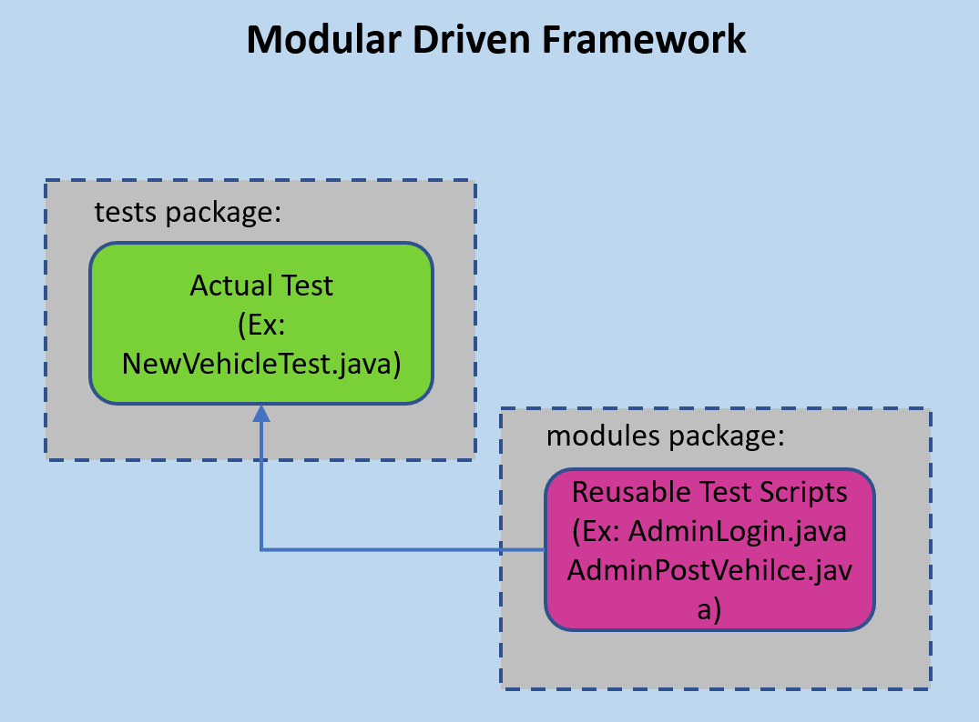

In the sample application that we are going discuss, which is an online car rental system, the following are some of the functionalities that are frequently used.

1. Admin Login
2. Admin posting a vehicle
3. Admin posting a brand etc.

When we automate the system using Modular Driven Framework, we separate this functionality in the form of separate test scripts and use them in other test scripts.

Pros:

1. The framework introduces the high level of modularization which leads to easier and cost-efficient maintenance.
2. The framework is pretty much scalable
3. If the changes are implemented in one part of the application, only the test script representing that part of the application needs to be fixed to leave all the other parts untouched.

Cons:

1. While implementing test scripts for each module separately, we embed the test data (Data with which we are supposed to perform testing) into the test scripts. Thus, whenever we are supposed to test with a different set of test data, it requires the manipulations to be made in the test scripts.

# **48A. Selenium - Frameworks - Implementing Selenium Modular Framework - Part1**

**Implementing Modular Framework:**

Since Modular Driven framework is separating the commonly used functions and write them as separate scripts lets identify the commonly used functionalities under admin area.

1. Login functionality – Login is a commonly used functionality as you have to login to Admin area if you want to do any thing.
2. Posting Vehicle – Posting vehicle can be a commonly used functionality.

There can other commonly used functionalities like posting brands etc., but let’s implement a modular framework for the following test case initially.

The test case is

Login to admin -> Navigate to Vehicles and then Post Vehicle -> Post a vehicle

Since we identified Login and Post a vehicle sections are commonly used functions, we will write separate test scripts for them.

Create a new project ModularDriven and create a package modules under it and create two classes under this and those classes are

* AdminLoging.java
* AdminVehiclePost.java

AdminLogin.java:

**package** modules;

**import** org.openqa.selenium.By;

**import** org.openqa.selenium.WebDriver;

**public** **class** AdminLogin {

WebDriver driver;

**public** AdminLogin(WebDriver driver) {

**this**.driver = driver;

}

**public** **void** login() {

driver.get("http://localhost/carrental/admin/");

driver.findElement(By.*xpath*("//input[@name='username']")).sendKeys("admin");

driver.findElement(By.*xpath*("//input[@name='password']")).sendKeys("Test@12345");

driver.findElement(By.*xpath*("//button[@name='login']")).click();

}

}

In the above program, we pass the driver that we create in our test when we create the object of the class which will be invoked by the constructor of the class.

Then we have implemented a separate function login() which will does the steps for login.

1. It will open the admin home page
2. It will enter the user name
3. It will enter the password
4. It will click on login button.

# **48B. Selenium - Frameworks - Implementing Selenium Modular Framework - Part2**

**AdminPostVehicle.java**

**package** modules;

**import** java.util.List;

**import** org.openqa.selenium.By;

**import** org.openqa.selenium.WebDriver;

**import** org.openqa.selenium.WebElement;

**public** **class** AdminVehiclePost {

WebDriver driver;

**public** AdminVehiclePost(WebDriver driver) {

**this**.driver = driver;

}

**public** **void** postvehicle() {

//Enter Vehicle Title

driver.findElement(By.*xpath*("//input[@name='vehicletitle']")).sendKeys("Toyota Avalon");

//Select brand BMW

driver.findElements(By.*cssSelector*(".btn.dropdown-toggle.btn-default")).get(0).click();

WebElement brands = driver.findElements(By.*cssSelector*(".dropdown-menu.inner")).get(0);

List<WebElement> links = brands.findElements(By.*tagName*("li"));

String brand = "BMW";

**for** (**int** i = 1; i < links.size(); i++)

{

System.***out***.println(links.get(i).getText());

**if**(brand.equalsIgnoreCase(links.get(i).getText())) {

brands.findElements(By.*tagName*("li")).get(i).click();

**break**;

}

}

//Enter vehicle overview

driver.findElement(By.*xpath*("//textarea[@name='vehicalorcview']")).sendKeys("Nice BMW Car");

//Enter vehicle price per day

driver.findElement(By.*xpath*("//input[@name='priceperday']")).sendKeys("60");

//Select Fuel Type

driver.findElements(By.*cssSelector*(".btn.dropdown-toggle.btn-default")).get(1).click();

WebElement fueltypes = driver.findElements(By.*cssSelector*(".dropdown-menu.inner")).get(1);

List<WebElement> fueltypes_li = fueltypes.findElements(By.*tagName*("li"));

String fueltype = "Petrol";

**for** (**int** i = 1; i < fueltypes_li.size(); i++)

{

System.***out***.println(fueltypes_li.get(i).getText());

**if**(fueltype.equalsIgnoreCase(fueltypes_li.get(i).getText())) {

fueltypes.findElements(By.*tagName*("li")).get(i).click();

**break**;

}

}

//Select model year

driver.findElement(By.*xpath*("//input[@name='modelyear']")).sendKeys("2018");

//Select Seating Capacity

driver.findElement(By.*xpath*("//input[@name='seatingcapacity']")).sendKeys("4");

//Upload image 1

driver.findElement(By.*xpath*("//input[@name='img1']")).sendKeys("C:\\Users\\padal\\eclipse-workspacenew\\HybridKeywordDriven\\data\\images\\audisedan\\audi1.jpg");

//Upload image 2

driver.findElement(By.*xpath*("//input[@name='img2']")).sendKeys("C:\\Users\\padal\\eclipse-workspacenew\\HybridKeywordDriven\\data\\images\\audisedan\\audi2.jpg");

//Upload image 3

driver.findElement(By.*xpath*("//input[@name='img3']")).sendKeys("C:\\Users\\padal\\eclipse-workspacenew\\HybridKeywordDriven\\data\\images\\audisedan\\audi3.jpg");

//Upload image 4

driver.findElement(By.*xpath*("//input[@name='img4']")).sendKeys("C:\\Users\\padal\\eclipse-workspacenew\\HybridKeywordDriven\\data\\images\\audisedan\\audi4.jpg");

//Upload image 5

driver.findElement(By.*xpath*("//input[@name='img5']")).sendKeys("C:\\Users\\padal\\eclipse-workspacenew\\HybridKeywordDriven\\data\\images\\audisedan\\audi5.jpg");

//Select AirConditioner

driver.findElement(By.*xpath*("//label[@for='airconditioner']")).click();

//Select powerdoorlocks

driver.findElement(By.*xpath*("//label[@for='powerdoorlocks']")).click();

//Select antilockbreaking system

driver.findElement(By.*xpath*("//label[@for='antilockbrakingsys']")).click();

}

}

In the above class we are getting the driver again using the constructor. Then we created a function postvehicle(), which will does all the actions for posting a vehicle like

1. Entering the vehicle title
2. Selecting the vehicle brand
3. Entering the vehicle overview
4. Selecting the fuel type
5. Selecting the different images
6. Selecting the different accessories etc.

# **48C. Selenium - Frameworks - Implementing Selenium Modular Framework - Part3**

**Creating the Actual Test:**

So, we have developed the two reusable test scripts. Now we develop the test.

Create another package “tests” and create a class under this with name adminpostvehicle.java.

**Adminpostvehicle.java**

**package** tests;

**import** org.openqa.selenium.By;

**import** org.openqa.selenium.WebDriver;

**import** org.openqa.selenium.firefox.FirefoxDriver;

**import** modules.AdminLogin;

**import** modules.AdminVehiclePost;

**public** **class** adminpostvehicl {

**public** **static** **void** main(String[] args) **throws** InterruptedException {

System.*setProperty*("webdriver.gecko.driver", "C:\\BrowserDrivers\\geckodriver.exe");

WebDriver driver = **new** FirefoxDriver();

//Login to the admin homepage

AdminLogin al = **new** AdminLogin(driver);

al.login();

//Click on vehicles link

driver.findElement(By.*linkText*("Vehicles")).click();

//Click on Post a Vehicle link

driver.findElement(By.*linkText*("Post a Vehicle")).click();

//Post a vehicle

AdminVehiclePost avp = **new** AdminVehiclePost(driver);

avp.postvehicle();

//Close Browser

Thread.*sleep*(2000);

driver.close();

}

}

In the above test we are logging as an admin and we are posting a vehicle. Since we have already developed the reusable scripts, first we are creating an object for the AdminLogin class by passing the driver and then we are invoking the login functionality using that object.

After that we have to navigate to the post vehicle page so we have written the steps here for clicking on Vehicles link and Post a Vehicle link.

After that since we have already written the test scritp for posting a vehicle, we have crated an object for that class by passing the driver to it and then we invoked the method postvehicle().

This way, we can write the reusable functionality as separate scripts and use them in our test cases and this is modular framework.

The overall project in Eclipse, will look like the following.

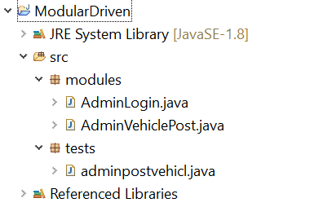

# **49. Selenium - Frameworks - Selenium Data Driven Framework**

**Data Driven Framework:**

While testing any application, we may have to test a functionality with different sets of data. In such cases we can’t embed the data in the test scripts. We have to separate the data from the script. In these cases, we store the data in an external file like an excel file or csv file and read the data from there and this is nothing but data driven framework.

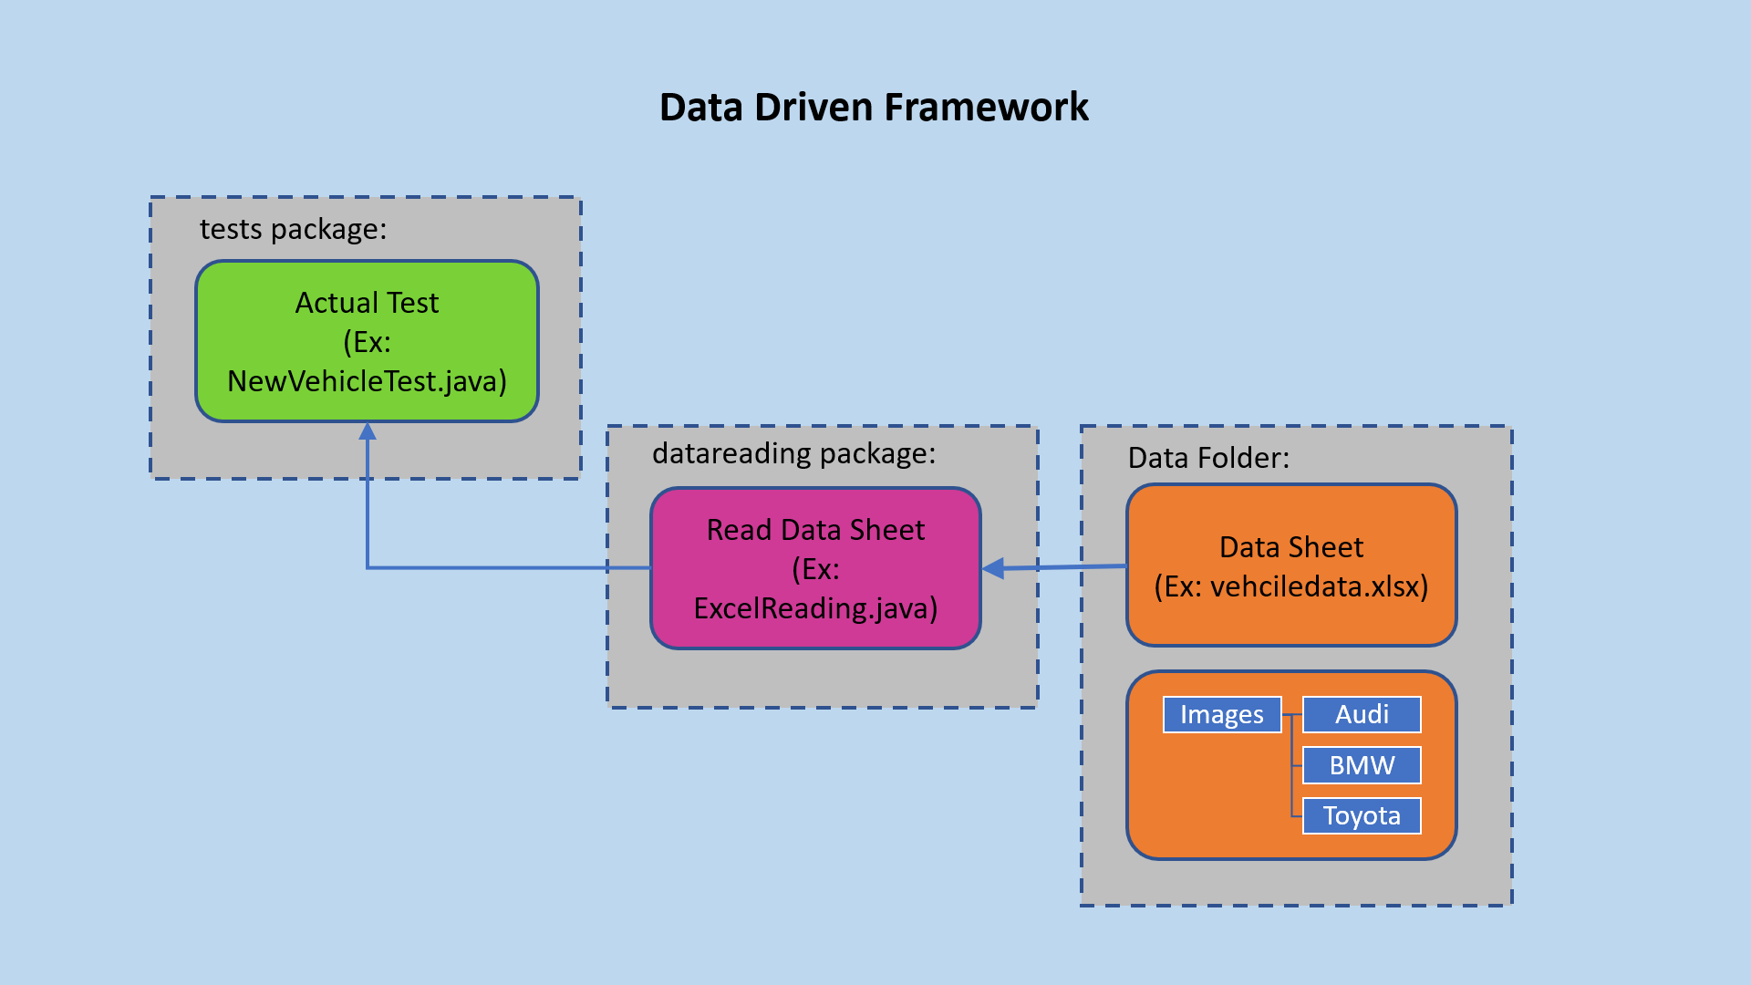

In our sample application let’s say we have to post a vehicle one time in one test script, in another test script we have to post 2 vehicles and in another test script we have to post 3 vehicles. Since it is the same post vehicle steps have to be repeated for a number of times for this particular functionality we separate the data and put it in an excel sheet.

Example Data Sheet:

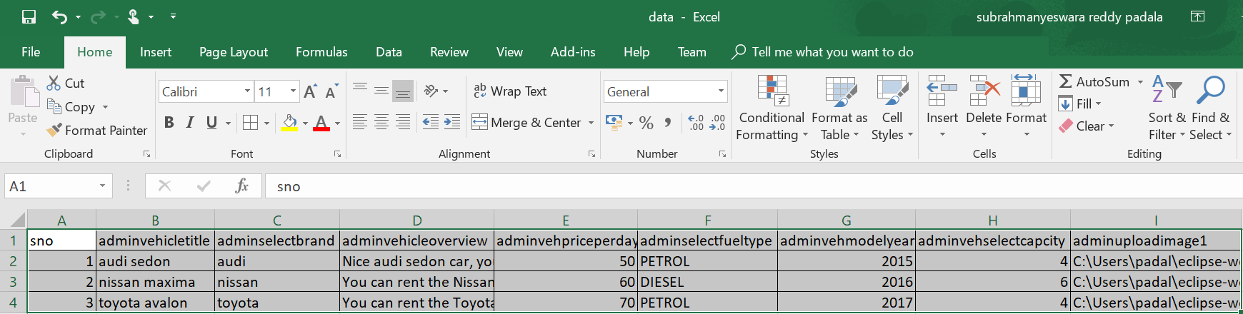

We will create a separate class to read the above data and we will use this class in the main test script we run to pass the data to the functionality.

Pros:

* The most important feature of this framework is that it considerably reduces the total number of scripts required to cover all the possible combinations of test scenarios. Thus, lesser amount of code is required to test a complete set of scenarios.
* Any change in the test data matrix would not hamper the test script code.
* Increases flexibility and maintainability
* A single test scenario can be executed altering the test data values.

Cons:

* The process is complex and requires an extra effort to come up with the test data sources and reading mechanisms.
* Requires proficiency in a programming language that is being used to develop test scripts.

# **49A. Selenium - Frameworks - Data Driven Framework Implementation - Part1**

**Data Driven Framework Implementation:**

Let’s implement data driven framework for posting three vehicles.

Create a new project “DataDriven” in Eclipse.

Create a folder “data” under this where we store the excel file with the data. Since we need images as well for posting a vehicle, create a separate folder “images” under “data” folder and put the different images here.

Create an excel sheet with name “vehicledata.xlsx” under this and enter the data for posting a vehicle under this. It should look like the following.

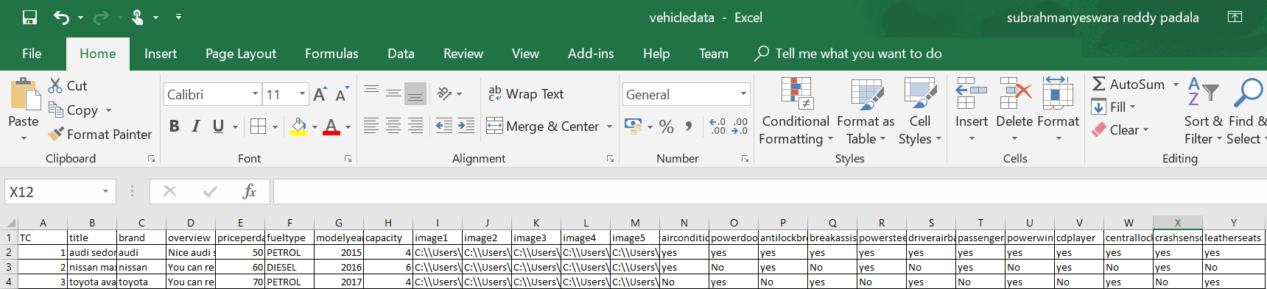

We have entered all the data in the excel sheet and we have mentioned the path for the images in the sheet. The data folder under the project should look like this.

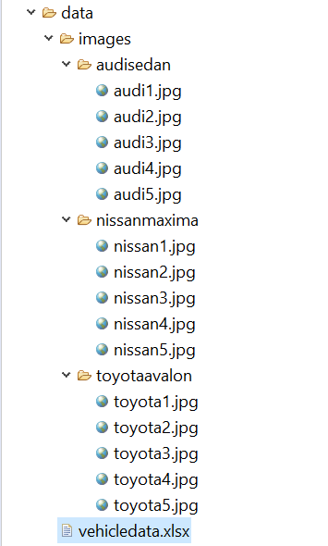

# **49B. Selenium - Frameworks - Data Driven Framework Implementation - Part2**

**Reading the data from the excel sheet:**

Now we need to have a functionality to read the data from the excel and return it to the test case. Normally, we develop the java files for reading the excel files separately in a different package as it would be easier for us to identify the actual tests from the helper classes.

So, create a new package under the project with name “datareading” and create a class “ExcelReading.java” under that. It should look like the following.



ExcelReading.java:

**package** datareading;

**import** java.io.FileInputStream;

**import** java.io.IOException;

**import** java.util.ArrayList;

**import** java.util.HashMap;

**import** java.util.Iterator;

**import** java.util.List;

**import** java.util.Map;

**import** org.apache.poi.ss.usermodel.Cell;

**import** org.apache.poi.ss.usermodel.DataFormatter;

**import** org.apache.poi.ss.usermodel.Row;

**import** org.apache.poi.xssf.usermodel.XSSFSheet;

**import** org.apache.poi.xssf.usermodel.XSSFWorkbook;

**public** **class** ExcelReading {

**public** Map<String, Map<String, String>> readdata() **throws** IOException {

Map<String, Map<String, String>> mp = **new** HashMap<String, Map<String, String>>();

//Get access to the workbook

FileInputStream fis = **new** FileInputStream("./data/vehicledata.xlsx");

XSSFWorkbook workbook = **new** XSSFWorkbook(fis);

//Get the sheet you want

XSSFSheet sheet = workbook.getSheet("vehiclesinfo");

//Get all the rows

Iterator<Row> rows = sheet.iterator();

List<String> fieldnames = **new** ArrayList<String>();

**while**(rows.hasNext()) {

String testcase = "";

List<String> ls = **new** ArrayList<String>();

Map<String, String> mpss = **new** HashMap<String, String>();

Row rowno = rows.next();

Iterator<Cell> cells = rowno.iterator();

**int** i = 0;

**if**(rowno.getRowNum() == 0)

{

**int** k = 0;

**while**(cells.hasNext()) {

Cell value = cells.next();

DataFormatter df = **new** DataFormatter();

String cellvalue = df.formatCellValue(value);

**if**(k>0) {

fieldnames.add(cellvalue);

}

k++;

}

}

**if**(rowno.getRowNum() > 0) {

**while**(cells.hasNext()) {

i++;

Cell value = cells.next();

DataFormatter df = **new** DataFormatter();

String cellvalue = df.formatCellValue(value);

**if**(i == 1) {

testcase = cellvalue;

}

**else** {

ls.add(cellvalue);

}

}

**for**(**int** j=0; j<fieldnames.size(); j++) {

mpss.put(fieldnames.get(j), ls.get(j));

}

mp.put(testcase, mpss);

}

}

workbook.close();

**return**(mp);

}

}

In the above class what we are doing is we are opening the file and get all the data required into a map. We don’t keep the excel open until our test is completed, because if we are running the tests parallelly other tests might try to access the data sheet for other information and it will slow down the tests.

First, we read the header part of the data sheet like “adminvehcletitle”, “adminselectbrand” etc into a list.

Then we will go through each row of data and read it into a list. Now we create a map using the header names and the actual data by creating a loop.

Now we get 3 maps of data for the 3 data rows created. We will add it to a main map and return it.

# **49C. Selenium - Frameworks - Data Driven Framework Implementation - Part3**

**Test for posting three vehicles:**

Create a folder “tests” under the project and create a class “NewVehicleTest.java” under that. It should look like the following now.

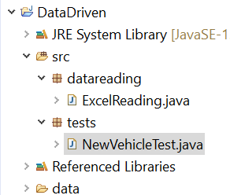

Now in the NewVehicleTest.java, we will first create an object for ExcelReading.java and call the function datareading(), which will return the data in the form of map.

Now we will iterate over the map and will pass the data to the actual steps so that the functionality will be repeated for the entire data set.

**package** tests;

**import** java.io.IOException;

**import** java.util.List;

**import** java.util.Map;

**import** java.util.Map.Entry;

**import** org.openqa.selenium.By;

**import** org.openqa.selenium.WebDriver;

**import** org.openqa.selenium.WebElement;

**import** org.openqa.selenium.firefox.FirefoxDriver;

**import** datareading.ExcelReading;

**public** **class** NewVehicleTest {

**public** **static** **void** main(String[] args) **throws** IOException, InterruptedException {

ExcelReading erm = **new** ExcelReading();

Map<String, Map<String, String>> mp = erm.readdata();

System.***out***.println(mp);

**int** notestcases = mp.size();

System.***out***.println(notestcases);

System.*setProperty*("webdriver.gecko.driver", "C:\\BrowserDrivers\\geckodriver.exe");

**for**(Entry<String, Map<String,String>> mp1: mp.entrySet()) {

WebDriver driver = **new** FirefoxDriver();

//open car rental admin page

driver.get("http://localhost/carrental/admin/");

//Login to admin page

driver.findElement(By.*name*("username")).sendKeys("admin");

driver.findElement(By.*name*("password")).sendKeys("Test@12345");

driver.findElement(By.*name*("login")).click();

driver.findElement(By.*linkText*("Vehicles")).click();

driver.findElement(By.*linkText*("Post a Vehicle")).click();

String testcase = mp1.getKey();

System.***out***.println("Test Case: "+testcase);

//List<String> testdata = (List<String>) mp1.getValue();

Map<String, String> mp2 = mp1.getValue();

//Enter Vehicle title

driver.findElement(By.*name*("vehicletitle")).sendKeys(mp2.get("title"));

//Click on brands dropdown

driver.findElements(By.*cssSelector*(".btn.dropdown-toggle.btn-default")).get(0).click();

WebElement brands = driver.findElements(By.*cssSelector*(".dropdown-menu.inner")).get(0);

List<WebElement> links = brands.findElements(By.*tagName*("li"));

**for** (**int** i = 1; i < links.size(); i++)

{

System.***out***.println(links.get(i).getText());

**if**(mp2.get("brand").equalsIgnoreCase(links.get(i).getText())) {

brands.findElements(By.*tagName*("li")).get(i).click();

**break**;

}

}

driver.findElement(By.*xpath*("//textarea[@name='vehicalorcview']")).sendKeys(mp2.get("overview"));

driver.findElement(By.*xpath*("//input[@name='priceperday']")).sendKeys(mp2.get("priceperday"));

//Select fuel type

driver.findElements(By.*cssSelector*(".btn.dropdown-toggle.btn-default")).get(1).click();

WebElement fueltypes = driver.findElements(By.*cssSelector*(".dropdown-menu.inner")).get(1);

List<WebElement> fueltypes_li = fueltypes.findElements(By.*tagName*("li"));

**for** (**int** i = 1; i < fueltypes_li.size(); i++)

{

System.***out***.println(fueltypes_li.get(i).getText());

**if**(mp2.get("fueltype").equalsIgnoreCase(fueltypes_li.get(i).getText())) {

fueltypes.findElements(By.*tagName*("li")).get(i).click();

**break**;

}

}

driver.findElement(By.*xpath*("//input[@name='modelyear']")).sendKeys(mp2.get("modelyear"));

driver.findElement(By.*xpath*("//input[@name='seatingcapacity']")).sendKeys(mp2.get("seatingcapacity"));

driver.findElement(By.*xpath*("//input[@name='img1']")).sendKeys(mp2.get("image1"));

driver.findElement(By.*xpath*("//input[@name='img2']")).sendKeys(mp2.get("image2"));

driver.findElement(By.*xpath*("//input[@name='img3']")).sendKeys(mp2.get("image3"));

driver.findElement(By.*xpath*("//input[@name='img4']")).sendKeys(mp2.get("image4"));

driver.findElement(By.*xpath*("//input[@name='img5']")).sendKeys(mp2.get("image5"));

**if**(mp2.get("airconditioner").equalsIgnoreCase("yes"))

driver.findElement(By.*xpath*("//label[@for='airconditioner']")).click();

**if**(mp2.get("powerdoorlocks").equalsIgnoreCase("yes"))

driver.findElement(By.*xpath*("//label[@for='powerdoorlocks']")).click();

**if**(mp2.get("antilockbreakingsystem").equalsIgnoreCase("yes"))

driver.findElement(By.*xpath*("//label[@for='antilockbrakingsys']")).click();

**if**(mp2.get("breakassist").equalsIgnoreCase("yes"))

driver.findElement(By.*xpath*("//label[@for='brakeassist']")).click();

**if**(mp2.get("powersteering").equalsIgnoreCase("yes"))

driver.findElement(By.*xpath*("//label[@for='inlineCheckbox5']")).click();

**if**(mp2.get("driverairbag").equalsIgnoreCase("yes"))

driver.findElement(By.*xpath*("//label[@for='driverairbag']")).click();

**if**(mp2.get("passengerairbag").equalsIgnoreCase("yes"))

driver.findElement(By.*xpath*("//label[@for='passengerairbag']")).click();

**if**(mp2.get("powerwindows").equalsIgnoreCase("yes"))

driver.findElement(By.*xpath*("//label[@for='powerwindow']")).click();

**if**(mp2.get("cdplayer").equalsIgnoreCase("yes"))

driver.findElement(By.*xpath*("//label[@for='cdplayer']")).click();

**if**(mp2.get("centrallocking").equalsIgnoreCase("yes"))

driver.findElement(By.*xpath*("//label[@for='centrallocking']")).click();

**if**(mp2.get("crashsensor").equalsIgnoreCase("yes"))

driver.findElement(By.*xpath*("//label[@for='crashcensor']")).click();

**if**(mp2.get("leatherseats").equalsIgnoreCase("yes"))

driver.findElement(By.*xpath*("//label[@for='leatherseats']")).click();

Thread.*sleep*(5000);

driver.close();

}

}

}

# **50. Selenium - Frameworks - Selenium Keyword Driven Framework**

**Keyword Driven Framework:**

The main advantage of keyword driven framework is, once this framework is created, even manual testers without any automation idea, can create the tests and run the tests without any problem.

Keyword Driven framework is a technique in which all the operations & instructions to be performed are written separately from the actual test case. For example, if we want to login to an application we perform the actions like opening the browser, entering the username, entering the password and clicking on login button.

We create a keyword sheet with these keywords and the corresponding actions will be written in a java file. Now whenever we have to login to the application we use these keywords and the corresponding class file which has the action methods to perform these actions and login into the application.

The following is an example of the keywords sheet.

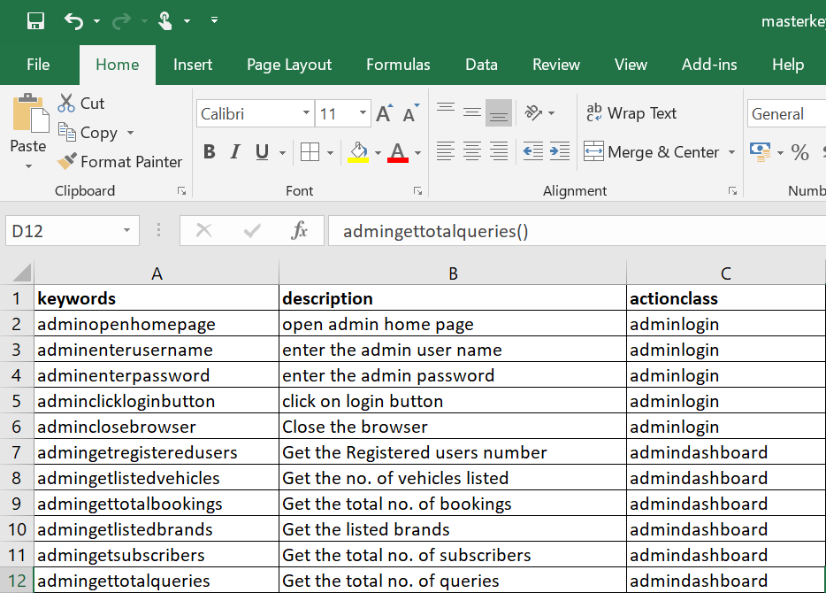

The actual test case will be an excel file like the following.

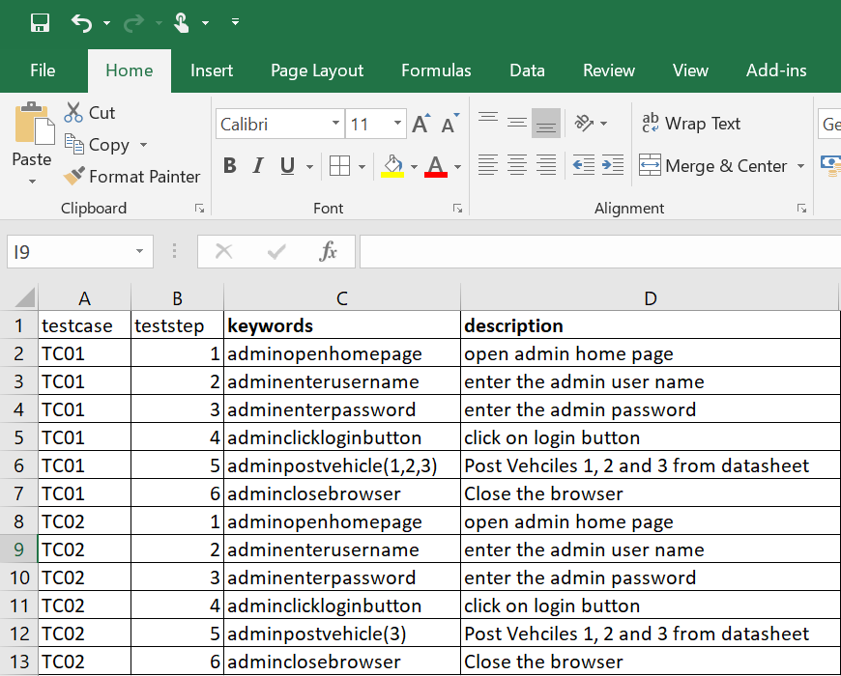

The above contains two test cases TC01 and TC02.

We maintain this test case information in a separate file like the following.

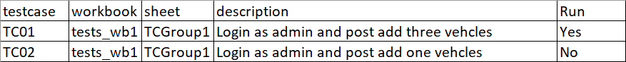

We can maintain the run mode as yes or no that means only the test cases with run mode as yes will be run during execution.

We write programs to read the keywords for each test case and perform the actions corresponding to the keyword.

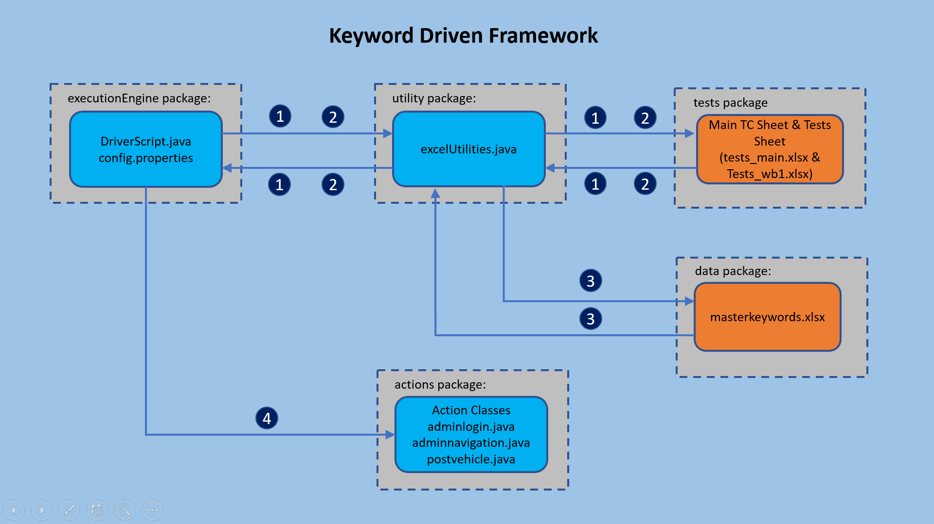

Once this framework is prepared, since it’s only creating an excel sheet with keywords, even manual testers can create these sheets and put them in framework.

Pros:

* In addition to advantages provided by Data Driven testing, the Keyword driven framework doesn’t require the user to possess scripting knowledge, unlike Data Driven Testing.
* A single keyword can be used across multiple test scripts.

Cons:

* The user should be well versed with the Keyword creation mechanism to be able to efficiently leverage the benefits provided by the framework.
* The framework becomes complicated gradually as it grows and a number of new keywords are introduced.

# **50A. Selenium - Frameworks - Implementing Selenium Keyword Driven Framework - Part 1**

**Implementing a Keyword Driven Framework:**

Create a project in eclipse with name “KeywordDrivenProject”.

Create the keywords sheet initially. Make sure that you have no duplicate keywords in the file.



You can use the actionclass names as per the functionality of the keywords. For example adminopenhomepage, adminenterusername, adminenterpassword, adminclickloginbutton and adminclosebrowser are all belong to adminlogin class. I will write adminlogin class which constitute methods to perform the actions needed for these keywords.

Create a folder “data” and place this file under that folder.

Now we have the master keywords sheet.

Now write the individual test cases. The individual test cases contain mainly keywords and description of those keywords. I have developed one test case initially..

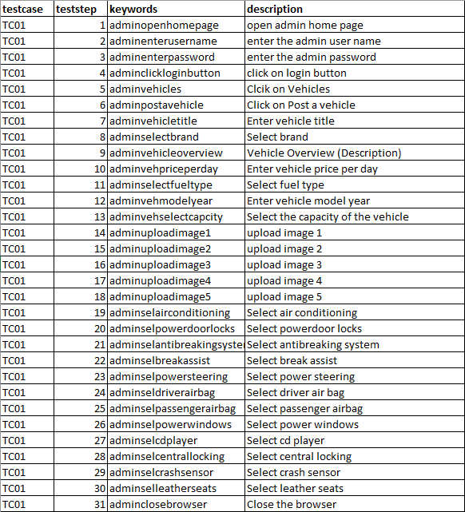

Name this file as tests_wb1 and the sheet name as TCGroup1.

Now develop the main test cases file.

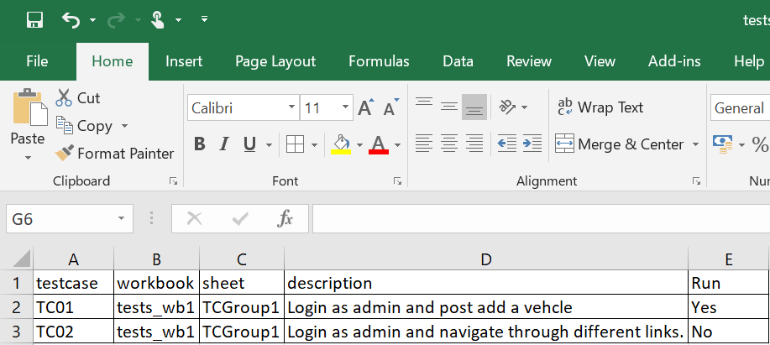

Here I have developed two tests. I mentioned the run mode for one test case as Yes and for the other as No, since I haven’t developed the second test case. Name this file as tests_main.xslx. Mentioned the workbook and sheet with the names given for the individual test steps file.

Now save these files under data folder under the project.

# **50B. Selenium - Frameworks - Implementing Selenium Keyword Driven Framework - Part 2**

**Creating Action Class adminlogin.java**

For each keyword we have defined an action class in the masterkeyword.xls so we have to develop these classes first. Since we have defined the keywords for opening home page, entering login name etc., in the action class adminlogin.java let’s develop that first.

Create a package “actions” in the project and create a class adminlogin.java under that.

**package** actions;

**import** org.openqa.selenium.By;

**import** org.openqa.selenium.WebDriver;

**public** **class** adminlogin {

WebDriver driver;

**public** adminlogin(WebDriver driver){

**this**.driver = driver;

}

**public** **void** adminopenhomepage() {

driver.get("http://localhost/carrental/admin/");

}

**public** **void** adminenterusername() {

driver.findElement(By.*name*("username")).sendKeys("admin");

}

**public** **void** adminenterpassword() {

driver.findElement(By.*name*("password")).sendKeys("Test@12345");

}

**public** **void** adminclickloginbutton() {

driver.findElement(By.*name*("login")).click();

}

**public** **void** adminclosebrowser() {

driver.close();

}

}

We will use a constructor to pass the driver first to the object. After that we define the methods with the same name as that of keyword.

# **50C. Selenium - Frameworks - Implementing Selenium Keyword Driven Framework - Part 3**

**Creating action class adminnavigation.java :**

Since the keywords adminvehicle, adminpostvehicle are for the action class “adminnavigation.java” lets create this class. Create a class “adminnavigation.java” under “actions” package.

**package** actions;

**import** org.openqa.selenium.By;

**import** org.openqa.selenium.WebDriver;

**public** **class** adminnavigation {

WebDriver driver;

**public** adminnavigation(WebDriver driver) {

**this**.driver = driver;

}

**public** **void** adminclickdashboardlink() {

driver.findElement(By.*linkText*("Dashboard")).click();

}

**public** **void** adminclickbrandslink() {

driver.findElement(By.*linkText*("Brands")).click();

}

**public** **void** adminclickcreatebrand() {

driver.findElement(By.*linkText*("Create Brand")).click();

}

**public** **void** adminmanagebrands() {

driver.findElement(By.*linkText*("Manage Brands")).click();

}

**public** **void** adminvehicles() {

driver.findElement(By.*linkText*("Vehicles")).click();

}

**public** **void** adminpostavehicle() {

driver.findElement(By.*linkText*("Post a Vehicle")).click();

}

**public** **void** adminmanagevehicles() {

driver.findElement(By.*linkText*("Manage Vehicles")).click();

}

**public** **void** adminmanagebookings() {

driver.findElement(By.*linkText*("Manage Booking")).click();

}

**public** **void** adminmanagetestimonials() {

driver.findElement(By.*linkText*("Manage Testimonials")).click();

}

**public** **void** adminmanagecontactusquery() {

driver.findElement(By.*linkText*("Manage Conatctus Query")).click();

}

**public** **void** adminregusers() {

driver.findElement(By.*linkText*("Reg Users")).click();

}

**public** **void** adminmanagepages() {

driver.findElement(By.*linkText*("Manage Pages")).click();

}

**public** **void** adminupdatecontactinfo() {

driver.findElement(By.*linkText*("Update Contact Info")).click();

}

**public** **void** adminmanagesubscribers() {

driver.findElement(By.*linkText*("Manage Subscribers")).click();

}

}

# **50D. Selenium - Frameworks - Implementing Selenium Keyword Driven Framework - Part 4**

**Creating action class postvehicle.java:**

Since posting vehicle keywords are for the action class “postvehicle.java”, lets develop this. Create a class “postvehicle.java” under the “action” package.

**package** actions;

**import** java.util.List;

**import** org.openqa.selenium.By;

**import** org.openqa.selenium.WebDriver;

**import** org.openqa.selenium.WebElement;

**public** **class** postvehicle {

WebDriver driver;

**public** postvehicle(WebDriver driver) {

**this**.driver = driver;

}

**public** **void** adminvehicletitle() {

driver.findElement(By.*xpath*("//input[@name='vehicletitle']")).sendKeys("Toyota Avalon");

}

**public** **void** adminselectbrand() {

driver.findElements(By.*cssSelector*(".btn.dropdown-toggle.btn-default")).get(0).click();

WebElement brands = driver.findElements(By.*cssSelector*(".dropdown-menu.inner")).get(0);

List<WebElement> links = brands.findElements(By.*tagName*("li"));

String brand = "Toyota";

**for** (**int** i = 1; i < links.size(); i++)

{

System.***out***.println(links.get(i).getText());

**if**(brand.equalsIgnoreCase(links.get(i).getText())) {

brands.findElements(By.*tagName*("li")).get(i).click();

**break**;

}

}

}

**public** **void** adminvehicleoverview() {

driver.findElement(By.*xpath*("//textarea[@name='vehicalorcview']")).sendKeys("Nice Toyota Avalon for rent");

}

**public** **void** adminvehpriceperday() {

driver.findElement(By.*xpath*("//input[@name='priceperday']")).sendKeys("60");

}

**public** **void** adminselectfueltype() {

driver.findElements(By.*cssSelector*(".btn.dropdown-toggle.btn-default")).get(1).click();

WebElement fueltypes = driver.findElements(By.*cssSelector*(".dropdown-menu.inner")).get(1);

List<WebElement> fueltypes_li = fueltypes.findElements(By.*tagName*("li"));

String fueltype = "PETROL";

**for** (**int** i = 1; i < fueltypes_li.size(); i++)

{

System.***out***.println(fueltypes_li.get(i).getText());

**if**(fueltype.equalsIgnoreCase(fueltypes_li.get(i).getText())) {

fueltypes.findElements(By.*tagName*("li")).get(i).click();

**break**;

}

}

}

**public** **void** adminvehmodelyear() {

driver.findElement(By.*xpath*("//input[@name='modelyear']")).sendKeys("2017");

}

**public** **void** adminvehselectcapcity() {

driver.findElement(By.*xpath*("//input[@name='seatingcapacity']")).sendKeys("4");

}

**public** **void** adminuploadimage1() {

driver.findElement(By.*xpath*("//input[@name='img1']")).sendKeys("C:\\Users\\padal\\eclipse-workspacenew\\DataDriven\\data\\images\\toyotaavalon\\toyota1.jpg");

}

**public** **void** adminuploadimage2() {

driver.findElement(By.*xpath*("//input[@name='img2']")).sendKeys("C:\\Users\\padal\\eclipse-workspacenew\\DataDriven\\data\\images\\toyotaavalon\\toyota2.jpg");

}

**public** **void** adminuploadimage3() {

driver.findElement(By.*xpath*("//input[@name='img3']")).sendKeys("C:\\Users\\padal\\eclipse-workspacenew\\DataDriven\\data\\images\\toyotaavalon\\toyota3.jpg");

}

**public** **void** adminuploadimage4() {

driver.findElement(By.*xpath*("//input[@name='img4']")).sendKeys("C:\\Users\\padal\\eclipse-workspacenew\\DataDriven\\data\\images\\toyotaavalon\\toyota4.jpg");

}

**public** **void** adminuploadimage5() {

driver.findElement(By.*xpath*("//input[@name='img5']")).sendKeys("C:\\Users\\padal\\eclipse-workspacenew\\DataDriven\\data\\images\\toyotaavalon\\toyota5.jpg");

}

**public** **void** adminselairconditioning() {

driver.findElement(By.*xpath*("//label[@for='airconditioner']")).click();

}

**public** **void** adminselpowerdoorlocks() {

driver.findElement(By.*xpath*("//label[@for='powerdoorlocks']")).click();

}

**public** **void** adminselantibreakingsystem() {

driver.findElement(By.*xpath*("//label[@for='antilockbrakingsys']")).click();

}

**public** **void** adminselbreakassist() {

driver.findElement(By.*xpath*("//label[@for='brakeassist']")).click();

}

}

# **50E. Selenium - Frameworks - Implementing Selenium Keyword Driven Framework - Part 5**

**.properties file to hold paths and developing DriverScript.java:**

.properties file is used to hold global paths like paths to the sheets etc.

Create a package “executionEngine” under the project.

Create a file with name config.properties under this package and put the following code.

WB_PATH_TESTS = C:\\Users\\padal\\eclipse-workspacenew\\KeywordDrivenProject\\tests\\tests_main.xlsx

WB_PATH_TESTS_SHEET = TestCases

WB_PATH_TEST_CASES = C:\\Users\\padal\\eclipse-workspacenew\\KeywordDrivenProject\\tests\\

MASTERKW_PATH = C:\\Users\\padal\\eclipse-workspacenew\\KeywordDrivenProject\\data\\masterkeywords.xlsx

MASTERKW_SHEET = globalkeywords

ADMIN_UNAME = admin

ADMIN_PWD = Test@12345

USER_UNAME = subbu123@gmail.com

USER_PWD = subbu123

Here we are saving the paths to the tests_main.xls, individual test cases and also the masterkeywords.xlsx file. We use these paths in our programs.

DriverScript.java: Create a class with name DriverScript under the package “executionEngine”.

**public** **static** **void** main(String[] args) **throws** Exception {

excelUtilities eu = **new** excelUtilities();

Properties gldata = **new** Properties();

InputStream input = **new** FileInputStream("src/executionEngine/config.properties");

gldata.load(input);

List<List<String>> testcases = **new** ArrayList<List<String>>();

testcases = eu.getTestCases(gldata.getProperty("WB_PATH_TESTS"), gldata.getProperty("WB_PATH_TESTS_SHEET"));

System.***out***.println(testcases);

DriverScript.*prepareKeywords*(testcases);

}

The above main method will read the properties file for the path for the main tests excel which contains the test cases. Once it gets the path it will pass this information to a method called “getTestCases()” in “excelUtilities.java” file. So we need to create this method.

Create another package with name “utility” and create a class “excelUtilities.java” under that. Create the method “getTestCases()” to read the main test cases file.

//This function will return all the main test cases like TC01, TC02 etc where run = "yes"

**public** List<List<String>> getTestCases(String wbpath, String sheetname) **throws** IOException{

//This list holds all the test cases

List<List<String>> testcases = **new** ArrayList<List<String>>();

FileInputStream fis = **new** FileInputStream(wbpath);

XSSFWorkbook workbook = **new** XSSFWorkbook(fis);

XSSFSheet sheet = workbook.getSheet(sheetname);

//Get all the rows

Iterator<Row> rows = sheet.iterator();

**while**(rows.hasNext()) {

//This list holds each test case info test case no, workbook, sheet

List<String> testcaseinfo = **new** ArrayList<String>();

Row rowno = rows.next();

Cell tcvalue = rowno.getCell(0);

Cell wbvalue = rowno.getCell(1);

Cell shvalue = rowno.getCell(2);

Cell rvalue = rowno.getCell(4);

String testcasevalue;

String workbookvalue;

String sheetvalue;

String runvalue;

DataFormatter df = **new** DataFormatter();

runvalue = df.formatCellValue(rvalue);

**if**(runvalue.equalsIgnoreCase("yes")) {

testcasevalue = df.formatCellValue(tcvalue);

testcaseinfo.add(testcasevalue);

workbookvalue = df.formatCellValue(wbvalue);

testcaseinfo.add(workbookvalue);

sheetvalue = df.formatCellValue(shvalue);

testcaseinfo.add(sheetvalue);

testcases.add(testcaseinfo);

}

}

workbook.close();

**return** testcases;

}

Using the above two methods, the test cases likeTC01, TC02 with their workbook names and sheet names will be returned.

# **50F. Selenium - Frameworks - Implementing Selenium Keyword Driven Framework - Part 6**

**Getting the Individual Test Cases Keywords:**

Now we got the test cases information like test case no., the workbook name and sheet where these test cases are. Now we have to go into each test case and get the keyword for each test case. The following method does that by calling getKeywordsFromTestCase() method in excelUtilities.java file.

prepareKeywords() method in DriverScript.java:

**public** **static** **void** prepareKeywords(List<List<String>> testcases) **throws** IOException, ClassNotFoundException, NoSuchMethodException, SecurityException, IllegalAccessException, IllegalArgumentException, InvocationTargetException, InstantiationException, InterruptedException {

Properties gldata = **new** Properties();

InputStream input = **new** FileInputStream("src/executionEngine/config.properties");

gldata.load(input);

**int** total_testcases = testcases.size();

excelUtilities ecu = **new** excelUtilities();

**for**(**int** i=0; i<total_testcases; i++) {

List<String> keywords = **new** ArrayList<String>();

keywords = ecu.getKeywordsFromTestCase(testcases.get(i).get(0),gldata.getProperty("WB_PATH_TEST_CASES")+testcases.get(i).get(1)+".xlsx", testcases.get(i).get(2));

System.***out***.println(keywords);

*getDependencies*(keywords);

}

}

getKeywordsFromTestCase() method in excelUtilities.java:

//This function will get the keywords from excel

**public** List<String> getKeywordsFromTestCase(String tcno, String wbpath, String sheetname) **throws** IOException{

FileInputStream fis = **new** FileInputStream(wbpath);

//System.out.println("workingfine");

XSSFWorkbook workbook = **new** XSSFWorkbook(fis);

XSSFSheet sheet = workbook.getSheet(sheetname);

//Get all the rows

Iterator<Row> rows = sheet.iterator();

List<String> keywords = **new** ArrayList<String>();

**while**(rows.hasNext()) {

Row rowno = rows.next();

Cell tccell = rowno.getCell(0);

DataFormatter df = **new** DataFormatter();

String tcvalue = df.formatCellValue(tccell);

**if**(tcvalue.equalsIgnoreCase(tcno)) {

Cell cellvalue = rowno.getCell(2);

String keyword = df.formatCellValue(cellvalue);

keywords.add(keyword);

}

}

workbook.close();

**return** keywords;

}

We get a list of keywords for each test case from the above methods.

# **50G. Selenium - Frameworks - Implementing Selenium Keyword Driven Framework - Part 7**

**Get the action classes from the masterkeywords.xlsx:**

Now we have to get the action classes from the masterkeywords.xlsx for the above keywords we got for each test case.

getDependencies() method in DriverScript.java

**public** **static** **void** getDependencies(List<String> keywords) **throws** IOException, ClassNotFoundException, NoSuchMethodException, SecurityException, IllegalAccessException, IllegalArgumentException, InvocationTargetException, InstantiationException, InterruptedException {

List<String> originalkeywords = **new** ArrayList<String>(keywords);

//originalkeywords = keywords;

Properties gldata = **new** Properties();

InputStream input = **new** FileInputStream("src/executionEngine/config.properties");

gldata.load(input);

excelUtilities ecu = **new** excelUtilities();

List lis = ecu.getActionsObjects(keywords, gldata.getProperty("MASTERKW_PATH"), gldata.getProperty("MASTERKW_SHEET"));

Set<String> actionclass = (Set<String>) lis.get(0);

Map<String, String> keywordvsac = (Map<String, String>) lis.get(1);

System.***out***.println(originalkeywords);

System.***out***.println(actionclass);

System.***out***.println(keywordvsac);

*executeTC*(originalkeywords,actionclass,keywordvsac);

}

getActionsObjects() method in excelUtilities.java:

//This function will return the action class names and object repository names a particular test case needs

**public** List getActionsObjects(List<String> keywords, String wbpath, String sheetname) **throws** IOException{

//This set holds the action class names needed

Set<String> actionclasses = **new** HashSet<String>();

//This map holds the keyword vs action class

Map<String, String> keywordsvsac = **new** HashMap<String, String>();

//This ArrayList holds all the above and will be returned

List lis = **new** ArrayList();

FileInputStream fis = **new** FileInputStream(wbpath);

XSSFWorkbook workbook = **new** XSSFWorkbook(fis);

XSSFSheet sheet = workbook.getSheet(sheetname);

//Get all the rows

Iterator<Row> rows = sheet.iterator();

**while**(rows.hasNext()) {

**try** {

Row rowno = rows.next();

Cell kwvalue = rowno.getCell(0);

Cell acvalue = rowno.getCell(2);

DataFormatter df = **new** DataFormatter();

String keywordvalue = df.formatCellValue(kwvalue);

String actionclassvalue;

**for**(**int** i=0; i<keywords.size(); i++) {

**if**(keywords.get(i).equalsIgnoreCase(keywordvalue)) {

actionclassvalue = df.formatCellValue(acvalue);

actionclasses.add(actionclassvalue);

keywordsvsac.put(keywords.get(i), actionclassvalue);

}

}

}

**catch**(Exception e) {

}

}

workbook.close();

lis.add(actionclasses);

lis.add(keywordsvsac);

**return** lis;

}

Using the above two methods we get the action classes for each keyword.

# **50H. Selenium - Frameworks - Implementing Selenium Keyword Driven Framework - Part 8**

**Now Execute the TC:**

Now we got all the information needed to execute a test case. So we can start with test execution. The following method executeTC() from DriverScript.ajva will do the execution.

**public** **static** **void** executeTC(List<String> originalkeywords, Set<String> actionclass, Map<String, String> keywordvsac) **throws** ClassNotFoundException, NoSuchMethodException, SecurityException, IllegalAccessException, IllegalArgumentException, InvocationTargetException, InstantiationException, IOException, InterruptedException {

System.*setProperty*("webdriver.gecko.driver", "C:\\BrowserDrivers\\geckodriver.exe");

WebDriver driver = **new** FirefoxDriver();

**for**(String str : originalkeywords) {

String keyword = str;

String actioncl = keywordvsac.get(keyword);

Class<?> cls = Class.*forName*("actions."+actioncl);

Method[] methodcall = cls.getDeclaredMethods();

**for**(Method m : methodcall) {

**if**(keyword.equalsIgnoreCase(m.getName()))

{

Method mc = cls.getDeclaredMethod(keyword);

Constructor constructor = cls.getConstructor(WebDriver.**class**);

mc.invoke(constructor.newInstance(driver));

}

}

}

}

We use java reflection classes to do this.

Using java reflections, we find the method corresponding to a particular keyword in the corresponding action class and we invoke that method. Since we loop it for all the keywords, all the methods will be executed.

Now all our files are ready and if we execute the file DriverScript.java it will execute all test cases with run mode as “yes”.